同济大学课程考核试卷（C卷）答案
2006—2007 学年第一学期
命题教师签名： 审核教师签名：
课号：42002301 课名：数据库原理与应用 考试考查：考试
此卷选为：期中考试( )、期终考试( )、重考( ) 试卷

年级 专业 学号 姓名 得分

- Explain the distinctions among the terms primary key, candidate key, and super key.
(10 points)

Answer:

A superkey is a set of one or more attributes that, taken collectively, allows us to identify uniquely an entity in the entity set. A superkey may contain extraneous attributes. If K is a superkey, then so is any superset of K. A superkey for which no proper subset is also a superkey is called a candidate key. It is possible that several distinct sets of attributes could serve as candidate keys. The primary key is one of the candidate keys that is chosen by the database designer as the principal means of identifying entities within an entity set.

- When we decompose a relation schema R with a set of functional dependencies F into R1, R2,….., Rn, we want the decomposition to satisfy three criteria. What are these three criteria? Describe them briefly.
(10 points)

Answer:

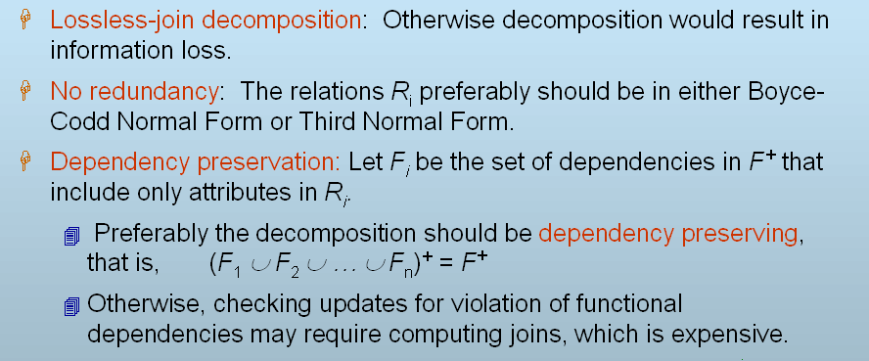

- There exist a relation schema R =(A, B, C, G, H, I), and a set of functional dependencies F ={ A →→ B,
B →→ HI,
CG →→ H }
Is R in 4NF? If it is not, follow the 4NF decomposition algorithm to decompose it.

(10 points)

Answer:

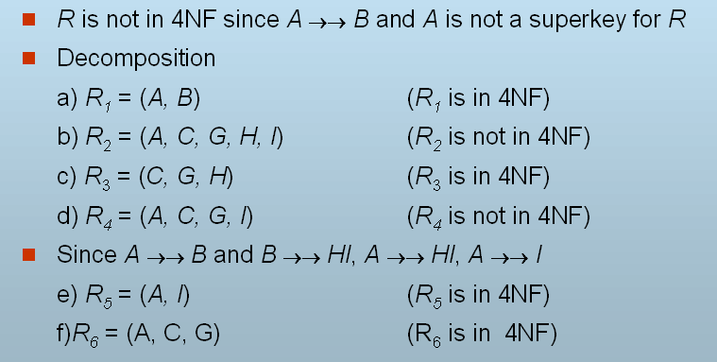

So R is decomposed into R₁, R₃, R₅, R₆.

