Good morning, thank you for (TA’s name) joining our demo. We’re excited to present what we come up for this project.

In this project, we used **Python**as our programming language to build a web application. MySQL is the database we used in this project. Django is our main backend framework. Our frontend framework uses bootstrap.

We type commands in cmd: py manage.py runserver and give us this link. Copy and paste it to the browser. This is how the interface looks like. The basic 5 statistics are displayed here including count of stores offering childcare, count of products, count of distinct advertising campaigns, count of stores, count of stores offering food. The following are 9 reports and 2 maintenances including population and holiday maintenance as required by the project spec. I’ll show you the maintenance functions first, and then the 9 reports.

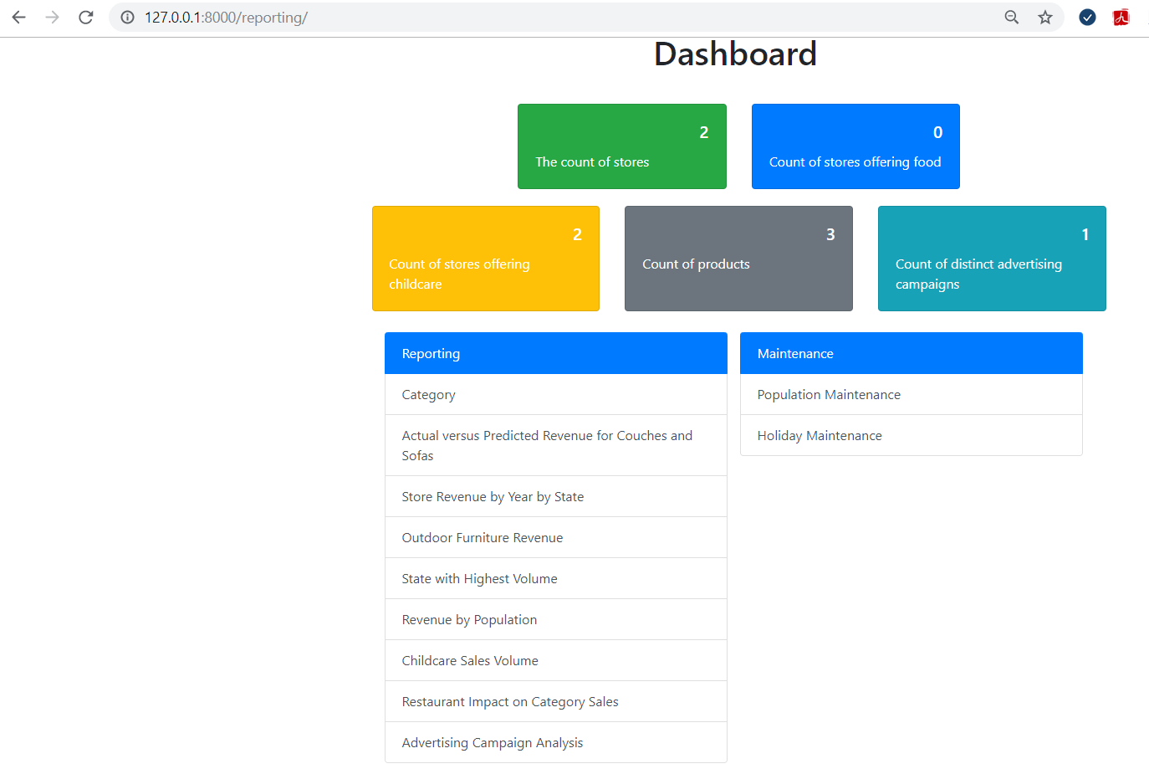

There are two maintenances: Population and holiday maintenance.

1. Click on population link, user can select state, city and it shows the population. If no selection, update population button is dabbled. If input another number. It shows the success message. Note: population length should be between 0- 10.

2. If the same population is entered, disable the button.

3. If we decide not to update population, choose other state, button disabled again.

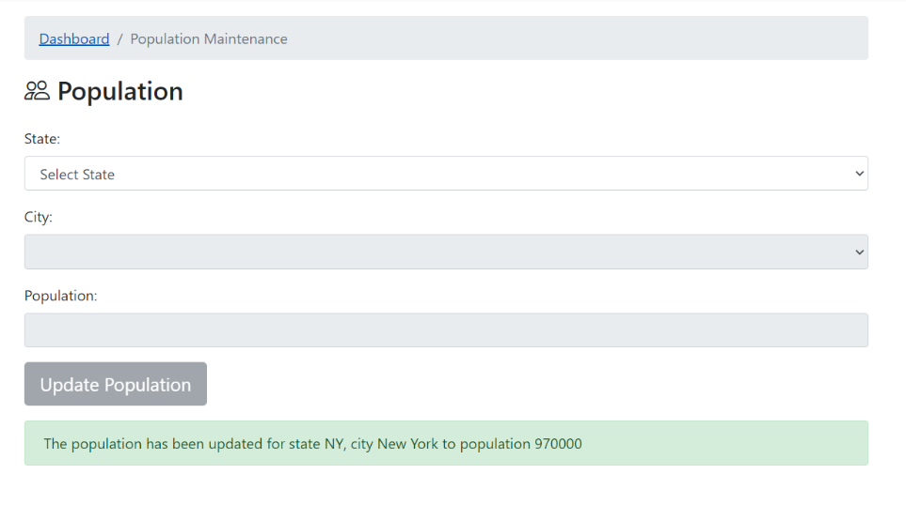

Click on the holiday maintenance link: 1. it shows holiday list. A date can have multiple holiday names.

2. If the user wants to add holiday, click add holiday button. If no selection, add holiday button is disabled. User needs to input Holiday Name and Select Holiday Date from DateTimePicker. And the holiday is added. Note: The Date Text box is read only and only support the time picker to reduce the error handling cost. And when we go back to holiday list you can see the holiday is added.

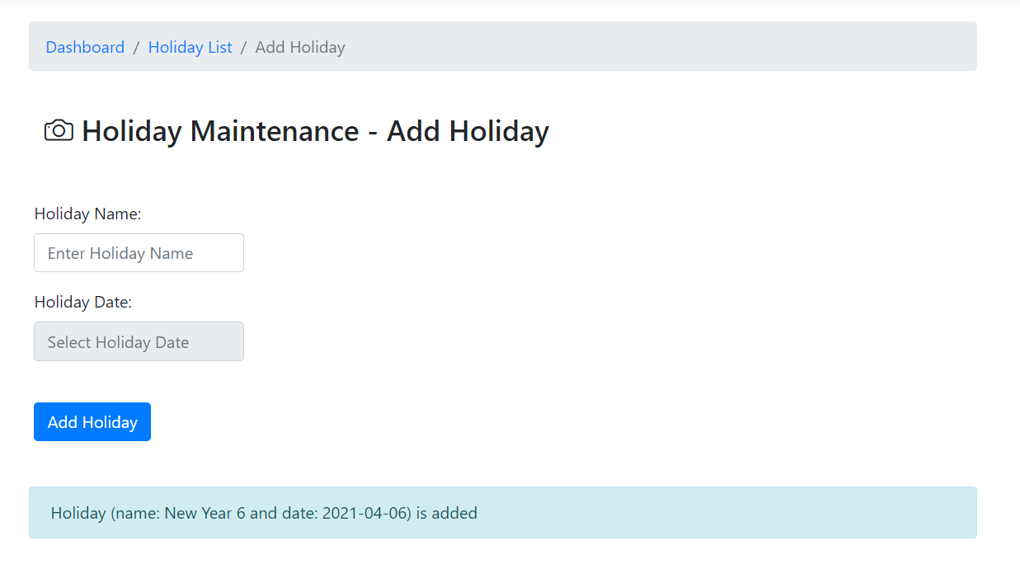

3. If holiday existed with the same name and same day, it shows the message:

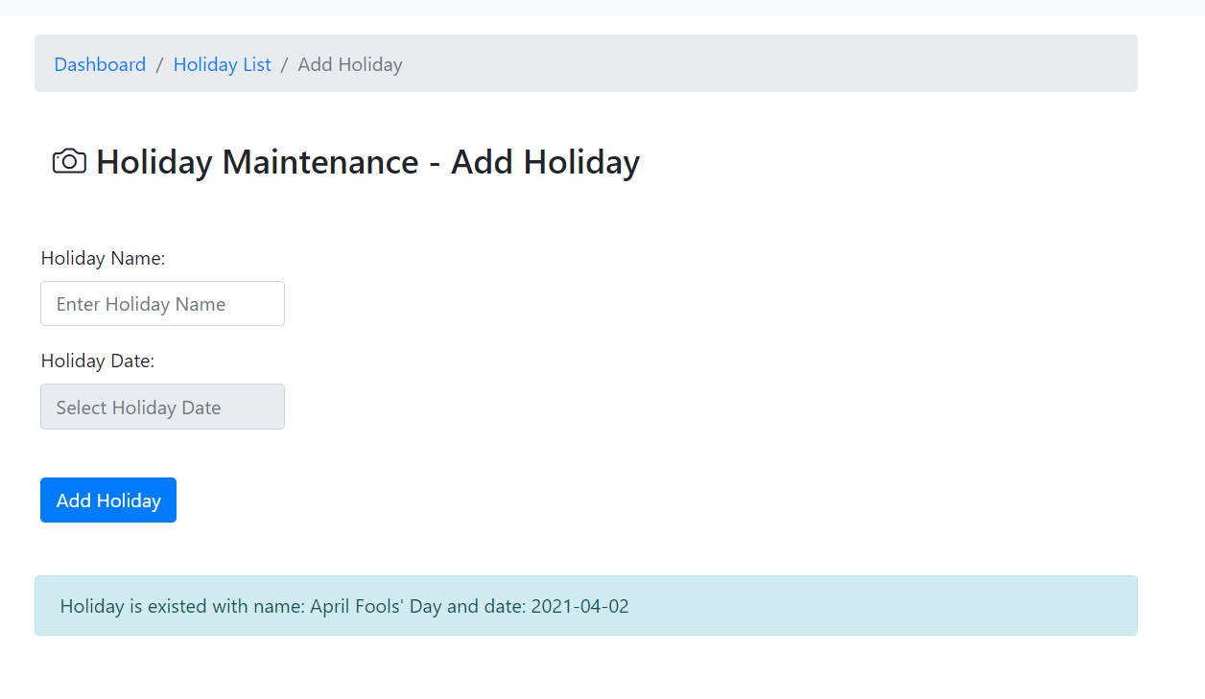

Now let’s go to the reports. Report 1 is the category report. 1. Once the user clicks this link, it returns this table. Columns include category name, total number of products, Min & Average & Max retail price of products. 2. Each category includes those without products are listed here. 3. Report is sorted by category name in ascending order. Click the “Dashboard” here, you can return to main menu.

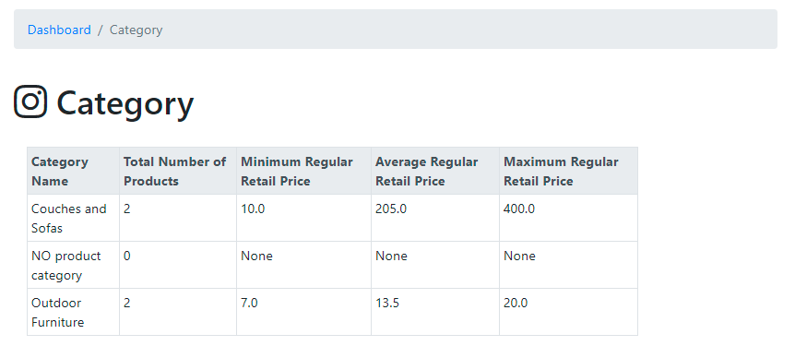

Report 2 is the report about actual versus predicted revenue for couches and sofas. Once the user clicks this link, it returns this table. 1. This report is only for the products in the category of couches and sofas. 2. The column in this table include product ID, name, retail price, total number of items sold, total number of items sold at discount price, total number of items sold at retail price, actual revenue, predicted revenue, and the difference. 3. Predicted revenue…. 4. As required by the spec, only predicted revenue differences greater than $5000 (either positive or negative) are displayed here and sorted in descending order. Difference is calculated between the actual revenue and the predicted revenue. This is the report 2. Again, click “Dashboard” and return the main menu.

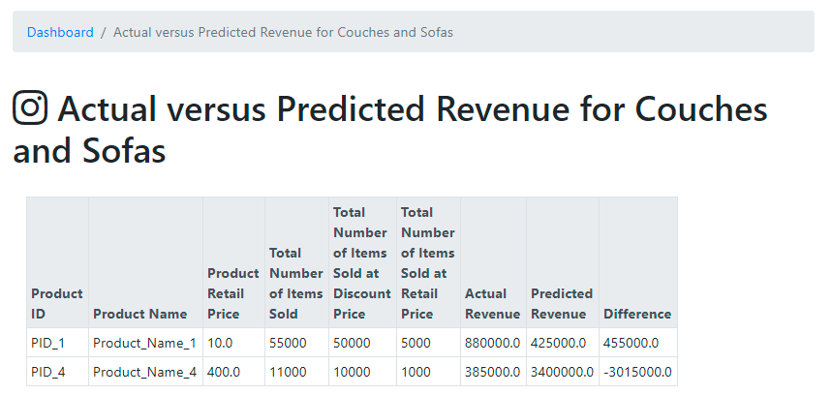

Report 3 is the store revenue by year by states report. 1. When clicking this link, it asks the user to select a state and then click Run Report button. Note, here if you don’t select any state, run report button is disabled. Once we select a state and click the button, it goes to this table. 2. Columns include store ID, Store Address, city name, sales year and total revenue. 3. The report is sorted first by year in ascending order and then by revenue in descending order. （select state: CA）

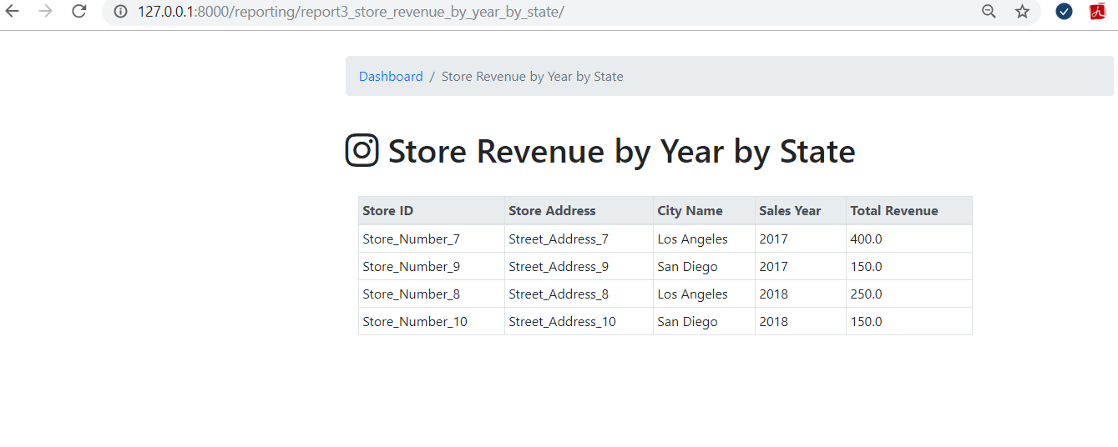

Report 4 is the report about outdoor furniture revenue on Groundhog day. 1. This report is only for products in the category of outdoor furniture. 2. It returns the table with columns of year, total number of items sold, average number of items sold per day, total number of items sold on Groundhog day (Feb.2). 3. The report is sorted by year in ascending order.

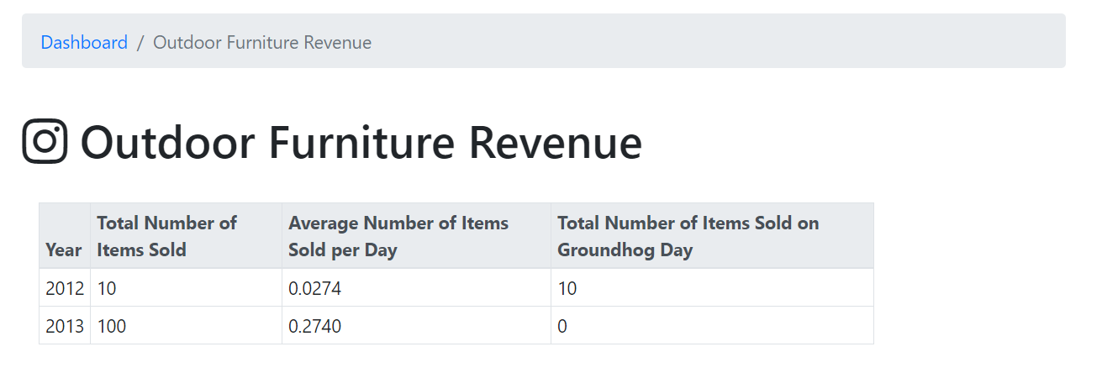

Report 5 is the State with Highest Volume Report. 1. Clicking the link, user need to select year and month first. If no selection, Run Report button is disabled. Then, it returns this table with the column of the category name, the states that sold the highest number of units in that category (include items sold by all stores in the state), and the number of units that were sold by stores in that state.  2. The table is sorted by category name ascending. 3. Note: Each category will only be listed once unless there are more than one state with the highest sales units. (select 2021 March)

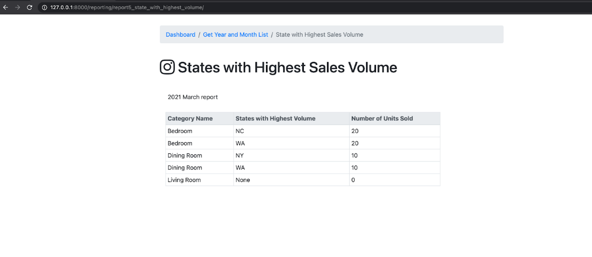

Report 6 is the revenue by population report. The user clicks report 6 link and goes to this table. 1. It includes columns of years, categories for city sizes including small city, medium city, large city and extra large city. 2. Years are in ascending order. 3. Note: when population is updated in the Population Maintenance, the city size category in this report will also be updated simultaneously. (Try New York city, make it become the extra large city)

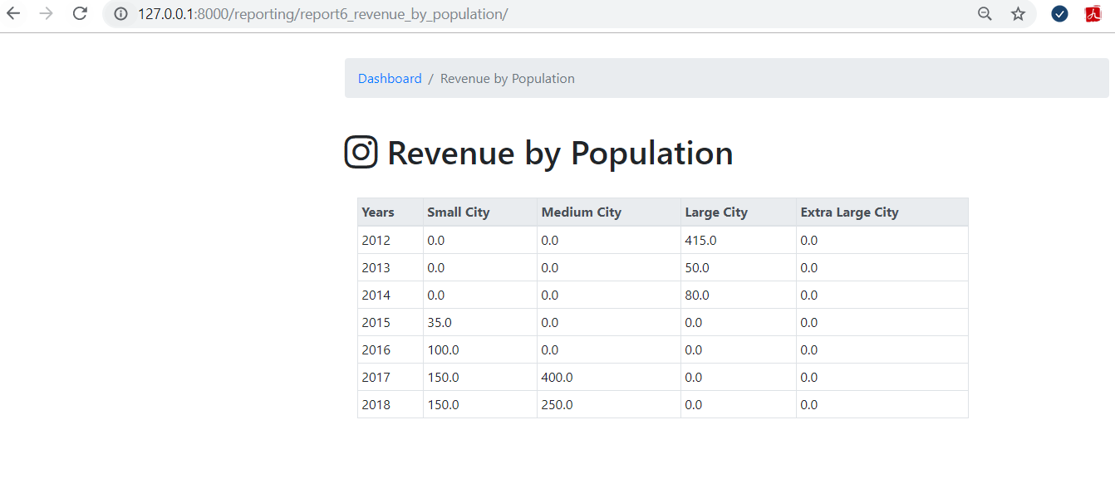

Report 7 is the report about childcare sales volumes. 1. Once the user clicks on the Childcare Sale Volume, it returns all available sales data for the last 12 months and for each childcare time limit. 2. Columns include all childcare time limits and there is also one column for no childcare limit.

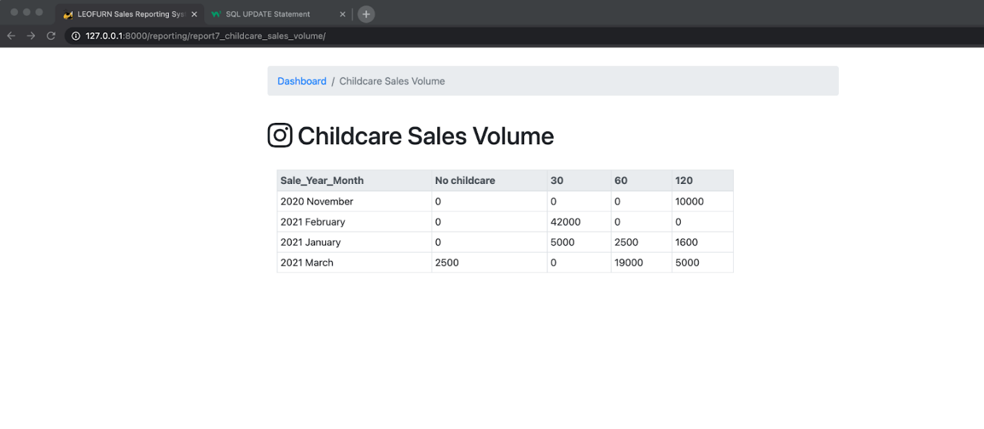

Report 8 is about the Restaurant Impact on Category Sales. Click the link and shows this table. 1. The columns include category, store type, quantity sold. Store type includes non-restaurant and restaurant. 2. The report is ordered by category name ascendingly, with non-restaurant store data listed first. 3. For the Store Type that has no quantity sold, 0 will be shown in the quantity sold column. 4. Note: any categories that are not assigned products is not included in this report.

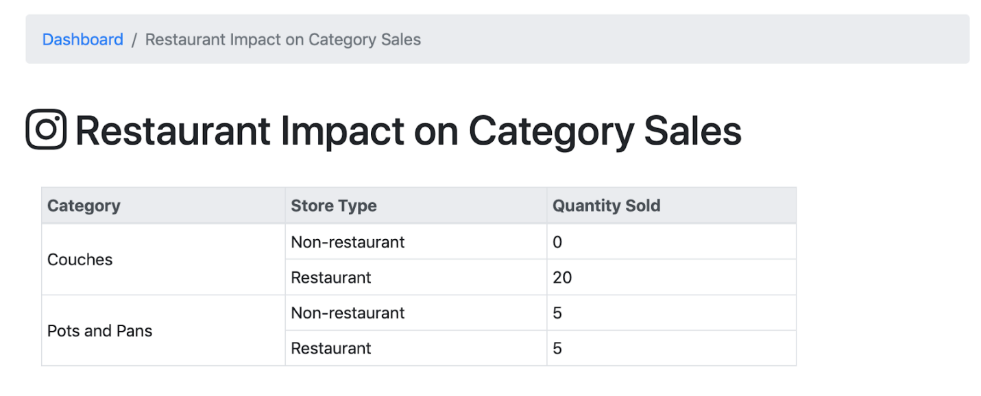

Report 9 is advertising campaign analysis report. 1. Click the link and it returns the table with the column of product ID, product name, sold during campaign, sold outside campaign and difference (difference calculation). 2. The results are sorted by difference in descending (highest to lowest) order. 3. Only the top 10, followed by the bottom 10 from the results are shown in this report.

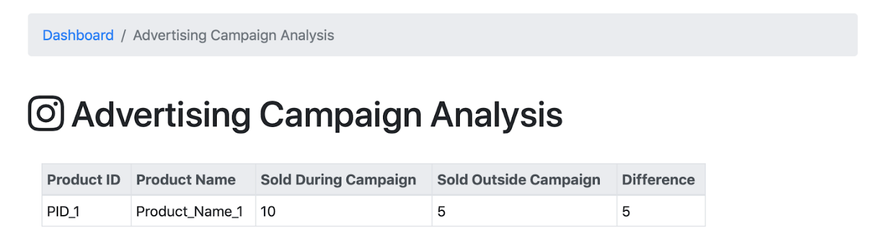

For all reports, if there are no data meet the report criteria, “No Records!” will be shown.

End~

That’s it. Any questions? Again, thank you for joining us. We’ve learnt a lot from this course. Thanks! Have a good weekend……