Display Revenue by Population

Task Decomp

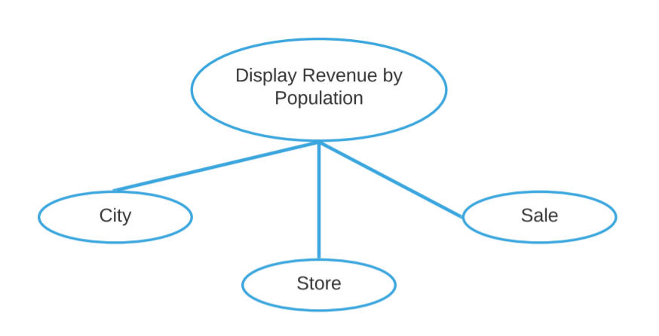

**Lock Types**: Read-only (Share-locked) on City, Store and Sale tables

**Number of Locks:** Several different schema constructs are needed

**Enabling Conditions:** All 3 are enabled when report loading transaction is triggered

**Frequency**: Low- All 3 have the same frequency

**Consistency (ACID):** Read Committed

**Subtasks:** Mother Task is not needed. No Decomposition needed

Abstract Code

* User clicked on ***View Revenue by Population button/Link*** from **Main Menu**:
* Run the **Display Revenue by Population** task: query for information about the total revenue based on the group of Store’s City Population Size Category and Sale Year
* Display City Size Category, Year and Revenue with Ascending Order in a tabular form

View Childcare Sales Volume

Task Decomp

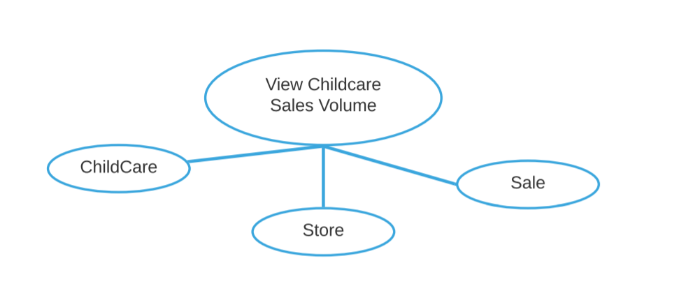

**Lock Types**: Read-only (Share-locked) on Store, Sale and ChildCare tables

**Number of Locks:** Several different schema constructs are needed

**Enabling Conditions:** All 3 are enabled when report loading transaction is triggered

**Frequency**: Low- All 3 have the same frequency

**Consistency (ACID):** Read Committed

**Subtasks:** Mother Task is not needed. No Decomposition needed

Abstract Code

* User clicked on ***View Childcare Sales Volume Report button/Link*** from **Main Menu**:
* Run the **View Childcare Sales Volume** task: query for information about the total sales volume with childcare category based on the group of childcare time limitation and from the last 12 month’s sales
* Display Childcare Category, Childcare Time Limit and Total Sales by Month in a tabular form

View Holidays

Task Decomp

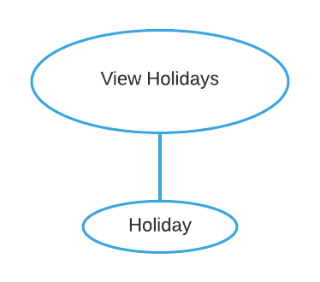

**Lock Types**: Read-only (Share-locked) on Holiday table

**Number of Locks:** Single

**Enabling Conditions:** Triggered when report page is loading

**Frequency**: Low

**Consistency (ACID):** Read Committed

**Subtasks:** Mother Task is not needed. No Decomposition needed

Abstract Code

* User clicked on ***Holiday Maintenance*** ***button/Link*** from **Main Menu**:
* Run the **View Holiday** task: query for information about the holiday
* Display Holiday List in ***Holiday Maintenance UI***

Add Holiday

Task Decomp

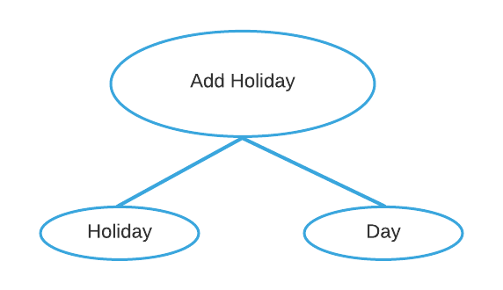

**Lock Types**: write exclusive-locked on Holiday and Day tables

**Number of Locks:** 2

**Enabling Conditions:** Triggered when report page is loading

**Frequency**: Low

**Consistency (ACID):** Serializable

**Subtasks:** Mother Task “View Holidays” is needed. No Decomposition needed

Abstract Code

* User enters Holiday Name (‘$HolidayName’) in input textbox and select Date (‘$HolidayDate’) in Calendar Dropdown
* If data validation is successfully for both holiday name and date in Client Side, then:
  + When **Add** button is clicked:
    - If Holiday Name and Date existed:
* Go back to ***Holiday Maintenance UI*** with holiday existed notification message
  + - If Holiday Name not existed but date existed:
* Store the Holiday Name in Holiday Table and link its date with Day Table
* Go back to Holiday Maintenance UI with success message
  + - If both Holiday Name and date do not exist
* Store the Holiday Name and date in both Holiday and Day Tables
* Go back to Holiday Maintenance UI with success message
* Else: display the error message in ***Holiday Maintenance UI***