Dashboard

Task Decomp

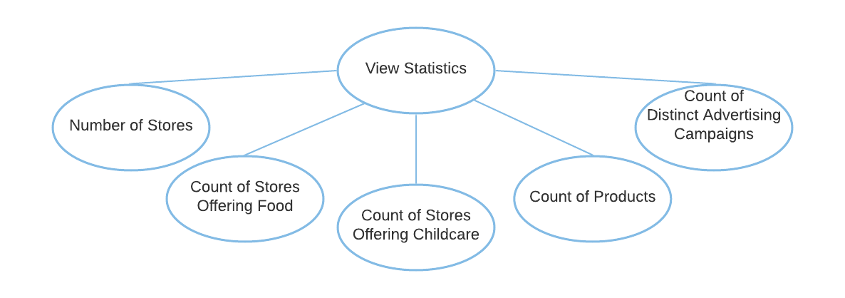

**Lock Types**: 4 Read-only on STORE, CHILDCARE, PRODUCT, and ADVERTISING_CAMPAIGNS tables

**Number of Locks**: Several different schema constructs are needed.

**Enabling Conditions**: None – all five statistics are available to show once the page is loaded and menu is displayed.

**Frequency**: High – all five statistics are shown every time when the main page is loaded.

**Consistency (ACID)**: Not critical, order is not critical.

**Subtasks**: All tasks must be done but can be done in parallel. Mother task is required to coordinate subtasks. Order is not necessary.

Abstract Code

* Show *“****Holiday Maintenance****”, “****View Product by Category Report****”, “****View Actual vs. Predicted Revenue for Couches and Sofas Report****”, “****View Store Revenue by Year by State Report****”, “****View GroundHog Day Outdoor Furniture Report****”, “****View State with Highest Volume by Category Report****”, “****View Revenue by Population Report****”, “****View Childcare Sales Volume Report****”, “****View Restaurant Impact on Category Sales Report****”, “****View Advertising Campaign Analysis Report****”,* and *“****Population Maintenance****”* buttons/links on the **Dashboard** form.
* Upon:
  + Click ***Holiday Maintenance*** button – Jump to the **Holiday Maintenance** form.
  + Click ***View Product by Category Report*** button – Jump to the **View Product by Category Report** task.
  + Click ***View Actual vs. Predicted Revenue for Couches and Sofas Report*** button – Jump to the **View Actual vs. Predicted Revenue for Couches and Sofas Report** task.
  + Click ***View Store Revenue by Year by State Report*** button – Jump to the **Get Available State List** task.
  + Click ***View GroundHog Day Outdoor Furniture Report*** button – Jump to the **View GroundHog Day Outdoor Furniture Report** task.
  + Click ***View State with Highest Volume by Category Report*** button – Jump to the **Get Year and Month List** task.
  + Click ***View Revenue by Population Report*** button – Jump to the **View Revenue by Population Report** task.
  + Click ***View Childcare Sales Volume Report*** button – Jump to the **View Childcare Sales Volume** **Report** task.
  + Click ***View Restaurant Impact on Category Sales Report*** button – Jump to the **View Restaurant Impact on Category Sales Report** task.
  + Click ***View Advertising Campaign Analysis Report*** button – Jump to the **View Advertising Campaign Analysis Report** task.
  + Click ***Population Maintenance*** button – Jump to the **Population Maintenance** form.
* Display statistics for “the count of stores”, “count of stores offering food (have a restaurant, a snack bar, or both)”, “count of stores offering childcare”, “count of products”, and “count of distinct advertising campaigns” on the **Dashboard** form.
  + Show “the count of stores”.
    - Query for total count of Store_Number in the STORE table.
    - Display the total count.
  + Show “count of stores offering food”.
    - Query for the total count of Store_Number in the STORE table that has either or both Has_Restaurant and Has_Snack_Bar value as true.
    - Display the total count.
  + Show “count of stores offering childcare”.
    - Query for the total count of Store_Number in the STORE table that has a Childcare center association in the CHILDCARE table.
    - Display the total count.
  + Show “count of products”.
    - Query for the total count of PID in the PRODUCT table.
    - Display the total count.
  + Show “count of distinct advertising campaigns”.
    - Query for the total count of Description in ADVERTISING_CAMPAIGNS table.
    - Display the total count.

Get Year and Month List

Task Decomp

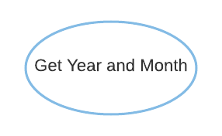

**Lock Types**: Read-only on DAY table.

**Number of Locks**: Single.

**Enabling Conditions**: Triggered when ***View State with Highest Volume by Category Report*** button is clicked.

**Frequency**: Medium – monthly report.

**Consistency (ACID)**: Not critical, order is not critical.

**Subtasks**: Mother Task is not needed. No decomposition needed.

Abstract Code

* User clicked on the ***View State with Highest Volume by Category Report*** button from the **Dashboard** form.
* Run the **Get Year and Month** task: query for information about the available *year* and *month* fields from the DAY table.
  + Display both *year* and *month* lists in descending order on the drop-down list form.
* On the drop-down list form, show ***Run Report*** button.
* Upon:
  + Click ***Run Report*** button –
    - If both *year* and *month* are selected – Jump to the **View State with Highest Volume by Category Report** task.
    - If one or both fields are empty – display a message asking for user input.

View State with Highest Volume by Category Report

Task Decomp

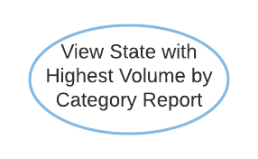

**Lock Types**: 5 Read-only on CITY, DAY, SALE, CATEGORY, and STORE table

**Number of Locks**: Several different schema constructs are needed.

**Enabling Conditions**: Triggered when ***Run Report*** button from the drop-down list form is clicked.

**Frequency**: Medium – monthly report.

**Consistency (ACID)**: Not critical, order is not critical.

**Subtasks**: Mother Task is not needed. No decomposition needed.

Abstract Code

* User clicked on the ***Run Report*** button from the drop-down list form.
* If data validation is successful for both *year* and *month* input fields, then proceed.
* Run the **View State with Highest Volume by Category Report** task:
  + Find all Sales data from the SALE table based on the *year* and *month* (from the DAY table) selected.
  + Get all Category_Name data (from the CATEGORY table).
  + In each category, aggregate sales unit data from all stores (from the STORE table) by state (from the CITY table) and find the states that sold the highest number of units.
    - If two or more states tied for having the greatest number of units, then save all those states and their total units.
  + Sort by category name ascending, display each category name, its corresponding states with the highest units sold and total units sold.
* When ready, user can click on the ***Return*** button to return to the **Dashboard** form.