Assessment task: A3 Part A
Date: 23/05/2026

Note: This template will support the development of the task no provide the template will make the task marked as 0

Exercise:  Write the activity name, portfolio number, and session number exactly as it appears on the activity sheet (e.g., "Portfolio 1.1 – Activity 2: Use Case Diagram – Video Learning Platform" or "Portfolio 2 – Activity 4: Sales Commission Loop"). This allows the marker to trace your work directly to the task. | Purpose/ Tool:  Explain in your own words what concept or skill this activity is practising (e.g., "modelling system actors using a Use Case Diagram" or "applying a while loop for repeated user input"). Then state the tool(s) used: e.g., diagrams.net, GENAI, PlantUML, Python 3.x / VS Code, IDLE, or Jupyter Notebook. | Inputs/prompt:  Record everything you provided as input to produce the result.  - For coding tasks: list all variables, data types, and test values entered (e.g., fahrenheit = 300, type: int).  - For AI/diagram tasks: paste the full prompt you wrote to GENAI or the scenario text you used (e.g., "Can you draw a Use Case diagram of [exercise text]?").  This column shows your intentional thinking before executing the task. | Code / AI Output:  Paste the full working result of the activity.  - For coding tasks: paste your complete Python code using a monospace font (Courier New 10pt), with proper indentation and at least one inline comment (#) per logical block.  - For AI/diagram tasks: paste the raw response from GENAI or the PlantUML script generated, exactly as received, before any modifications. Do not paste partial content, the marker must see the complete result. Resize the font to 3-5 | Screenshot (incl. timestamp)  Insert a screenshot that visually confirms the task was personally executed.  - For coding tasks: capture the IDE or terminal showing the code running and its console output.  - For AI/diagram tasks: capture the final diagram exported from diagrams.net as PNG, or the GENAI conversation window. In all cases, the system date and time must be visible (taskbar or terminal header) to verify authenticity.  Resize images to 50–70% to keep the document tidy. | Output Analysis:  Evaluate and reflect on your result in 3–5 sentences. Structure your response around four points:  (1) Describe the output or diagram produced.  (2) Confirm whether it meets the task requirements (correct output, valid diagram notation, class specifications).  (3) Note any errors, corrections, or differences found — especially for AI tasks, compare the AI output against what was taught in class and explain what you changed or would change.  (4) Write a brief personal reflection on what this exercise reinforced or taught you. Keep this concise — avoid extended paragraphs.
Portfolio Project – Member 4 (Game Program + Arcade Manager)  Program Title: FunZone Arcade – Number Challenge and Mood Guessing Game | This activity develops a Python arcade system that combines two fun and interactive games into one program. The first game challenges the user to guess a secret number within limited chances, while the second game tests the user’s thinking skills through an mood meaning quiz. The arcade menu allows the user to choose games repeatedly until they decide to exit. The project demonstrates the use of functions, loops, decision structures, exception handling, lists, random number generation and user interaction in Python. Tool used: Python 3, Random Library and Jupyter Notebook. | Variable:  caleb_secret_number – integer  caleb_attempts – integer  caleb_user_guess – integer  caleb_quiz_list – list  caleb_random_quiz – tuple  caleb_attempts – integer  caleb_user_answer – string  Test values entered:  Menu Choice = 1  Guess = 6  Menu Choice = 2  Answer = sad | # FunZone Arcade Program  # Member 4 – Python Arcade Project  # Import library  import random  # -----------------------------------------------------  # Function: Number Challenge Game  # -----------------------------------------------------  def caleb_number_game():  print("===== NUMBER CHALLENGE GAME =====")  # Generate random number  caleb_secret_number = random.randint(1, 10)  # Number of attempts  caleb_attempts = 3  # Game loop  while caleb_attempts > 0:  try:  # User input  caleb_user_guess = int(input("Guess the secret number between 1 and 10: "))  # Correct answer  if caleb_user_guess == caleb_secret_number:  print("You guessed the correct number.")  return  # Hint for user  elif caleb_user_guess < caleb_secret_number:  print("Too low. Try again.")  else:  print("Too high. Try again.")  # Reduce attempts  caleb_attempts -= 1  print("Attempts Remaining:", caleb_attempts)  except ValueError:  print("Invalid input. Please enter numbers only.")  print("Game Over.")  print("The correct number was:", caleb_secret_number)  # -----------------------------------------------------  # Function: Mood Guessing Game  # -----------------------------------------------------  def caleb_mood_game():  print("\n===== MOOD GUESSING GAME =====")  # Quiz list  caleb_quiz_list = [  ("I feel joyful and smile a lot", "happy"),  ("I feel relaxed and peaceful", "calm"),  ("I feel unhappy and low", "sad"),  ("I have too much energy and excitement", "excited")  ]  # Select random quiz  caleb_random_quiz = random.choice(caleb_quiz_list)  # Display clue  print("Guess the mood from this clue:")  print(caleb_random_quiz[0])  # Number of attempts  caleb_attempts = 3  # Loop until user finishes  while caleb_attempts > 0:  # User answer  caleb_user_answer = input("Enter your answer: ").lower()  # Correct answer  if caleb_user_answer == caleb_random_quiz[1]:  print("Correct answer! Well done.")  return  else:  caleb_attempts -= 1  print("Incorrect answer.")  print("Attempts Remaining:", caleb_attempts)  print("Game Over.")  print("Correct answer was:", caleb_random_quiz[1])  # -----------------------------------------------------  # Arcade Menu Manager  # -----------------------------------------------------  while True:  print("================================")  print("WELCOME TO FUNZONE ARCADE")  print("================================")  print("1. Number Challenge Game")  print("2. Mood Guessing Game")  print("3. Exit")  try:  # User menu selection  caleb_menu_choice = int(input("Enter your choice: "))  # Run selected game  if caleb_menu_choice == 1:  caleb_number_game()  elif caleb_menu_choice == 2:  caleb_mood_game()  elif caleb_menu_choice == 3:  print("Thank you for playing FunZone Arcade.")  break  else:  print("Invalid choice. Please select from the menu.")  except ValueError:  print("Invalid input. Please enter numbers only.") | 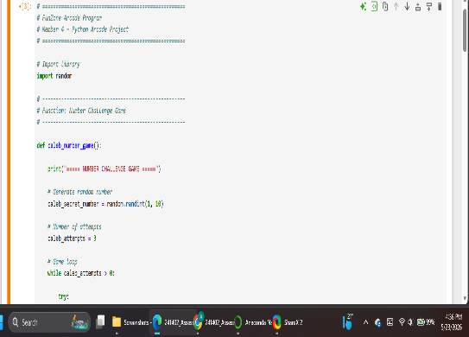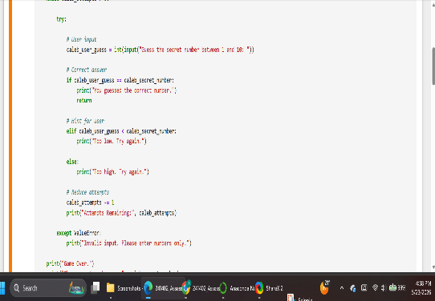  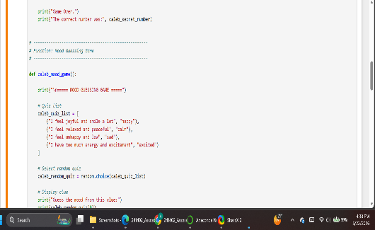  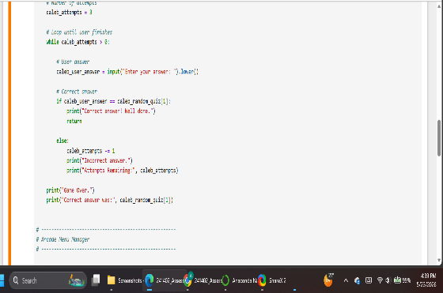  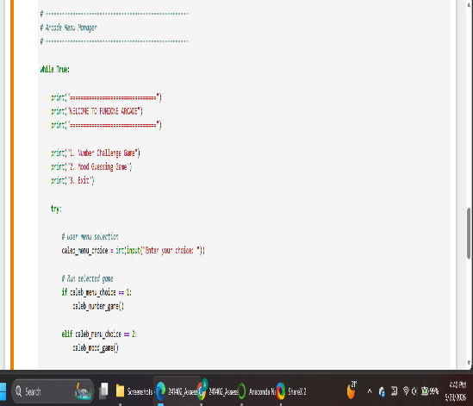  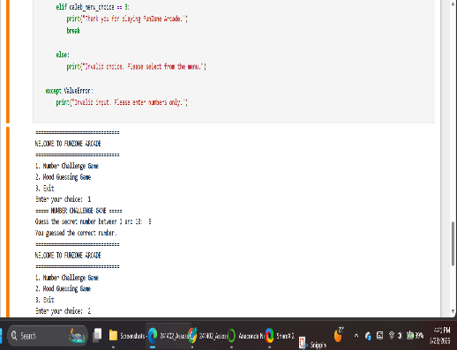  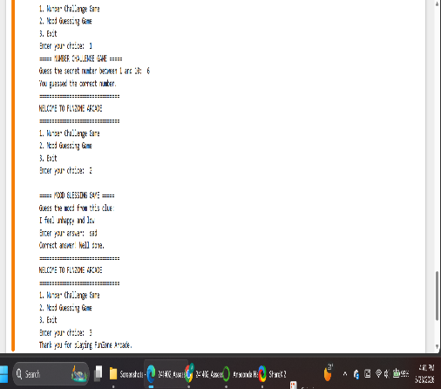 | The program combines two fun games into one arcade system. The Number Challenge Game allows the user to guess a random number while the Mood Guessing Game asks the user to guess the correct mood from a clue. The program uses loops, functions and decision statements to control the games and check user answers correctly. The output is accurate and the program runs successfully without errors. This activity helped me improve my understanding of Python game programming and user interaction

