libefpak Reference Manual

C library to manage EFPAK packages
Table of Contents
1. History 3
2. Overview 4
3. Command line tool 7
4. Library reference 8

History

Date | Version | Comments | Author
01/16/2015 | 0.0 | Initial version | FLM

Overview
EFPAK (Embedded Firmware PAcKage) packages contain data that are part of DANCE instrument firmware upgrade operations. The EFPAK format packages data blocks in a single container. Data can be of various type:
- EFPAK format related information,
- Regular files to be stored in a filesystem,
- Individual disk partition or full disk images,
- Executable code.

The format consists of a sequence of data blocks:

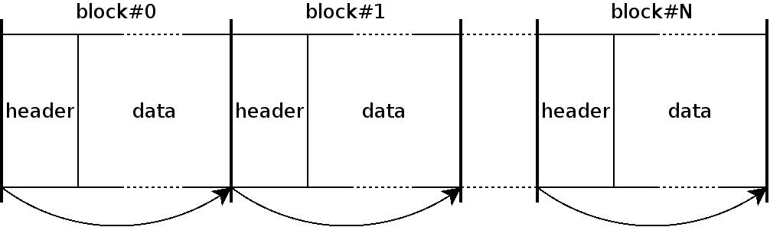

Each block starts with a header followed by the actual data:

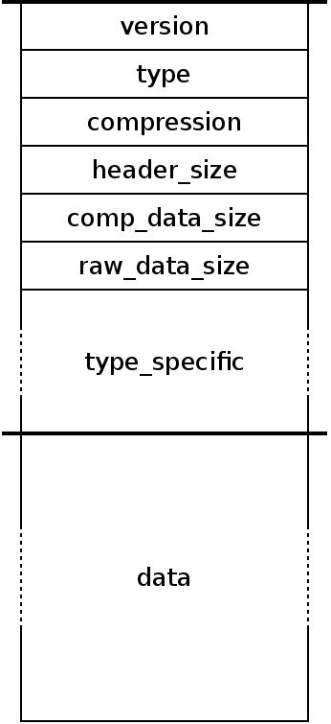

The format itself is close to the ZIP format, and favors rapid iteration over individual data blocks. It allows for an efficient implementation in memory constraint environments. Also, data larger than 4GB can be handled.

Individual data blocks can be compressed. Currently, the DEFLATE compression algorithm is used.

Blocks can be of several types:
- EFPAK_BTYPE_FORMAT: the block contains information related to the package format itself (versioning …),
- EFPAK_BTYPE_DISK: the block contains a raw disk. It should only be used during the initial disk installation,
- EFPAK_BTYPE_PART: the block contains a full disk partition,
- EFPAK_BTYPE_FILE: the block contains a file,
- EFPAK_BTYPE_HOOK: the block contains a user defined hook that is called at particular stages during the extraction process.

By default, every data block is extracted sequentially to the destination storage. During the package creation, more logic can be implemented by adding user defined procedures, or hooks, which will be called at particular stages of the extraction process. The stages include:
- EFPAK_HOOK_NOW: the hook is called when first detected by the extraction process,
- EFPAK_HOOK_PREX: the hook is called before a block extraction,
- EFPAK_HOOK_POSTX: the hook is called after a block extraction,
- EFPAK_HOOK_MBR: the hook is called before the disk master boot record is written,
- EFPAK_HOOK_COMPL: the hook is called when the extraction process completes, either due to success or error.

Hooks perform actions and drive the extraction process in order to implement full firmware update procedures. The code of a hook consists in any form of contents executable by the operating system, especially ELF binaries or shell scripts. During the package creation, the hook contents are either directly embedded as a data block, or is a reference to an executable already present in the instrument.

Hooks are called with command line arguments that depends on the extraction process state:
- now
- prex { part | file} { boot,root,app | file_path }
- postx { part | file} { boot,root,app | file_path } error_code
- mbr
- compl error_code

A hook can drive the extraction process by returning pre-defined values:
- EFPAK_HOOK_CONTINUE (0): the extraction process continues,
- EFPAK_HOOK_SKIP_BLOCK (1): the current block is not extracted,
- EFPAK_HOOK_STOP_SUCCESS (2): the extraction process stops with success,
- EFPAK_HOOK_STOP_ERROR (255): the extraction process stops with error,
- Any other value: the behavior is not specified.
The extraction process state automaton, as seen from the hook perspective, is depicted in the following diagram:

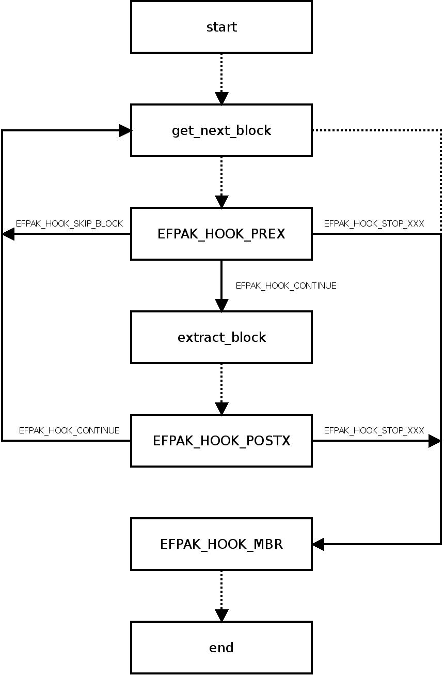

Command line tool
A tool called efpak allows to manage packages. Available commands include:
- Creation of a package,
- Retrieving package information,
- Addition and extraction of contents,
- Send the package to a DANCE device.

Creating a new package:
$> efpak create foo.efpak

Adding a hook to be called before and after each block extraction:
$> efpak add_hook foo.efpak hook.sh prex,postx

Adding boot, root and application partitions:
$> efpak add_part foo.efpak boot.img boot vfat
$> efpak add_part foo.efpak root.img root squash
$> efpak add_part foo.efpak app.img app ext3

Adding some files to the device app/ directory:
$> efpak add_file foo.efpak fu.txt /app/fu.txt
$> efpak add_file foo.efpak bar.txt /app/bar.txt
$> efpak add_file foo.efpak baz.txt /app/baz.txt

Adding a whole directory to the device app/ directory:
$> efpak add_dir foo.efpak local_dir /app

Sending the package to a device:
$> efpak send foo.efpak comex004

Installing the package on a local disk /dev/mmcblk0:
$> efpak install foo.efpak mmcblk0

Listing the package contents:
$> efpak list foo.efpak

Library reference

Files
libefpak.a | static library
libefpak.h | C library header

Dependencies

Types
efpak_istream_t
efpak_ostream_t
efpak_header_t
efpak_format_header_t
efpak_disk_header_t
efpak_part_header_t
efpak_file_header_t
efpak_hook_header_t

Constants
EFPAK_BTYPE_FORMAT | Block header is of type efpak_format_header_t
EFPAK_BTYPE_DISK | Block header is of type efpak_disk_header_t
EFPAK_BTYPE_PART | Block header is of type efpak_part_header_t
EFPAK_BTYPE_FILE | Block header is of type efpak_file_header_t
EFPAK_BTYPE_HOOK | Block header is of type efpak_hook_header_t

EFPAK_BCOMP_NONE | Block data not compressed
EFPAK_BCOMP_ZLIB | Block data compressed using ZLIB/DEFLATE

Functions
efpak_istream_init_with_file
efpak_istream_init_with_mem
efpak_istream_fini
efpak_istream_next_block
efpak_istream_start_block
efpak_istream_end_block
efpak_istream_seek
efpak_istream_next
efpak_ostream_init_with_file
efpak_ostream_fini
efpak_ostream_add_disk
efpak_ostream_add_part
efpak_ostream_add_file
efpak_ostream_add_hook

