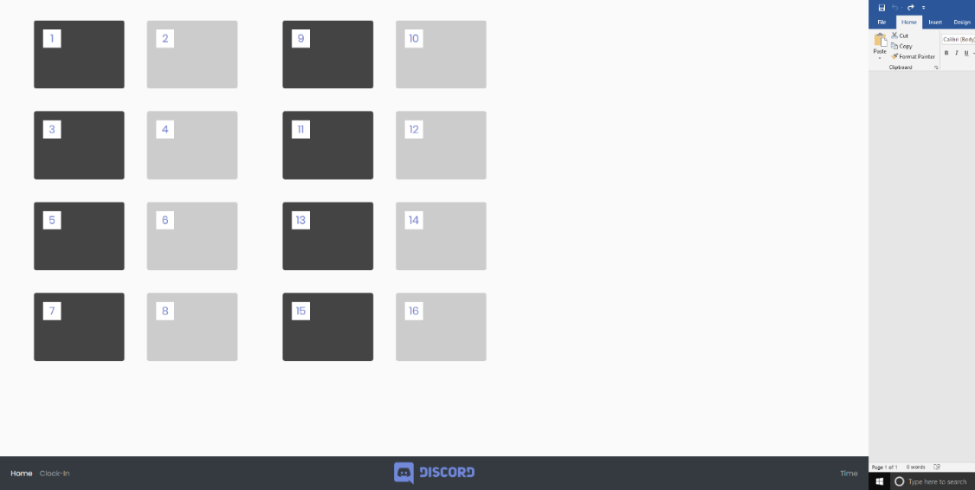Image 1: Landing/Default ScreenL This is the first screen a user will see upon logging in: **See left**

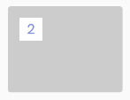

Image 2: Each numbered box represents a table in the restaurant. The color of the squares and boxes will signify information the customer has relayed to the waitstaff: **See left**

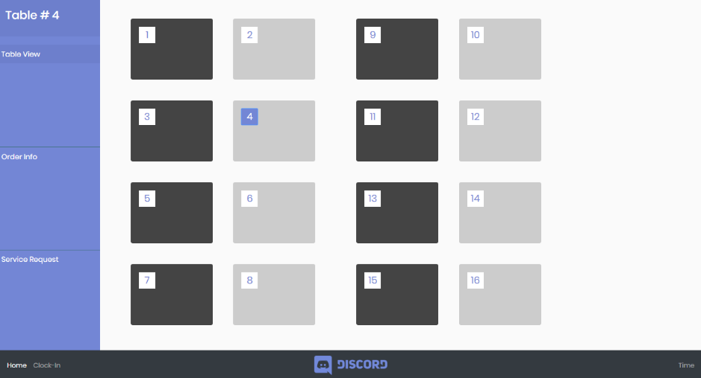Image 3: When a numbered box is pressed, we have a sidebar that comes in from the left to show ways we can interact with our table: **See left**

Image 4: When a waitstaff wishes to clear, or check, any notifications, they can do so in the Service Request tab. After tapping on the field, we can see what drinks need to be refilled and clear the queue with the tap of a button.

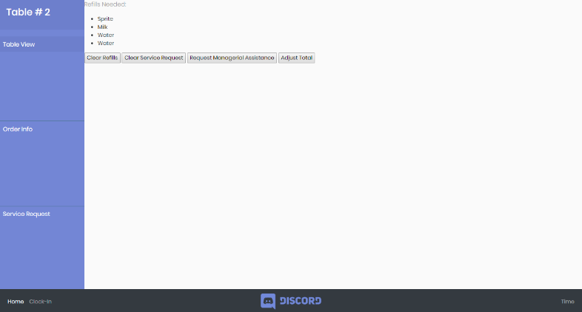If a customer has requested service, we can also clear that notification as well.

If we need a manager’s override, we can request one by tapping on the respective button.

Image 5: The nav bar, which is located at the bottom of the screen, contains:

* Home: A navigator which will return us into the terminal login screen.
* Clock in: a login field which will be used to track labor.
* The company’s brand, currently a placeholder. When pressed, this will return the user back to image 1:
* A clock, currently marked as “Time” that represents the machine’s clock to show the user an accurate time.

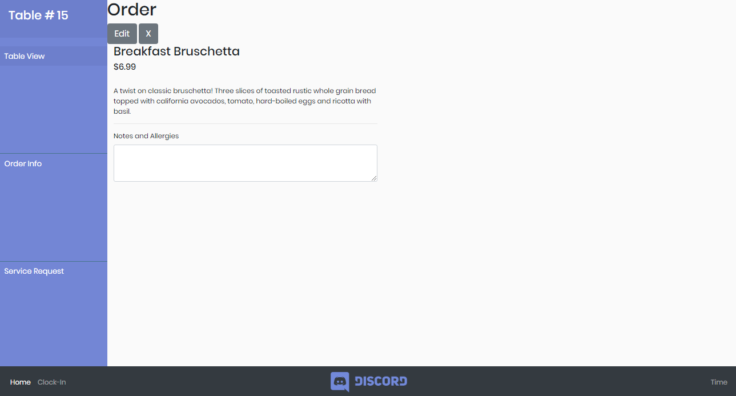Image 6: Order

By tapping the order tab, we navigate to a screen where all of the table’s orders are visible. There is also two buttons to edit information, or remove an item. This is important if a customer wants to change their order after sending it to the kitchen.