Laboratory 3 – Game design and development

2026-2027



Elaborated by:
Francisco Nunes
Xavier Barbedo

Index

Contents
Introduction 3
Objectives 4
Overview 5
Developing the required task 7
Conclusion 9
Meanings 10
References 11

introduction

This was a project developed within the scope of game design and development subject. The instructions for the project were delivered via a list of tasks.
The project starts off with a pre-made game provided by the teacher and is directed towards making the students familiar with the Unity game engine by adding and modifying the provided assets.
Students were separated into groups of two elements to attain the required objectives and to develop better interpersonal communication and team work capabilities.

Objectives

This project had the objectives of the following topics:

- Familiarization with the Unity game engine;

- Continuation of the development of a Unity project, following instructions;

- Understanding of basic programming concepts;

- Understanding of tools integrated into Unity;

- Delivery and management of laboratory project deliverables;

- Updating of project repository(ies);

- Introduction to the concepts of Scriptable Objects, properties, and Lambda expressions.

Overview

On this lab we had to do make scripts and modifications so the character would take damage when the “P” key was pressed and eventually when the life was bellow or at 0 the player would die. When the player dies an animation plays with the main character laying motionless.

Developing the required task

Level 1 –
Moving on from the overview, on level 1 the objectives were to create new scripts and folders, the scripts would control the player health.
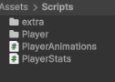

Level 2-
On level 2 we added scripts that would control the damage taken when the “P” key was pressed and that would also make the player status dead after the life dropped to 0 or bellow
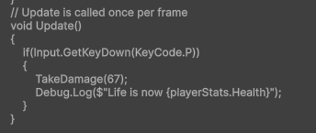

Level 3-
During level 3 we used the animator to make the dead animations and made the player stop moving when dead
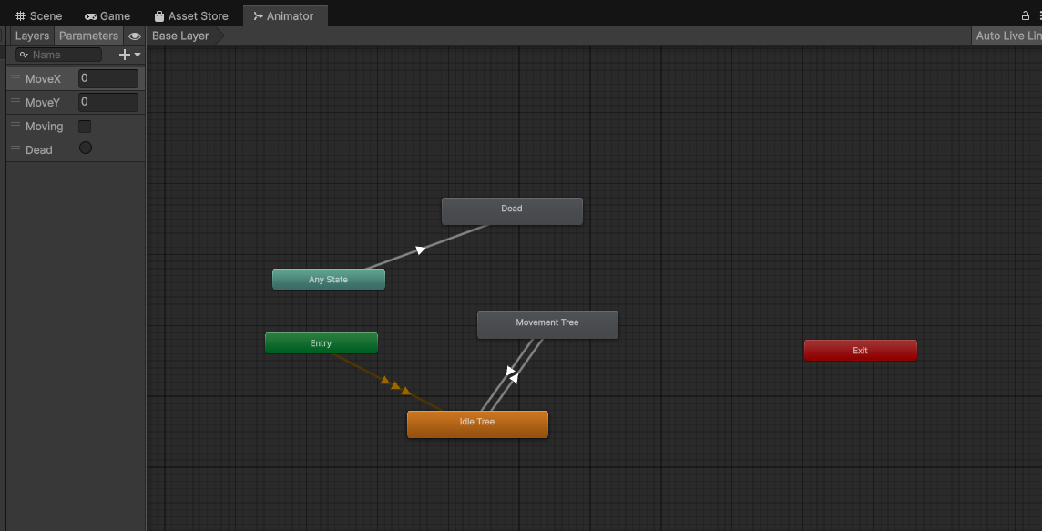

Level 4-
During level 4 we connected playermovement and playerhealth to the animation controller

Level 5-
During level 5 we made so that the character would not move after death

Conclusion

With this lab we can conclude that our first exposition to unity was a success, we learnt how to add death animations and make characters have a life meter and take damage.

