Overview dashboard for project team that includes pod health in green, cluster resource gauges, application memory graph and database table query count graph.

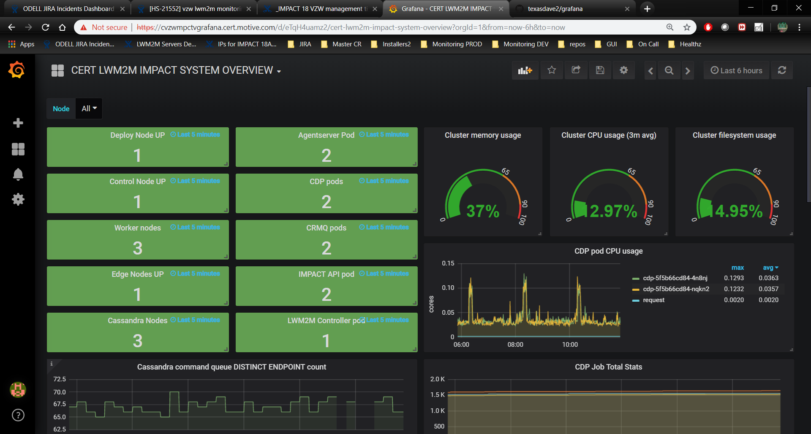

Application dashboard with JVM job, GC, error log, and JDBC connection health graphs

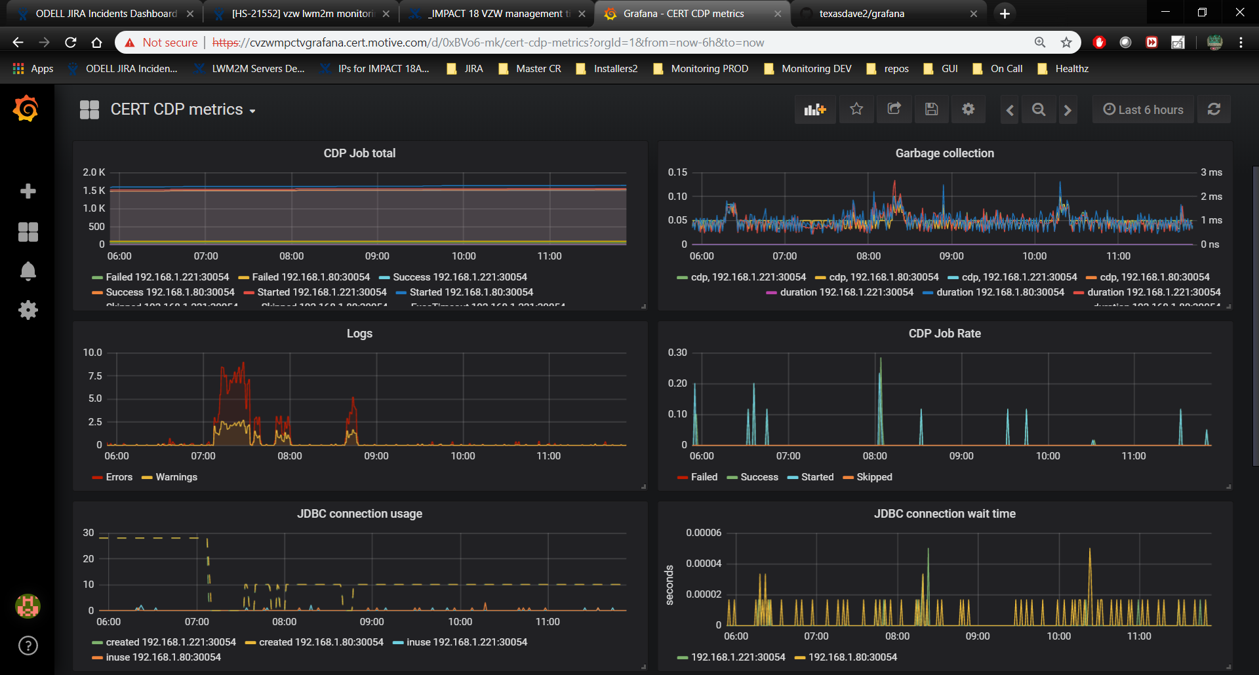

Application metrics showing the scale of our lwm2m system, millions of responses to devices per week

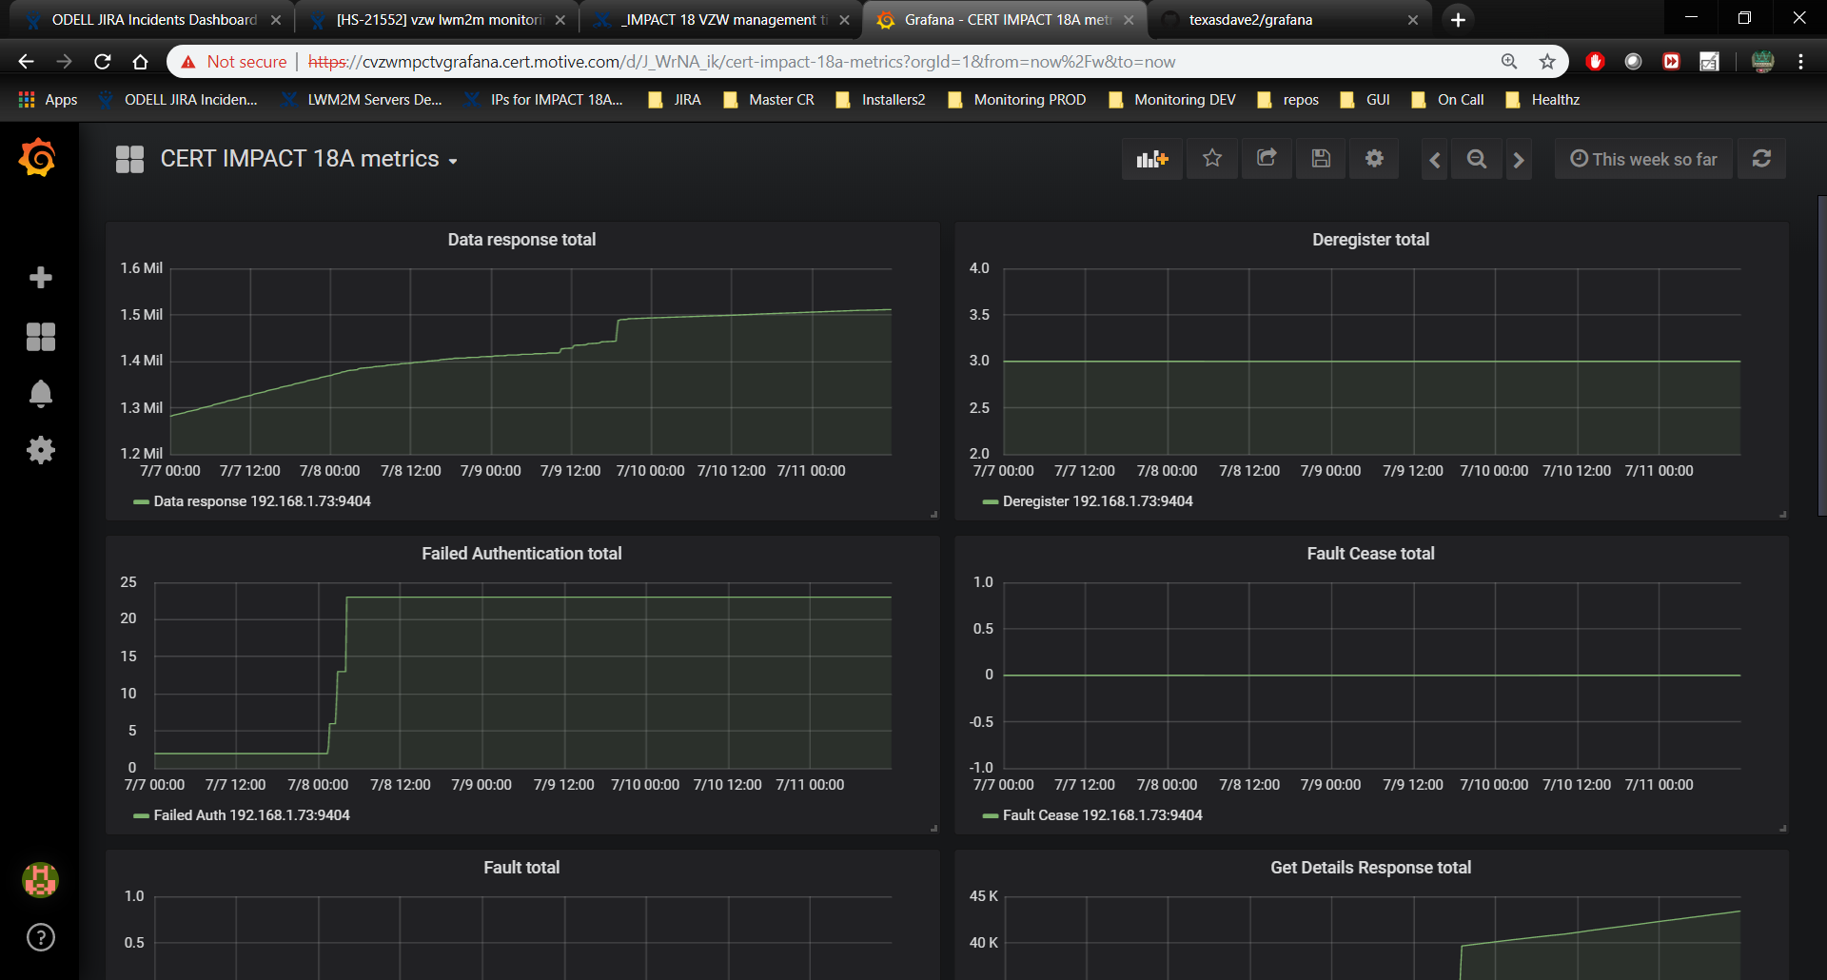

Gauges to display license expiration days remaining

