PART D PLOTS
(Learning rate used: 0.1, T=100)
- GD for X
  - 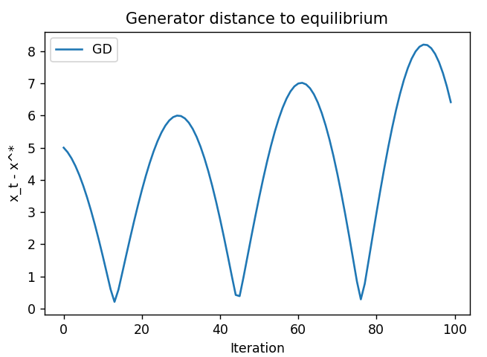
- PP for X
  - 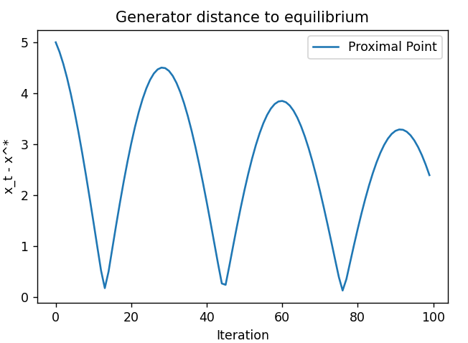
- EG for X
  - 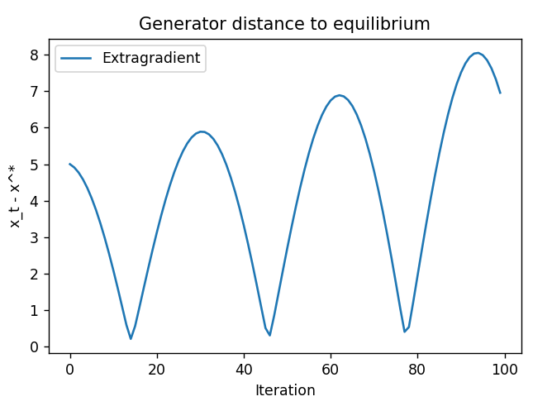
- OGD for X
  - 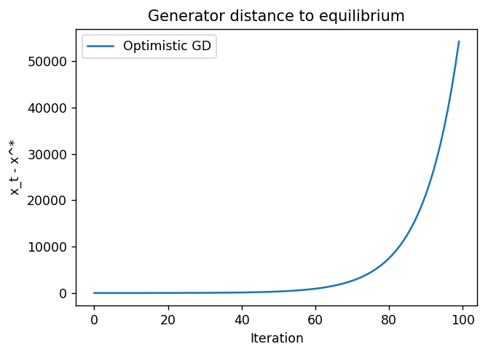
- GD for Y
  - 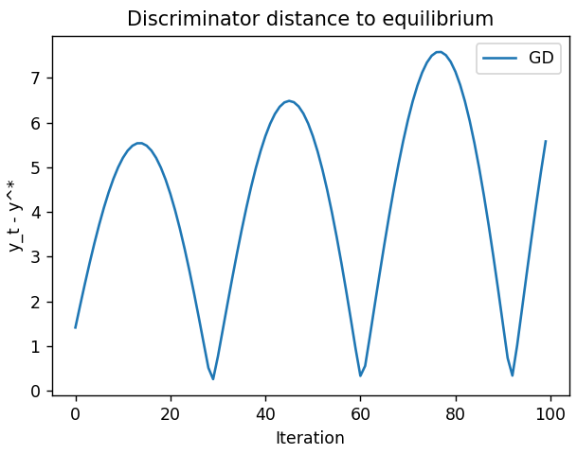
- PP for Y
  - 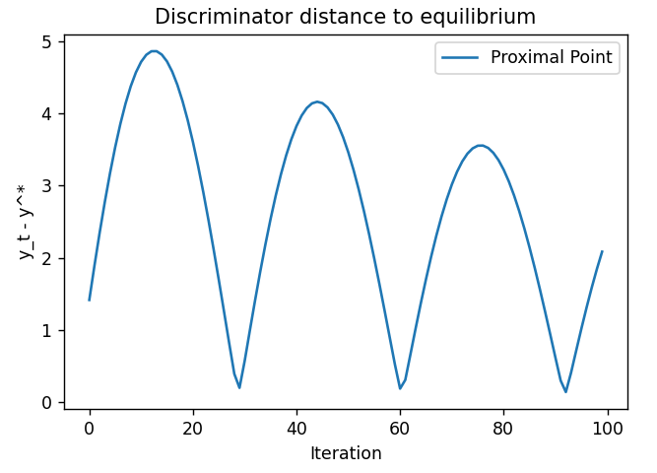
- EG for Y
  - 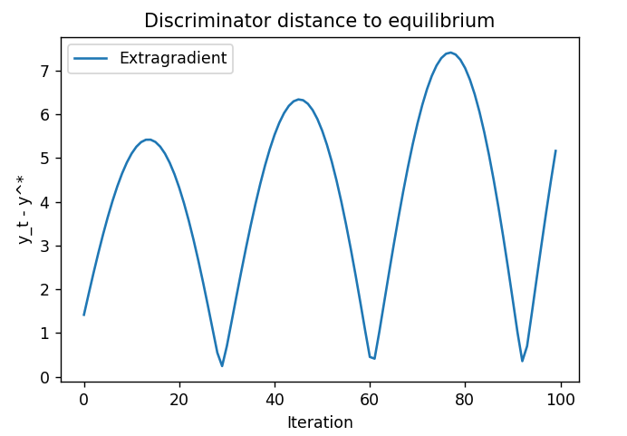
- OGD for Y
  - 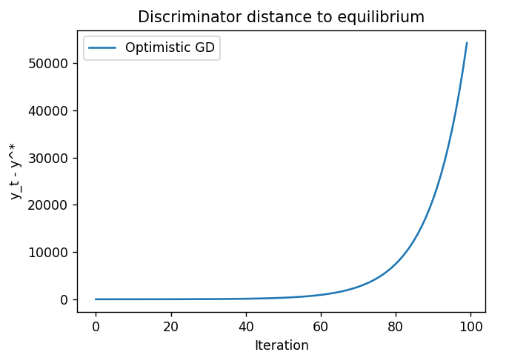

PART E PLOTS
(Learning rate used: 0.1, T=100)

