Find the Best Neighborhood for Opening a Pet Service Store in Manhattan

# Data Description

* The first data set is got from Forsquare API. The data set provides the list of 40 neighborhoods in Manhattan, their precise latitudes, longitudes, and venue information. For Tina’s pet service store, we don’t need all the venue information. The most relevant venues are pet related venues, such as pet service, pet store and pet café because they are potential competitors. Pet café may also be potential customers if they don’t groom their pets by themselves. Park is also important because dog owners will walk their dogs there and very likely will visit the pet service stores near the park.

Other related venues include gym, yoga studio and spa if the pet owners want to do some excises instead of going back home and waiting while their pets are in the store. Those venues also includes supermarkets and shopping malls in case the pets owners would like to go shopping. Coffee shop, bakery, tea room and sandwich shop are other choices for pet owners to take a nibble. People more likely to choose a store or sevice if it is convenient for them.

The Manhattan venue data are cleaned up with only the related features left in the data frame as in the picture below.

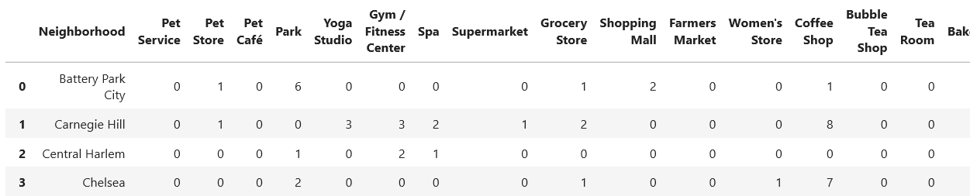

* Another important data set is the retail renal price in Manhattan. I got the information from rebny.com [1]. It has the most recent ground floor retail rental price per square feet in different Manhattan neighborhoods from spring 2018 to spring 2019. However those locations don’t cover all the neighborhoods as listed in the Forsquare data. I manually map those prices to all neighborhoods by finding the nearest location in the data table to each neighborhood using google map search. The data is also sorted by neighborhood in alphabet order, which looks like the figure below.

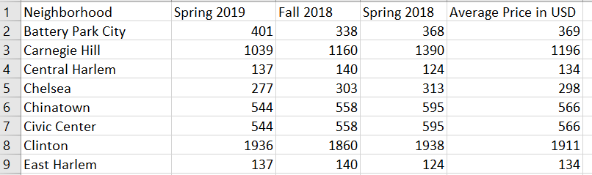

* The third data set is the apartment rental price in Manhattan I grabbed form rentcafe.com. It provides the latest average apartment rental price in all Manhattan neighborhoods updated by February, 2020 for an average size of 703 square feet apartment. From those data, we will know if the potential customers would like to spend more money on pet services. The data is sorted by neighborhood in alphabet order as the figure below.

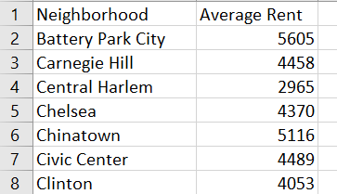

References:

1. THE REAL ESTATE BOARD OF NEW YORK <https://www.rebny.com/content/dam/rebny/Documents/PDF/News/Research/Retail%20Reports/2019_Spring_ManhattanRetailReport.pdf>
2. Average Rent in Manhattan, NY https://www.rentcafe.com/average-rent-market-trends/us/ny/manhattan/