SUPPORTING METHODS

Demographic modeling methods
Polygonum (Bistorta) viviparum is an arctic/alpine perennial plant for which demographic data were collected annually from 2001 – 2011 at four populations on Niwot Ridge, CO. Size and survival data were recorded on all plants (11882 individual transitions, see detailed methods in Doak & Morris 2010). Size is measured as the square root of estimated leaf area. Reproduction is exclusively via asexual bulbils that are produced on inflorescences, and the measure of reproduction is the size-dependent product of the probability of producing one or more inflorescences and the estimated number of bulbils produced if reproducing. Data across all years and sites was pooled to yield one estimate of the number of new recruits (bulblings) seen a year later per bulbil (0.00676). Bulbling sizes were also pooled and used to characterize the size distribution of bulblings as normally distributed with a single mean (4.00) and SD (0.886). We truncated sizes to a maximum of 60 to prevent large size categories with no individuals in discrete matrix models.
Paramuricea clavata, the Mediterranean red gorgonian, is a slow-growing and long-lived arborescent octocoral that typically occurs from 10-110 m depth. Demographic data for individual colonies (the unit of demographic analysis) were collected annually at three sites for 3-5 years each from 1999-2004 in the NW Mediterranean Sea (4685 individual transitions, Linares et al. 2007; Linares & Doak 2010). Size is quantified by maximum colony height. Size-dependent reproduction was estimated as the product of (1) the production of gonads per colony, estimated from the relationship between oocyte number and size derived from data in Table 5 of Coma et al. (1995; Table 5) and (2) the fecundity of the gonads (fraction of gonads converted to eggs; Linares et al. 2008). We estimate the first year survival of new recruits across all years and sites as 0.667, the mean of size class 2 survival from Linares et al. (2007). All surviving recruits are assumed to move to the smallest size class. We truncated sizes to a maximum of 75 to prevent large size categories with no individuals in discrete matrix models.
Vulpicida pinastri is a short-lived epiphytic lichen that grows on several trees and shrubs. Data on individual thalli were collected annually from 2004-2009 in Kennicott Valley, AK on individuals growing on Alnus stems in a mixed spruce-alder forest. Size and survival data were collected in each thallus, with the square root of thallus area used as the measure of size (1621 individual transitions, see Shriver, Cutler & Doak 2012 for methods). Reproduction was assumed to be proportional to the circumference of a thallus, which bears the majority of asexual propagules. Recruits per circumference necessary to achieve a stable population was estimated as 0.047 in the original study of this species (Shriver et al. 2012). New thalli sizes were estimated as coming from a uniform distribution bounded at (0.124, 0.50) which reflect the range of the smallest thallus sizes encountered in the field study.
All demographic data sets are available in Dryad Digital Repository doi:10.5061/dryad.t6c3573.
We took a similar approach to modeling vital rates for all three species. For each IPM, we fit separate models of each vital rate as continuous functions of size. For each vital rate, we fit multiple models and selected the best-supported model using AIC. We modeled survival as a binomial glm and reproduction as a linear model and considered models with size and with and without size². We used the same binomial approach for the probability of reproducing, a separate parameter for bistorts. For the normal approach to growth modeling, we modeled the mean and variance of size at time t+1 as linear, quadratic, or cubic spline functions of starting size. For the beta approach, we fit quantile regressions to the 0.01 and 99.9 quantiles and used these values as estimates of the min_{yt} and max_{yt} values to transform size at time t+1 to a (0,1) interval according to eq. 2. We considered quantile regressions as linear, quadratic, or cubic functions of starting size. We then fit beta regressions that included linear, quadratic, or cubic spline effects of starting size on the mean and/or the precision of size at time t+1. We discretized each IPM using the midpoint rule into matrices with > 100 size classes that evenly divided the size classes used in the PPMs. These were 123 classes for coral, 118 classes for bistort, and 125 classes for lichen.
For each species, we also fit PPMs with discretely estimated vital rates and 50 size classes. The largest size class was chosen to ensure adequate sample sizes for the estimation of vital rates, especially across bootstrapped replicates, and the remainder of the size range was evenly divided into 49 other size classes. Model outputs for each of these species converge with 20 or more bins (Figure S2), suggesting that a 50 x 50 matrix projection model is of sufficiently high-dimension. We estimated transition rates by using the observed survival and size transition rates and the mean fecundity of each size class.
We calculated the population growth rate as the dominant eigenvalue of each matrix. We calculated the damping ratio as the ratio of the dominant eigenvalue to the absolute value of the second eigenvalue, and the average lifespan as the age at which the probability of still being alive was first <1%. We also estimated the first time-step reactivity as the proportional change in population growth given a starting population comprised of the largest size class, and correcting for differences in matrix dimension between IPMs and PPMs by using a population vector giving the proportional abundance of each of the size classes in the IPM represented by the largest size class in the PPM. We replicated this model fitting procedure 200 times by randomly re-sampling the dataset with replacement to obtain bootstrapped distributions of all model outputs.

REFERENCES
Coma, R., Zabala, M. & Gili, J. (1995) Sexual reproductive effort in the Mediterranean gorgonian Paramuricea clavata. Marine Ecology Progress Series, 117, 185-192.
Doak, D.F. & Morris, W.F. (2010) Demographic compensation and tipping points in climate-induced range shifts. Nature, 467, 959-962.
Linares, C., Doak, D., Coma, R., Díaz, D. & Zabala, M. (2007) Life history and viability of a long-lived marine invertebrate: the octocoral Paramuricea clavata. Ecology, 88, 918-928.
Linares, C. & Doak, D.F. (2010) Forecasting the combined effects of disparate disturbances on the persistence of long-lived gorgonians: a case study of Paramuricea clavata. Marine Ecology Progress Series, 402, 59-68.
Peterson, M.L., Morris, W.F., Linares, C. & Doak, D.F. Data from “Improving structured population models with more realistic representations of non-normal growth”, Dryad Digital Repository, doi:10.5061/dryad.t6c3573
Shriver, R.K., Cutler, K. & Doak, D.F. (2012) Comparative demography of an epiphytic lichen: support for general life history patterns and solutions to common problems in demographic parameter estimation. Oecologia, 170, 137-146.

SUPPORTING FIGURES

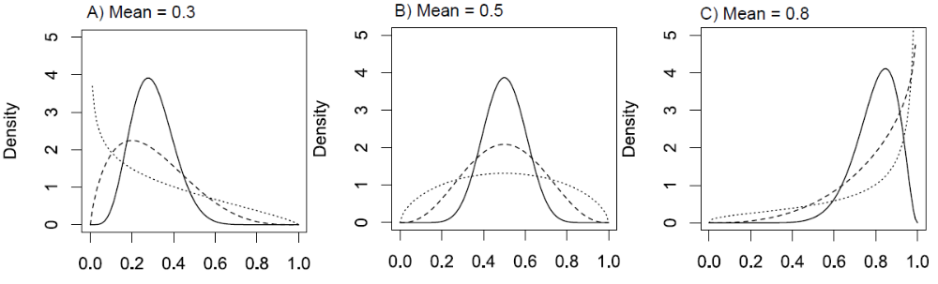

Figure S1: Examples of the flexibility of the beta distribution, which can be either A) right skewed, B) symmetric, or C) left skewed, depending on the mean value (0.3, 0.5, and 0.8, respectively) and variances (solid lines = 0.01, dashed lines = 0.03, dotted lines = 0.06). Note that for very high variances, the beta distribution can also take a U-shape, with high density near 0 and 1, although this is unlikely to be useful for modeling growth data.

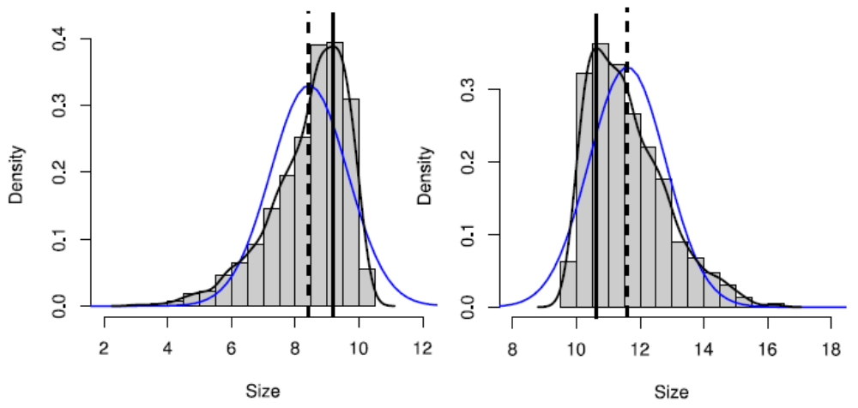

Figure S2: Consequences of fitting a normal distribution to skewed growth data. Grey bars give the histogram and black curves give the empirical probability density of 1000 points drawn from a skewed normal distribution with negative (left) or positive (right) skew. Blue curves give the normal probability density fit to the data by maximum likelihood. The fitted normal distribution matches the mean (dashed vertical lines) and variance of the data, but badly mis-estimates the mode or peak of the probability density (solid vertical lines). This results in a density function that overestimates the probability of growth with negative skew or of shrinkage with positive skew, and underestimates the probability of shrinkage with negative skew or of growth with positive skew.
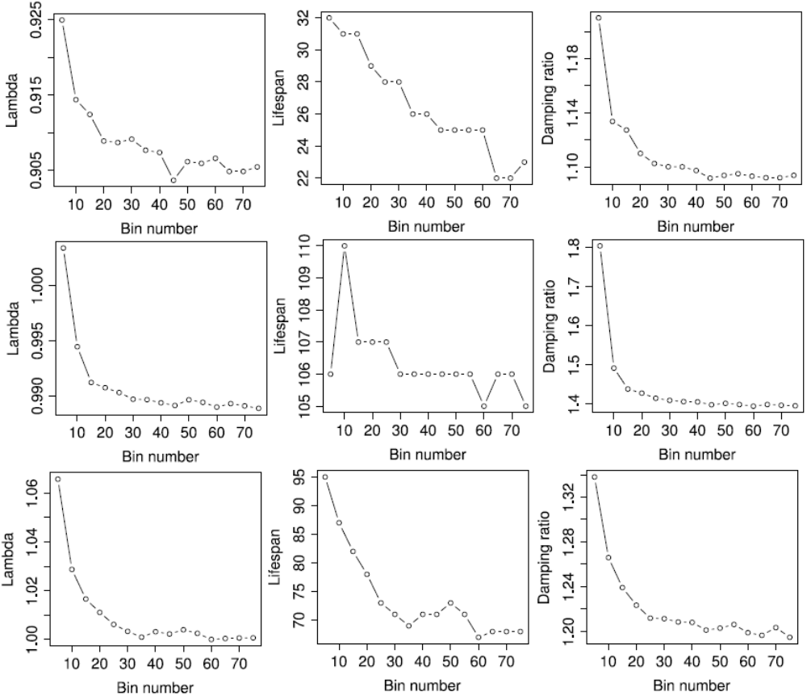

Figure S3: The number of bins has a small effect on the outputs of PPMs. Estimates of Left) population growth rate, Center) lifespan, and Right) damping ratio largely stabilize with more than 20 bins. Effects of bin number on outputs are small compared to the variance associated with bootstrapping the dataset (compare to boxplots in Figure 3). Results are from discretely estimated PPMs fit to demographic data for Top) coral (Paramuricea clavata), Center) bistort (Polygonum viviparum), and Bottom) lichen (Vulpicida pinastri).

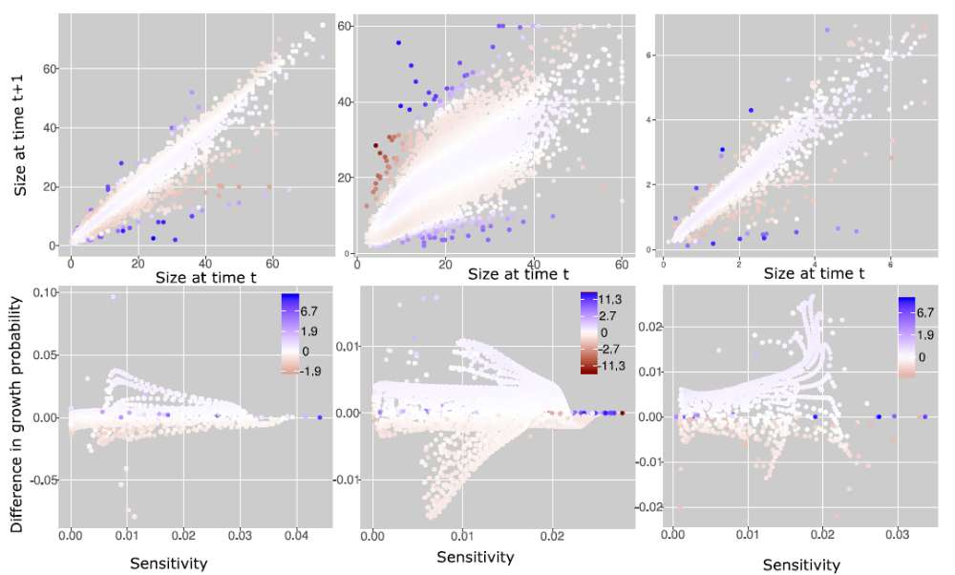

Figure S4: Fit of the beta vs. normal models to different segments of the growth distribution. Top row: size at time t+1 against size at time t, with each data point colored by the difference in its log-likelihood under the normal approach vs. the beta approach (bluer values indicate greater log likelihood of the normal model and redder values indicate greater log likelihood of the beta model). In all three cases, greater statistical support for the normal stems from its ability to better predict extreme outliers, as well as to slightly better predict the majority of data points close to the mean growth, whereas the beta approach is a better fit to the bands of moderate negative or positive skew relative to the mean. Bottom row: For each observed growth transition, the difference in its predicted probability from the normal vs. beta approach (positive values indicate greater probability under the normal model and negative values indicate greater probability under the beta model) against the sensitivity of lambda to that transition. Points are colored by the difference in their log-likelihood, as in the top row. The strongest log-likelihood support for the normal approach (darkest blue values) comes from data points for which the methods produce similar predictions, whereas the beta approach has log-likelihood support (redder values) for data points that are predicted to have very different probabilities under the two methods. From left to right, columns show results for coral, bistort, and lichen.

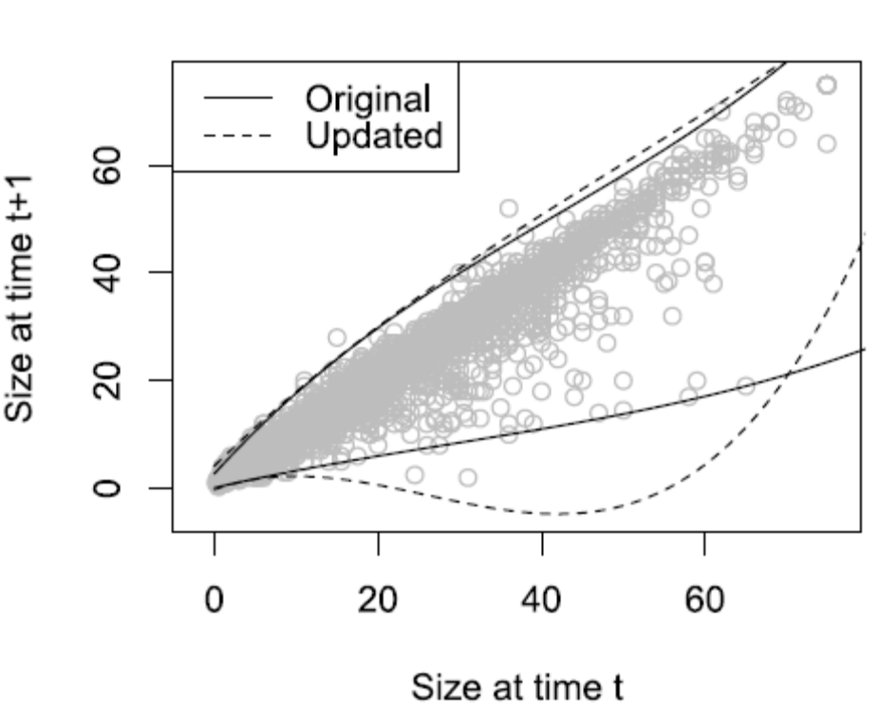

Figure S5: An exploratory directed search identifies bounds that increase the log likelihood of the beta approach relative to the estimates from a separate quantile regression. Points are the size transitions for coral (Paramuricea clavata). Solid lines give the estimated minimum and maximum sizes obtained from a cubic quantile regression of the 0.1 and 99.9 quantiles. Dashed lines give updated bounds from an exploratory search of the parameters to increase the log likelihood of the entire model. The AIC of the original model is 19816; the updated AIC is 19227. Note that these are not the maximum likelihood estimates, as the bounds must be constrained within some biologically reasonable range (see Appendix 3 for details).

