LIME, Oregon mini field trip report, May 6, 2007, Orthoclase Crystals
By Rhonda Gheen My FIRST try at a report without help from Mike!

To give credit where credit is Due I found this field trip location on the rockhound Billy-Bob’s website! He has a list of places he’s been and this one was close enough to be a “medium” distance day trip for us. If you look his report up forget his offramp/milepost numbers though---they are Totally botched!!!

It was a warm spring day and leisurely start for us to get to this spot. We’d just had to cancel our big trip to McDermitt due to a plague of doctor appointments and so a new location with a new mineral (to us) to hunt (despite being on an access road right beside the noisy freeway) was a great mood lifter!

If you are passing this location traveling it’s an easy spot to stop for a rockhound “quickie”! It’s simply THE “Lime” exit off 84 (between Baker City and Ontario). NOTE: If driving south from Baker you will PASS the NEW cement plant first which is Also right on the highway! After the off ramp go east Past the scenic??? OLD cement plant (ruins), past the “junk” surrounded big parking area (we picked up an antique nail in a tire that looked like a spike), and look for the big curve pictured with the tan-pink FINE gravel slide. Parking is directly across.
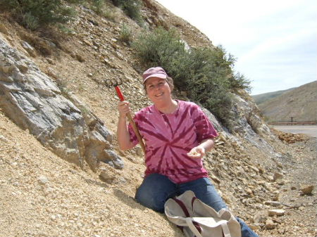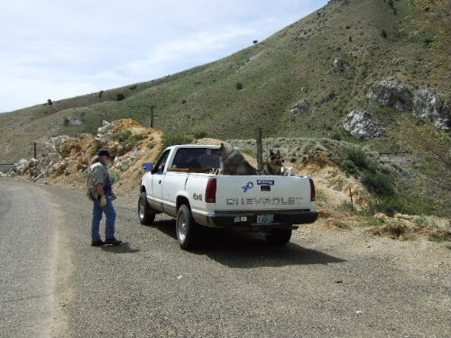
.
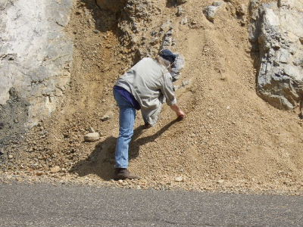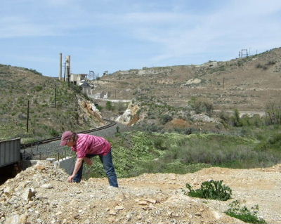

Also across the road is partly a high ridge of matrix material and the railroad tracks are steeply below (dangerous scree to drop off- Keep kids off the top of that ridge!).Parking is right by the ridge and there is a trail down the side to the tracks.

Most of the other slides along this little paved road are gray with lime chunks, gray plates of rock or large chunks of tan rock without the feldspar crystals. Any hound will say “Oh, that Has to be it” when they spot the correct scree. It looks like a crumbled granite formation amid the limestone(where the feldspar happened to get the chance to grow). In the picture you can see how far past the plant we went too. There is quartz and marble out there as well but we spent all our time pickin itty-bitties and doing only a small amount of exploration. There is Burnt River access up the same road a bit. We got the dogs wet and watered but the gravel bed was nothing like the Burnt River gravel beds to the north that are full of serpentine and chert and jaspers with prizes of agate and petrified wood!(that access crosses Highway 7 near Whitney).

SO, back to This spot; the Other thing is that the Billy-B website touts his 2 inch orthoclase crystal in a picture and our best in 2 hours was ¾ Inch….so don’t get your expectations too high! Washed off the little buggers boast many crystal habits and are darned cute though! I know feldspar crystals get huge and are not rare BUT we haven’t had a place to collect Any so this was really FUN for us!

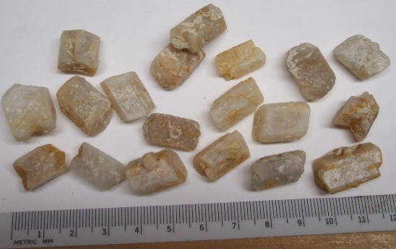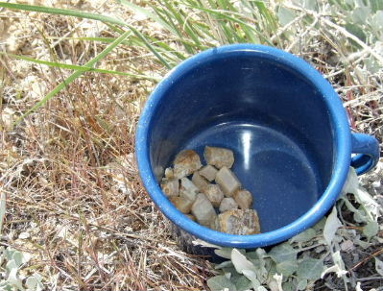

Many of the crystals that Look like broken pieces in the rubble end up being whole terminated crystals! They are just often stubby! The washing and sorting process at home was a lot more rewarding than we originally thought it would be! We took some crumbly matrix chunks to break at home too, but for us the naturally eroded out crystals were both cleaner and more often whole.

This one-stop picking was a Really GOOD collecting jaunt for us! Our day was a pleasant Spring temperature but that highway corridor there is a Wind Tunnel almost all the time so be prepared if you go there!!! My eyes watered in the gale and I had to wipe them many times and get my back to the wind to be able to SEE and pick the crystals! Also the area appears deserted BUT at least 5 cars passed us on that paved frontage road on that Sunday…there may be no traffic on weekdays, but cross back and forth on that blind curve with Caution!

Thank you again McRockers for sharing an outing with us! KOR, Rhonda, Rick, Mason & Kodi

