
Dooble
A Web Browser
Version 2.1.9.3 (2018.07.04)

Table of Contents
Introduction 4
AES Implementation 5
Accepted / Blocked Domains 6
Accept Mode 6
Block Mode 6
Address Widget 8
Certificate Exceptions 9
Clear Items 12
Command-Line Options 13
Cookies 14
Domain Filter 14
Purge Periodically 14
Debian 16
Downloads 17
Favorites 18
File Menus 19
File 19
Authenticate 19
New Private Window 19
New Tab 19
New Window 19
Save 19
Close Tab 19
Print 19
Print Preview 20
Exit Dooble 20
Edit 20
Clear Items 20
Clear Visited Links 20
Find 20
Settings 21
Tools 21
Accepted / Blocked Domains 21
Certificate Exceptions 21
Cookies 21
Downloads 21
Favorites 21
History 21
View 21
Show Full Screen 21
Show Status Bar 21
Help 21
About 21
Documentation 22
History 23
Performance and Security Considerations 24
Private Windows 25
Settings 27
Display 27
Pin Windows 27
History 27
Privacy 27
Credentials 27
Disabled 27
Enabled with a Password 27
Enabled without a Password 27
UTC Time Zone 28
Web 28
Local Storage 28
User Agent 28
XSS Auditing 28
Sources of Randomness 30
BSD 30
Linux 30
Windows 30
Supported Protocols 31
Threefish Implementation 32
Translations 33
Web Page Features 34

Introduction
Dooble is an elegant, simple, and zero-dependency Web browser. The application should be functional on any operating system where Qt 5.9.x is supported.
The source is readily available at https://github.com/textbrowser/dooble/tree/master/2.x.
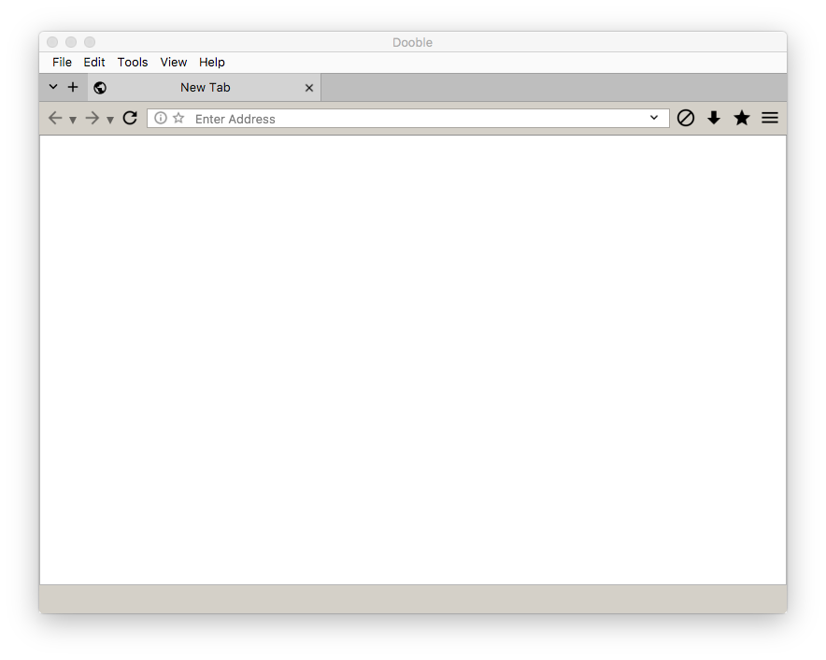

AES Implementation
The AES implementation is derived from the guidelines provided by http://nvlpubs.nist.gov/nistpubs/FIPS/NIST.FIPS.197.pdf. The implementation is independent of architecture.

Accepted / Blocked Domains
Dooble supports the accepting and blocking of specific domains. The Accepted / Blocked Domains window allows for the defining of domains which are to be accepted or blocked. Domains are stored in the SQLite database dooble_accepted_or_blocked_domains.db. An operating mode may also be prepared within this window. Supported operating modes are defined below.

Accept Mode
Only the specified domains may be accessed either directly or indirectly.

Block Mode
The specified domains are blocked. While in this mode, Dooble will prevent direct and indirect access to the listed domains.
Note: Defined domains also reside in a session container which is optimized for rapid (amortized O(1)) discovery. The special container contains all of the defined domains.
Note: The bundled Data directory contains the file dooble_accepted_or_blocked_domains.txt. An import feature is included in the Accepted / Blocked Domains window. An import will enable (Blocked or Accepted) existing domains.
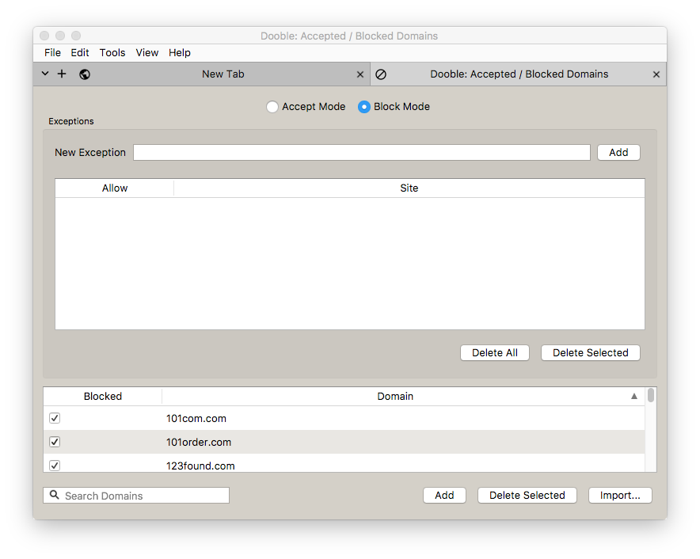

Address Widget
The address widget contains the current page’s URL. The present URL may be inserted in the Favorites container by pressing the information tool button.
The current site’s cookies may be accessed via a context menu. The context menu also allows for the removal of the current site’s non-private certificate exception, if a certificate exception has been previously accepted.
Note: All address widgets share a common history container. The container is optimized for rapid (amortized O(1)) discovery of history items and is required for displaying previously-accessed URLs in address widgets.
Note: Certificate exceptions are not available for private URLs. That is, if a certificate exception is accepted from a private window, the exception is only available within that window. Other non-private and private Dooble windows will not have insight into the accepted certificate exception.
Note: Dooble applies the Levenshtein Distance algorithm during the history-discovery process.
Note: Private windows record visited links in the internal history containers.

Certificate Exceptions
Web sites may raise SSL/TLS certificate errors. Some of these certificate errors may be overridden.
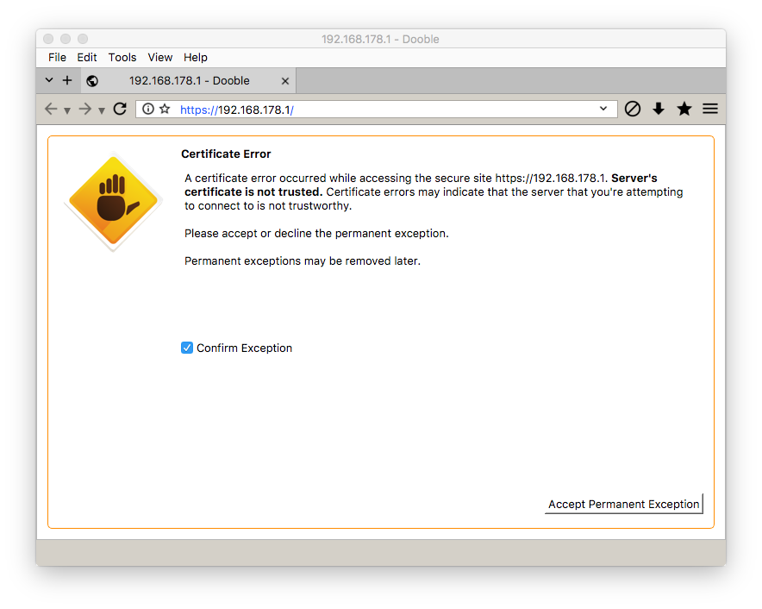
Once overridden, the Web site and the certificate error are recorded in the SQLite database dooble_certificate_exceptions.db unless the parent window is a private window. For private windows, certificate exceptions exist only within such windows.
Overridden non-private sites are presented in the Certificate Exceptions window. Within this window, exceptions may be revoked.
Note: Certificate errors may be raised by third-party requests.
Note: Private windows will also interrogate permanent certificate exceptions. If a permanent certificate exception is discovered for the given private URL, the particular Web site will be loaded by the private page.
Note: Version 2.00 of Dooble allows for a single certificate exception to be defined for a given URL. Future revisions may allow for multiple exceptions.
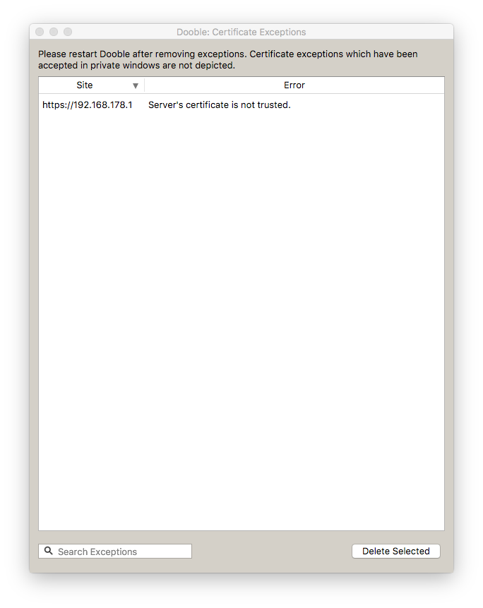

Clear Items
The Clear Items modal dialog may be used to remove an assortment of content.
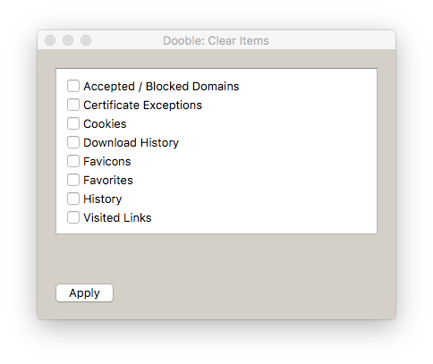

Command-Line Options
From https://peter.sh/experiments/chromium-command-line-switches/.
The option disable-reading-from-canvas may be of interest.

Cookies
The Cookies window depicts Dooble’s current cookies. The SQLite database dooble_cookies.db contains cookie data.

Domain Filter
If set, only the specified domain's cookies are displayed.

Purge Periodically
If enabled, unchecked domains will be purged every 15 seconds. Purging occurs on the main thread.

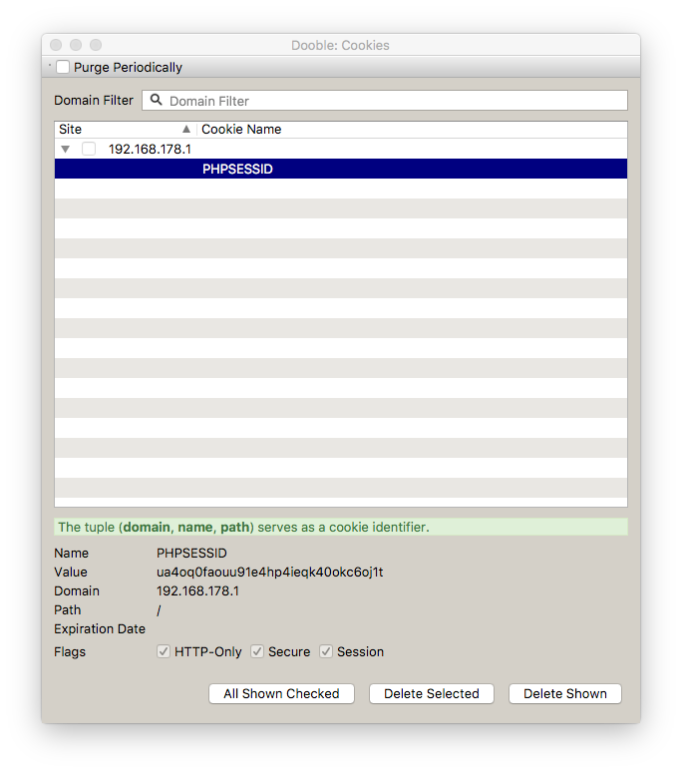

Debian
The Debian package is GPG-signed. This section describes the process of verifying the signature.
First, create a special directory.
> mkdir E324939BF29D7B80
Next, install debsig-verify via aptitude.
> sudo aptitude install debsig-verify
Then, copy the bundled file Documentation/dooble.pol to E324939BF29D7B80.
> cp Documentation/dooble.pol E324939BF29D7B80
Import the bundled public key Documentation/dooble.asc.
> gpg --no-default-keyring --keyring E324939BF29D7B80/debsig.gpg --import Documentation/dooble.asc
Finally, verify the Debian package.
> debsig-verify --keyrings-dir . --policies-dir . ./Dooble-2.1.5.deb
Results should be similar to the following.
debsig: Verified package from 'Dooble' (Text Browser)

Downloads
Dooble supports the downloading of data. Active and inactive downloads are depicted in the Downloads window. Active downloads may be canceled. Files associated with canceled downloads are discarded. Dooble provides a mechanism for restarting a canceled or interrupted download if the application is generated using Qt 5.10.x. Downloads data are stored in the SQLite database dooble_downloads.db.
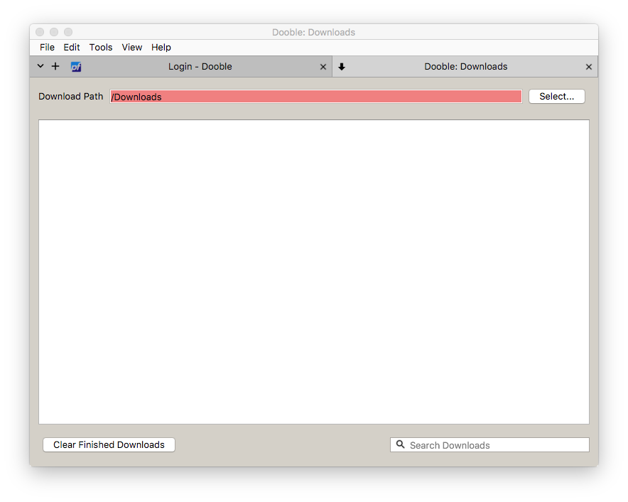

Favorites
Favorites are replacements of bookmarks. Included in the Favorites non-modal dialog are various sort options. Favorites, along with history items, are stored in the SQLite database dooble_history.db.
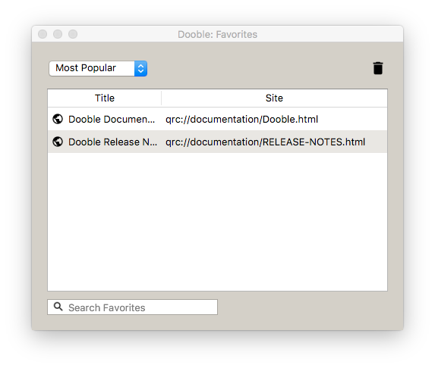

File Menus
Dooble offers a traditional menu bar. The menu bar’s visibility may be configured via the Display panel in the Settings window. If the menu bar is permanently hidden, its visibility may be modified via the F10 key. Some menu options include mnemonics and shortcuts.

File
The File menu includes several basic functions.

Authenticate
If permanent credentials are defined, this option is enabled. An authentication dialog is displayed if the option is selected. If credentials are correctly authenticated, global containers are populated. Please note that interface components must be populated via the main thread and this activity may burden Dooble.

New Private Window
Open a new private window. Please also read the Private Windows section for details on private browsing.

New Tab
A new tab is appended to the end of the tab widget.

New Window
Open a new window.

Save
Save the current page. The action invokes a download request. A file-selection dialog is not displayed.

Close Tab
Close the current tab. If the current tab is the only Dooble tab and active downloads exist, a confirmation prompt is displayed.

Print
A modal print dialog is displayed.

Print Preview
Not implemented. Permanently disabled.

Exit Dooble
Exit Dooble. A confirmation prompt is displayed if active downloads exist.

Edit

Clear Items
Display an instance of the modal Clear Items dialog.

Clear Visited Links
Remove contents from the local Visited Links file.

Find
Enables the Find panel.
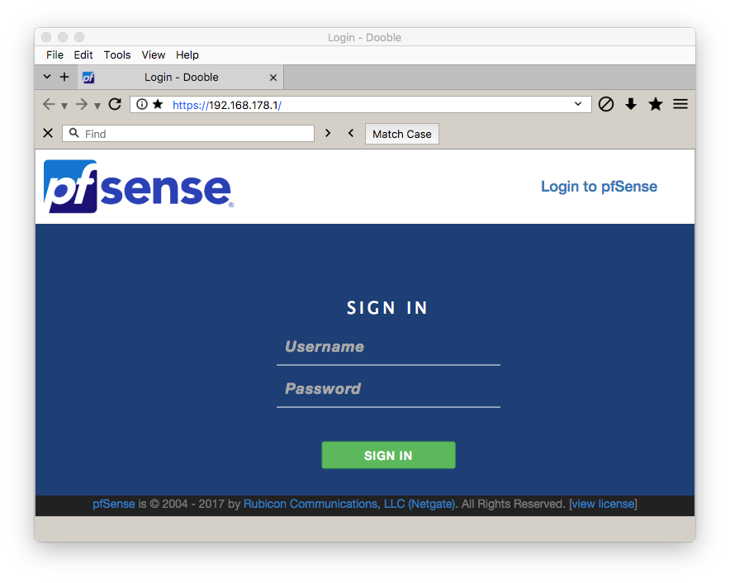

Settings
Display the Settings window.

Tools

Accepted / Blocked Domains
Display the Accepted / Blocked Domains window.

Certificate Exceptions
Display the Certificate Exceptions window.

Cookies
Display the global Cookies window. If the window is a private window, the private window's Cookies window is displayed.

Downloads
Display the Downloads window.

Favorites
Display the Favorites non-modal dialog.

History
Display the History window.

View

Show Full Screen
Disable or enable full-screen mode.

Show Status Bar
Hide or show the status bar.

Help

About
Display the non-modal About dialog.
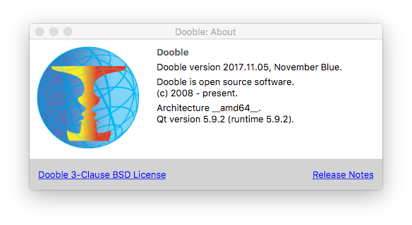

Documentation
Display this document in a Dooble tab.

History
The History window is a general-purpose container depicting Dooble’s browsing history. A simple search is included. Selected items may be removed via a context menu. The SQLite database dooble_history.db contains history data, along with favorites data.
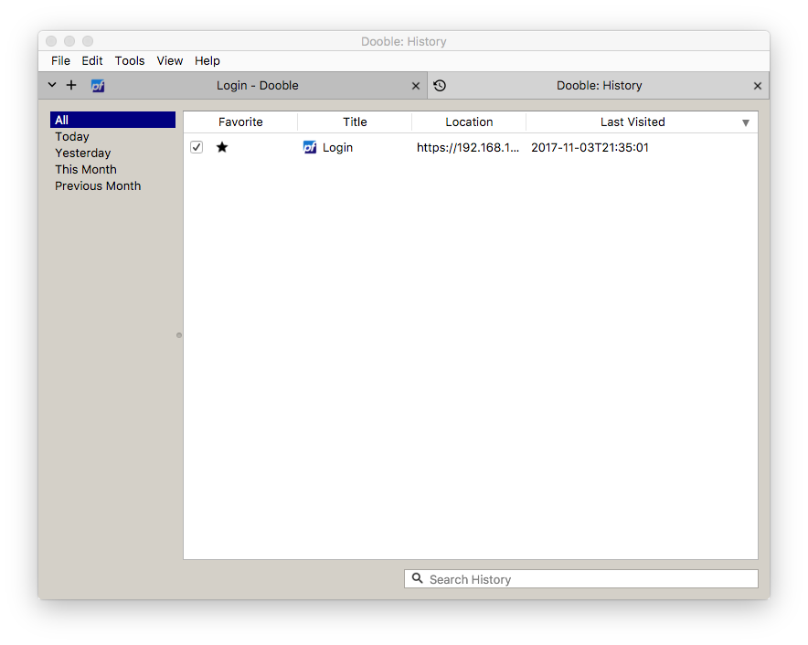
Note: Purged items are not automatically removed from the History window during a session. Subsequent sessions will represent the most current contents of dooble_history.db.

Performance and Security Considerations
- Accepted / Blocked domains are stored in a container that’s designed for rapid (amortized O(1)) discovery. The container is populated during the initialization of Dooble.
- Authentication is interruptible.
- Constant byte-by-byte comparisons are implemented wherever cryptographic digests are involved.
- Cryptographic keys are zeroed on destruction. Sensitive fields are cleared after use. Please note that these processes do not guarantee that sensitive data are destroyed effectively.
- Dooble does not exercise secure memory.
- Dooble populates icons of table items only when required. The software inspects respective views and determines the entries which require icons.
- History items are safely purged within a dedicated thread.
- Initial gathering of History data is performed by a thread.
- Processing large quantities of icon data will certainly burden most software applications. Dooble provides an innovative solution. Address widgets, the Favorites window, and the History window implement an intelligent algorithm which causes Dooble to load only the icon data of visible items. Once loaded, the icon data are cached. Also included are SQLite database indexes. This innovative solution produces an exceptionally-smooth rendering of important data.
- Some SQLite database writes occur without synchronization. Future releases will introduce synchronization.
- The AES and Threefish implementations are not designed to be thread-safe.
- The process of preparing credentials may be interrupted.

Private Windows
When browsing in private windows, Dooble does not save the following data:
- Certificate Exceptions
- Cookies
- Favicons
- History
- Temporary Files
- Visited Links
While in private windows, Dooble does save:
- Downloads
- Favorites
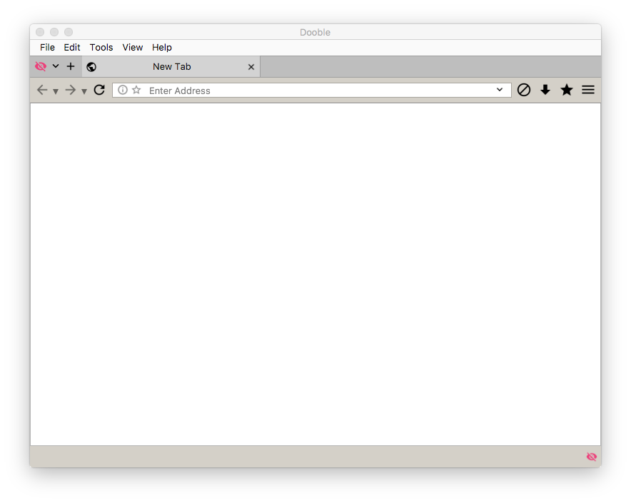

Settings
This section describes some of the areas of the Settings window. Settings values are stored in the SQLite database dooble_settings.db.

Display

Pin Windows
Some support windows may be pinned. Pinning is the process of embedding support windows within a Dooble window.

History
A dedicated thread determines if browsing history has expired. The thread is also responsible for removing expired history data. The thread is safely canceled upon termination of Dooble.

Privacy

Credentials
Dooble provides a process of storing authentically-encrypted data in various databases. This process is completely optional. Three separate modes are included:

Disabled
This is the default mode. In this mode, Dooble stores data in cleartext.

Enabled with a Password
Dooble shall permanently store data in authentically-encrypted containers using credentials generated via the provided password.

Enabled without a Password
Dooble shall store private data in authentically-encrypted containers using session credentials. The data will not be available in future sessions.
Additional specifics are listed bellow.
CBC is the preferred cipher mode of operation.
SHA3-512 is the favored hash algorithm.
The password must contain at least 1 character.
The process is interruptible.
The pseudo-random password salt is composed of 64 bytes.

UTC Time Zone
Set the environment variable TZ to UTC.

Web

Local Storage
Required for HTML5 storage.

User Agent
The user agent is sometimes used for content negotiation between the Dooble client and a server. The initial value is system-dependent. To reset, please clear the field and press the Apply button. Please reset the field whenever new Qt products are provided.

XSS Auditing
Per Qt’s documentation, XSS Auditing monitors load requests for cross-site scripting attempts. Suspicious scripts are blocked.
Note: Dooble does not remove the local WebEnginePersistentStorage directory during a reset. Please remove this directory after a reset completes.
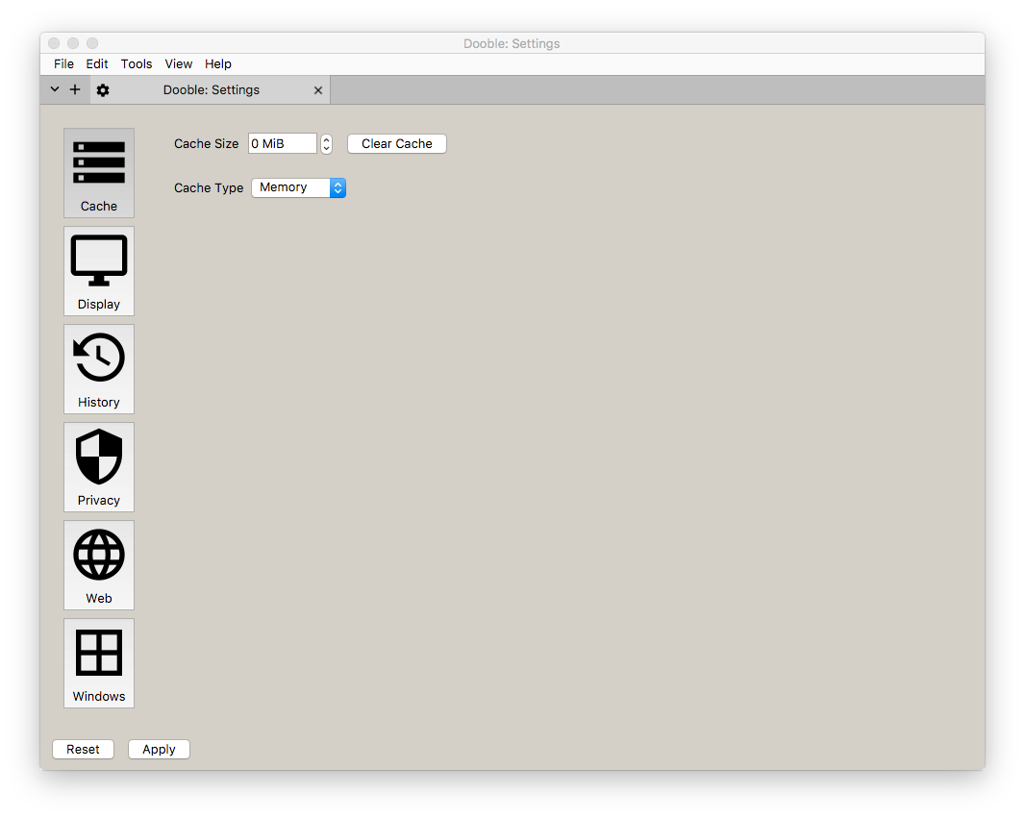

Sources of Randomness
Dooble requires data streams of random data for an assortment of cryptographic algorithms. This section briefly describes the sources of these data streams for various operating systems.

BSD
BSD-like systems acquire pseudo-random data from the /dev/random device.

Linux
Linux systems acquire pseudo-random data from the /dev/urandom device.

Windows
Please read https://msdn.microsoft.com/en-us/library/windows/desktop/aa379942(v=vs.85).aspx.

Supported Protocols
Dooble supports the FILE, FTP, GOPHER, and HTTP(S) protocols.

Threefish Implementation
The Threefish implementation is derived from the guidelines provided by http://www.skein-hash.info/sites/default/files/skein1.1.pdf. The implementation is independent of architecture.

Translations
Translations are incomplete. Translating Dooble is quite simple. Please download and install Qt from https://download.qt.io, download Dooble’s source, and become an expert in Qt’s Linguist. Linguist documentation exists at https://doc.qt.io/qt-5/qtlinguist-index.html.

Web Page Features
Some pages may submit requests for accessing local devices. When a feature request is received by Dooble, a notification is displayed. A request may be accepted or denied. The URL and the policy are recorded after a transaction completes. Existing entries may be reviewed via the Web panel of the Settings window.
Please note that a notification is displayed only for the first received request for a given page during a page load. That is, received requests are not queued. If a request is received while a request is pending, the received request is denied and an entry is added to the Features Permissions panel of the Web section in the Settings window.

