Hundred-number randomized listening practice

Starting screen
The initialization provides a feature “Play Number” which will use text-to-speech to pronounce a number from among the ones shown on the screen, such as “fifty three”.
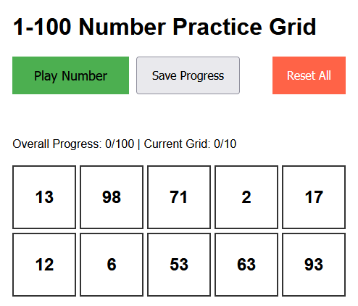

Progress tracking (visual and textual)
For each matched number, the number cell turns purple and a “✓ Found” confirmation is displayed. The progress is reported as a ratio of the 100 numbers in the complete set and the ratio of the 10 randomized numbers in the current 10-number set.
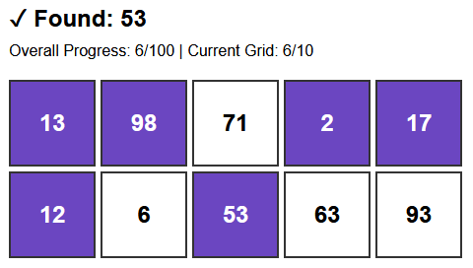

Continued interaction, saving and resetting
After the first grid on 10 numbers is complete, the user gets an option to click the Continue button, which will generate another grid with a new set of 10 randomized numbers from the 100-number set. Numbers are not repeated.
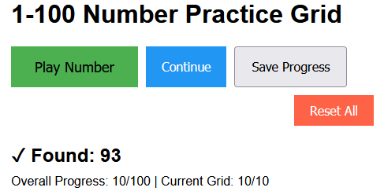
The Save Progress button will maintain the current state of progress and display a brief inline confirmation message that dismisses automatically. This permits the user to continue progressing after an interruption of the practice session.
The Reset All button will remove all previous progress from memory and start again with a randomized set of 10 numbers out of 100 possibilities.

Completion of the 100-number set
When all 100 numbers have been reviewed there will be a success message for the user. The Continue button will disappear and the Play Number button will not function until the user chooses to Reset All.
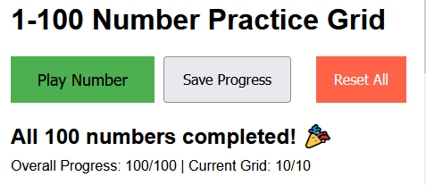

Device setup note and audio affordance
A bilingual note box appears at the top of the page with instructions for installing an English voice on Android and iOS devices. It also includes a note that progress saving requires standard (non-private) browsing. An audio icon is added to the Play Number button. 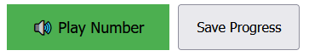
On the first use of Play Number, a dismissible inline banner reminds the user to turn on device audio. Play Number is grayed out when Continue button is seen. 

