

“Smart Gutter Management System”

Submitted in Partial Fulfillment of the Requirement for the Degree of

BACHELOR OF ENGINEERING

Submitted By

Priya Gupta Gangaram

Nikki Ram Subodh

ACKNOWLEDGMENTS

“Smart Gutter Management System Using IOT And AI”

Gutter systems in residential, commercial, and municipal areas often face challenges such as water overflow, blockages due to debris accumulation, and stagnant water, leading to maintenance difficulties and potential structural damage. The Smart Gutter Management System is an IoT-driven solution designed to monitor, analyze, and optimize drainage performance. By integrating real-time sensors, automation, and cloud-based analytics, this system ensures efficient water flow, prevents blockages, and minimizes manual maintenance efforts.

The Smart Gutter Management System enhances drainage efficiency, reduces maintenance costs, and contributes to sustainable urban infrastructure. With the potential for smart city integration, predictive analytics, and renewable energy sources, this innovative system provides a scalable and effective solution for modern drainage management.

TABLE OF CONTENTS
Content Page
1. Abstract 1
2.Table of Contents 2
3. List of figure 3
4. Problem statement 4
5. Literature survey 5
6. Project overview 6
7. Solution offered
- Block diagram 7
- Circuit diagram 8
- Working operation 9
8. Outcome 10-13
9. Hardware and Software component 14
10. Information about component 15-17
11. Future scope 18
12. Conclusion 19
13. References 20

LIST OF FIGURES

Figure Page

ESP8266 10

Water Level Sensor-HC-SR04 Ultrasonic Sensor 10

YF-S201 Hall Effect Water Flow Sensor 11

12V Rechargeable Battery 12

Jumper Wires 12

USB Cable 13

PROBLEM STATEMENT

During the rainy season, blocked or damaged gutters can lead to severe issues such as water overflow, flooding, and property damage. Traditional methods of monitoring and cleaning gutters are reactive, inefficient, and labor-intensive. There is a need for a smart solution that can proactively monitor gutter conditions, detect potential blockages or leaks, and provide real-time alerts to prevent damage and ensure effective water drainage.
Current solutions for gutter maintenance are largely reactive, relying on periodic cleaning and basic filtering mechanisms that are often insufficient in preventing blockages and overflows. There is a clear need for an intelligent, automated system that can proactively monitor gutter conditions, detect potential issues in real time, and provide immediate solutions.
The Smart Gutter Management System aims to revolutionize gutter maintenance by integrating IoT sensors, automation, and AI-driven predictive analytics. This system will monitor water flow levels, detect blockages. Additionally, real-time alerts and cloud-based monitoring will enable users to take proactive measures, reducing reliance on manual intervention and minimizing the risk of damage and high maintenance costs. By leveraging smart technology, this solution will enhance drainage efficiency, improve property safety, and contribute to sustainable urban water management.

LITERATURE SURVEY

- Smart Drainage Monitoring and Controlling System Using IOT
- Authors - Tushar Pathak1, Sanyogita Deshmukh2, Pooja Reddy3, Prof H. P. Rewatkar4
- Abstract - India is constantly moving towards automation and aiming to build every city a smart city. For making a smart city we need to consider many parameters such as smart water management, smart electricity management, smart transportation etc. There will be a need of smart underground infrastructure which includes underground water pipelines, communication cables, gas pipelines, electric flow, etc. As most of the cities in India have adopted underground drainage system, it is very important that this system should work in a proper manner to keep the city clean, safe and healthy. If they fail to maintain the drainage system, the pure water may get contaminated with drainage water and can spread infectious diseases. So different kind of work has been done to detect, maintain and manage these underground systems. Also, leaks and bursts are unavoidable aspects of water distribution system management and can account for significant water loss within a distribution network if left undetected for long period. This project represents the implementation and design functions for monitoring and managing underground/road-sided drainage system with different approaches. It also gives a detail regarding the safety issues like gases which adversely affects to the workers, temperature details weather it is suitable for the workers or not and also blocking parts are present or not.

2. SMART REAL-TIME DRAINAGE MONITORING SYSTEM
- Authors - RAHUL KRISHNAN V, SUMUKHA S, TARUN PRASANNA
- Abstract -Every individual has the right to live in a healthy environment. Blocked drains often cause flooding in many other developing countries, leading to unhygienic conditions. Consequently, sewage gas poisoning of the air leads to a host of health issues. One of the main causes of the increase in Aides mosquito populations is standing water on the road for extended periods of time. It is difficult to track manually because issues don't always become apparent until they are completely blocked and the area is underwater. This study suggests a warning system that creates sensed data using IOT and GSM techniques and sends it to the controlling authorities to stop such incidents before they have a chance to affect the public. An ultrasonic sensor detects sewer gas, a water level sensor tracks water flow, and a MQ135 sensor measures sewer distance. Real-time data monitoring will be possible for both the public and the authorities through an online website that uses NodeMCU. When the level hits a predetermined level, it will use GPS to pinpoint the location of the problematic areas and send a text message via GSM to report the issues. The user can modify the threshold values to fit their preferences. Because the system shows real-time data and ensures timely notifications to the appropriate authority, people in the neighbourhood can live healthier lives.

PROJECT OVERVIEW
Gutter systems play a crucial role in water drainage management for residential, commercial, and municipal applications. However, traditional gutter systems frequently face challenges such as overflow due to heavy rainfall, blockages caused by debris accumulation, stagnant water leading to mosquito breeding, and structural damage resulting from prolonged exposure to water. These issues not only cause property damage but also increase maintenance costs significantly.
The Smart Gutter Management System is an innovative, IoT-based solution designed to address these challenges effectively. By integrating real-time sensors, automation mechanisms, and AI-driven predictive analytics, the system ensures efficient drainage by continuously monitoring water flow levels, detecting blockages, and automating cleaning mechanisms. The system also leverages cloud-based analytics for real-time monitoring and predictive maintenance, reducing the need for manual intervention and optimizing the overall efficiency of drainage networks.
  - Objectives
The Smart Gutter Management System aims to revolutionize drainage management by incorporating intelligent automation and real-time monitoring to enhance efficiency and sustainability. The key objectives of the project are:
- Real-Time Monitoring: Implement advanced sensors to track water levels, flow rates, and debris accumulation in gutters, ensuring proactive issue detection.
- Automated Blockage Detection and Clearance: Integrate mechanical actuators and water jets to remove debris and prevent clogging, reducing manual cleaning requirements.
- AI-Driven Predictive Maintenance: Utilize machine learning algorithms to analyze historical data and predict potential drainage issues before they occur, enabling timely interventions.
- Remote Access and Control: Leverage IoT and cloud-based platforms to allow users to monitor and control gutter operations remotely via web and mobile applications.
- User Alerts and Notifications: Implement an automated alert system to notify users of potential issues through SMS, emails, or app notifications, ensuring prompt action.
  - Significance
The significance of this project lies in its ability to provide a sustainable and efficient solution for drainage management. The Smart Gutter Management System addresses several critical issues, such as overflow, blockages, stagnant water, and maintenance costs, through intelligent automation. By integrating IoT, AI, and cloud computing, the system enhances water management, prevents property damage, and reduces labor-intensive maintenance tasks.
It also contributes to environmental sustainability by utilizing solar power, reducing water wastage, and ensuring efficient use of resources. Additionally, its scalability allows it to be deployed across residential, commercial, and municipal drainage systems, making it a valuable innovation for modern urban planning and smart city initiatives.

SOLUTION OFFERED

1. Block diagram:

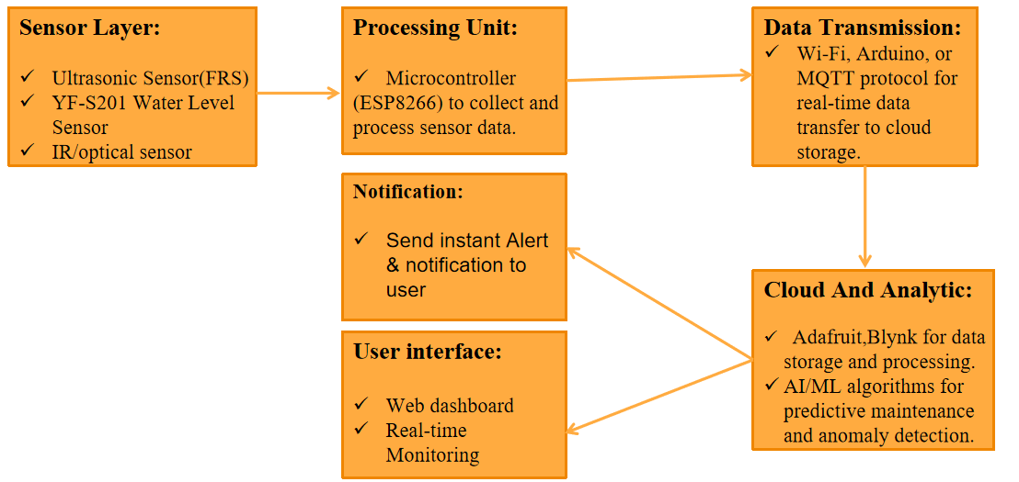

2. Circuit diagram:

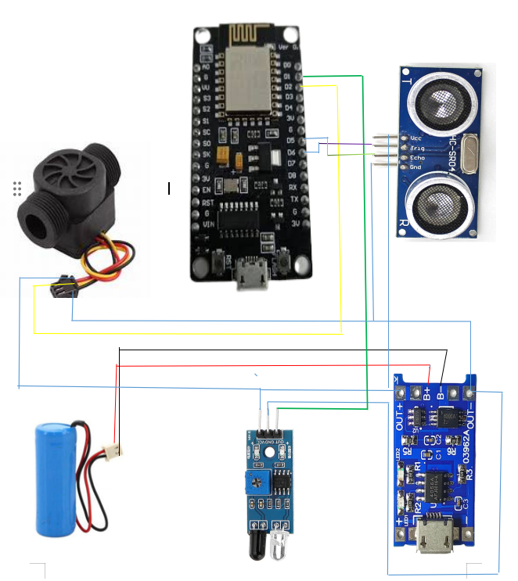

3. WORKING OPERATION

The Smart Gutter Management System operates through an integrated approach combining sensors, IoT communication, data analytics, and user interaction. The workflow is as follows:
- Data Collection via Sensors: The Smart Gutter Management System begins by gathering real-time data using various sensors. Water level sensors continuously monitor the rise in water levels to detect potential overflow risks. Flow rate sensors measure the speed of water movement to identify any blockages or slow drainage. Additionally, infrared (IR) or optical sensors detect the presence of debris such as leaves, plastic, or other obstructions that may hinder the proper flow of water.
- Data Processing and Analysis: Once the sensor data is collected, it is processed by a microcontroller, such as an ESP32, Arduino, or Raspberry Pi. This processing unit analyzes the data to identify anomalies such as stagnant water, reduced flow rate, or debris accumulation. If any irregularities are found, the system triggers predefined actions based on set conditions to ensure efficient drainage.
- IoT Communication and Cloud Storage: The processed data is transmitted using IoT communication protocols such as Wi-Fi, LoRa, or MQTT to a cloud-based platform like AWS IoT, Firebase, or ThingSpeak. The cloud platform stores the data for further analysis and utilizes AI/ML algorithms to predict potential maintenance needs, analyze patterns, and provide insights on possible drainage failures.
- AI-Powered Predictive Maintenance: The system leverages AI and machine learning to analyze historical data, weather conditions, and past drainage issues to predict potential failures. If the AI model forecasts an increased risk of blockages or overflow, it proactively notifies users to schedule maintenance, preventing emergency situations and costly repairs.
- User Interface and Alerts: A dedicated web dashboard and mobile application provide users with real-time monitoring and control over the system. Users can access live data, receive instant alerts, and take necessary actions remotely. This ensures that the drainage system is efficiently managed without requiring constant manual supervision.
- Energy Efficiency and Sustainability: The Smart Gutter Management System can be integrated with solar panels for power efficiency, making it an eco-friendly and cost-effective solution. This ensures continuous operation even in remote or off-grid locations without reliance on external power sources.

OUTCOME

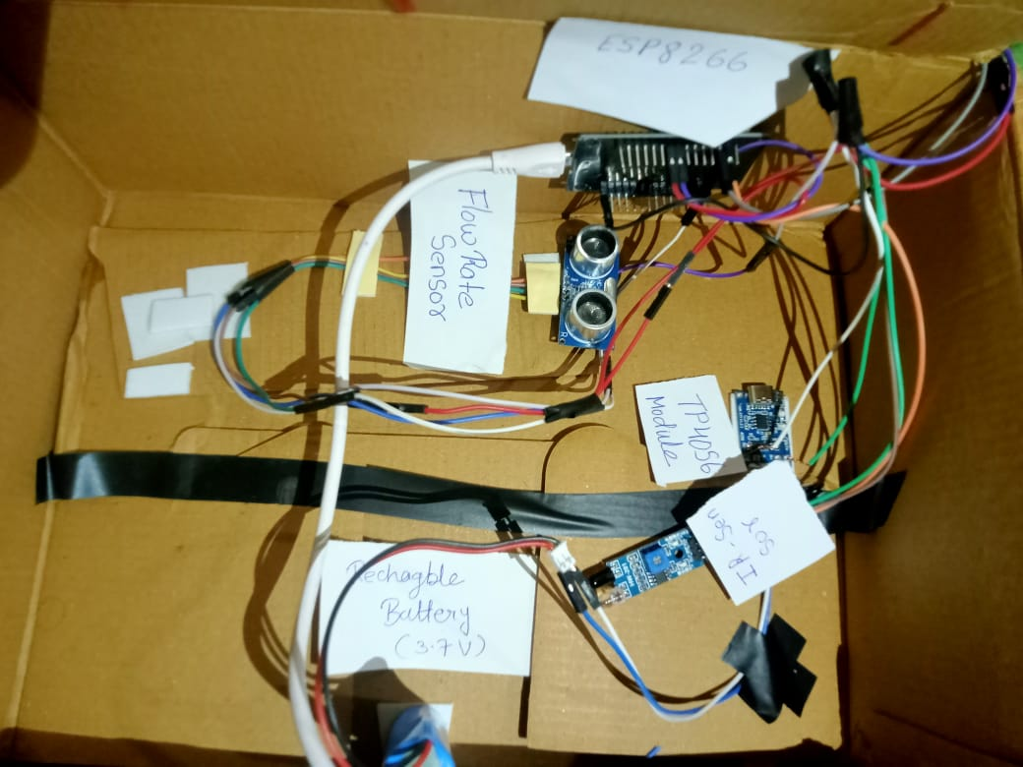

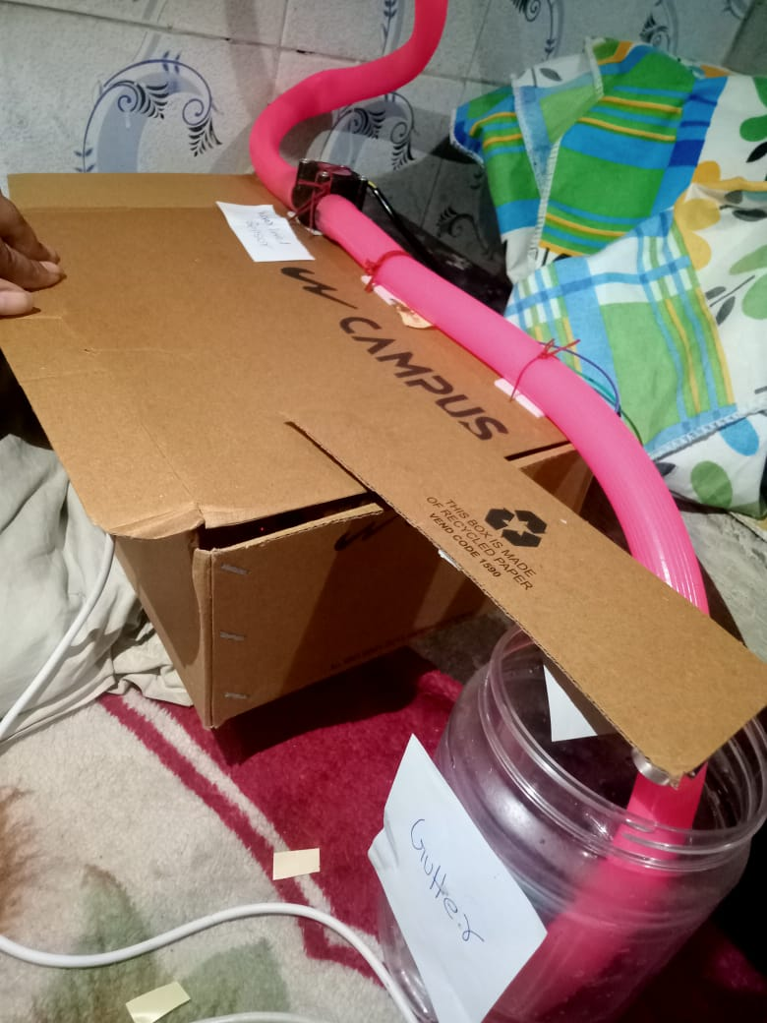

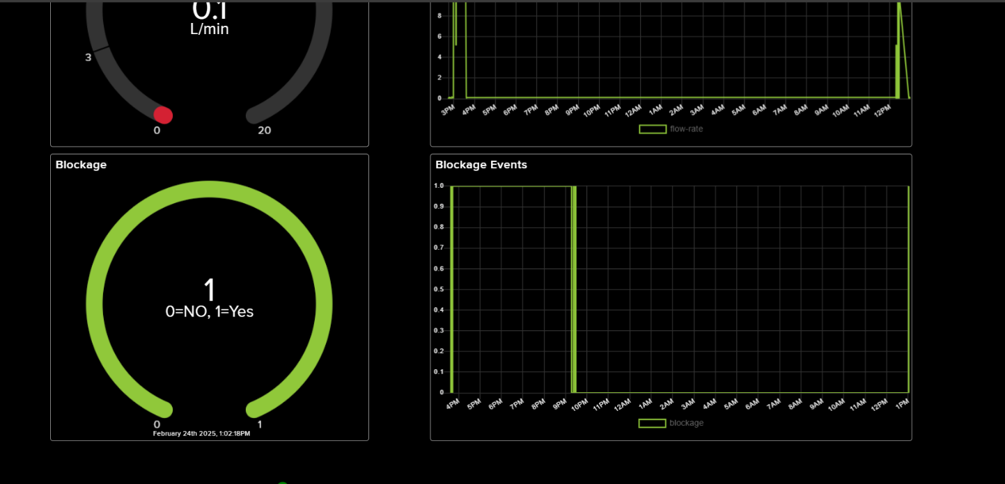

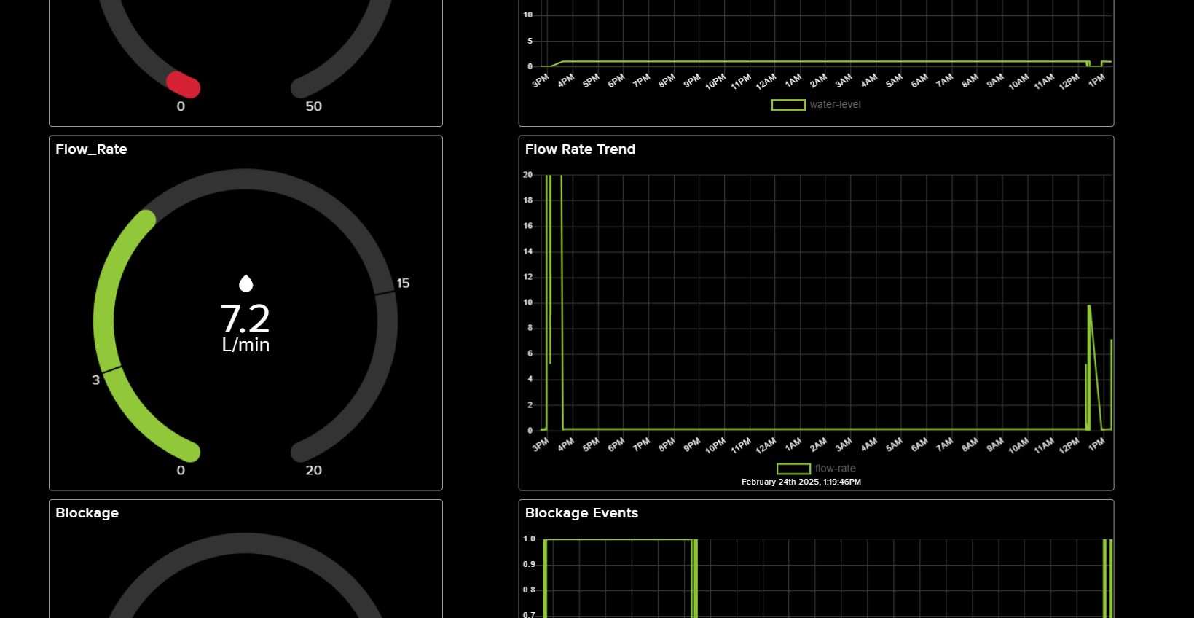

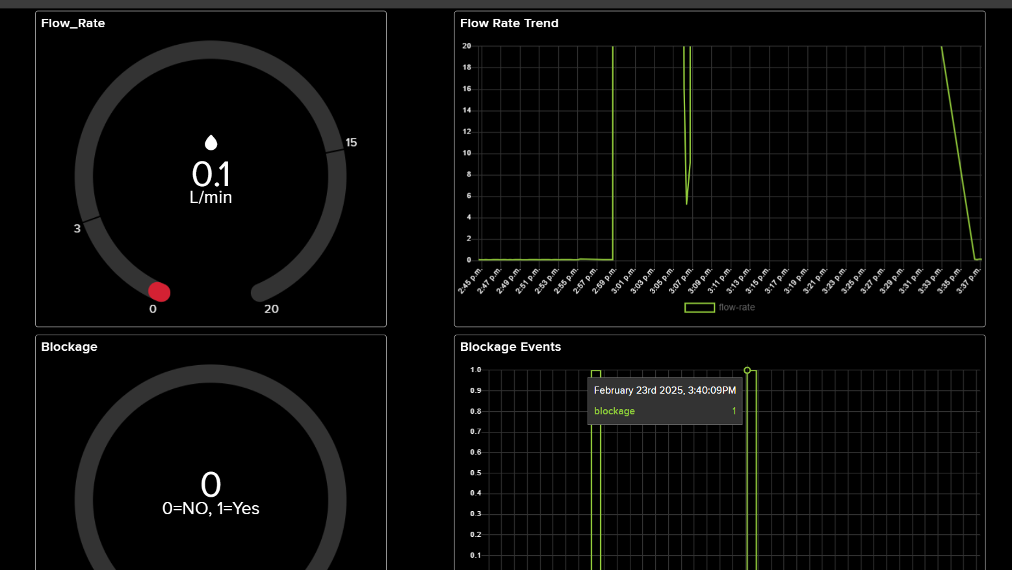



TECHNOLOGY USED TO SOLVE THE PROBLEM

- Microcontroller- ESP8266
- Water Level Sensor-HC-SR04 Ultrasonic Sensor
- Flow Rate Sensor- YF-S201 Hall Effect Water Flow Sensor
- Blockage Detection Sensor- Ultrasonic Sensor
- Communication Module- ESP8266 Wi-Fi
- Power Supply- 3.7V Rechargeable Battery
- Jumper Wires (Male-to-Male, Male-to-Female, Female-to-Female)
- USB Cable
- Embedded Programming- MicroPython (ESP8266)
- Adafruit IO
- Data Transmission Protocols-MQTT
- AI/ML Algorithms
- Real time monetering (Adafruit IO)
- Notification(blynk)
- Database

INFORMATION ABOUT HARDWARE AND SOFTWARE COMPONENTS

- Microcontroller- ESP8266
- The ESP8266 is a powerful and energy-efficient microcontroller, widely used in IoT applications due to its built-in Wi-Fi and Bluetooth capabilities.
- It features a dual-core Tensilica Xtensa LX6 processor running at 240 MHz, with 520 KB of SRAM and support for external flash memory, making it suitable for real-time data processing.
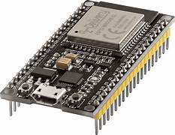

Fig.1

- Water Level Sensor-HC-SR04 Ultrasonic Sensor
- The HC-SR04 Ultrasonic Sensor is widely used for water level detection due to its high accuracy, affordability, and ease of integration with microcontrollers likeESP8266.
- It operates on the principle of ultrasonic sound waves, where the sensor emits high-frequency sound pulses and measures the time taken for the echo to return after bouncing off the water surface.

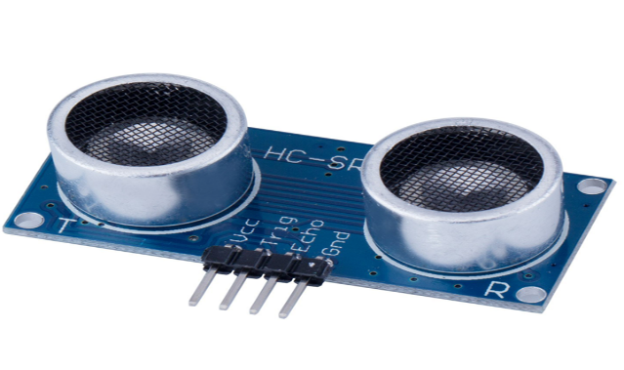
Fif.2

- Flow Rate Sensor- YF-S201 Hall Effect Water Flow Sensor
- The YF-S201 Hall Effect Water Flow Sensor is used to measure the flow rate of water in real-time. It operates using a magnetic rotor and Hall sensor, generating pulse signals proportional to the water flow.
- The sensor supports a range of 1 L/min to 30 L/min and works with a 5V to 24V power supply, making it compatible with ESP8266. Made of durable, waterproof plastic, it ensures long-term reliability in outdoor applications. In the Smart Gutter Management System, it helps detect blockages and monitor drainage efficiency to prevent overflow and stagnation.

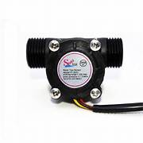
Fig.3
- Power Supply- 12V Rechargeable Battery
- The 12V Rechargeable Battery serves as the primary power source for the Smart Gutter Management System, ensuring uninterrupted operation.
- It provides stable power to components like ESP8266, sensors, actuators, and water pumps. With rechargeable lithium-ion or lead-acid options, it offers long battery life and durability.

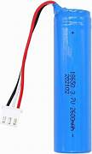
Fig.4
- Jumper Wires (Male-to-Male, Male-to-Female, Female-to-Female)
- Jumper wires are flexible, insulated wires used to create temporary or permanent connections between electronic components on a breadboard or circuit board. They come in three types: male-to-male, male-to-female, and female-to-female, making them compatible with microcontrollers like ESP8266.
- These wires are essential for connecting sensors, actuators, and power sources without soldering. They typically have a 2.54mm pitch and are available in different lengths and colors for easy identification. In the Smart Gutter Management System, jumper wires help establish reliable connections between sensors, microcontrollers, and power .
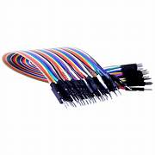
Fig.5

- USB Cable
- A USB cable is used for powering and programming microcontrollers like ESP8266 in the Smart Gutter Management System.
- It connects the microcontroller to a computer or power adapter, enabling firmware uploads, data transfer, and debugging. Common types include Micro USB, Type-C, and USB-A to USB-B, depending on the device.
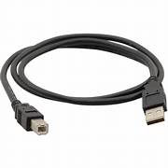
Fig.6

FUTURE SCOPE

The future scope of the Smart Gutter Management System includes integrating it with smart city infrastructure for real-time monitoring and control, incorporating artificial intelligence for advanced predictive maintenance and automated drainage management, and enhancing sustainability through the use of solar-powered units or energy-efficient technologies.

- AI-Based Predictive Analytics: The Smart Gutter Management System can be enhanced with advanced deep learning models to improve predictive maintenance. By analyzing historical data, weather forecasts, and real-time sensor inputs, AI algorithms can accurately predict potential drainage failures before they occur. This will allow users to take preventive measures, reducing maintenance costs and preventing severe water damage.

- Integration with Smart City Infrastructure: Future developments can enable the system to integrate with municipal drainage networks and smart city frameworks. By connecting with government databases and real-time weather monitoring systems, the smart gutter can automatically adjust its operations and contribute to large-scale urban drainage management. This integration will help authorities prevent flooding, improve city planning, and optimize public infrastructure.

- Solar-Powered Units for Sustainability: To make the system more eco-friendly and self-sufficient, solar-powered units can be implemented. These units will ensure uninterrupted operation, even in remote or off-grid areas, reducing dependency on external power sources. This feature will also support green initiatives by promoting the use of renewable energy in urban and residential drainage management.

- Weather Forecast-Based Automation: Future versions of the system can incorporate real-time meteorological data to enhance drainage efficiency. By analyzing weather forecasts, the system can proactively adjust its operations, such as increasing drainage capacity before heavy rainfall or sending early alerts to users. This will help prevent sudden overflows and improve overall system performance.

- Enhanced User Interface with AI Chatbot Support: A more interactive user experience can be developed by integrating AI-driven chatbot support and voice-command capabilities. Users will be able to monitor and control the system using natural language commands through mobile apps or smart home assistants. This will improve accessibility and ease of use for homeowners, municipal authorities, and commercial facility managers.

- Self-Cleaning Mechanism for Debris Removal: A future upgrade can include an advanced self-cleaning mechanism to remove accumulated debris without human intervention. By integrating robotic cleaning arms or high-pressure water jets, the system can ensure continuous, obstruction-free water flow, further reducing maintenance efforts.

- Remote Control and Automation through IoT: With improvements in IoT technology, the system can feature enhanced remote control capabilities. Users will be able to monitor and adjust the system settings in real-time from anywhere via their smartphones or computers. This will provide greater flexibility and control, ensuring efficient drainage management with minimal manual effort.

CONCLUSION

The Smart Gutter Management System is a transformative solution designed to revolutionize drainage management by addressing common issues such as blockages, overflow, and stagnant water. By integrating IoT, AI, and cloud-based technologies, the system ensures real-time monitoring, predictive maintenance, and data-driven decision-making, significantly reducing manual interventions. With the use of smart sensors, microcontrollers, and cloud computing, the system continuously collects and analyzes data, identifying potential issues before they become critical. This proactive approach helps in minimizing water damage, preventing flooding, and maintaining smooth water flow.

One of the key advantages of this system is its versatility and scalability, making it suitable for a wide range of applications, including residential homes, commercial buildings, industrial facilities, and municipal drainage networks. By providing real-time alerts and insights through a dedicated web dashboard and mobile application, users can monitor drainage conditions remotely and take immediate action when necessary. Moreover, the integration of AI and machine learning allows for continuous improvement, optimizing drainage operations and predicting potential failures based on historical trends and weather conditions.

In addition to its technological capabilities, the Smart Gutter Management System contributes to sustainability through the integration of solar-powered units, reducing energy consumption and operational costs. Future advancements can further enhance the system's efficiency by incorporating smart city integration, AI-driven automation, and weather-based response mechanisms, making urban and residential drainage systems more intelligent and self-sufficient.
Overall, the Smart Gutter Management System presents a smart, efficient, and cost-effective approach to modern drainage management. By leveraging the power of IoT, AI, and automation, it not only enhances water management but also plays a crucial role in flood prevention, infrastructure resilience, and environmental sustainability. With continuous improvements and future innovations, this system has the potential to become a standard solution in smart urban planning and infrastructure development, ensuring safer and more efficient drainage networks for communities worldwide.

REFERENCES

https://ijrpr.com/uploads/V5ISSUE3/IJRPR23601.pdf

https://universe.roboflow.com/for-the-planet-v9dsm/drain-detection-wk9un

https://universe.roboflow.com/konguai/dic-detection

https://universe.roboflow.com/konguai/dic-detection

https://www.jetir.org/papers/JETIR2405620.pdf

https://www.ijres.org/papers/Volume-9/Issue-7/Series-5/E09072329.pdf

