

***Version 24.3.0***



**Table of Contents**

1. Summary 3

1.1 Company Overview 3

1.2 Integration Overview 3

1.3 Feature List 4

2. Component Overview 4

2.1 Functional Overview 4

2.2 Use Cases 5

2.3 Compatibility 5

2.4 Limitations/Constraints 5

2.5 Privacy, Payment 5

3. Integration Guide 5

3.1 Adding the cartridge in SFCC UX Studio 5

3.2 Business Manager Setup and Configuration 6

3.2.1 Activating the cartridges in Business Manager 6

3.2.2 Enable Cartridge Module 6

3.2.3 Importing Metadata 7

3.2.4 Type Extensions 7

3.2.5 Define the Open Commerce API settings 9

3.2.6 External Interfaces 10

4. Operation, Maintenance 10

4.1 Data Storage 10

4.2 Logs 11

4.3 Failover and Recovery Process 11

4.4 Locales 12

4.5 Support 12

5. User Guide 12

5.1 Roles, Responsibilities 12

5.2 TextMaster account setup on Salesforce Commerce Cloud 13

5.2.1 API setup 13

5.2.2 API Authentication 14

5.2.3 Attribute setup 15

5.2.4 Language Mapping 15

5.2.5 Jobs setting 15

5.3 General Advice 16

6. Testing 16

6.1 Send content for translation 17

6.2 Follow up translation projects in Business Manager 18

6.2.1 Primary Dashboard 19

6.2.2 Secondary Dashboard 19

6.3 Import the translated content 19

6.4 Note on Project AutoLaunch 20

6.5 Note on Page Designer 20

6.6 Note on Variation Attribute export 21

7. Storefront Functionality 21

8. Known Issues 21

9. Release History 21

# Summary

## Company Overview

[TextMaster](https://www.textmaster.com/) offers dedicated ecommerce translation services that enable businesses to easily expand their international reach. By combining advanced cloud translation technologies with a network of verified expert translators in over 50 languages, TextMaster is redefining how businesses handle translation. More than 10,000 companies, in 110 countries trust TextMaster to optimize their translation workflow including leading brands like LVMH, Kenzo, The Kooples and Foot Locker.

Our philosophy: building a global translation platform that simplifies workflows while making translators even more productive. Our core technology includes Memento™, the first real-time, cloud-based translation memory that is combined with advanced post-edited machine translation, which can reduce translation costs up to 80%.

The TextMaster cartridge on Salesforce Commerce Cloud gives you access to TextMaster’s verified translator network and technology, all in one place.

## Integration Overview

**Easily set up with minimal technical support, the TextMaster Cartridge allows you to manage and synchronize your translations within the Salesforce Cloud Commerce admin panel.**

Once installed, you can instantly connect to your TextMaster account and upload the content you want to translate on the TextMaster translation management platform. Before launching a translation project, you can receive a quote including a translation memory analysis to know the exact cost of your project. Once your translators have completed the jobs, translations are instantly available and ready to be published on your website. You can also get a real-time update on your project status, see the history of completed projects and either approve a translation or ask for revisions

## Feature List

* Certified Commerce Cloud Integration
* One-click export and import of catalog content
* All content types (product, categories, content assets) and attributes handled
* Batch or manual selection
* Advanced dynamic search and filtering of items
* Automatic change detection
* Automated quote capability with live translation memory analysis
* Seamless and automatic translation workflow
* Dashboard for real-time status tracking
* Assign to your team of preferred translators

# Component Overview

## Functional Overview

This cartridge export data to/from Salesforce Commerce Cloud to/from TextMaster’s translation management platform. There two systems primarily sync the following types of data:

* Product
* Category
* Content asset
* Library Folder
* Page Designer
* Page Component

The cartridge has the following three parts:

* A Business Manager extension that provides a custom UI to search your content. It enables you to filter and select the data that will be sent for translation.
* An SiteGenesis controllers cartridge to have storefront Job triggering logics for SiteGenesis sites.
* Jobs that are responsible for exporting / importing the data.
* A storefront-based controller that works as an API to trigger these jobs externally by TextMaster.

## Use Cases

* Translation of all/some of the products assigned to a catalog.
* Translation of all/some of the content assets assigned to a website.
* Translation of all/some of the categories assigned to a catalog.
* Translation of all/some of the library folders assigned to a website.
* Translation of all/some of the page designer objects assigned to a website.
* Translation of all/some of the page designer component objects assigned to a website.

## Compatibility

This cartridge is based on JS controllers, new job framework and is based on SiteGenesis 105.2.0 version and 21.7 compatibility mode.

## Limitations/Constraints

The new translation UI, provided as part of the Business Manager extension, can be resource extensive if all products are searched.

The list of served languages are maintained in TextMaster’s database and is accessible through API within the connector. This list can be varied and non-served languages may be considered for translation through the usage of Language Mapping feature which is available in the connector.

## Privacy, Payment

This cartridge does not access any credit card information. It imports/exports catalog, category and content asset data.

# Integration Guide

## Adding the cartridge in SFCC UX Studio

To upload the cartridges into the SFCC server, you first need to add the cartridges in SFCC UX Studio. In order to do this, follow these instructions.

1. In UX Studio, select in the menu File > Import.
2. In the import dialog, select General > Existing Projects in the workspace and click on 'Next'.
3. Ensure 'Select archive file' is selected and select the compressed cartridge file by clicking on the 'Browse' button.
4. Click on 'Finish' button to import the cartridges.
5. Studio will now ask you if you want to link the cartridge to your active DigitalServer connection. Click on yes or manually link the cartridge to your server by checking the project under project references in the server connection properties.

## Business Manager Setup and Configuration

For the TextMaster integration to work, the following needs to be configured in the Business manager.

### Activating the cartridges in Business Manager

Before the TextMaster functionality can become available to Site, the cartridges have to be added to the cartridge path of the Site. In order to do this, follow the following instructions:

1. Log into Business Manager.
2. Navigate to Administration > Sites > Manage Sites.
3. Click on the site name and on the next page go to the 'Settings' tab.
4. In the 'Cartridges' input field add int_textmaster_controllers:int_textmaster_core in front of base cartridge path.
5. Click on 'Apply' button.
6. To activate the cartridge for the Sandbox/Development/Production instances repeat steps 4 and 5 after selecting the appropriate instance from the 'Instance Type' dropdown menu.
7. Go to 'Manage the Business Manager site'.
8. In the Cartridges input field add bm_textmaster:int_textmaster_core.
9. Click on 'Apply' button.

### Enable Cartridge Module

To enable Cartridge module,

1. Go to Administration > Organization > Roles & Permissions.
2. Click on "Administrator" and click on "Business Manager Modules" tab.
3. In Select Context dialog, check your site ID checkbox and click on "Apply" button.
4. Find ‘TextMaster’ and check the checkbox to enable it.
5. Click on “Update” button.

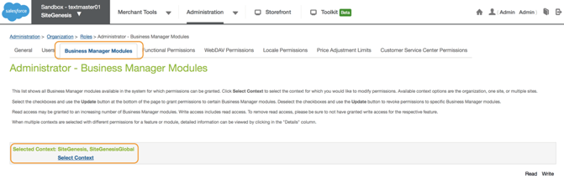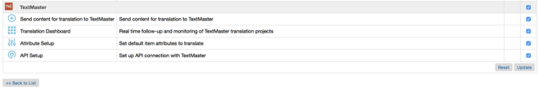

**NOTE: Master properties file -** The cartridge has only one properties file. The “textmaster.properties” file contains all the static values and API endpoints used in the cartridge.

### Importing Metadata

For the TextMaster integration to work, the following object structures (metadata) needs to be imported and configured in the Business manager. Follow the below steps:

1. In the cartridge bundle find **metadata/textmaster-meta-import** folder.
2. In the cartridge bundle, inside **metadata** folder compress textmaster-meta-import folder to generate **textmaster-meta-import.zip** file.
3. Go to Business Manager Menu > Administration > Site Development > Site Import & Export
4. Under Import: Upload Archive: Ensure that the radio button with label **Local** is enabled (Else click on the radio button to enable it)
5. Click on Choose File input field, select the **textmaster-meta-import.zip** file from open dialog box and click on upload button
6. After finishing the upload, from the Archives list click the radio button corresponding to **textmaster-meta-import.zip** and click on Import button
7. Click on OK button of the confirmation box asking “Are you sure that you want to import the selected archive?”

### Type Extensions

* **Custom site preference**

In Business Manager, navigate to Merchant Tools> Site Preferences > Custom Preferences. Custom site preference groups with the ID “TextMaster” is available.

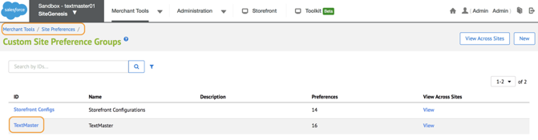

Please select it and edit the attributes as needed.

For each site, set the values for your site preferences.

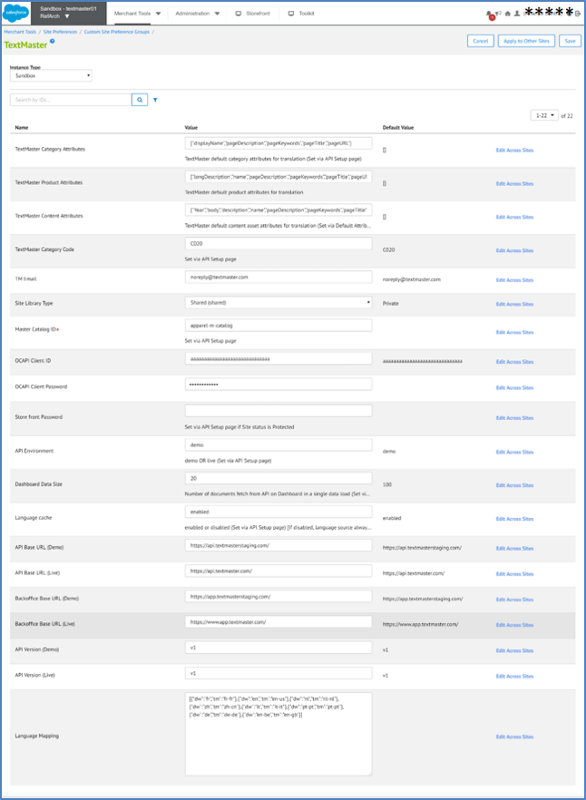

### *Define the Open Commerce API settings*

1. Go to Administration > Site Development > Open Commerce API Settings.
2. In ‘Select Type’ select "Data" in the dropdown list.
3. In ‘Select context’ select "Global (organization-wide)" in the dropdown list.
4. In the JSON content, ensure that the value for key "client_id" corresponds to your client ID in account.demandware.com
5. In the settings JSON content, inside "resources" array, add the value which is available in the file link_textmaster/documentation/TextMaster-OCAPI-Settings-Data-Global.txt

Keep Client ID and Password for OCAPI in Site Preference.

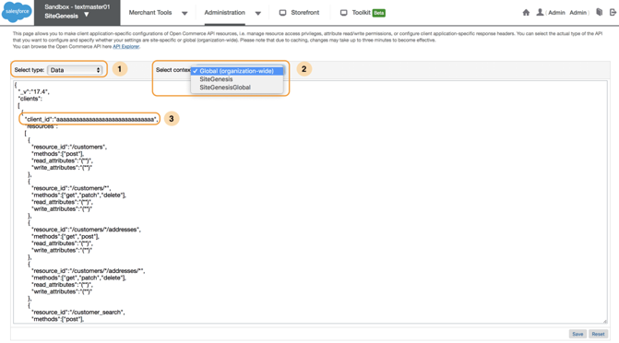

### External Interfaces

No external interfaces are integrated with this cartridge.

# Operation, Maintenance

## Data Storage

This integration requires System Object Extension to store translated locale codes.

* **Product custom attribute**

1. TranslatedLanguages (String) –Store translated locale codes.

* **Category custom attribute**

1. TranslatedLanguages (String) – Store translated locale codes.

* **Catalog custom attribute**

1. TranslatedLanguages (String) – Store translated locale codes.

* **Custom Object**

This cartridge will create custom objects and store incoming parameters for the job triggering controllers. For Import job each new request will update the existing custom object instance instead of creating a new one. For Auto Launch job new custom object instance will be created for each project and then the Auto Launch API call triggers this object instance will be removed. This is to ensure any misuse of the functionality.

1. TMCheckImportStatusHolder
2. TMFailedImportDataHolder
3. TMImportDataHolder
4. TMMasterProducts
5. TMQuoteDataHolder

## Logs

This integration introduces a few new custom logs:

**Textmaster Custom Log –**Such as thecustom-textmaster-blade7-1.mon.demandware.net-0-appserver-20200221.log. This log file contains all errors related information in the int_textmaster_controllers, int_textmaster_coreand bm_textmastercartridges.

**Service communication Logs –** These logs contain every request and response to the TextMaster API endpoint. To enable these logs, go to Administration > Operations > Services >textmaster.http and check the Communication Log Enabled preference. Examples of service communication log –

service-textmaster-blade7-1.mon.demandware.net-0-appserver-20200221.log

All log files are located in the Logs folder (under Administration > Site Development >Development Setup > Logs).

## Failover and Recovery Process

If the TextMaster service is unavailable the user will not be able to get TextMaster language list and cannot send data for translation. The service availability can be tracked in SFCC using the Service Status in the Commerce Cloud Business Manager. (Go to Administration > Operations > Service Status >textmaster.http)

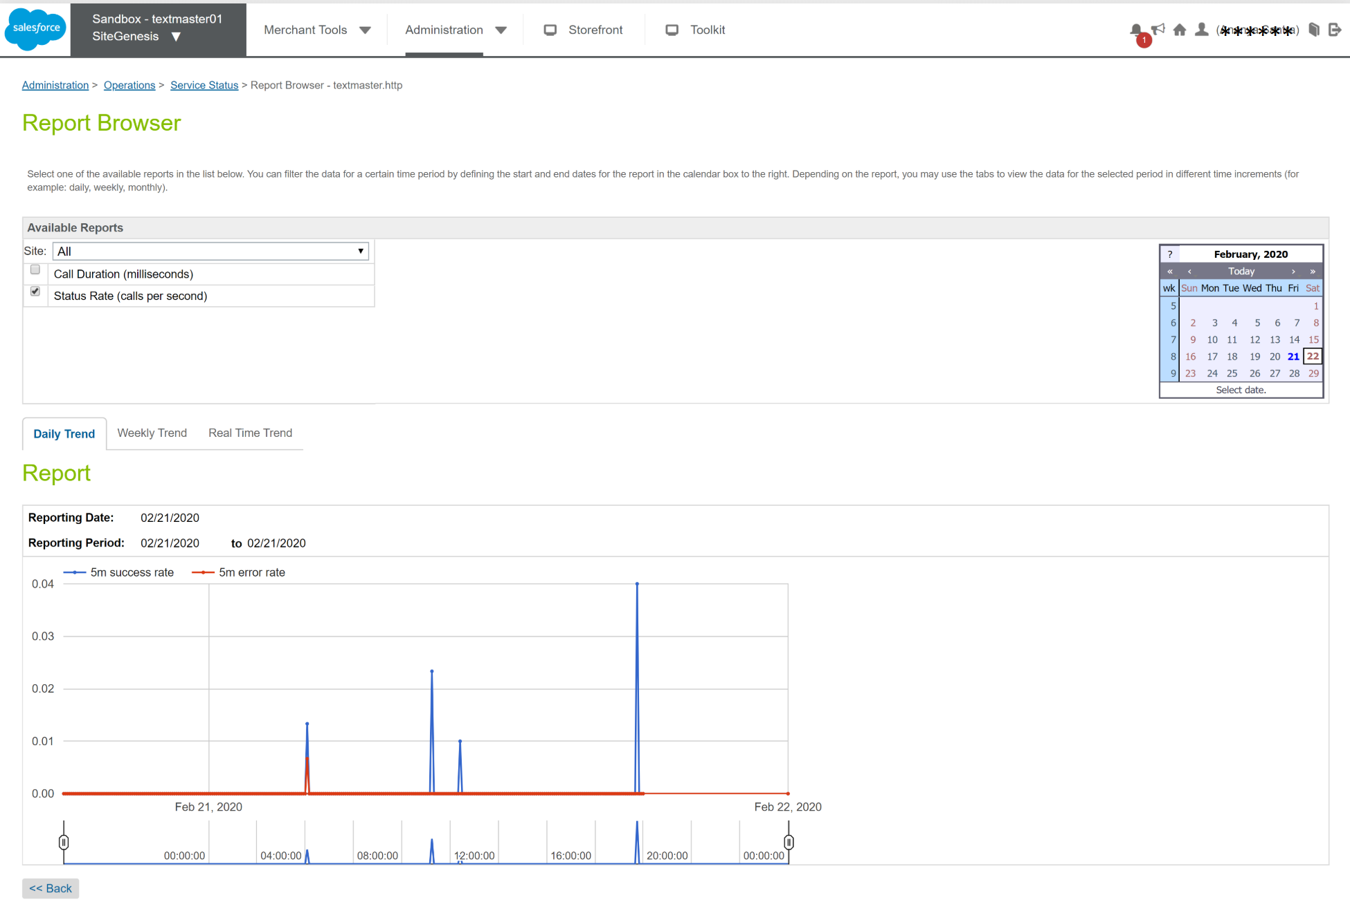

In case the cartridge doesn’t work appropriately, please contact [integrations@textmaster.com](mailto:integrations@textmaster.com).

## Locales

Integration works with all the locales which are available for the storefront. The translating languages must be configured on the Language mapping page of the plugin. If the intended language is not visible on the language list of TextMaster then any available language could be mapped for it.

## Support

The TextMaster team will be available for any suggestions or support request at [integrations@textmaster.com](mailto:integrations@textmaster.com)

# User Guide

## Roles, Responsibilities

The cartridge setup will typically be done by a SFCC developer.

## TextMaster account setup on Salesforce Commerce Cloud

### *API setup*

You will find the API setup page in **Merchant Tools >TextMaster> API Setup**

This API setup page allows you to connect Salesforce Commerce Cloud to your TextMaster account. You can either use:

* The Live API environment: you will use it to connect Salesforce to your TextMaster account in order to launch your translation projects.
* The Demo API environment: you will use it to connect Salesforce to a test account or ‘TextMaster sandbox account’ in order to test the translation workflow before starting your first translation project. **If you want to use this Demo API environment, please contact us at** [**integrations@textmaster.com**](mailto:integrations@textmaster.com)**. We will help you create your testing account and guide you through the tests.**

Choose the right API environment and the appropriate Store Category. Enter your Master Catalog ID. It’s a mandatory field on this page: The Product Import feature needs it as there is no SFCC Script API to get it. No need to keep Storefront catalog ID here.

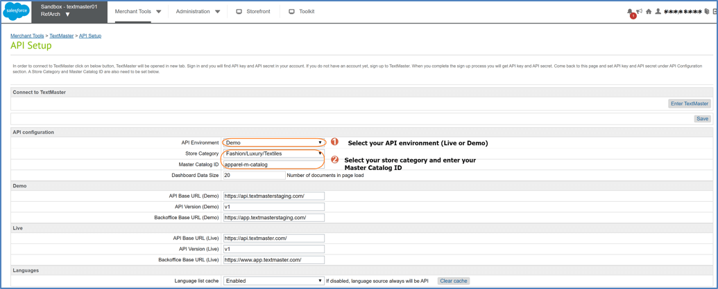

**Other values in the API Setup:**

Dashboard Data Size: It’s the number of items that will be displayed in the Translation Dashboard in order of creation. To fetch all the items you sent for translation, you have the option of loading more with the button 'Load more data' which is placed at last page of Dashboard need to be pressed.

Language list cache: On Export page cartridge calls two TextMaster APIs related to Languages (to fetch TextMaster supported language list and list of Source to Target language abilities) which deal with bulk amount of data. If Language list cache settings is Enabled, cartridge will not call these two APIs in each page loads but will take the data from cache.

Store Front protection password: If the status of your site is 'Online (Protected)' then you may set the password here as you set for your site under Administration > Sites > Manage Sites ><siteID> - Site Status

### *API Authentication*

After saving data on the API Setup page, by pressing ‘Save’ button, press the ‘Enter TextMaster’ button to login to your TextMaster account. This button will open the TextMaster account page in new browser tab. Login to TextMaster account or Sign Up to create new account.

**Creating OAuth Application:**

OAuth Application is required to be created on TextMaster account and this OAuth Application must be connected on API Authentication page of the SFCC plugin. After login to the TextMaster account page, follow the below steps:

1. Enter the ‘Api & Loop’ page  
   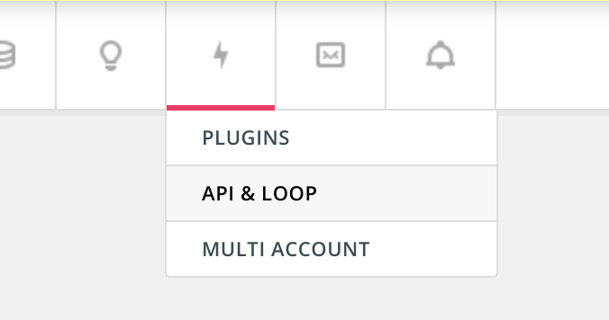
2. Click ‘View OAuth Applications’
3. Click ‘New Application’
4. In ‘Name’, type any name for your app (Eg:- Authentication SFCC plugin)
5. In ‘Authorization callback URL’, enter callback URL in format ‘https://**<hostname of your SFCC business manager environment>**/on/demandware.store/Sites-Site/default/TMTranslation-Authentication’  
   Alternatively this URL could be copied from ‘API Authentication’ page of the TextMaster plugin modules in the business manager of your SFCC instance.
6. Under ‘Scopes’, choose check boxes of **project:manage** and **user:manage**
7. Click ‘Submit’ button

You will get an Application ID and Secret for the application that you just created.

Come back to ‘API Authentication’ page of the TextMaster plugin modules in the business manager of your SFCC instance. Enter Application ID and Secret to the form and press ‘Authorize in TextMaster’ button. It will redirect you to TextMaster account to authorize it. You may follow the instructions and authorize the app. It will redirect you back to SFCC page. You may press the ‘Generate Token’ button to internally generate token which will be used for all the API communications by the plugin.

You can hit ‘Clear Authentication’ button to clear the existing authentication if you want to authorize new Application anytime in future.

### *Attribute setup*

This page allows you to preselect the attributes that should apply to translation by default. It will allow you to gain some time when creating your translation projects.

To set up default attributes

1. Go to Merchant Tools >TextMaster> Attribute Setup
2. Select Item Type.
3. Check the attributes.
4. Click on ‘Save’ button.

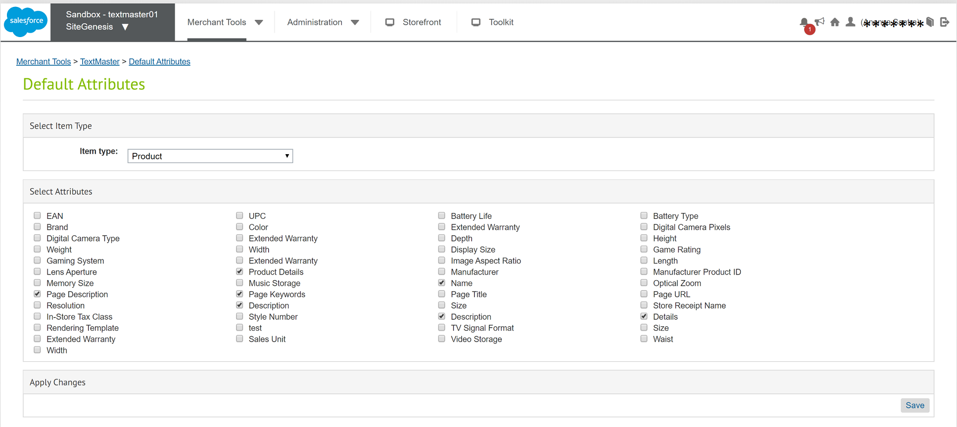

### *Language Mapping*

In order to be able to send content for translation from or to a given SFCC locale, add the locale in the list and configure it with a TextMaster language. When a locale is bolded, it means it is active on your storefront and it can be used as a source language.

To set up language mapping

1. Go to Merchant Tools >TextMaster>Language Mapping.
2. Click on ‘Add a language mapping’ button.
3. Select SFCC Language and TextMaster Language from selection drop down.
4. Click on ‘Save’ button.

### *Jobs setting*

The jobs need to be replicated for all the sites.

For example, the job **TextMasterAskForQuoteSiteGenesis** is replicated so that the new job will have an ID with the format **TextMasterAskForQuote<siteID>**. If the site ID is XyZ, the new job will be "**TextMasterAskForQuoteXyZ**". Under the "Job Steps" for the job, the scope must be the site ID, say "XyZ" if site ID is XyZ and edit the Job Step id with siteId.

Follow the same steps for other jobs to replicate for all sites.

## General Advice

* Since Business Manager custom modules have browser side JavaScript files, it is advised to clear/invalidate cache of Business Manager site on Administration > Sites > Manage Sites > Business Manager – Cache, after finishing the integration steps.
* On Merchant Tools > TextMaster > API Setup, it is good to keep ‘Language list cache’ Enabled so that functionalities will be faster wherever TextMaster language list is needed. It could be Disabled for a while when TextMaster team advices that new languages are added to TextMaster’s back office, so that it will be loaded to plugin integration.
* It is advised to perform an end to end feature testing with a TextMaster Demo API environment to ensure that the integration works as expected, before connecting to Live environment.

# Testing

Once the cartridge is installed and integrated based on instructions, please try to send content for translation.

Select a website, go to Merchant Tools and check if you can see the TextMaster Menu as seen below:

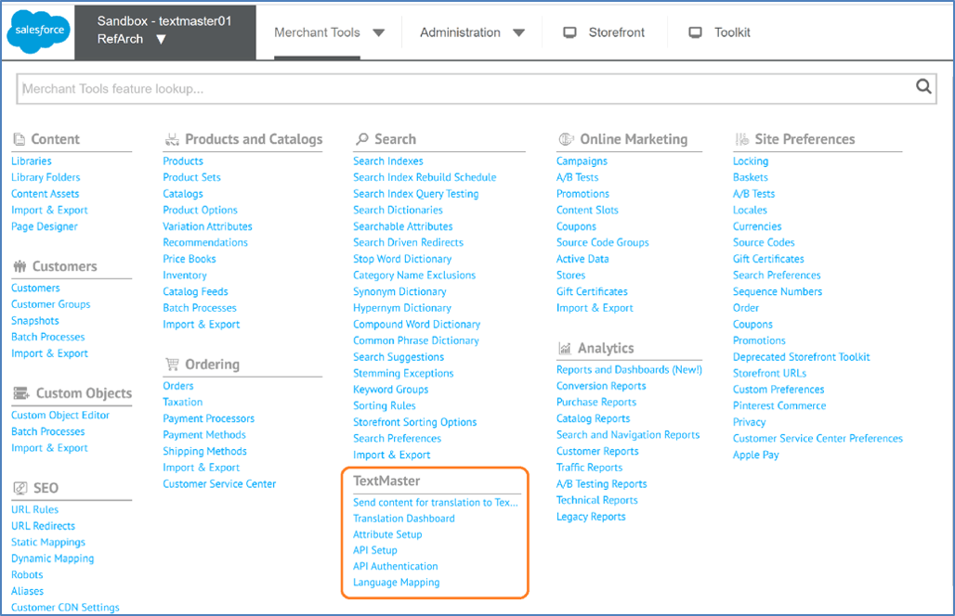

## Send content for translation

**Step 1: Select your translation content**

1. Select all the fields of your content search: content type, catalog, categories, source language, target language(s).
2. Launch your research
3. Select the content you want to send for translation. You can select up to 500 products. You can filter by ID, category, language(s), etc.
4. Select “Send to TextMaster”.

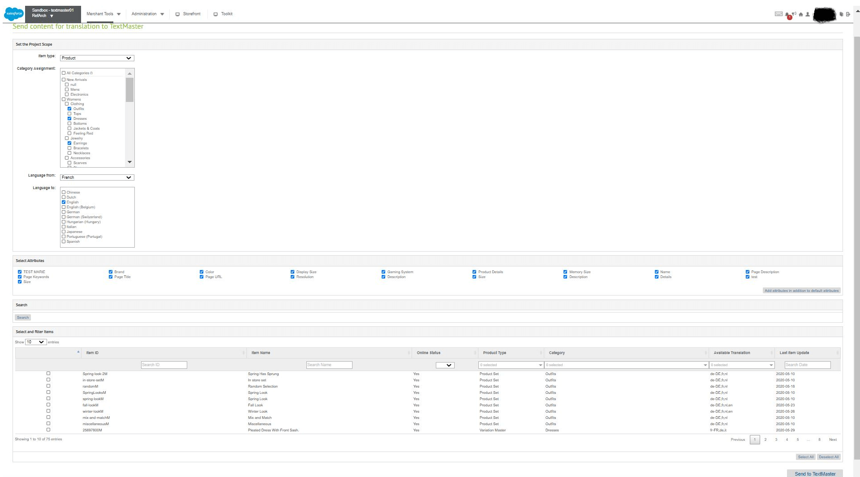

**Step 2: Select your translation templates**

1. Select the templates you’ve already created on TextMaster (for more information please contact the TextMaster team at [integrations@textmaster.com](mailto:integrations@textmaster.com)
2. Click on ‘Place Order’ button.

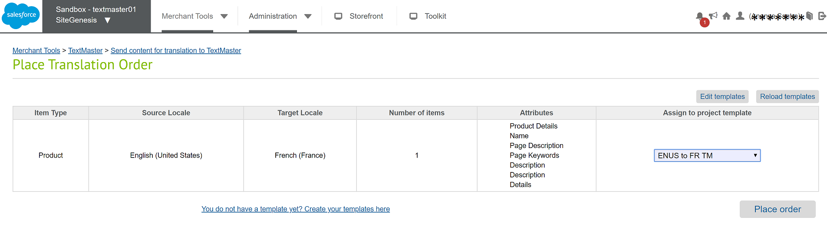

## Follow up translation projects in Business Manager

Find the documents you’ve sent to TextMaster in the Translation Dashboard that you will find in Merchant Tools >TextMaster> Translation Dashboard:

* In Creation projects
* Counting Words projects
* In Progress projects
* In Review projects
* Completed projects

### *Primary Dashboard*

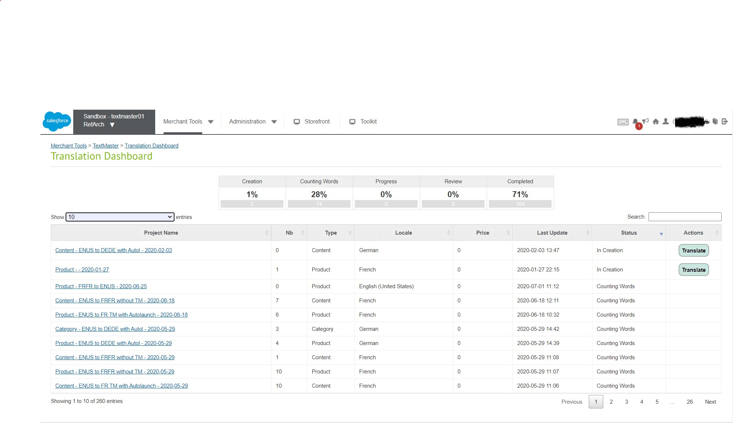

This dashboard contains all the projects that were created into textmaster. If the Project is in the ‘In Creation’ Status, you can translate your project by clicking the **Translate** button. On clicking the project name link, it will take us to the secondary dashboard.

### *Secondary Dashboard*

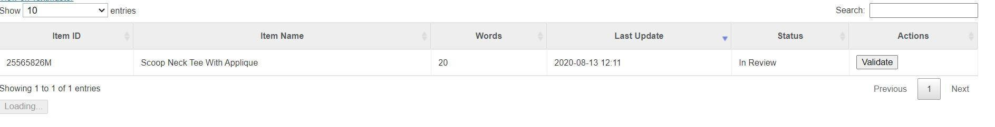

The Secondary Dashboard contains all the documents of the respective project. If any document is in the ‘In Review’ status, then you can validate the document by clicking the **Validate** button.

## Import the translated content

As soon as the author finishes a translation, you can visualize the translation in context in your dashboard by selecting “**Review translated content**”.

Whenever the exported content is ready to be imported at TextMaster side, TextMaster backend will trigger the synchronizing URL and the import feature will be triggered. Merchant does not require to initiate the import feature. Synchronizing URL looks like as in following format:

***https://{sandbox_domain}/on/demandware.store/Sites-{SiteID}-Site/default/TMImport-Data?projectid={projectID}&documentid={documentID}***

If the storefront is protected with user name and password, in case of development or staging sandbox, merchant has to share the authentication credentials to TextMaster team so they can trigger the synchronizing URL including the login credentials as in following format:

***https://{login_user_name}:{login_password}@{sandbox_domain}/on/demandware.store/Sites-{SiteID}-Site/default/TMImport-Data?projectid={projectID}&documentid={documentID}***

## Note on Project AutoLaunch

If you choose a TextMaster template on Export UI which is Auto Launch enabled at TextMaster, then your project will be automatically launched.

## Note on Page Designer

* There are no straight forward API methods to get the list of Page Designers and Page Components. Plugin’s User Interface has difficulties to read data of those objects. There is a custom cache based mechanism was developed as part of the export of Page Designers and Page Components. After integration of the cartridge, all the pages’ data must be converted to custom cache so that plugin will be able to read them on export page. For that, the job ‘TextMasterConvertPagesToCache<siteID>’ needs to be executed before exporting the data to TextMaster. This job is not required to be executed regularly. But whenever someone made a manual change on Pages’ data then before going for an export session, this job is expected to be executed so that the manual changes will be appeared on the custom cache and are reflected on export page. Import feature will update the imported data with custom cache without the help of this job. So this job is related to any manual data changes before an export session. Single time execution of this job is sufficient after a minor or huge manual data updates before an export session.
* Page Designer's Component objects need to be marked as Localized for relevant target languages within default Page Designer User Interface before they are getting imported back to SFCC (<https://documentation.b2c.commercecloud.salesforce.com/DOC1/topic/com.demandware.dochelp/content/b2c_commerce/topics/page_designer/b2c_localized_page.html>)

## Note on Variation Attribute export

There is no way to read all the available variation attribute values (like color and size values) of a master product through API methods. These values are forced to read from the export master catalog XML. So If there is a plan to export variation attribute values to TextMaster, it is advised to execute the job having ID ‘TextMasterExportMasterCatalog<Site ID>’, once after the integration of the cartridges to the SFCC instance to keep the master catalog XML as a data source.

# Storefront Functionality

There are a couple of storefront controllers that trigger backend jobs (Import and Sending Quote) as part of the cartridge. There are no customizations required to existing custom solutions. All the details are provided in the above section of External Interfaces.

# Known Issues

No known issues at the time.

# Release History

| **Version** | **Date** | **Changes** |
| --- | --- | --- |
|
| 24.3.0 | 03-Dec-2024 | * Search Content Assets by IDs * Load Content Assets in pages |
| 24.2.4 | 05-Nov-2024 | * Bug fix on Callback URL for alias domain |
| 24.2.3 | 28-Aug-2024 | * Saving default attributes in custom cache instead of site preferences  * Bug fix on Documents dashboard Preview Content URL |
| 24.2.2 | 13-Jun-2024 | * Import callback URL is generalized |
| 24.2.1 | 16-May-2024 | * Component data HTML encode and decode fix |
| 24.2.0 | 25-Mar-2024 | * Added translation feature for set of string attributes for Product, Category, Content Asset and Library Folder |
| 24.1.2 | 04-Mar-2024 | * CTA link correction on page components custom cache |
| 24.1.1 | 09-Feb-2024 | * Page Designers cache conversion job improvement |
| 23.2.0 | 04-Dec-2023 | * Page Designer listing  * Improving the Components selection dashboard  * Send all the Components of a page at once |
| 23.1.0 | 01-Jun-2023 | * Send components of multiple page designers to TextMaster  * Show Page Designer column on components list on Export page  * Select all target languages on a single click on Export page |
| 22.3.1 | 21-Oct-2022 | * Bug fix: Pagination on template loading |
| 22.3.0 | 26-Sep-2022 | * New job to trigger previously failed import  * Export item limit increased to 4000  * Metadata changes |
| 22.2.1 | 24-May-2022 | * Bug fix on Export and Import of variation attribute values of master products |
| 22.2.0 | 27-Apr-2022 | * Project name can be suggested by the user  * Improvement on Authentication feature |
| 22.1.0 | 15-Feb-2022 | * Certification 2022 |
| 20.9.1 | 17-Nov-2021 | * Bug fix on refresh API authentication token |
| 20.9.0 | 03-Nov-2021 | * New architecture for impex of Pages and Components objects  * Preview Content button for documents of status In Extra Review and In Review |
| 20.8.0 | 25-Oct-2021 | * Removed deprecated Signature method for API communication  * Added new Authentication method to generate token for API communication  * Improved AutoLaunch feature |
| 20.7.0 | 27-Jul-2021 | Export and Import Page Designer and Page Designer Component objects |
| 20.6.0 | 24-Jun-2021 | * Export and Import Library Folder * Translated content review link on Dashboard |
| 20.5.0 | 16-Dec-2020 | Search products based on product IDs without selecting categories |
| 20.4.0 | 28-Aug-2020 | Search items enhanced   * New date field added – Exclude items exported on or after this date |
| 20.3.0 | 14-Aug-2020 | Translation dashboard enhanced   * Primary Dashboard – Projects list & Translate Button * Secondary Dashboard – Documents list & Validate Button |
| 20.2.0 | 05-Mar-2020 | * Cartridges: int_textmaster_core, bm_textmaster, int_textmaster_sfra, int_textmaster_controllers * Jobs architecture changed * Pipelines removed |
| 20.1.0 | 05-Feb-2020 | * Source Languages – Mapped languages * API Setup page – Clear cache button |
|
| 20.0.0 | 10-Jan-2020 | Language Mapping |
| 18.3.0 | 23-Jul-2019 | * Source Languages - allowed languages * Target Languages - active languages |
| 18.2.0 | 26-Apr-2019 | SFRA cartridge added |
| 18.1.0 | 28-Nov-2018 | Enhanced performance, easy integration |
| 17.1.0 | 16-Dec-2016 | Initial release |