Lavish trips during crises raise questions among taxpayers
(Washington Examiner) – The first family, Michelle Obama fresh from her annual Aspen ski vacation with her daughters, and President Obama back from a weekend of golf in sunny Palm Springs, Calif., have spent tens of millions in tax dollars to vacation, and they still have two more years to go, according to an accounting of their trips.
As the first lady readies for a trip to Japan and Cambodia this month, Secrets calculated that the first family has racked up 38 holidays, working vacations, and fun trips like a date night in New York. They are on par to take at least 45 holidays before leaving office.
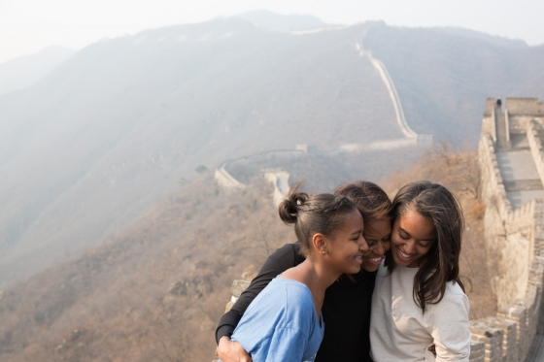
First lady Michelle Obama with her daughters, Sasha and Malia, in China last year. (White House Photo)
Costs are hard to pin down, and most come as a result of Freedom of Information Act suits from taxpayer watchdog Judicial Watch which pegged the Obama-Biden vacation tab at $40 million last year. That was before first lady and daughters took spring break in China, and the first family’s annual summer vacation in Martha’s Vineyard, Christmas in Hawaii, and this year’s holidays.
For just a handful of trips, the Air Force and Department of Homeland Security have complied with the FOIA cases, but the costs of security, prepositioning of aircraft, staff housing and transportation and communications are typically not disclosed and are always covered by the government for every single president.
For example, Judicial Watch FOIA suits for just two vacations in 2013 produced flight costs of $5,250,624. But undisclosed are, for example, the costs of a trip to China last year by Michelle, her mom Marian Robinson and daughter Sasha and Malia.
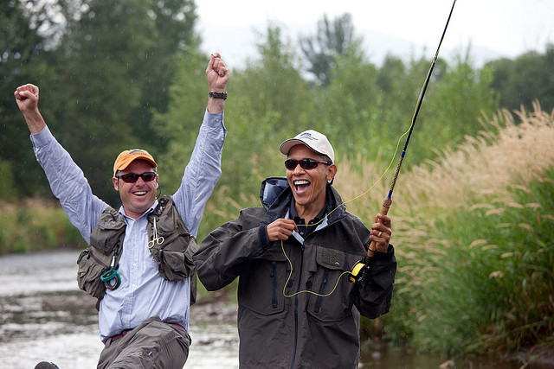
Fishing guide Dan Vermillion reacts as President Obama almost hooks a trout in August 2009. (Official White House photo by Pete Souza)
“The Obamas are abusing the public trust and the taxpayers with unnecessary luxurious vacations and travel,” Judicial Watch President Tom Fitton said in releasing those details of flight charges to Martha’s Vineyard and Hawaii. “These staggering costs show why these documents were covered up and we had to sue in federal court to get them. Another transparency fail for the Obama gang.”
The White House argues that personal costs are covered by the first family, but critics say that those costs are a miniscule amount of any trip. And critics of stories like this one argue that presidents need to take breaks and their work never ends, even on holiday.
While former President George W. Bush took more vacation days than the estimated 175 by the Obamas, critics slap Obama because most of Bush’s vacations were taken at his ranch in Texas, not the lavish digs he prefers in places like Hawaii and Martha’s Vineyard, Mass. He has also criticized the rich.
CBS White House Reporter Mark Knoller, the unofficial presidential record keeper, calclates that the president has taken 22 vacation trips spanning all or part of 160 days.
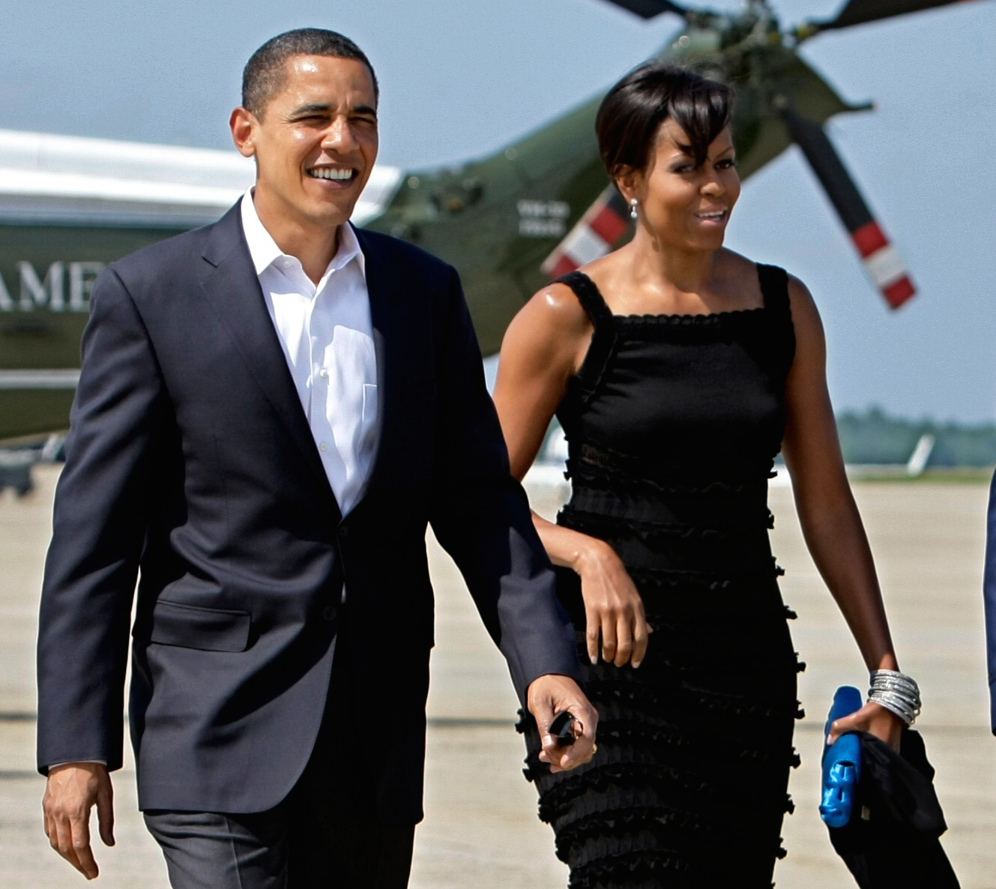
First couple leaving Marine One to hop on Air Force One for a date night to New York in May 2009. (AP Photo)
Our number is adjusted to include separate trips by the first lady and their daughters, Sasha and Malia, as well as quick trips like their May 30, 2009 date night to New York City and last year’s trip to New York to attend the wedding of former personal chef Sam Kass.
What’s more, White House reporters told Secrets that some trips by the first lady and daughters are kept secret from the media, so a full accounting is difficult.
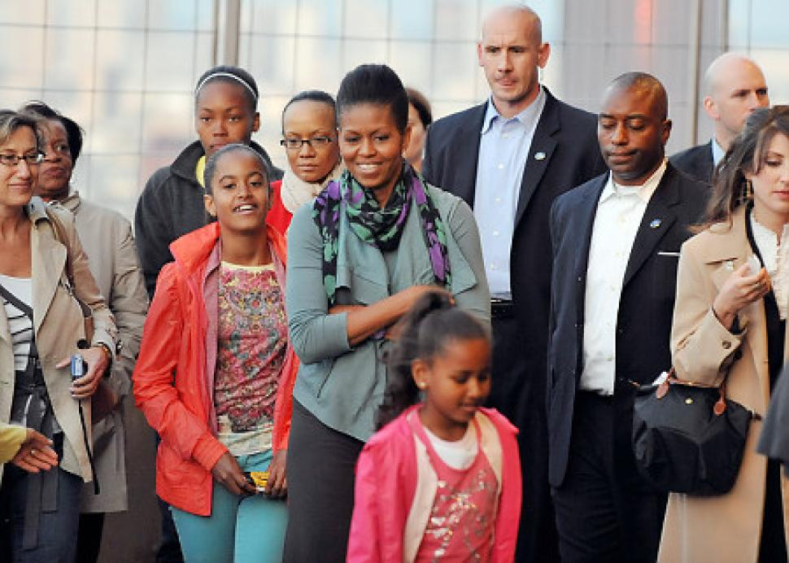
First lady, her mother and daughters visit the Eiffel Tower in June 2009.
Our list below also omits the many dozens of days the president spent golfing, about 220 since taking office.
2009
Feb. 13-16, the first family travels to Chicago. President plays some basketball and takes Michelle out for Valentine’s Day dinner at a restaurant run by one of Oprah’s former personal chefs.
May 30, the first couple travel to NYC for a date night where they saw ”Joe Turner’s Come and Gone.”
June 3-9, on a working trip to the Middle East and Europe, the Obama family takes in the sights,including a visit to the Eiffel Tower in Paris.
Michelle Obama and her girls stay behind to continue their vacation.
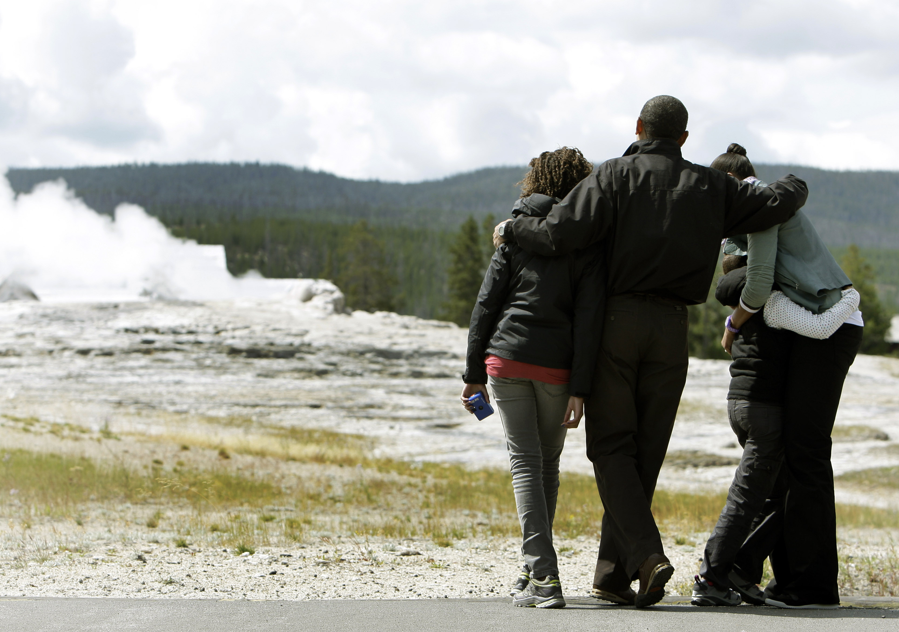
In 2009, the Obamas visited Old Faithful in Yellowstone National Park. (AP Photo)
August 14-16, the president goes fly fishing in Montana. He didn’t catch any but caught on to casting fast.
They family continued on to Yellowstone National Park and other sights.
August 23-30, the Obama’s start their first vacation on Martha’s Vineyard, Mass., staying in an oceanfront home that rents for more than $35,000 a week.
Dec. 24-Jan. 3, the first Obama presidential Christmas in Hawaii where they stayed in an $8.9 million home.
2010
March 20-24, Michelle, Sasha, Malia, mom Marian Robinson and some pals to New York City for Broadway shows, a tour of the Empire State Building lunch at the Russian Tea Room.
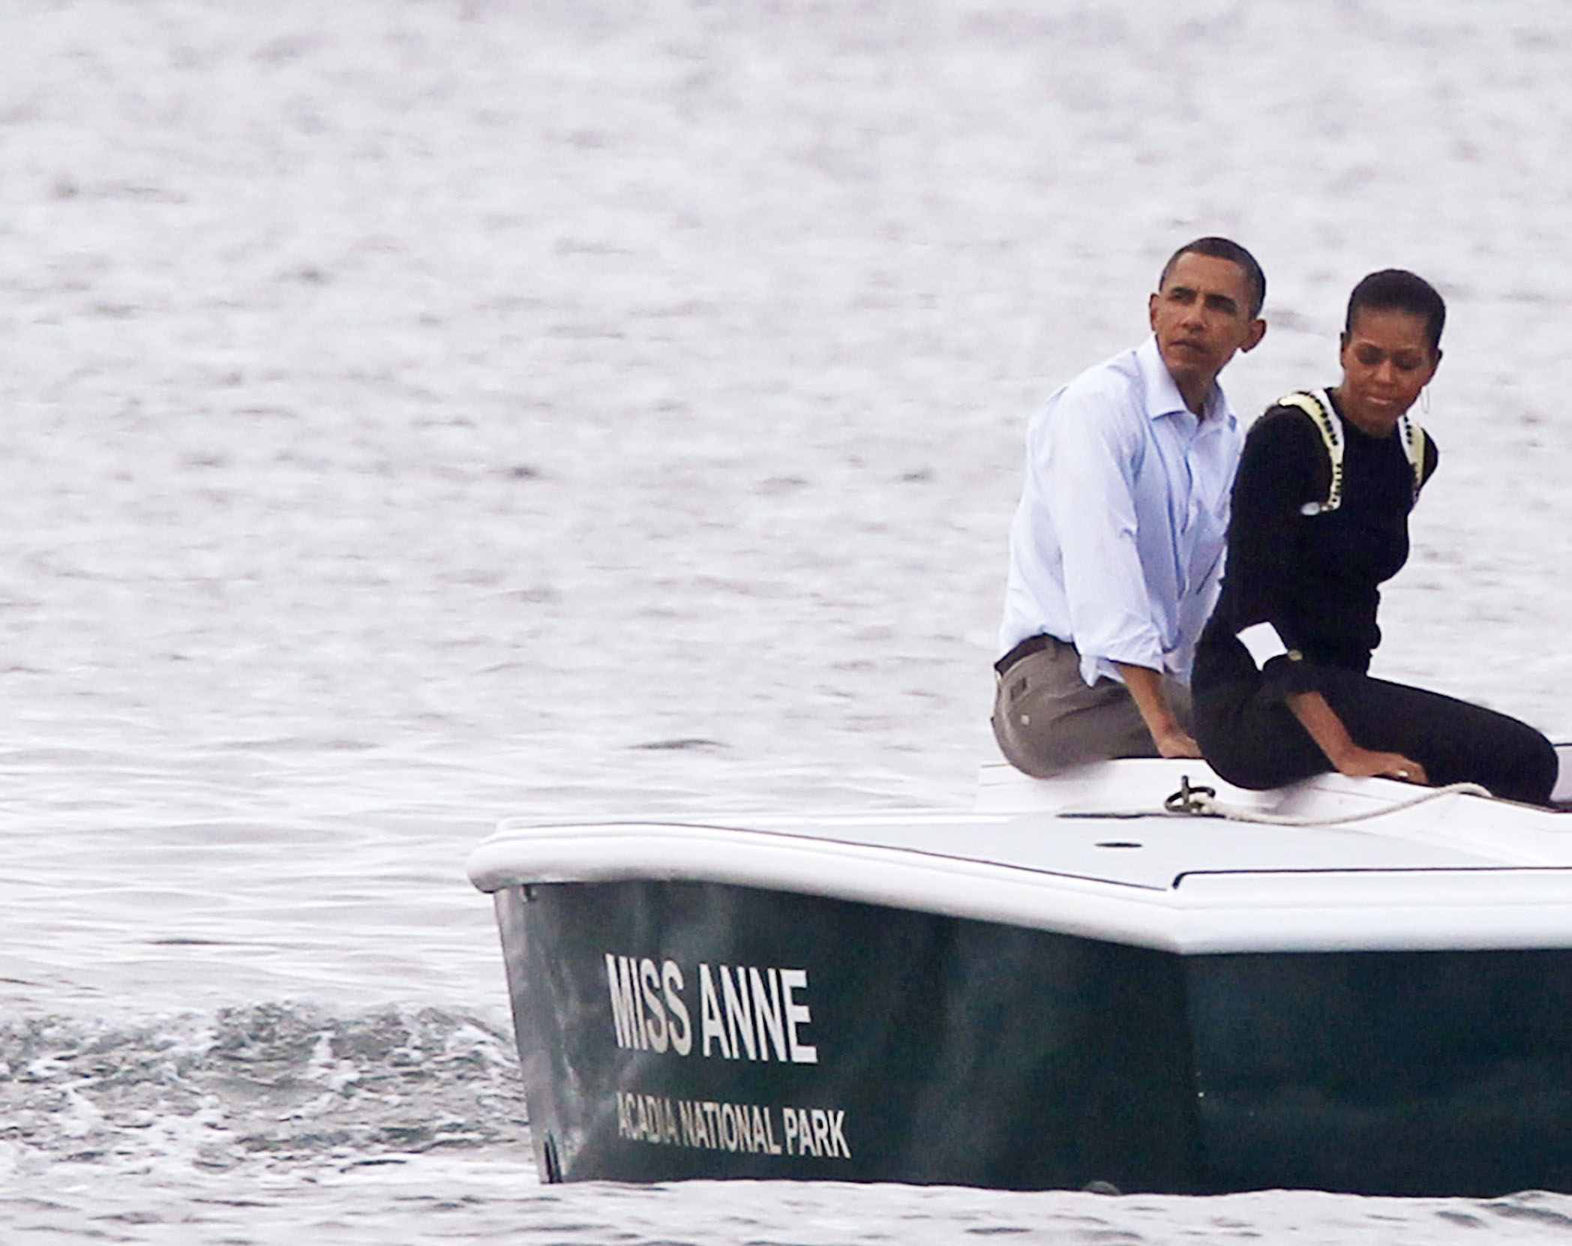
President Obama and first lady Michelle Obama take a boat tour of Frenchman Bay in Bar Harbor. (AP Photo)
April 23–25, President and Mrs. Obama in Asheville, N.C. for a weekend holiday.
May 27-31, Obama skipped the traditional Memorial Day speech at Arlington National Cemetery and traveled home to Chicago. He spoke instead at a smaller military cemetery.
July 17-18, a family vacation with first pup Bo in Bar Harbor, Maine.
August 4-8, Michelle Obama, daughter Sasha and an entourage travel to Spain. Judicial Watch pegged the cost at $467,000.
August 3-4, Obama in Chicago alone to celebrate his 49th birthday.
August 14-15, the first family vacations on Florida’s Gulf Coast to show support for locals hit by the BP oil spill.
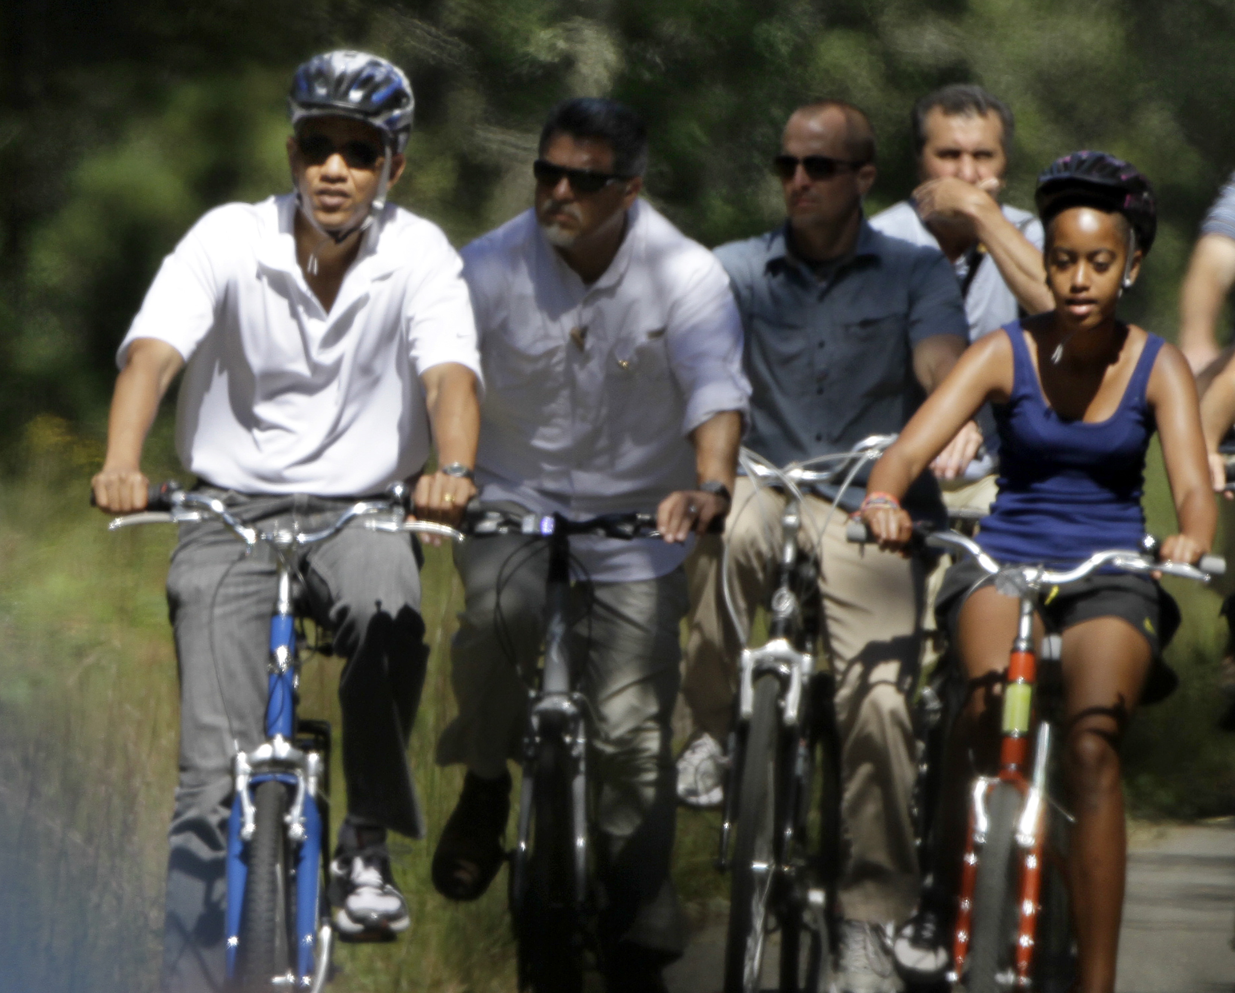
Obama, left, and his daughter Malia, front right, ride bicycles along a path on the island of Martha’s Vineyard, in August 2010. (AP Photo)
August 19-29, the first family is in Martha’s Vineyard for their second summer vacation.
Dec. 23-Jan. 2 in Hawaii for their second presidential Christmas vacation in a $3,500 a night home.
2011
Feb. 19-21, Michelle, Sasha and Malia travel to Vail to ski and hit a restaurant that served pickled pumpkin salad and braised ancho-chile short rib.
March 21-25, Obama, Michelle, Sasha and Malia, on spring break, on a working vacation to Latin America were the girls took in Rio’s Christ the Redeemer statue.
Aug. 16-28, for the first family’s third summer vacation on Marthas Vineyard.
Dec. 23-Jan. 2 in Hawaii for Christmas and a 10-day break.
2012
Feb. 17-19, Michelle and her daughters traveled to Aspen to ski.
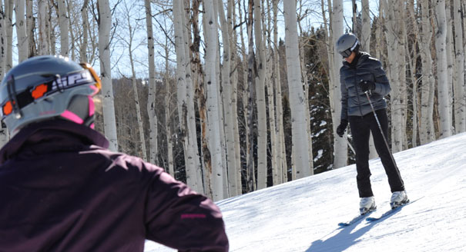
Michelle Obama skis in Colorado in 2012. (AP Photo)
March, Malia traveled to Mexico with friends. Judicial Watch said basic costs totaled $115,500.
Dec. 22-26 the Obama’s spend Christmas in Hawaii. The president cut his part short to return home to negotiate the ”fiscal cliff” with Congress.
2013
Feb. 15-18, Michelle Obama and her two daughters ski in Aspen, Co.
Feb. 16-18, President Obama flew to Palm Springs, Ca., for three days of golf.
March 2013, Sasha and Malia Obama were vacationing at the Atlantis resort on Paradise Island in the Bahamas.
June 17-18, while the president was at a summit in Ireland, Michelle and her daughters did some sightseeing that cost an additional $251,000, according to Judicial Watch.
Michelle Obama’s mother, Marian Robinson, takes a bow after they danced with children during a visit to the Emthonjeni Community Center in Zandspruit Township, Johannesburg. (AP Photo)
June 26–July 2, Michelle toured African nations with Sasha and Malia after meeting up with president.
Obama reacts as he misses a shot while golfing on the island of Martha’s Vineyard in 2013. (AP Photo)
Aug. 10-18, the fourth summer vacation in Martha’s Vineyard.
Obama with a shaved ice treat while vacationing in Hawaii last Christmas. (AP Photo)
Dec. 20-Jan. 6, for 17 days in Hawaii for Christmas.
2014
Feb. 14-17, Michelle Obama with daughters Sasha and Malia for a ski vacation in Aspen, Co.
Feb. 14-16, Obama golfed in Palm Springs, Ca. and also met with King Abdullah II of Jordan. Judicial Watch said the flight cost was $2,066,594.
March 8-9, the president and first lady traveled to Key Largo, Fla., for a golfing vacation.
March 19-26, Michelle Obama, her mom and daughter Sasha and Malia spend a spring break in China.
Aug. 9-24, the first family their fifth summer vacation on Martha’s Vineyard, staying in a seven-bedroom, 9-bathroom, 8,100-square-foot home they rented by the Vineyard Sound.
August 30, the president makes a special trip to New York to attend the wedding of his family’s former personal chef, Sam Kass.
Dec. 19-21, a 17-day Christmas vacation in Hawaii
2015
Feb. 14-16, Michelle Obama and daughters ski in Aspen, Co.
Feb. 15-17, President Obama traveled again to Palm Springs for a boys weekend of golf.

