# ConclusionS

As Timothy Beal so aptly puts it in his analysis of the cultural iconicity of bible in the twilight of print culture, “It’s the end of the Word as we know it, and I feel fine.”[1] I couldn’t agree with Beal more and I am excited to see what bible can and will become as interface in the continually emerging technological landscape of machine learning and artificial intelligence. Bible as interface, irreducible to its contents alone, has provided us a way to see how bible continues to enact bible amidst substantial technological change such as the rise of the codex and the emergence of internet technologies. Bible at its best is an interface that enables relationships with users that can not be reduced to simple consumption of its contents. The affordances of high surface area, collaboration, and anarchy facilitate this kind of interface and we have seen these affordances at work in the ancient technologies of the roll and codex manuscript as well as in the digital technologies of XML and APIs. The continuity of these affordances, though expressed differently in each interface, provides a way for users to see the connection of emerging bible interfaces to the long history of bible use, even as bible begins to extend beyond the book. In a sense, our analysis here has demonstrated that bible as interface is irreducible to the book.

Early on, I articulated three aims at work in this project related to the argument of bible as interface: 1) focusing attention on the materiality of bible even into the digital realm; 2) finding an alternative to the anxiety around the impact of emerging technologies on the use of bible; and 3) beginning to build new capacities for biblical scholars to study and engage bible in our emerging technological landscape. The process of *material media translation*–the translation of affordances from one interface to another–provides an anchor for all three of these aims. The translation of the affordance of anarchy from the scribal emendations of Codex Sinaiticus to the search endpoints of the BibleSearch API demonstrates the radically different materialities at work in these bible interfaces and the impact on use. Ongoing scribal participation in an ancient manuscript through the margins and the space between lines and letters resisted the closure or fixicity of a text. The search endpoints of the BibleSearch API allow a user to bring together typically disparate texts in ways that can surface new possible meanings and relationships in the text.

At its best, bible has and always will afford this kind of anarchy through the constraints and possibilities of its materiality in interface. Even if this anarchy looks more troubling and threatening to those who value the stability of the texts of bible, the continuity throughout history of this affordance of anarchy in the acts of material media translation can offer us a way to engage emerging bible interfaces from a place of familiarity and value, not anxiety. The ability to attend to these continuities and distinctives in the process of material media translation of bible as interface will demand an ever expanding development of new capacities as well as holding onto the value of those capacities already well developed in the discipline of biblical scholarship. It is our responsibility as students of this material cultural phenomenon of bible to develop the capacities to engage bible on its terms as its materialities continue to expand in each emerging technological landscape in which we find ourselves. The scale of this expansion, and hence, the demand for our ongoing learning, is only beginning to make itself known. This demand for learning, for building new capacities, and for doing this together in collaborative community excites me. So, it is indeed the end of the Word as we know it, and I feel more than fine.

## Face of the Deep

One of the ways I propose for biblical scholars to begin learning the capacities needed to study bible as interface is to go beyond the critical analysis of existing bible interfaces and to participate in the designing and building of emerging bible interfaces. With the help of The Experimental Humanities Lab at Iliff School of Theology[^ehiliff] and the Baker-Nord Center for the Humanities at Case Western Reserve University,[^bakernord] I have had the privilege of participating in this process of collaborative design and construction of an emerging bible interface. For the 2014-2015 academic year, through the generous support of the Baker-Nord Center, I had the privilege of working with an inspiring and inquisitive team[2] to collaboratively explore ways in which emerging digital technologies might unsettle our notions of sacred text translation. For a little over a year, our team worked remotely and co-located to imagine a web interface that would encourage a disposition of attention to ambiguity in the translation processes of Genesis 1.1.

Working with this team through Baker-Nord provided the seed for a bible interface project that we have taken up in the Experimental Humanities Lab at Iliff, my home institution, which we have called *Face of the Deep*.[3] I was initially hoping that the *Face of the Deep* bible interface would be a part of this dissertation, so our team spent significant time together developing a proof of concept in the Fall of 2016. Due to the lack of evaluative and logistical infrastructure in our doctoral program for digital dissertations, work on the interface has been put on pause. Yet, below I outline some early experiments in the theory and practice of design for *Face of the Deep*. The design of this interface is deeply formed by the affordances of high surface area, collaboration, and anarchy that we have seen in bible as interface.

## Two Lobes of Infinity

*Face of the Deep* provides users an encounter with the relational networks of artifacts that constitute bible. We have taken a broad notion of artifact in this project, including translations, versions, manuscripts, images, art, film, music, etc. I think of the interface design of *Face of the Deep* as the constant interplay of the two lobes of the infinity sign. *Lobe 1* is an ongoing and iterative machine learning process gathering artifacts and data from sources and from user interaction and creating correlative metadata that provides possible links among artifacts in this bible interface by connecting words to conceptual domains through grammatical and semantic abstraction. Optical Character Recognition (OCR), image recognition tools, and video processors will engage media for potential terms or attributes that can be passed into the conceptual algorithm map for metadata processing. We will use an object oriented database to store and access artifacts in a manner that problematizes any strict database/interface dichotomy and foregrounds interface’s irreducibility to content consumption. Natural language processing will provide the algorithms to take streams of data and find correlations between artifacts and create the corresponding metadata by moving back and forth between semantic and conceptual realms using tools such as WordNet.[4] Lobe 1 affords high surface area because it is constantly new artifacts as contact points for users, it affords collaboration by incorporating user participation into the discovery of artifacts and the construction of relationships between artifacts, and it affords anarchy by bothering any simple reduction to a governing data set that dictates all possible uses.

Enacting the proliferation characteristic of emerging digital interfaces, *Face of the Deep* will use partner interfaces to provide artifacts for the ongoing training of the machine learning engine and for user engagement. Some of these partner interfaces would include bible interfaces we considered in this dissertation, such as the Digital Bible Library and the BibleSearch API for textual translations and audio artifacts. Our team would also be interested in helping develop an API for the digital images and transcriptions of the Codex Sinaiticus Project to make it easier to incorporate these artifacts in the interface. In gathering partner interfaces, we will privilege open access artifacts and will provide pointers to each artifact when possible, rather than copying and ingesting full objects into our interface. Pointing users to other interfaces provides another affordance of anarchy by resiting attempts to keep users within one interface, but promoting the interconnection of interfaces as much as possible.

*Lobe 2* of *Face of the Deep* leverages the algorithms of lobe 1 to render a web interface that allows user interaction with and participation in constellations of artifacts that make up the tradition surrounding a biblical text. Users arrive at the *Face of the Deep* interface and are presented with a textual translation of bible based on the default language settings in their system of access. A touch or click on a portion of text zooms to that portion of text as shimmering artifacts making up letters, almost as if letters are buzzing, and then these objects release from formation in letters into a slowly swirling constellation of objects.

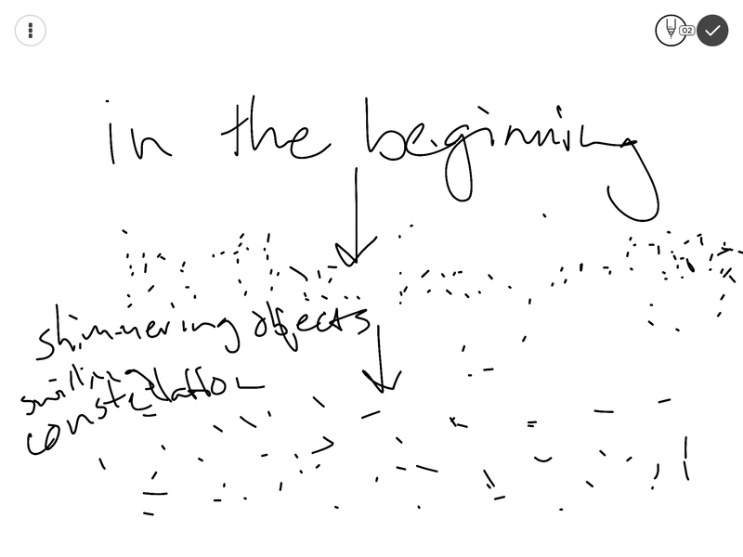

Figure 1. Opening animations of the *Face of the Deep* interface.

To the left of the swirling constellation will be a clickable cloud of object type toggles to allow filtering of artifacts in the constellation by particular object types, such as text, image, video, etc. All types will be displayed by default. Clicking on a type marker one time will remove that object type from the constellation and clicking again will bring these objects back into the swirl. To the right of the constellation will be a clickable cloud of concept toggles for filtering in a similar fashion.[5]

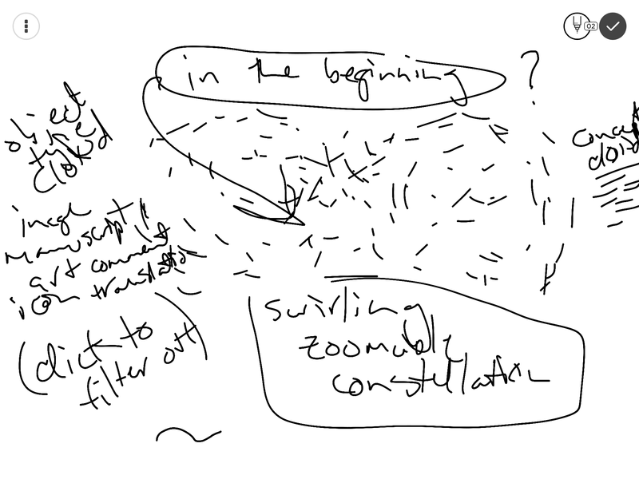

Figure 2. Constellation view of the *Face of the Deep* interface

Our team has discussed having ways to organize the swirling artifacts (e.g. versions) by time or other attribute for pedagogical aims (e.g. show historical trajectory of translations for comparison and genealogy). These facet or filter clouds illustrate a collaborative affordance, allowing the user to participate in the shape and content of the interface. The progression from translated text to swirling constellation of artifacts affords both high surface area and anarchy. The few simple words of the biblical text explode into an ever expanding collection of artifacts that have shaped and been shaped by the particular text selected by a user. This constellational approach to engaging the tradition entangled around a biblical text dramatically expands the possible contact points for a user with this particular text. The machine learning engine supporting the web interface will continue to find relevant artifacts to add to the constellations and create relationships among them, which resists any attempts at closure or consolidation to a complete or governing tradition of bible.

When a user interacts with this constellation, a touch or click on any object will bring it into focus and show annotations, sharing options, and perhaps even a way to suggest correlation with another object in the constellation. The annotation feature will allow general comments and spatially located point specific annotations on the objects composing the constellation. All annotations will allow text, image, html embeds, audio, or video.[6] Here, the user has the ability to collaboratively mark the interface in several ways as well as to impact the metadata algorithms of lobe 1 by suggesting correlations and simply by engaging the artifacts.[7]

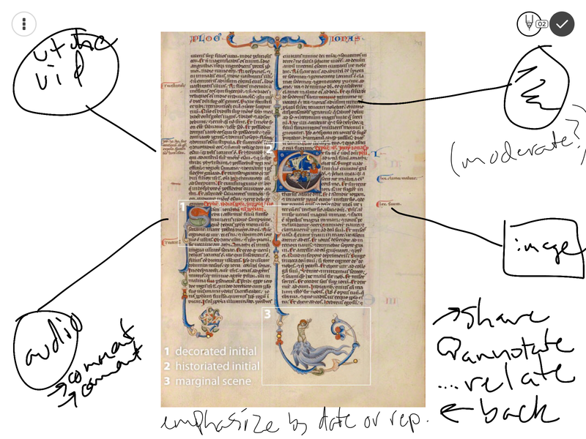

Figure 3. Item view of the *Face of the Deep* interface

Similar to the larger constellation view, item view will also offer clickable clouds of related concepts and object types. Yet, in item view, a click on a cloud item will take the user to a new constellation based on their selection. This will allow users to move from a single artifact to alternative constellations based on the attributes of a given artifact.

Given the layers of this *Face of the Deep* interface, a user can simply read a biblical text through without delving into these constellational spaces. But, shimmering and swirling beneath the surface of these words and letters awaits ever expanding and anarchic possibilities for encountering the traditions and the users that have participated in the ongoing production of bible. This constant entanglement of surface and depth, embodied in the *Face of the Deep* interface, affords collaboration, high surface area, and anarchy, inviting users to dive further in as participants in the many contact points of bible, while resisting any attempts at gaining a comprehensive grasp of the whole. I am eager to see what our team and others will continue to image for bible as interface and I look forward to developing the capacities to participate.

1. Beal, *The Rise and Fall of the Bible*, Kindle location 309.
2. Timothy Beal, Sarah Gridley, Eric Pellish, William Deal, and Michael Hemenway.
3. We did all of our initial development of the *Face of the Deep* project in a public repository on GitHub, which you can find at https://github.com/textpotential/faceofthedeep, accessed on October 10, 2017.
4. For more information on WordNet, see https://wordnet.princeton.edu, accessed on October 10, 2017.
5. We could have countless clouds or cascading clouds that allowed filtering by different attributes (language, time period, genre, etc.)
6. We discussed annotation moderation of some sort and requiring account registration to participate in the interface in these ways.
7. Our machine learning lobe could internalize analytics based on user patterns in their participation in the interface to foreground certain artifacts or correlations.