A dot-based, dual-view user interface for realistic embroidery simulation

Abstract. Traditional digital embroidery tools provide a grid-based user interface that allows users to fill squares with predefined stitches and colors, limiting the dynamic nature of the real embroidery process. This paper introduces a dot-based, dual-view user interface for embroidery simulation, enabling users to create stitches by connecting pairs of dots on a grid—simulating the actual movement of a needle through fabric. The dual-view canvas reveals both the front and back sides of the embroidery simultaneously, offering real time insight into how stitched patterns evolve on both surfaces. In contrast to the physical process, where the embroiderer can view only one side at a time, the proposed user interface enables continuous awareness of both sides—supporting learning, precision, and creative exploration in a uniquely digital environment.

- Introduction
Modern digital embroidery tools for hand embroidery are largely rooted in conventions established by printed pattern magazines. For decades, cross-stitch and embroidery designs were shared through grids printed in books and magazines, where each square represented a stitch or a color symbol indicated the thread [figure 1]. These charts served as visual instructions, guiding embroiderers to reproduce patterns by counting and stitching square by square.
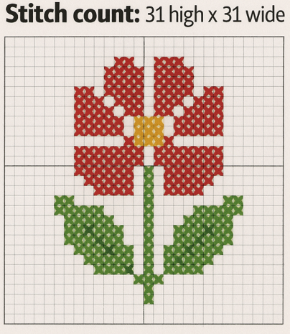
[figure 1]
Digital embroidery tools—such as FlossCross and Stitch Fiddle—mimic this legacy format. They provide a grid-based interface where users can fill in cells with symbols and colors corresponding to embroidery threads [figure 2 and 3], just as they would with paper charts. This method is straightforward and familiar to many hobbyists, especially those who have transitioned from traditional print resources to digital platforms.
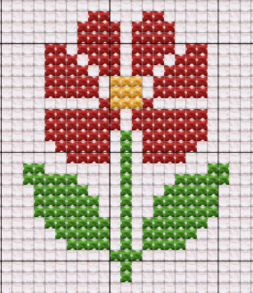
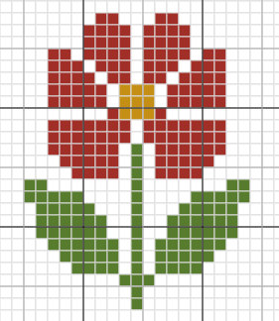
[figure 2 and 3]

However, these digital tools restrict users to a predefined set of stitches and symbols, limiting the expressive and technical range of embroidery. Users cannot freely construct or simulate new stitch types; instead, they must choose from a fixed palette of options (see Figures 4 and 5). Moreover, the underlying stitching technique is not captured—the tools record only the visual outcome, not how the pattern is actually made. As a result, it is up to the embroiderer to interpret and execute the design manually, often requiring experience or additional guidance to translate a symbolic chart into a coherent physical embroidery technique.

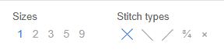
[figure 4 and 5]

The proposed user interface reimagines digital embroidery design by shifting away from symbolic, grid-based editing toward a more mechanically grounded and visually responsive approach. Instead of selecting predefined stitches from a palette, users create embroidery by connecting dots on a canvas—each representing a needle puncture point. A stitch is formed by drawing lines between dots, directly simulating the movement of a needle through fabric.

This dot-based interaction mirrors the actual hand-embroidery process more closely, allowing users to define any stitch structure they can imagine, rather than being limited to a fixed set. It becomes possible to build both standard and custom stitches, explore variations, and visualize complex threading paths that go beyond what traditional tools can support. This flexibility opens up opportunities for experimentation, learning, and creative exploration.
The proposed user interface also introduces a dual-view canvas, showing both the front and back sides of the embroidery in real time. In physical embroidery, users can only see one side at a time, and the back often remains unseen - but important - aspect of the work. By visualizing both sides simultaneously, the tool makes the connection between result and technique explicit. Users gain insight into how the stitching method affects the structure on both surfaces, enabling more deliberate, controlled, and informed design decisions.
Overall, the new user interface changes the role of the user from a symbol arranger to a stitch constructor. It transforms embroidery design in the digital space from a passive visual task into an active, technique-aware process - closer to the experience of stitching by hand.

- Design Goals
The development of the dot-based, dual-view embroidery interface was guided by several design goals aimed at bridging the gap between symbolic pattern design and real-world stitching practice:

- Enable users to construct any stitch by connecting points manually, rather than selecting from a predefined list. This encourages creativity, accommodates personal stitching styles, and supports learning through exploration.

- Clearly depict the presence of the needle and the direction of stitching using visual cues. When the needle and thread are on the front side, a solid line is drawn from the last pierced hole to the cursor, simulating the thread's movement, and a large solid dot marks the needle’s current position. When the needle is on the back side, both the line and the dot become dashed. This dynamic visualization helps users track the stitching process clearly and reinforces the sensation of physically moving the needle through the fabric.

- Allow stitches to begin or end at positions between the visible holes in the grid. These hidden holes reflect the reality of hand embroidery, where the needle can pierce anywhere in the fabric—not just on a fixed, regular grid. This flexibility makes it possible to create smoother curves, varied angles, and more realistic stitch paths.

- Provide a dual-view canvas where the user can see both the front and the back sides of the work at all times. This promotes awareness of how technique affects both sides, a critical but often overlooked aspect of real embroidery.

- Make the relationship between stitch structure and final appearance visible and interactive, serving as an educational tool for those new to embroidery. By modeling actual thread movement and revealing its consequences, the interface helps users build confidence and understanding.

- Provide a digital medium for those who may no longer be able to physically embroider due to limited mobility, visual impairment, or other physical challenges. The user interface is designed to be compatible with alternative input methods, including eye tracking, voice commands, and brain-computer interfaces (BCI) - allowing users to simulate the physical act of embroidery through gaze, speech, or thought. This opens new pathways for inclusive creativity, enabling individuals with severe motor impairments to engage meaningfully with the craft.

- UI Architecture and Interaction Model
Like other cross-stitch editors, the software includes a raster-based working area that corresponds to the woven structure of embroidery fabric. However, instead of simply coloring squares, the user interacts with individual needle puncture points ("holes"), creating stitches by explicitly simulating the motion of the needle. The position and state of the needle are represented by a bigger dot, which is visually accompanied by a thread line extending from the last pierced hole to the current cursor position. This line dynamically illustrates the path of the thread as the user moves the cursor, reinforcing the physical relationship between the needle’s movement and the thread's behavior.

The basic workflow proceeds as follows (see Figure 6):
- Step 1 – The needle begins on the back side of the fabric. A dotted marker indicates this state.
- Step 2 – When the user clicks into a dot (hole), the needle passes to the front. The marker changes to a solid dot, and the entry point is recorded.
- Step 3 – As the user moves the cursor to a new location, a solid line is drawn in the thread’s color to simulate the visible portion of the thread on the front side.
- Step 4 – Upon clicking another dot, a complete stitch’s segment is formed. The marker changes back to a dotted line, indicating that the needle has returned to the back side.
- Step 5 – While the needle is on the back, moving the cursor draws a dashed line representing the thread's path behind the fabric.
- Step 6 – Clicking another dot brings the needle back to the front, continuing the stitching sequence.

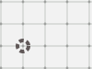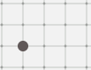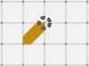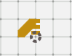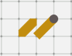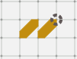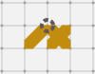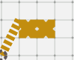
[figure 6]

To closely mimic the real embroidery process, the marker can be positioned at the corners of each square in the raster grid. These corners correspond to the holes in traditional cross-stitch fabric—entry and exit points where the embroidery needle passes through. However, in certain embroidery techniques, stitches may begin or end at intermediate positions, such as along the edge or center of a square (see Fig. 7). To accommodate this, the software enables the marker to also fix to the midpoint of each side and the center of the square. These five additional positions are not explicitly shown on the grid and are therefore referred to as hidden holes. In total, each square contains nine possible fixation points for the needle. This approach ensures comprehensive support for a wide range of embroidery techniques by offering maximum positional flexibility. It is important to note that reducing the working square’s granularity by half is rarely required, which is why the additional fixation points remain hidden by default, preserving visual clarity while maintaining expressive power.

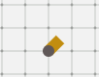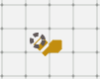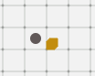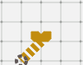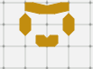
[figure 7]

In addition to the front-facing canvas, the interface includes a back-side view placed adjacent to the front [figure 8]. This dual-view layout enables users to observe how each stitch appears on both sides of the fabric in real time. The back side mimics the behavior of the front canvas with precise symmetry—each needle movement or thread drawn on the front side is automatically reflected on the corresponding position of the back, maintaining accurate spatial and directional consistency.
As on the front, the back-side canvas supports all nine fixation points per square, including the four corners, four midpoints, and the center. These positions correspond one-to-one with their front-side counterparts, replicating the physical behavior of real embroidery. This setup allows users to fully understand the structure of each stitch, including how threads are carried and where knots or overlaps might occur.

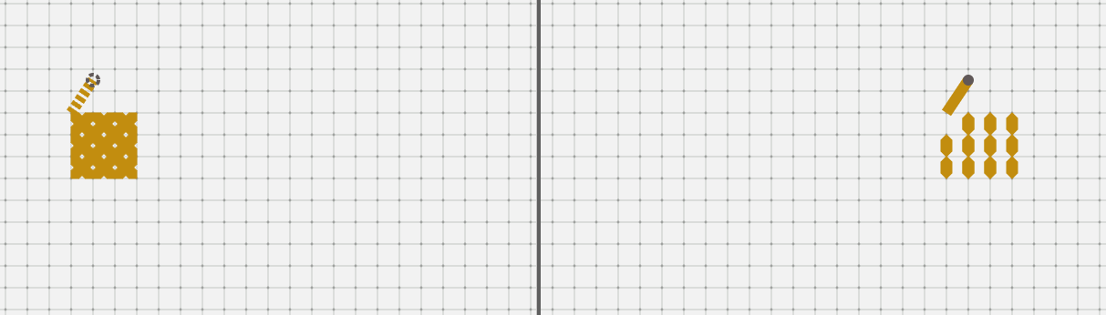
[figure 8]

- Technical Implementation
To support the interactive embroidery simulation, the system employs a layered canvas architecture organized by z-order [figure 9]. This design enables the separation of responsibilities across multiple visual layers while maintaining real-time responsiveness and visual clarity.

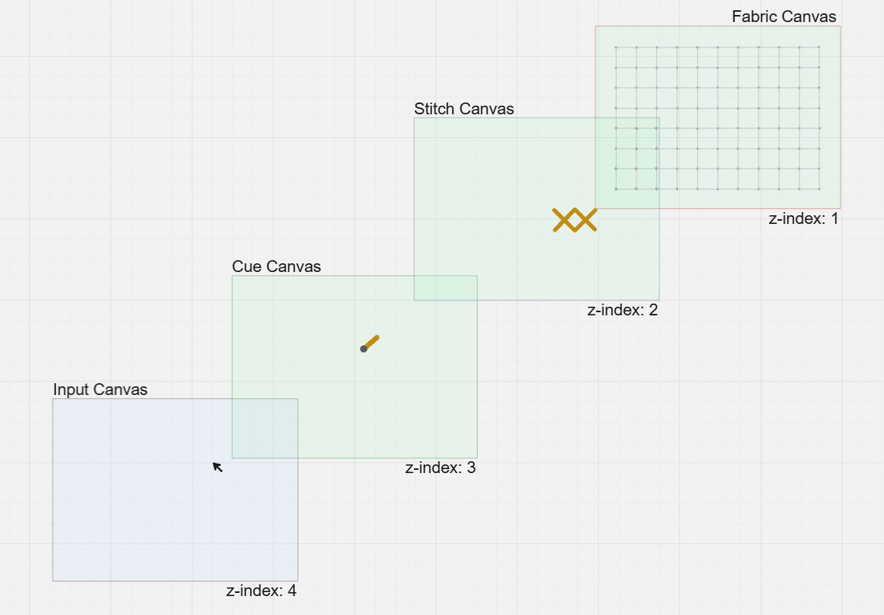
[figure 9]

The application uses four canvas layers, stacked from bottom to top:
- Fabric Canvas (z-index 1): This is the base layer responsible for rendering the raster grid that simulates the woven structure of cross-stitch fabric. It provides a visual reference for stitch placement and remains static throughout the interaction.
- Stitch Canvas (z-index 2): Above the fabric grid, this layer handles the rendering of completed stitches. Because stitch updates occur only upon user confirmation (e.g., after clicking), this layer is less dynamic and optimized for redrawing only when necessary.
- Cue Canvas (z-index 3): This dynamic layer visually connects the last punctured hole with the current cursor position, drawing a real-time line that mimics the thread being pulled by the moving needle. It provides immediate visual feedback as the user prepares to complete a stitch.
- Input Canvas (z-index 4): The topmost layer captures all user interactions, including mouse clicks, cursor movements, and touch gestures. It interprets these events and translates them into semantic embroidery operations, such as moving the needle between the front and back or recording a completed stitch.
By separating these layers, the system efficiently handles rendering updates without unnecessary redrawing of static elements. This architecture also enables modular control over each aspect of the embroidery process, improving maintainability and extensibility for future development.
The internal implementation is organized into three interconnected parts—the Input, Virtual Canvas, and Rendering—working together to provide a responsive and accurate simulation of the embroidery process [figure 10]. Each layer has a distinct responsibility, with clear separation of concerns and optimized communication between them.

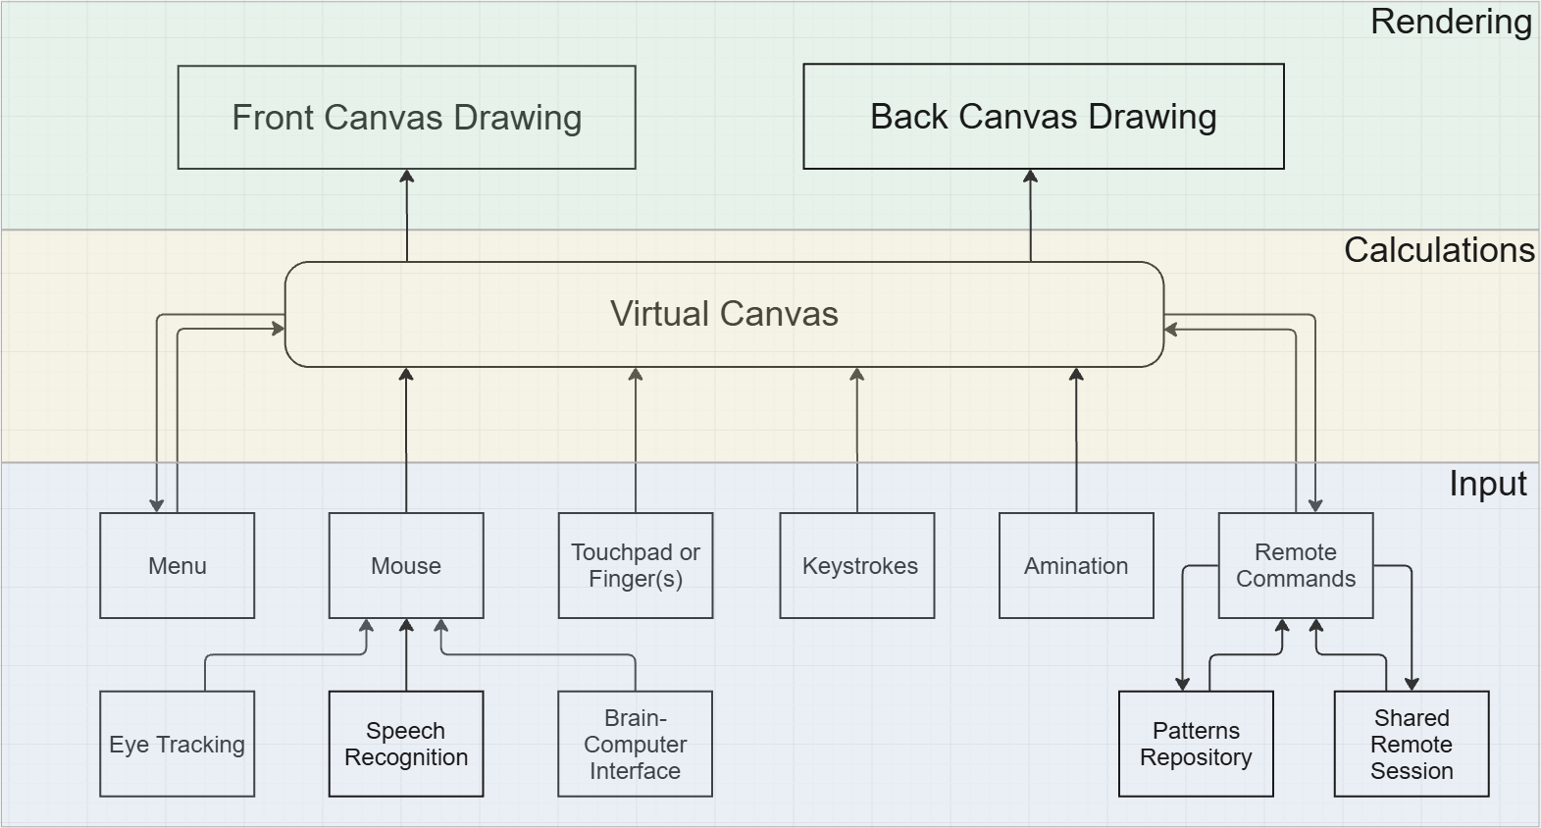
[figure 10]

The “Input” part serves as the interface between the user and the virtual canvas. It captures and interprets all forms of interaction, including:
- Mouse, touch, or pen gestures on the canvas.
- Keyboard shortcuts and modifier keys.
- Menu-based commands and tool selections.
- Programmatic actions such as animation commands.
At the heart of the system lies the “Virtual Canvas” part. It acts as a computational model of the embroidery state, maintaining:
- The position and state of the virtual needle and thread.
- The list of completed stitches and their positions.
- The current state of the grid.
Crucially, this layer performs a series of performance optimizations to ensure scalability, even on large canvases (e.g., 1000×1000 squares). One such optimization is region-based rendering: the system tracks which areas of the canvas are currently visible or require updates, and it passes drawing instructions only for primitives (such as stitches or thread lines) that fall within those regions. This ensures that off-screen elements are not processed unnecessarily, enabling smooth performance even when working with dense or expansive embroidery projects.
The “Rendering” part is responsible for drawing the current embroidery state to the screen using three stacked canvas elements, each with a specific role and z-index.

- Final Result
One of the most important benefits of the implemented system is its ability to visually represent the difference between embroidery techniques—not just on the front side, but also on the back side of the fabric. This capability allows users to not only design beautiful patterns but also evaluate and refine the quality of their stitching process.
To illustrate this, Figures 10 and 11 presents a comparison between two embroidery examples. Both follow the same front-side pattern but are executed using different techniques.
- On Figures 10, the stitches are made without regard for thread efficiency or clean transitions. While the front appears visually correct, the back side reveals a chaotic structure, with unnecessarily long thread floats, overlapping segments, and inconsistent needle paths. This type of stitching can waste thread, create tension imbalances, and make the fabric more fragile.
- On Figures 11, the same pattern is stitched using an optimized and deliberate technique. The back side is clean and structured, with short, direct connections between stitches, minimal overlap, and consistent directional flow. This reflects the kind of craftsmanship seen in high-quality embroidery, where not only the visual design but also the structural logic is preserved.

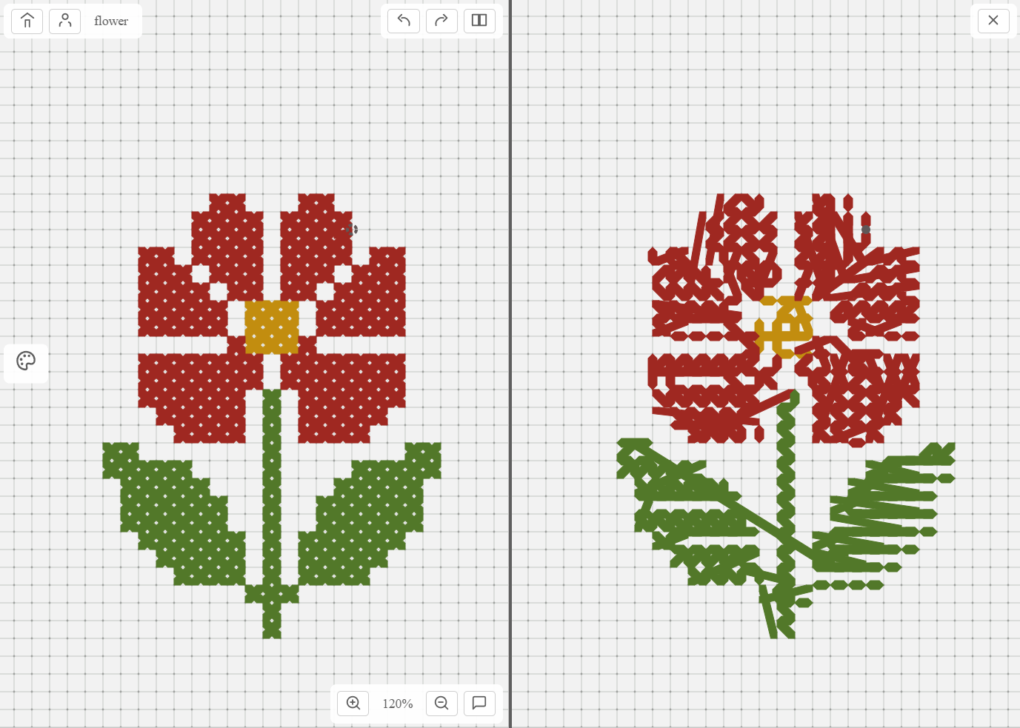
Figure 10
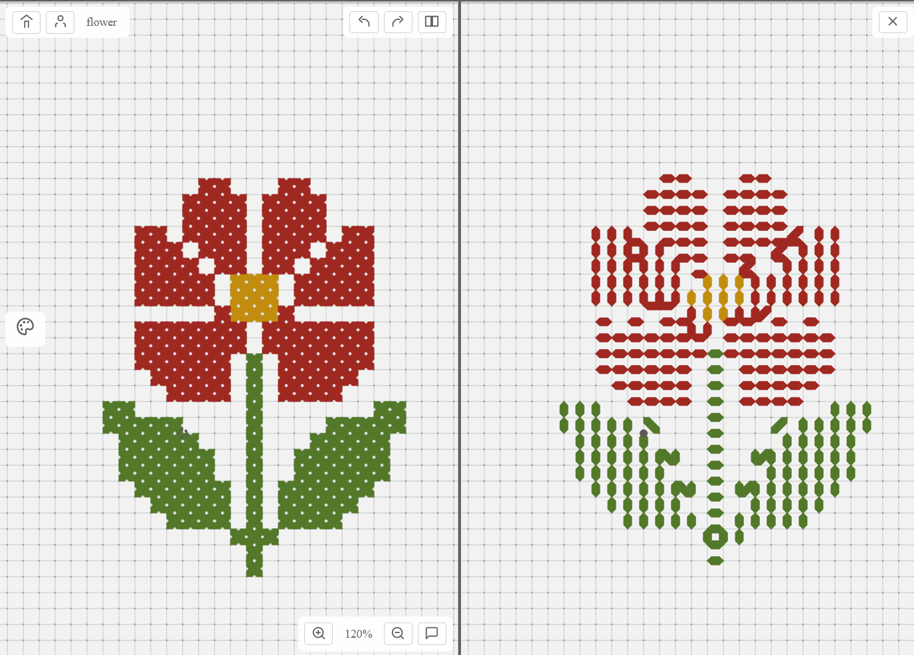
Figure 11

Finally, the system enables high quality evaluation through its dual-view interface, supporting both technical refinement and artistic expression. By visualizing both the front and the back sides of the embroidery process in real time, users are encouraged to develop a deeper understanding of embroidery as a structured and repeatable craft—preserving not only its aesthetic, but also its technique for future generations.

