Digital Modeling and Visualization of Embroidery Techniques
Elena Zaharieva-Stoyanova ¹[0000-0002-0313-0535], Stefan Bozov²[0009-0003-7536-8889]
¹ Technical University - Gabrovo, 4 H. Dimitar str., 5300 Gabrovo, Bulgaria
² Technical University - Gabrovo, 4 H. Dimitar str., 5300 Gabrovo, Bulgaria
zaharieva@tugab.bg, stefan.bozov@outlook.com
Abstract. This paper deals with problems related to digital presentation and preservation of handmade embroidery in the following aspects: techniques, master skills and numerous embroidery patterns created by generations of craftsmen. The development of a new cross stitch software application is presented, where the main idea of the suggested software solution is to give the user an opportunity to design embroidery patterns by determining the types of stitches used in a pattern and the technique for their implementation. This ensures the digitalization of not only embroidery patterns, but the embroidery technique itself as well. As a matter of fact, the offered software solution can be used as an environment for embroidery patterns design and software for instruction and sharing of information among craftsmen.
Keywords: Cross-stitch Pattern Software, Craft Software, CAD Systems, Domestic Handicrafts, Digital Preservation, Cultural Heritage, Computer-aided Design.
- Introduction
Textile production, needed for manufacturing clothes and household goods, is one of the important human activities that was practiced through the ages of human history (Grömer, 2019). Usually, it was considered a typical female work, involving all women in the family, who practiced different textile occupations (Krastanova, 2017). Subsequently, these home occupations developed into crafts which men began to be practice as well, and the continuation of this process marked the emergence of manufactured and industrial textile production. Despite technological progress, the manual production of home textiles in some countries, including Bulgaria, persisted until the end of the 19th and the beginning of the 20th century (Ilieva, 2011).
In recent years, traditional textile home occupations such as knitting, embroidery and crochet are kept as a hobby, but sometimes these activities develop into a more serious business, oriented to craft production. Unquestionably all these home crafts and occupations are part of the cultural heritage. It is important to note that the continuity of tradition is a guarantee of its transmission across generations and, accordingly, of its protection, preservation and survival (Popova, 2016).
Embroidery, as a traditional home craft, has deep historical traditions and it is part of the culture for many people (Dimitrova, 2022), (Nasledstvoto, n.d.), (Victoria and Albert Museum, 2024). Clothes decoration has not only an aesthetic value and determines the individual's belonging to a given community, but it also conveys the individual’s social status to the community. Very often, embroidery in clothing has also a magical meaning believed to protect a person from evil forces, to ensure health, prosperity and fertility (Veleva, Jordanova, Kiryakova, & Angelova, 2018). Nowadays, as a hobby, embroidery is one of the relatively frequently practiced home occupations. In recent years, there has been a growing interest in traditional folk costumes in Bulgaria and especially in Bulgarian embroidery as a code of cultural traditions (Nasledstvoto, n.d.). Such kind of interest could be observed in other countries as well, namely, in Romania (Gavan, 2016). Judging by the videos posted on the Internet, many crafts people (mostly women) all over the world are interested in embroidery as a traditional home occupation, too.
Up-to-date information technologies provide great opportunities for sharing knowledge, skills and all kinds of data needed for different types of embroidery manufacture. Craft software and particularly, cross stich software plays an important role in this process (FlossCross-Designer, n.d.), (Pixel-Stitch, n.d.), (StitchFiddle, n.d.), (Cross Stitch Saga, 2024), (Pattern Keeper, 2009). Moreover, craft software is significant to assisting people who deal with textiles. Therefore, it can be used for digital representation of old traditional patterns. Hence, it is essential that its functionality should be consistent with the peculiarities of the authentic techniques used in the past.
This paper proposes a new, innovative approach to the visualization of embroidery patterns involving the representation of the technology of patterns manufacturing. The main idea of the software solution is to preserve digitally the technological knowledge and skills of embroidery masters passed down through generations. Accordingly, this knowledge, which keeps traditions alive, will be preserved and passed on to future generations.
- Existing Graphics Presentation of Embroidery Patterns in Craft Software Applications
Typically, each cross-stitch software application is equipped with a graphical editor to develop embroidery patterns. An embroidery pattern image is described as a set of colored graphical symbols in a raster grid that corresponds to an embroidery canvas. The different graphical symbols represent the different types of stitches. Because the cross is the most frequently used embroidery stitch, it is often presented with a colored square only. The color of the graphic symbol or the color of the square corresponds to the embroidery thread. Actually, this presentation mimics printed embroidery patterns, which could be seen in embroidery books and magazines.
The usage of a raster grid filled with different color squares is the simplest way to present the embroidery patterns in cross stitch applications and it is easy for programming implementation (FlossCross-Designer, n.d.), (Pixel-Stitch, n.d.), (Pattern Keeper, 2009), (Cross Stitch Saga, 2024). Unfortunately, the functionality of such applications is limited just to the graphical representation of a pattern.

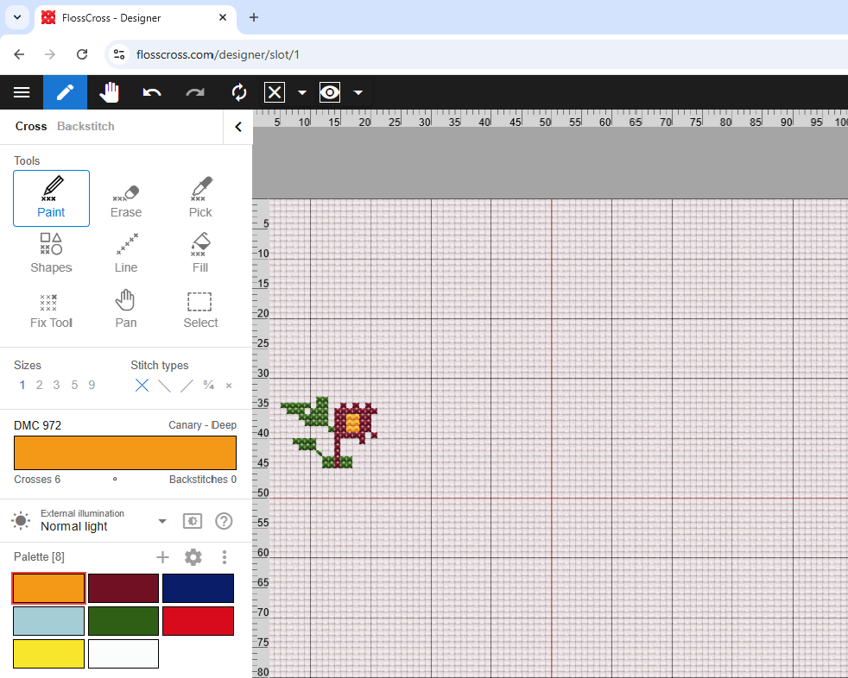
Fig. 1. FlossCross application main window.
It has to be mentioned that most of the existing cross stitch software applications are oriented to design tapestry patterns and for this reason they have a great number of thread colors, but do not support different stitch types. Tapestry patterns use one stitch type only – cross or continental stitch - and that way involving different stitch types is pointless. Examples of such applications are Saga (Cross Stitch Saga, 2024), Pattern keeper (Pattern Keeper, 2009), Markup (Mark R-XP, 2024) . On account of the fact that this research is aimed to presenting of Bulgarian national embroidery patterns, it focuses on cross stitch applications, that are suitable for such kind of embroidery patterns as StitchFiddle (StitchFiddle, n.d.), FlossCross (FlossCross-Designer, n.d.). Comparing these applications, FlossCross is more fitting for presentation of Bulgarian embroidery patterns because it supports some of most used stitch types (cross, continental and back stitch). Moreover, FlossCross working canvas imitates the cross-stitch fabric texture reproducing a real embroidery view. Unfortunately, Floss Cross and the other mentioned applications do not support all stitch types used in Bulgarian embroidery. The application supports the following stitch types - back stitch, full stitch (or cross), two versions of half stitch (continental, or slanted stitch), and eight versions of ¾ stitches. The latter is not typical for the Bulgarian national embroidery (see Fig. 1).
Stitch Fiddle is another well-known craft software application (see Fig 2). Many users appreciate highly this software because of its universality. It includes different techniques – cross stitch, knitting, crochet, etc. Unfortunately, this universality comes at the expense of the quality presentation of the different patterns types. However, the application has its advantages and in certain cases can be used to present embroidery patterns.

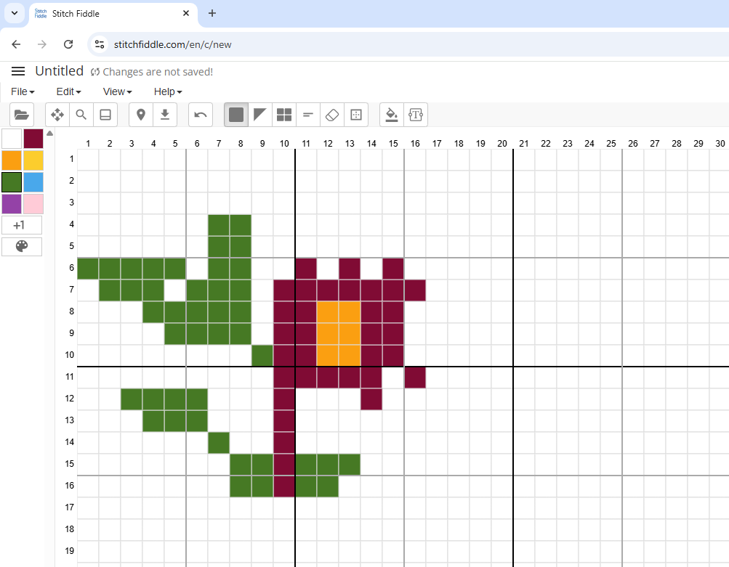

Fig. 2. StitchFiddle application main window.
In general, existing software applications have limited capabilities to present different embroidery techniques. On the one hand, they support a very small number of different types of stitches, and on the other, they do not provide information on how these types of stitches are technologically implemented. In practice, there is no way of preserving the actual embroidery technique besides adding text to the project. The lack of embroidery technique leads to following:
- Beginners may need to rely on external tutorials or guesswork.
- Stitchers may need to ask for clarification instead of immediately using a shared design.
- Back threads showing through, affecting the final appearance.
- Inaccurate thread length calculations and a higher risk of weak or unstable stiches
This paper proposes the development of cross stitch software application oriented towards embroidery pattern design focused on supporting different types of stitches and representation of their technological implementation. According to the design methodology, the application will differ essentially from the other craft software, the difference being expressed in the way the design process develops. The main idea is to present this design process in а digital way imitating the manufacture of embroidery and thereby give the possibility of describing embroidery technologies. The aim is to propose crafts people a digital tool through which they can show the different embroidery techniques and create digital analogs of the embroidery stitches.
- Approach to Cross Stitch Software Development
According to the analysis of existing software solutions, this paper presents an approach to developing cross-stitch software, which involves possibilities for digital description of different stitch types and the technological way of their implementation. The developing software solution is not only a graphic editor for cross stitch pattern, but it is an environment for digital representation of embroidery techniques as well. The aim is to create a tool for simulation of embroidery techniques which craft masters can share and exchange. In this manner the preservation of embroidery techniques as craft and part of the cultural heritage is guaranteed.
Like the other existing applications presented in the previous section, the software being developed as a graphic editor with working area a raster grid corresponding to a cross-stitch fabric (canvas). The cursor marks the position of the embroidery needle. The cursor type indicates the movement of the needle relative to the fabric - whether it moves from back to front or vice versa. The cursor movement simulates the way of the embroidery needle. The embroidery process is shown step by step in Fig. 3 and it can be represented by the following steps:
- Step 1 – The process starts with the needle at the back, the marker is dotted.
- Step 2 - If the user clicks (or taps with a finger), the marker changes to a solid dot, which signals that indicates the needle has passed through the hole and goes to the front.
- Step 3 - If the user moves the marker, a solid line is drawn that imitates the thread, and the marker suggests which hole it is currently on.
- Step 4 - After clicking on a hole, a solid line is drawn to mark a finished stitch, and the marker changes back to a dotted line to indicate that the needle has passed behind.
- Step 5 - When moving the marker, a dotted line is drawn with the color of the thread, indicating what is happening behind.
- Step 6 - When clicking on a hole again, the marker changes to solid and a solid line is being drawn. The background is not drawn, but the system saves information about it, thus ensuring that the embroidery technique is preserved.
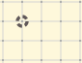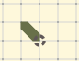

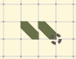

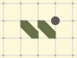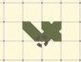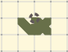

Fig. 3. The visualization of design process
To mimic a real embroidery process, the marker can fix each square angle of the raster grid. The square angles fix the holes of the cross-stitch fabric – points where the embroidery needle passes through the fabric. Because in some cases, when a specific embroidery technique is implemented, a pattern could be made using half a square, our software provides for fixing the center of the square and the middles of its four sides. Since these holes are not visualized on the raster grid, they are called hidden holes. Thus, the places where the cursor (or working needle) can fix are 9 in total (see Fig. 4). This approach is meant to cover all possibilities of where the embroidery needle can move from. Accordingly, it allows the implementation of any embroidery techniques. It should be noted that reducing the size of the working square by half is a rarely used technique. Therefore, these holes are intended to remain hidden.

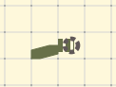
Fig. 4. Examples of hidden holes
The next step of the software development is to allow the user to monitor the view of the embroidery from both sides. Thanks to saving full information about the embroidery technique and visualization of the stitches on both the front and the back sides, the proposed software solution will allow the user to monitor the view of the embroidery from both sides. For this purpose, the desktop view is split into halves presenting the embroidery from both sides of the fabric. The left half shows the front side of the fabric; the right half corresponds to the back side. The movements of the marker, as well as the creation of stitches on the front side, are mirrored on the reverse side. If the marker is dotted on the left, it is solid on the right to indicate that a visible stitch is being created on the back. This will allow the user to track both sides at the same time, which is much more convenient than in existing software solutions, where the embroidery pattern is shown on the front side only.
The proposed software solution has several advantages over others. The main one is that it allows accurate reproduction of embroidery techniques. Moreover, such software allows the creation of videos representing the implementation of these techniques. The users are given the opportunity to observe the implementation process step by step. In addition, they themselves can create their own project in which they are able to show the implementation of a specific embroidery technique. Thus, different users can exchange knowledge and experience with each other.
- Results of Software Solution Testing
To demonstrate the capabilities of this software solution two patterns presenting real existing embroideries have been selected. Photos of ethnographic exhibits of embroidery on women's chemise have been used with a probable date of the turn of the19th century. The photos and embroidery patterns are shown in Fig. 5 and Fig. 6. The first pattern is a decoration of a chemise from Saparevo village. The stitches used in this pattern are a cross and a slant (see Fig. 5). This patten is designed with FlossCross (see Fig. 1) and Stitch Fiddle (see Fig. 2). As a software FlossCross can represent this pattern correctly, unlike StitchFiddle where it is not possible to differentiate a cross from a slanted stitch.

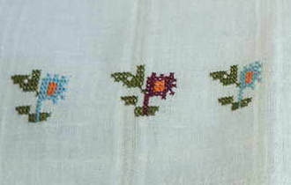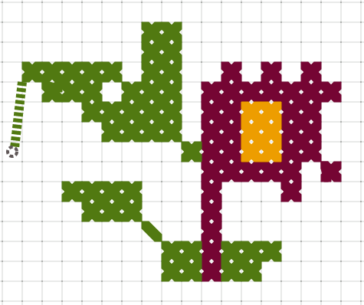
Fig. 5. Embroidery pattern of chemise decoration from Saparevo village, Dupnitsa region.
The second pattern (Fig. 6) is a decoration of a blouse from Vidin region. The embroidery stitch types used are flat, back (contour) and crosses. Unlike the first pattern, the second one cannot be described through existing software. The design process of currently used flat stitch technique is entirely based on application of the hidden wholes.
Another advantage of the suggested software is that it is possible for the user to choose between two different thicknesses of the working thread. The contour stitch embroidery is often performed with a thinner thread than crosses and slanted stitches. The existing cross stitch applications do not allow to change of thread thickness. On the contrary, the current project has this functionality, which is shown in Fig. 6.

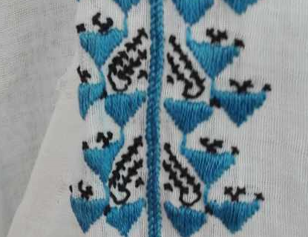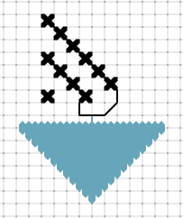

Fig. 6. Embroidery pattern of chemise decoration from Vidin region.
- Conclusions
Traditional home crafts and occupations are part of the cultural and historical heritage. Embroidery is one of the most frequently practiced domestic crafts. This paper deals with problems related to the preservation of handmade embroidery as techniques, master skills and a numerous embroidery patterns created by generations of crafts people. The development of a new cross stitch software application has been presented.
The main difference between this new software application and the existing ones is that the user is given the opportunity to design embroidery patterns by determining what types of stitches to be used and what kind of techniques to be chosen for the implementation. Thus, a craftsmen can clearly show how a given embroidery technique is performed and, accordingly, share their experience and knowledge with other users. The system will also be serviceable for users who would like to learn how a particular technique is practically performed. Actually, the proposed software can be considered as an environment for designing various types of embroidery.
At this stage of the project development, the working window has been created, and the main concept has been implemented, i.e. designing embroidery patterns step by step with the selected embroidery technique presented as a digital embroidery pattern. Future work on the project involves simultaneous visualization of the model on both sides of the fabric. The project also foresees the creation of an interactive animation, for the users to be able to go forward/backward via keyboard/button, showing the embroidery technique gradually. In that way, the user will be able to follow the project bit by bit from the very beginning to the end. Owing to the already created projects (stored thanks to a new data model), it is possible to add static and dynamic analysis of the projects. As a result of the above, functionality for sharing projects is envisaged. Users will have the opportunity be able to exchange experience, learn new techniques, and train others. This guarantees the preservation of embroidery as a handicraft and its survival into the future.

Acknowledgements.
The development, described in this paper, is supported by The Bulgarian Ministry of Education and Science, Project НИП-2025/15 of Technical University -Gabrovo.

References
Cross Stitch Saga. (2024, 12 1). Cross Stitch Saga. Retrieved from Cross Stitch Saga: https://play.google.com/store/apps/details?id=today.ipublish.crossstitchsaga&pli=1
Dimitrova, Z. (2022). Bulgarian Embroideries from Ruse Region. Sofia: SoftPress.
FlossCross-Designer. (n.d.). FlossCross. Retrieved from FlossCross - free online cross stitch pattern maker: https://flosscross.com/
Gavan, E. (2016). The home play - Transilvania A new perspective on the revitalization of the traditional costume among yang people. XII International research conference "Traditional crafts – past, present, future" (pp. 7-20). Gabrovo: Etar museum.
Grömer, K. (2019). Archeologilac Textile Research: Thectical , economic and social aspects of textile production and clothing Neolothic to the Early Modern Era. Wien: Historisch‐Kulturwissenschaftliche Fakultät Universität Wien.
Ilieva, V. (2011). Abadzhiyski zanayat v Gabrovsko [The "Abadzhiyski" craft in Gabrovo region]. VII International research conference "Traditional crafts – past, present, future" (pp. 121-130). Gabrovo: Etar museum.
Krastanova, K. (2017). Textile crafts as cultural heritage - valuableness and usages. XIII International research conference "Traditional crafts – past, present, future". XII, pp. 13-26. Gabrovo: Etar museum.
Mark R-XP. (2024). Mark R-XP. Retrieved from Mark R-XP: https://markuprxp.co.uk/
Nasledstvoto. (n.d.). Nasledstvoto. Retrieved from Nasledstvoto: https://nasledstvoto.com/page/about-us
Pattern Keeper. (2009). Pattern Keeper. Retrieved from Pattern Keeper: https://patternkeeper.app/
Pixel-Stitch. (n.d.). Pixel-Stitch. Retrieved from Pixel-Stitch: https://www.pixel-stitch.net/index.html
Popova, B. (2016). Traditional crafts in the epoch of globalization. XII International research conference "Traditional crafts – past, present, future". XI, pp. 357-367. Gabrovo: Etar museum.
StitchFiddle. (n.d.). StitchFiddle. Retrieved from StitchFiddle: https://www.stitchfiddle.com/en
Veleva, P., Jordanova, L., Kiryakova, G., & Angelova, N. (2018). The secret language of Bulgarian embroidery. Educational forum, online journal, 2/2018, Trakia University - Stara Zagora.
Victoria and Albert Museum. (2024). Embroidery – a history of needlework samplers. London: Victoria and Albert Museum. Retrieved from https://www.vam.ac.uk/articles/embroidery-a-history-of-needlework-samplers

