IEU SOFTWARE ENGINEERING FACULTY

SE 311 – Ufuk Çelikkan

Term Project Documentation

Token Based Single Sign On

Rojda Arslanparçası 20130601006

Benokan Kafkas 20140601031

Mustafa Teyfik Avkan 20130601007

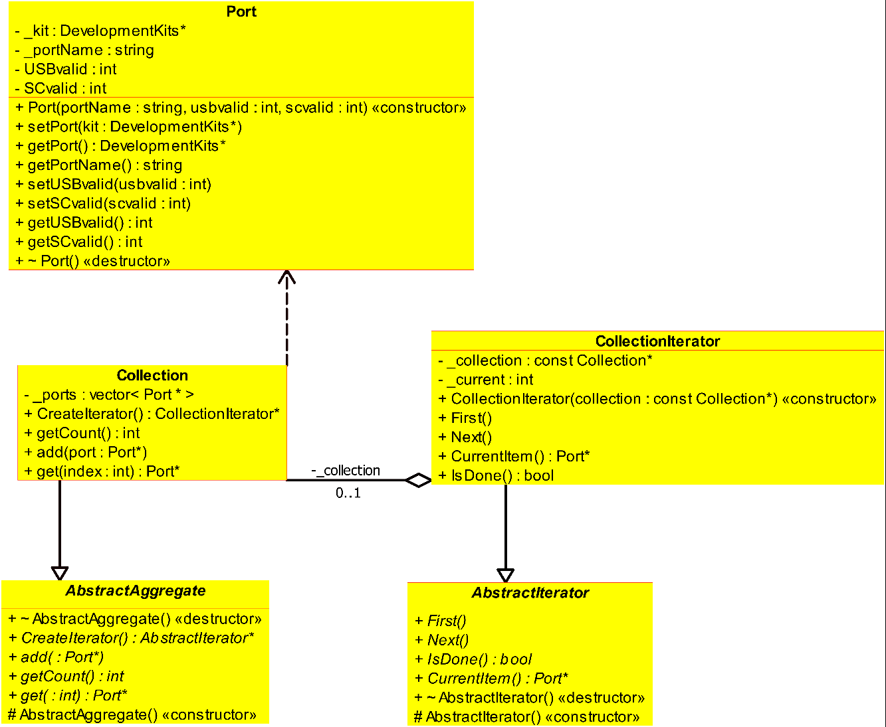

**Pattern Name :Iterator Pattern**

We used iterator pattern to traverse through 4 ports of our computer.

**Sub-Element Mapping:**

Port -> Client , AbstractIterator -> Iterator , CollectionIterator-> Concrete Iterator , Abstract Aggregate -> Aggregate, Collection -> Concrete Aggregate

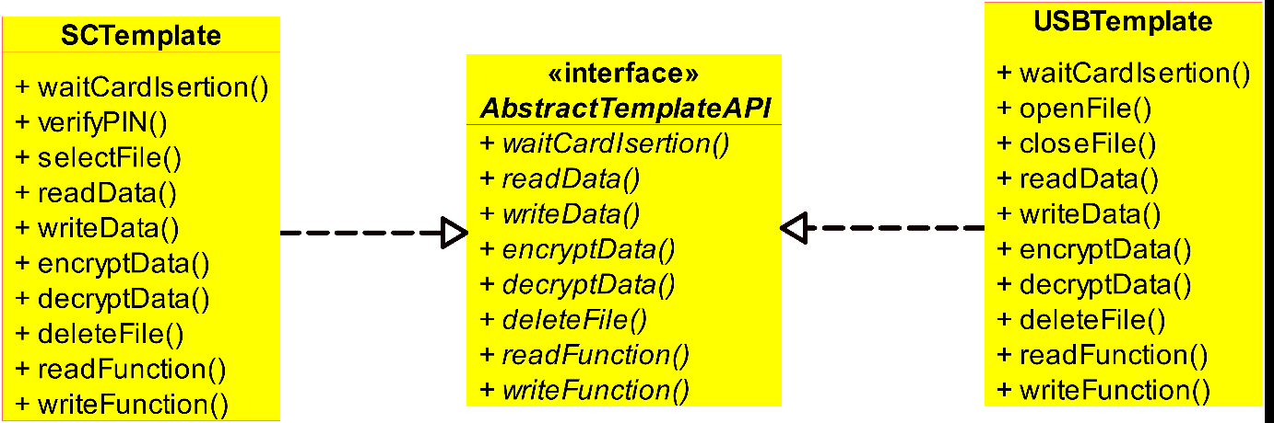

**Pattern Name : Template Pattern**

We used template pattern to conduct read and write operations of USBTemplate and SCTemplate together with Abstract template API.

**Because the format of these operations were different for each USB and SmartCard.**

**Sub-Element Mapping:**

AbstractTemplateAPI -> Abstract Class , SCTemplate -> Concrete Class , USBTemplate -> Concrete Class.

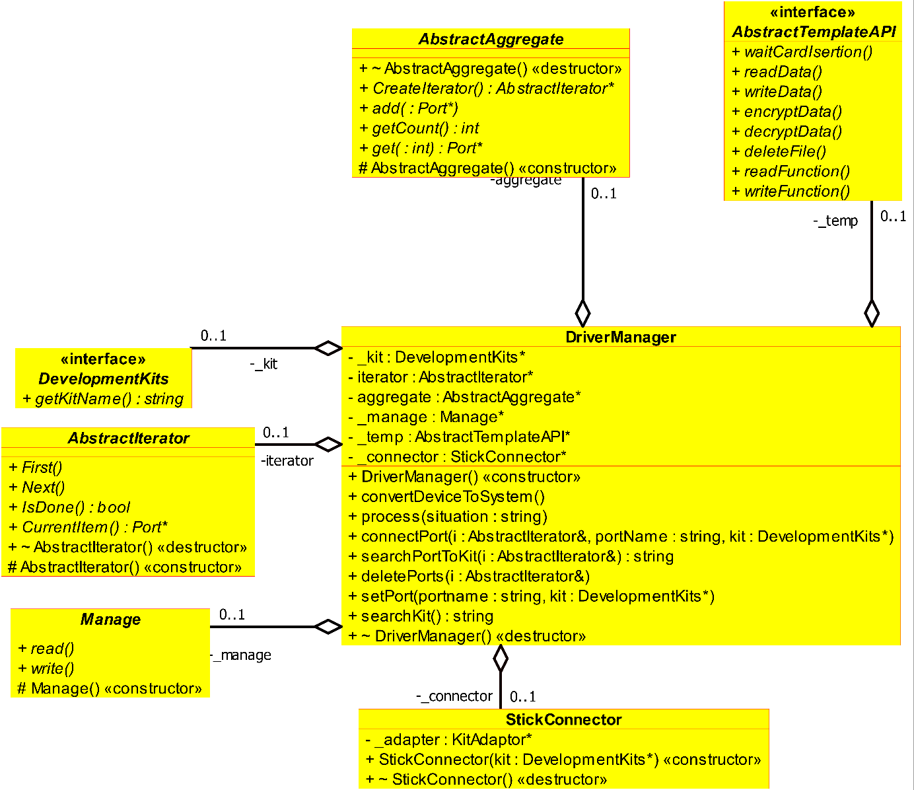

**Pattern Name : Facade Pattern**

We used facade pattern to create a better usable subsystem. We stacked the referred operations and objects of subclasses to the related Interface of Facade.

**Sub-Element Mapping:**

DriverManager -> Facade , DevelopmentKits -> user

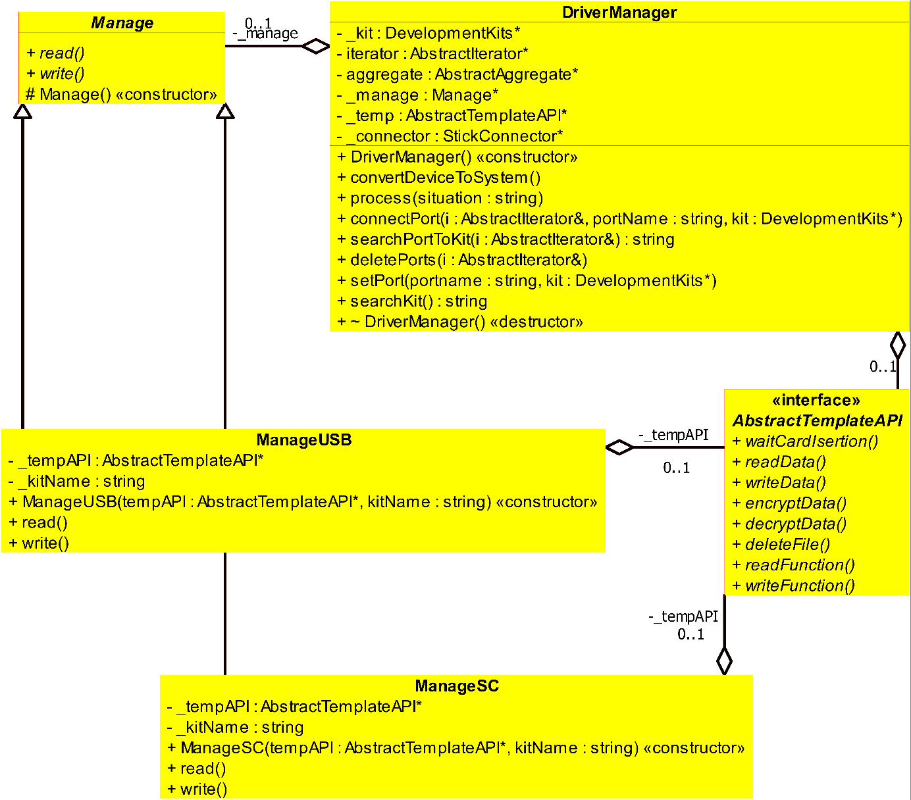

**Pattern Name: Command Pattern**

We used command pattern to call encapsulated requests. We also needed to implement a callback function capability. It also let us to parametrize clients with different requests .

**Sub-Element Mapping:**

driverManager->invoker&client , Manage->Abstract Command , ManageUSB&ManageSC -> concrete Command, abstractTemplateAPI ->receiver

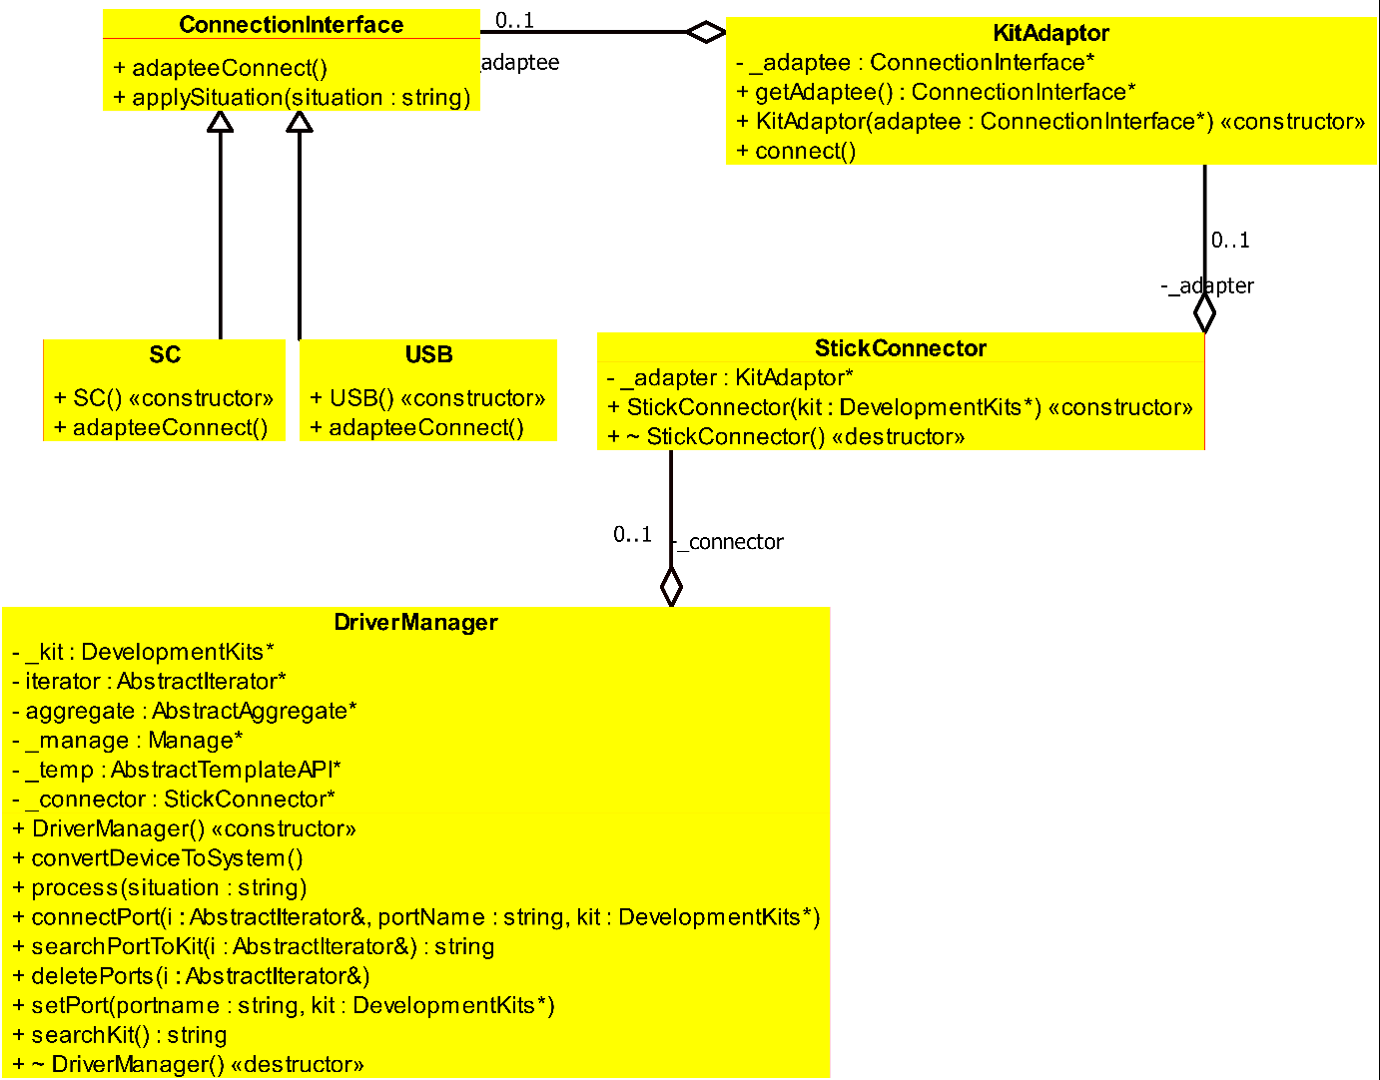

**Pattern Name : Adapter Pattern**

We used adapter pattern to make USB operations and Smart Card operations compatible by converting their interfaces.

Since we needed 2 drivers for usb and smart card adapter pattern had an vital importance for us.

**Sub-Element Mapping:**

KitAdaptor-> Adaptor,StickConnection-> target , AbstractAdapter-> ConnectionInterface , Adaptee->SC,USD, Client-> DriverManager

**INTEGRATED CLASS DIAGRAM**

