**3.1**

**1.**

We create a function from the following formulae.

$A=p{\left(1+\frac{r}{n}\right)}^{nt}$

P = Principal amount

r = Annual rate of interest

t = number of years.

A = amount accumulated.

n = No. of times the interest is compounded per year.

function Amount=comp_F(P,r,n,t)

Amount = P*(1+r/n)^(n*t);

Loans compounded 1; 2; 4; 12 times per year

1. One time per Year.

Amount = comp_F(P,r,n,t)

Amount =

6.3814e+005 => 638140

1. 2 times per year.

Amount = comp_F(P,r,2,t)

Amount =

6.4004e+005 => 6400400.

1. 4 times Per year.

Amount = comp_F(P,r,4,t)

Amount =

6.4102e+005 => 641020.

1. 12 times Per Year.

Amount = comp_F(P,r,12,t)

Amount =

6.4168e+005 => 641688

For loan compounded continuously we create a function using the formulae below.

C_Amount = P*exp(r*t);

Where; P is the amount at time zero.

exp is the exponential function and t represent the time period.

ContinousLoans = comp_Cnt(P,r,t)

ContinousLoans =

6.4201e+005 => 642010.

The Loan Compounded Continuously is the highest.

2.

$Amount=p*{\left(1+\frac{0.05}{n}\right)}^{n*t}$

$642010=500000{\left(1+\frac{0.05}{n}\right)}^{n*5}$

4.

Calculations will be based on the following formulae.

$R=\frac{iP}{N}/(1-{\left(\frac{i}{N}+1\right)}^{-NY})$

Where:

R = regular payment

i = annual interest rate

P = principal

N = number of payments per year

Y = number of years

Repayment rates = i*p/n /(1 - (i/n + 1)^(-n * y));

10 year

10 Year fixed rate mortgage with rate 3% and initial debt of 500, 000;

r = ((0.03*500000)/12)/(1-(0.03/12 + 1)^(-12*10));

r =

4.8280e+003 => 4828.0

For a 30 Year fixed-rate mortgage with rate 5%.

r = ((0.05*500000)/12)/(1-(0.05/12 + 1)^(-12*30));

r =

2.6841e+003 => 2684.1

5. Total Paid for 30 Year Mortgage.

360 * 2684.1 = 966276

Total Interest Paid = 966276 – 500000

466276

Total paid on the 10 Year Plan.

120 * 4828.0 = 579360

Total Interest Paid.

79360.

6.

r = ((0.03*450000)/12)/(1-(0.03/12 + 1)^(-12*10));

r =

4.3452e+003 => 4345.2

4345.2*120 = 521424.

10. Year Mortgage would save: 79360 - 71424 = 7936.

r = ((0.05*450000)/12)/(1-(0.05/12 + 1)^(-12*30));

r =

2.4157e+003 => 2415.7

869652-450000 = 419652

466276-419652 =

30 Year Mortgage Would Save: 46624

7. A long term loan can minimize the effect on operational cash flow, a debtor can borrow at a lower interest rate, a business can minimize investor interference, and it is also an effective way to build [credit worthiness](http://www.finpipe.com/credit-rating/).

**3.2**

**Programming Eulers Method.**

1. Function r = r(t)

r = r*t;

end;

function p = (y)

p = y*exp(r);

end;

1. Codes Attached.

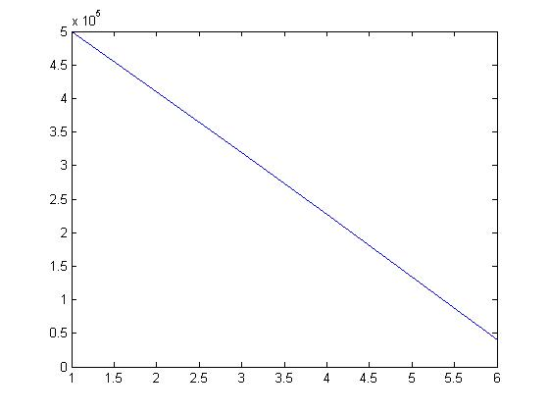

The Loans Will be Paid Off during The Sixth Year.

Outstanding Amounts =

1.0e+005 *

5.0000

4.0910

3.1727

2.2451

1.3079

0.3613

3.3.

Rates Following the form. r(t) = 0.05+0.002t+0.003cos(pi/5*t)

**paying $3000 per month**

**data1 = C_euler(500000,t,3000);**

data1

data1 =

1.0e+005 *

5.0000

4.6928

4.3824

4.0687

3.7517

3.4314

3.1076

2.7805

2.4499

2.1157

1.7781

1.4369

1.0921

0.7436

0.3915

0.0356 => The Loans will be Paid Off at The 15th year.

**Paying $4500 per month**

data2 =

1.0e+005 *

5.0000

4.5111

4.0173

3.5183

3.0143

2.5051

1.9908

1.4711

0.9462

0.4158 => The Loans will be Paid Off during the 10th year

1. **Interest Paid.**

For 3000 monthly payment

(3000*(15*12)) = 540000

Interest = 40,000.

For 4500 Monthly Payments.

(4500*(10*12)) = 540000

Interest = 40,000.

4.

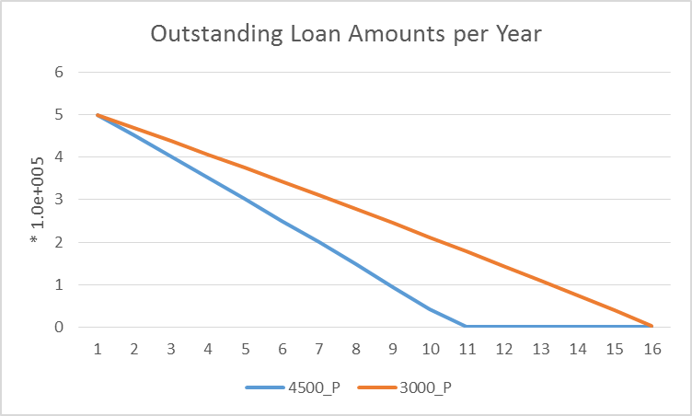

The gradient of the graphs indicate that, paying higher amounts reduces the time of completion while paying for higher interest amounts as seen from the drastic decline of the graphs.

The 30-year mortgage is the most popular choice because it offers the lowest monthly payment while the monthly payments for shorter-term mortgages are higher. A fixed-rate mortgage charges a set [rate of interest](http://www.investopedia.com/terms/i/interestrate.asp) that does not change throughout the life of the loan. Although the amount of [principal](http://www.investopedia.com/terms/p/principal.asp) and interest paid each month varies from payment to payment, the total payment remains the same, which makes budgeting easy for homeowners.

Thus it will be convenient for them to take short-term mortgages since it has overall lower costs and they are protected from sudden and potentially significant increases in monthly mortgage payments