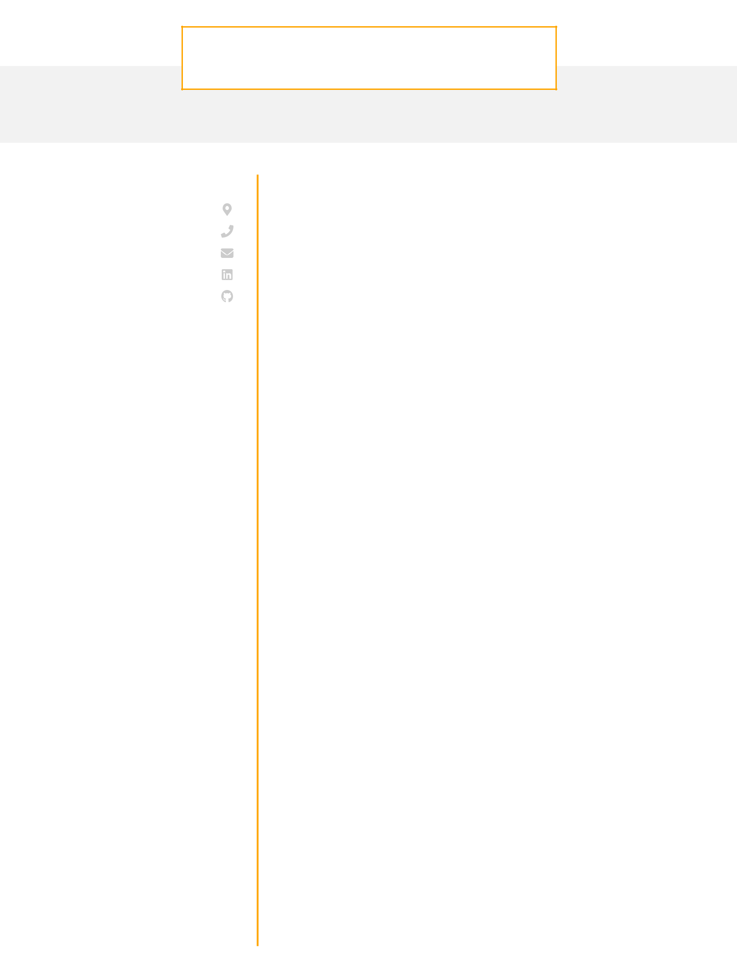JOHN **GONALEZ**

Python Developer

**CONTACT**

Pittsburgh, PA

1. 456-7890 john1652@gmail.com [LinkedIn](http://linkedin.com/in/john-g) [Github](http://github.com/john-gonzalez)

**EDUCATION**

**M.S.**

**Computer Science**

University of Chicago

Chicago, IL / 2014 - 2016

**B.S.**

**Computer Science**

University of Pittsburgh

Pittsburgh, PA / 2010 - 2014

**SKILLS**

HTML/ CSS

SQL (PostgreSQL, Oracle)

JavaScript (Angular)

Python (Django)

REST APIs (GraphQL)

AWS (Redshift, S3)

Git

**CAREER OBJECTIVE**

Experienced Python developer with extensive Django experience looking to continue to develop my skill set on the back-end at a company driven to addressing the climate crisis.

**WORK EXPERIENCE**

Python Developer

|  |  |
| --- | --- |
| DoorDash / September 2018 - current / Chicago IL | |
| · | Worked on building new Angular components for the customer- |
|  | facing web app which improved the time on page for the |
| · | average user by 2 minutes |
| Worked within an agile team and helped prioritize and scope |
|  | feature requests to ensure that the biggest impact features were |
| · | worked on first |
| Built extensive test coverage for all new features which reduced |
|  | the number of customer complaints by 7% |

Python Developer

Knewton / April 2016 - September 2018 / Pittsburgh PA

· Worked alongside another developer to implement RESTful APIs in Django that enabled our internal analytics team to increase reporting speed by 24%

· Using Selenium built out a unit testing infrastructure for a client web application that reduced the number of bugs reported by the client by 11% month over month

**PROJECTS**

**Cryptocurrency Price Tracker**

Creator

* Incorporated API calls to several applications and stored data eﬃciently in in our PostgreSQL backend
* Utilized D3.js to allow users to dynamically visualize price movements over time periods of their choosing