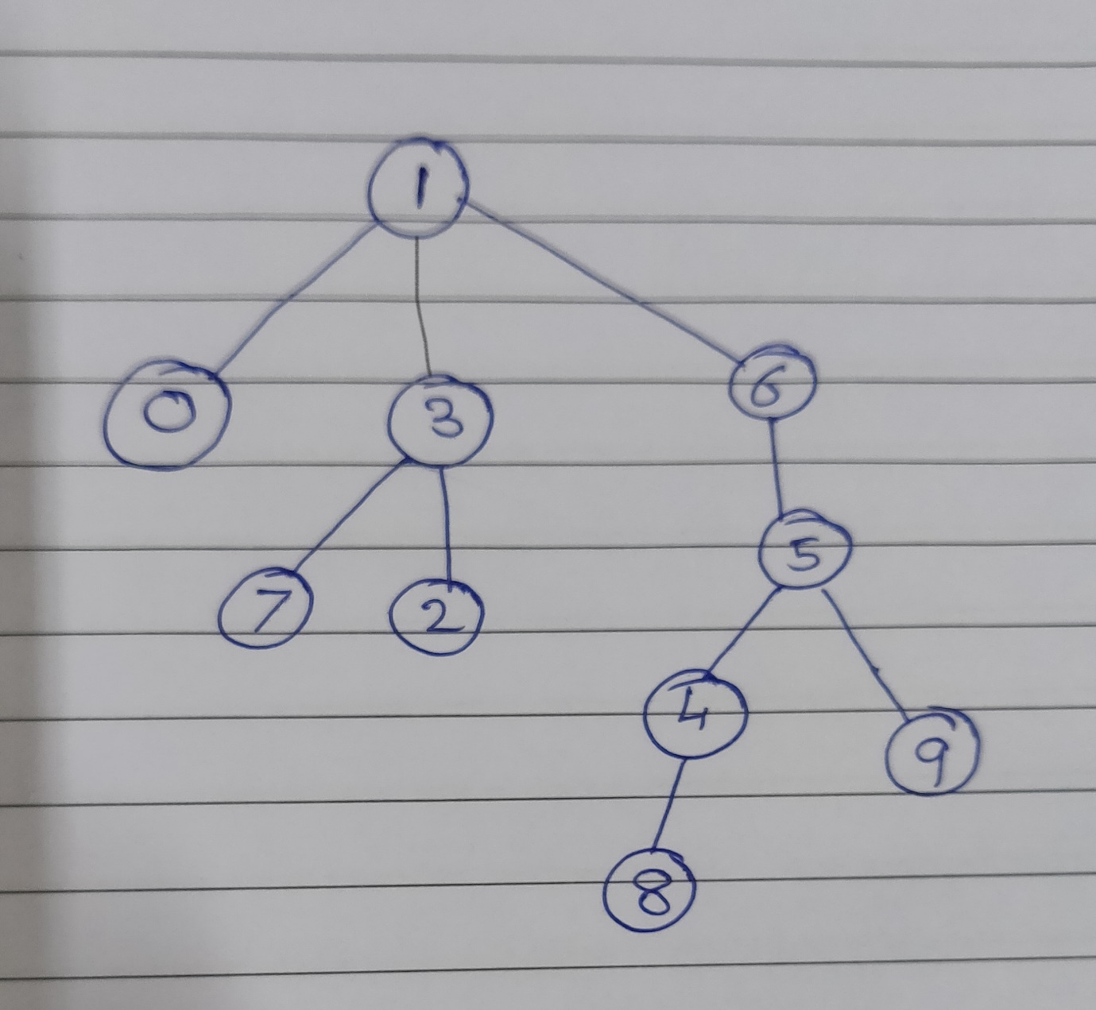

**This can be a weighted quick union method because the nodes are balanced by linking all the small branches below the large nodes. It is modified by avoiding large nodes branches.**