**Network Tour:**

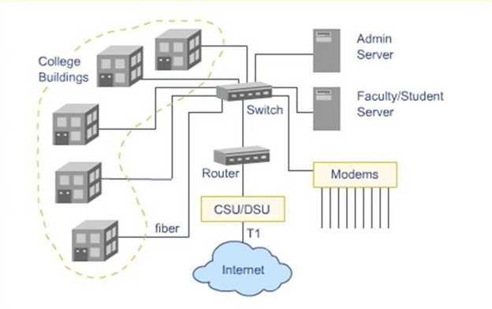

1. Each laptop is connected to a router, in our case cisco router, either by using a wifi or by using a ethernet, this type of connection comes into data link layer of the network.
2. Data from the data link layer is then forwarded to the destination address using the Network layer, Transport layer, Application layer.
3. Routers are then connected to the local server in our case along with a switch.
4. Switch helps to forward the signal based on the destination address. If the destination address is a local address then it forwards the message to that system else forwards to internet.
5. At internet level, a more sophisticated router are employed to manage the traffic.
6. Local server connected to the internet with a switch. Internet to our campus is provided by Souther Online, an ISP.
7. Connection from the ISP is in the form of an Optical fibre and these fibres are costly. So, optical fibre to LAN converter is used to make the work go cost efficiently.
8. Local server consists of a firewall, Testing server, a database in our case Oracle, proxy , and a backup server.
9. Firewall is used to block the unwanted websites or data from the network to enter into the MSIT network.
10. Database is maintained to store the data of each and every student in the college.
11. Backup server is used to recover the data from the server if any loss of data occurs in the server due to hacking or system failures.
12. Testing server is used to test any new program before dumping it into the main server.
13. Proxy is used to identify the student or clients uniquely.
14. The data in the local server can be accessed without connecting the internet, but rest of the data can only obtained with connection to the internet.