**Traditional Relational thought process in Monolith world**

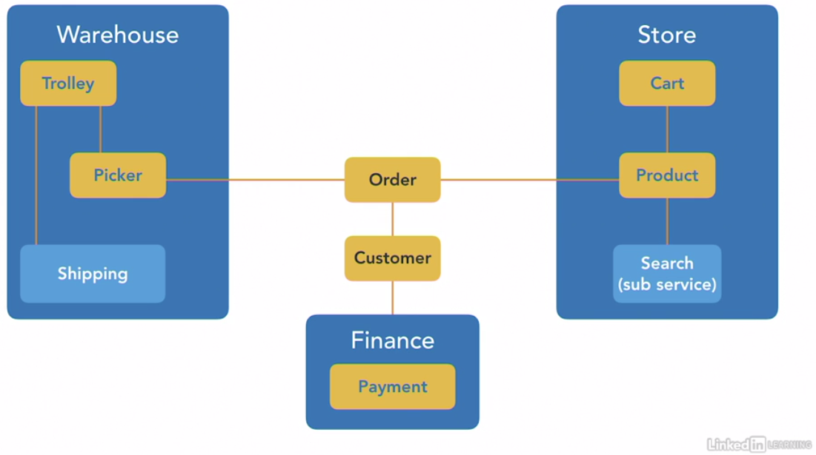

**Ubiquitous Language but Independent perspective as a Micro Service**

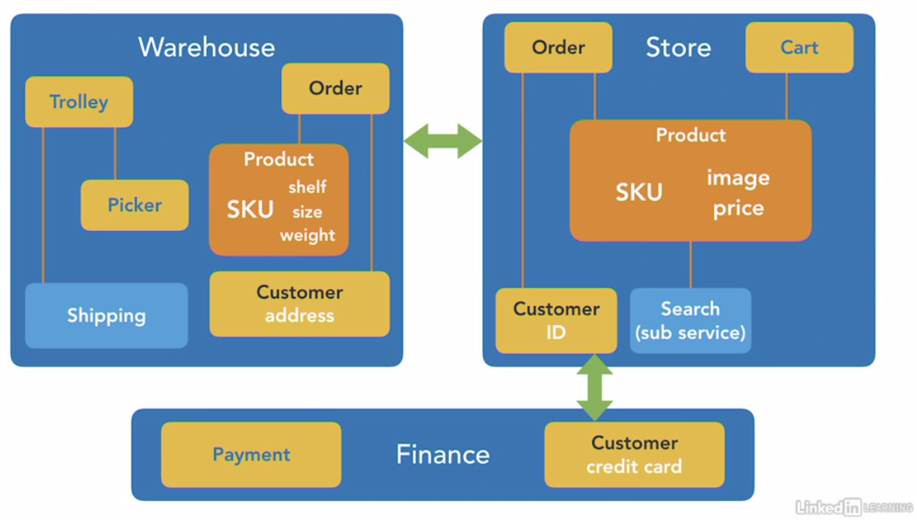

**Declarative Systems  
Microservices but Synchronous communication. “You do this now”  
“I know who does what” “Uff, How to revert if comm fails. Complicating my life”  
Downstream changes (new service introduced) would require changes in upstream (to call the new service).**

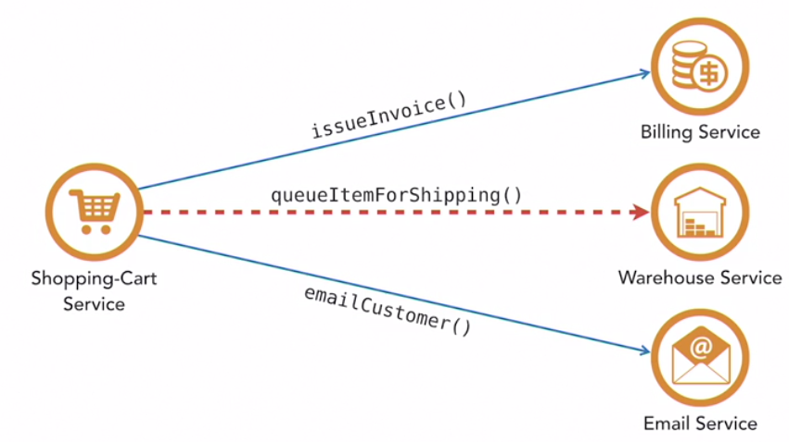

**Reactive Systems  
Microservices but Asynchronous communication. “I have done this. If you are interested, you may make use of it. My job is done.”  
Allows more downstream changes though upstream is not aware.**

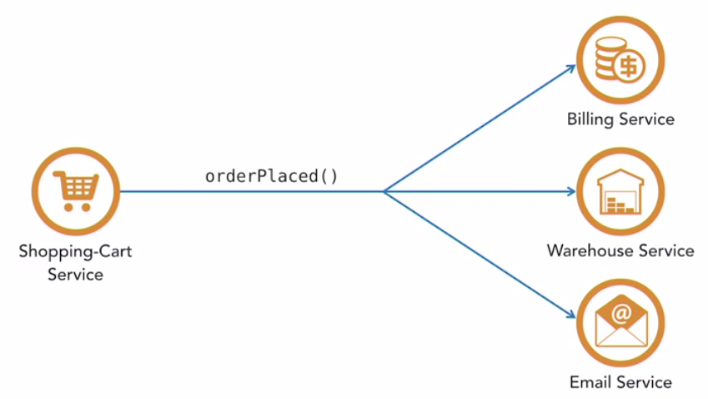

**Contexts and Interactions**

