Exploratory analysis: Nevada gaming win, 2015 to 2026
Updated 13 November 2026. It replaces the first version, which covered 2022 onward only.
- Data: data/clean/monthly_win.csv (newest figure for each month, D9) and data/clean/capacity_hold_monthly.csv (tables, machines, hold).
- Period: January 2015 to September 2026. 2020 and 2021 are left out (D23).
- Markets: LV Strip, Downtown, Reno, Laughlin.
- Charts: docs/charts/, made by scripts/eda_charts.py.

Summary
# | Finding | Why it matters for the product
1 | Every market except Laughlin reset about 25–40% higher after COVID | Pre-COVID years are a different level. Models must not treat 2015–19 as "normal" for size
2 | Since 2023, growth has nearly stopped (Strip flat), apart from Reno | "Same month last year" works well in a flat market. That's why it's hard to beat
3 | The seasonal pattern changed: the Strip's December peak is stronger, and January–February are weaker | Older seasons mislead. This supports retraining (D39)
4 | Fewer machines and tables, but each earns far more | Capacity changes are real. That's why there's a capacity alert (D37)
5 | Strip forecast misses follow baccarat luck (correlation 0.75) | Much of the Strip's error can't be forecast. Set expectations accordingly
6 | Small markets are noisier (Downtown 18%, Laughlin 16% month-to-month) | Wider ranges for the new markets (D29)
7 | Laughlin is shrinking. Downtown is growing fastest | Different stories per market, so a per-market rule is needed (D32)

1. A higher level after COVID
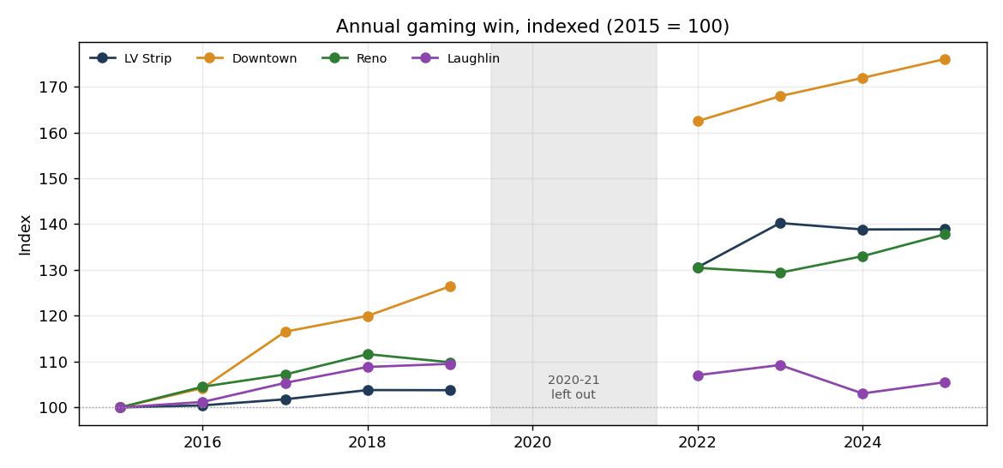
Market | 2015 ($m) | 2019 ($m) | 2025 ($m) | 2025 vs 2019 | Share of state, 2015 → 2025
Statewide | 11,115 | 12,031 | 15,801 | +31% | —
LV Strip | 6,348 | 6,587 | 8,815 | +34% | 57.1% → 55.8%
Downtown | 542 | 685 | 954 | +39% | 4.9% → 6.0%
Reno | 571 | 627 | 786 | +25% | 5.1% → 5.0%
Laughlin | 468 | 512 | 494 | −4% | 4.2% → 3.1%
From 2015 to 2019 growth was slow, at 1–6% a year. After reopening, every market except Laughlin came back 25–40% bigger. This was a step change, not steady growth.

2. Growth has stalled since 2023, except in Reno
- Strip: $8.9bn in 2023, then $8.8bn in both 2024 and 2025.
- Jan–Sep 2026 against the same months of 2025:
  - Statewide: +2.7%
  - Strip: +2.7%
  - Reno: +8.0%
  - Downtown: −0.9%
  - Laughlin: −1.3%
- Reno's growth is why "same month last year" keeps forecasting it too low (too low in 28 of 43 test months).

3. The seasonal pattern has shifted
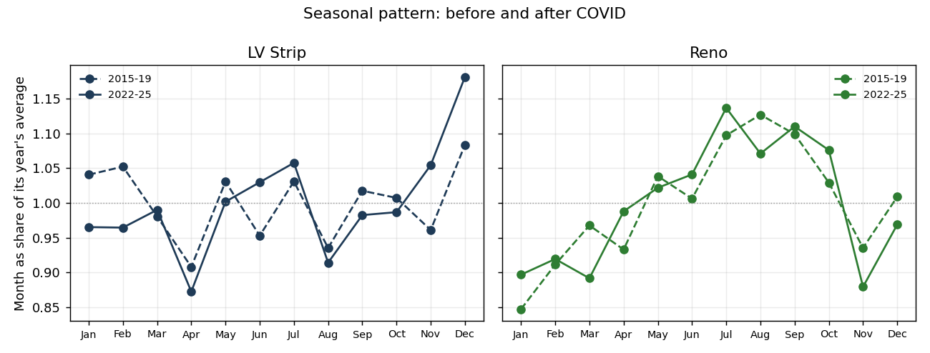
Each month as a share of its year's average:
Market, month | 2015–19 | 2022–25
Strip, December | 1.08 | 1.18
Strip, January | 1.04 | 0.97
Strip, February | 1.05 | 0.96
Strip, April (lowest) | 0.91 | 0.87
Reno, July to September (summer peak) | 1.10–1.13 | 1.07–1.14
Reno, November (dip) | 0.94 | 0.88
The Strip now depends more on December and less on early-year events. A model that learns seasons from 2015–19 will be partly wrong. That's one reason the Strip models improved with monthly retraining (D39).

4. Less capacity, more productivity
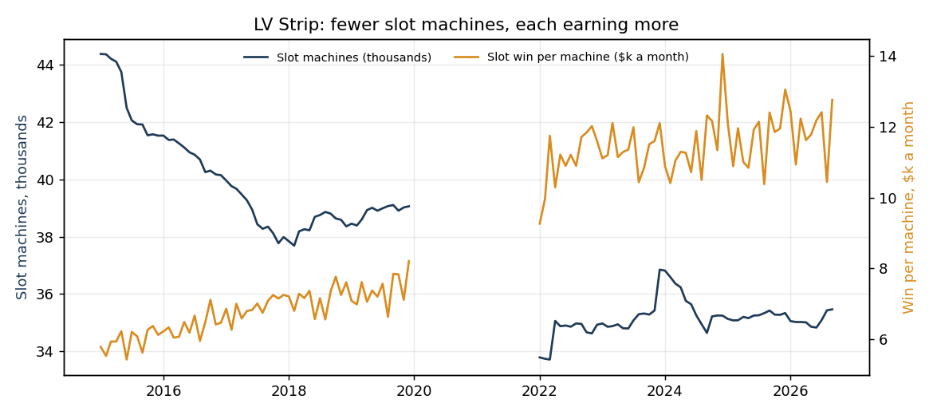
Market | Tables, 2015 → 2026 | Slot machines, 2015 → 2026 | Slot win per machine ($k a month), 2015 → 2025 | Tables' share of win, 2015 → 2025
LV Strip | 2,834 → 2,495 | 44,370 → 35,466 (−20%) | 6.0 → 11.7 | 51% → 44%
Reno | 425 → 293 | 11,467 → 8,893 (−22%) | 3.3 → 6.1 | 22% → 18%
Downtown | 419 → 355 | 10,462 → 9,840 (−6%) | 3.1 → 5.2 | 28% → 33%
Laughlin | 194 → 128 | 7,689 → 5,757 (−25%) | 4.5 → 6.6 | 11% → 8%
Casinos run fewer, higher-earning machines. On the Strip, slots now bring in a larger share than tables. Sudden capacity changes, such as closures, are what the capacity alert watches for.
Note: the venue count isn't comparable across 2018, when the Board's report changed from "locations" to "licensees" (D30).

5. Strip misses follow baccarat luck
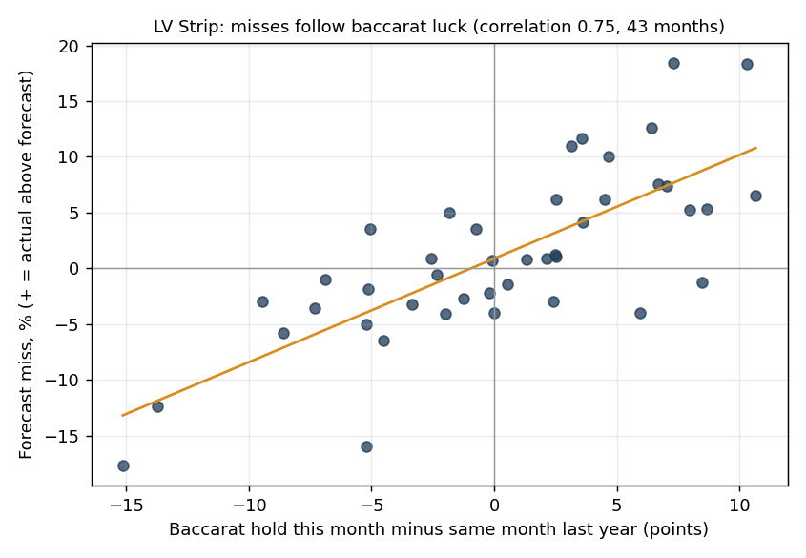
- "Hold" is the share of money bet that the casino keeps. For high-stakes baccarat it swings widely, from 7% to 27% a month on the Strip.
- Why it causes misses: "same month last year" copies last year's luck. When this year's hold is higher, the forecast comes out too low, and the other way round.
- How strong the link is: across the 43 test months, the forecast miss and the change in baccarat hold have a correlation of 0.75. For Reno, where tables matter less, it's 0.36.
- The limit: hold is only known after the month ends, so it explains misses but can't be used to forecast them.
- For the product: much of the Strip's error is luck, not model weakness. A future option is to forecast the amount bet, which is steadier, and apply a normal hold to it.

6. Volatility: how much a month moves from the month before
Market | 2015–19 | 2022–26
LV Strip | 11.8% | 11.6%
Reno | 10.4% | 11.9%
Downtown | 15.1% | 18.4%
Laughlin | 16.6% | 16.0%
The Strip is as volatile as before COVID. Downtown has become noisier. Downtown and Laughlin forecasts will need wider ranges.

7. The four markets tell different stories
Market | Story
LV Strip | The biggest market. Back at a higher level, but flat since 2023. Errors driven by baccarat luck
Downtown | Fastest growth since 2015 (+76% on 2015), but noisier
Reno | Steady growth, still rising in 2026, so it's under-forecast by a simple rule
Laughlin | Shrinking: −4% on 2019, with a quarter of its machines gone

Data checks for this analysis
- No zero or negative values. All 20 areas are present in all 117 months.
- Figures are the newest published (D9). The last 12 months, and 2019, may still be revised.

