Author: Medina Alberto

Student ID: S162512

Thesis: Cross Language Interactions: Evaluation and Effects in the Spring Framework.

In modern software development it is common to find different programming languages used in the source code of the same application. It has become relatively easy for any developer to make use of an Integrated Development Environments (IDE) to be able to compile and unite source codes written in different programming languages into coherent working applications. Due to the lack of a common ground on the written code, most frameworks in use are not able to check everything the user can code or write. The framework will limit itself to the specific language of the file, it will be able to control the correct syntax of it even when recalling different part of the application, as long as these parts are written in the same programming language as the file in exam. This can be repeated for any programming language inside the project, with a properly set working environment but the integrity is verified only for each different programming language.

This introduces the problem of polyglottism in programming language: when working on a project it is common to have dozens of different source files and libraries all integrated in the application project but due to the impossibility of the framework to compile and debug text as it is written down by the user, many changes that can be made while developing can be checked and verified only at runtime. If any modification has been made to something written in language ‘A’ that relies on an advanced programming interface (API) of a smaller application written in language ‘B’ we can easily make unnoticeable mistakes and discover and then debug them only at runtime with maybe hours of work wasted. The solution to this problem would be to provide to the framework, and not only the user, the possibility to understand and check how different parts of the application project interacts with each other and what rules apply to their interactions.
This thesis will focus on the capabilities of the Spring Framework, a widely used working environment, through the analysis of the rules that applies in application development. More precisely, the Spring Framework has a particular method to build and compile objects in which it reads all information regarding the application objects, data structure and java classes through metadata written with .xml format by the developer and then proceeds to code these objects. The thesis work has been of gathering, simplifying and reworking Spring rules into a simplified set, starting from Spring official documentation, which includes any possible option and variant but does not contain a simplified set of rules useful for an analysis regarding the cross language interactions. To support the data I gathered we decided to also include an analysis of an open-source project to verify and obtain feedback on the set of rules we resumed and see which method is the favourite one for our case in exam.
The most simple and renown example of cross language interaction is a internet webpage: the user’s browser receives a page written in HyperText Markup Language (HTML) whose content might have been retrieved from a server using Hypertext Preprocessor (PHP) and adjusted through Cascading Style Sheets (CSS) and modified or extended in its functionality through Javascript. Even using a development program capable of understanding all of these programing languages their interactions with one another can’t be verified and checked by a programmer, the developer must test how they work together hoping to find problems through observation. This same problem happens in the development of Android applications User Interfaces (UI) and Widgets. The core code of the application does not contain the information regarding the UI, instead it is written in a separate file written in eXtensible Markup Language (XML); so the developer writes code that will modify this structure read from the XML file. Another framework using XML files as data specification language is Microsoft’s .NET Framework, as many part of the framework use XML as native data representation format, storing most of its configuration data and also for namespaces configuration.
The Spring Framework approach the Enterprise Java Bean programming model in a way where the building of Programming Objects and the dependency management is left to the framework and the developer needs only to set the metadata necessary to the framework in XML files. The framework reads data from these files and tries to construct the Java-based objects there defined. The actual implementation of the Object is not instantaneous; to avoid conflicting dependencies, Spring, only set-up the Bean and their dependencies when they are needed at execution time, so that it can satisfy dependencies and create mock-up objects to solve problems.
For the Spring Framework I focused on a simple set of rules, starting the analysis in the order a Bean definition would made. First we have the Bean class property since it is mandatory in Beans definition in XML schema. The simplest syntax is:
<bean class = “class.location.path” >
Or, in the case of a factory Bean it needs a factory-bean and factory-method properties:
<bean factory-bean="springServiceStaticFactory" factory-method="createBeanInstance”>
Then if the Bean, as in our cases above mentioned, has a dependency or collaborator in another Bean it will need an id property to be named and used. As mentioned before in this thesis if we are working in a subsystem and we need a reserved namespace or we need aliases for autowiring we can add aliases in 2 ways, and depending on where the Bean will be referenced we use:
<alias name=”ourBeanName” alias=”aliasForOurBean”>
In the case where the Bean will be referenced outside of it, in a different layer or XML file. To give aliases in a quicker way, to reference the Bean in the same layer or XML file, we can give a list of aliases in a name property separated by comma, semicolons or empty spaces.
In the case where a Bean needs to reference another one, or has one as a property the referencing bean must use constructor arguments:
<property name=”beanOne”>
<ref bean=”referenceBean”>
The ref bean property can be not stated explicitly, if, even not knowing the type, the framework finds a Bean corresponding to the ref. Another way to refer to a Bean is through the idref property or contructor-arg, depending on the case. This approach is preferred because the referenced Bean is validated at deployment time and not runtime, saving time and error debugging in development.
Through references to other Beans we can set hierarchies and parent Bean to our own through a simple parent ref property:
<property name=”target”>
<ref parent=”parentBean”>
There is also the possibility of creating an “inner” Bean that may have no name or id and will be treated as a “private” property of our Bean.
Another peculiarity of Beans hierarchy is that collections, lists, maps and such will be overridden by any “discendent” Bean. That is a parent’s list will be overridden by the son’s one.
The last part was to take an Open Source Project that was developed with spring framework and study its structure and the use it made of the spring Beans module.
I choose Agile Express because it was one of the most updated project on GitHub, ensuring a working application and one that had the latest structure of Spring Framework implemented. At the time of the analysis Agile Express had chosen Spring Framework version 3.0.3, I considered only the Spring implementation that was possible with version 3.0.3. This project also included Maven for the dependency management. Configuration files for Maven have been omitted from this thesis Golden Master (GM) file, but they have been included in a separate GM file.
The full list of Bean occurrences are listed in the Appendix. The following graph shows the major occurrences and programming choices made by the developers.
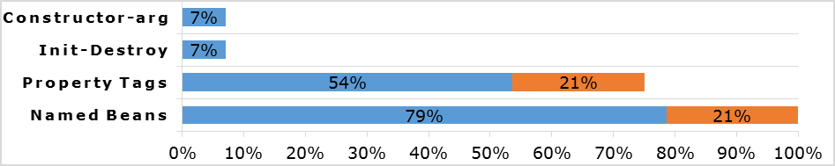
The analysis revealed different XML sources of metadata information for Beans. 28 occurrences of Bean definition have been found in a total of 7 XML file. Only 6 (21%) where nameless Beans, simply having a class reference; the remaining 22 always had at least an ID.
A total of 21 (75%) had properties added to the Bean, of which 15 (54%) occurrences had properties written using p-namespace and 6 (21%) the common property tag. Regarding other type of configuration, 1 Bean had an init-method and another had a destroy-method; with these 2 been the only occurrences regarding a Bean lifecycle. The constructor-arg was used only 2 times, of which 1 for a Bean in the test part of the code; a part of the project making use of Spring Test module.
The great use of p-namespace for property declarations tells us that it was preferred for simplicity or quicker development capabilities over the standard property tag system. SpEL was never used, instead in 2 files we found Maven properties used for Spring Bean metadata.
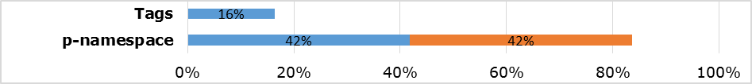
In applicationContextDataSource.xml there are 5 Maven property calls, all related to Beans properties values, and in applicationContextNotification.xml there are 18 Maven property calls all related to Bean properties values. All this for a total of 23 (42%) cases of Maven properties all used for p-namespace Spring Beans properties, against a total number of 46 (84%) cases of Spring Beans properties written in p-namespace.

