Lottery

UML Class Diagram DATA MODEL

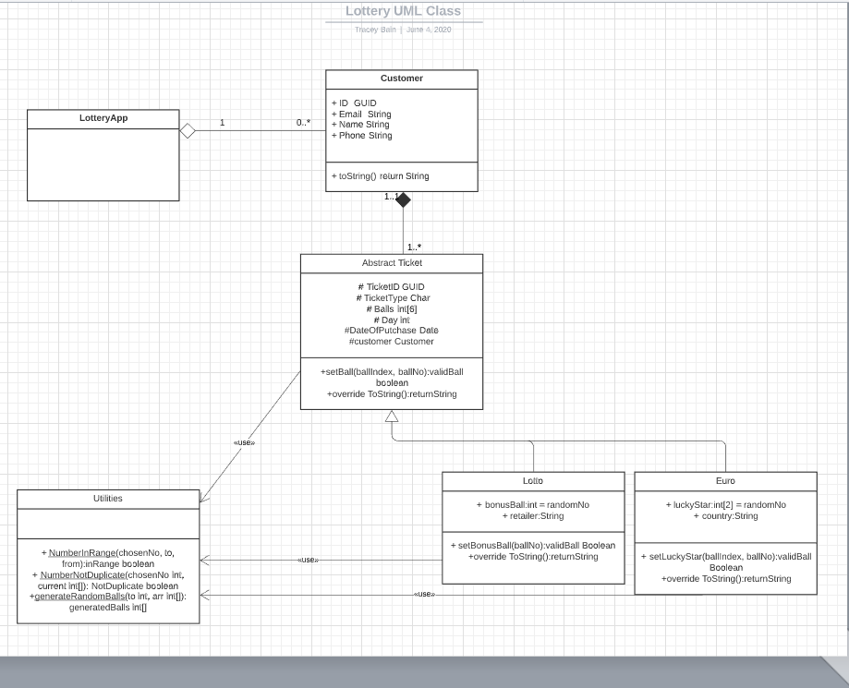

ERD

<https://app.lucidchart.com/documents/edit/3df80b8c-68ff-4442-a343-7c18f1ab0d47/0_0?beaconFlowId=16219A5195B4A334#?folder_id=home&browser=icon>

