A+ Computer Science Pong Lab – THE GAME Lab Value - 10

Lab Goal : This lab was designed to teach you more object oriented programming and how to write a very simple game.

Lab Description : Now that Block, Ball, and Paddle have all been tested numerous times, we can put them all together to make the Ping Pong Game. The hardest part of the game is getting the paddles to hit the ball. I am giving you some logic to make the Ball hit the left paddle. You must then create the logic to make the Ball hit the right paddle. You will use Pong.java to write the final game.

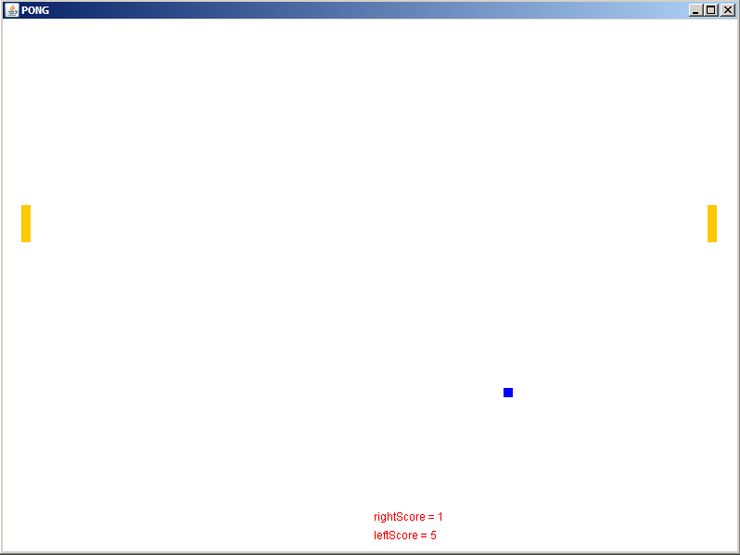
Basic logic to see if the Ball
collides with the left Paddle

if( (ball’s x <= left paddle’s x +left paddle’s width+abs(ball x Spd)
&&
( balls’s y >= left paddle’s y &&
balls’s y <= left paddle’s y + left paddle’s height ||
ball’s y + ball’s height >= left paddle’s y &&
ball’s y + ball’s height < left paddle’s y + paddle’s height ) )
{
if( balls’s x <= left paddle’s x +left paddle’s width – abs(ball x Spd )
set Y speed to negative of current speed
else
set X speed to negative of current speed
}

PONG GAME REQUIREMENTS

1. Get the Ball to bounce off the left paddle and right paddle (CollideLeft and CollideRight).

2. Add in scoring. Every time the ball gets past a paddle the other paddle/player gets a point. The Ball then needs to come out of the middle.

PONG GAME EXTENSIONS

1. Create a Wall class that is an extension of Block. Then, make new instance variables for all 4 Walls. Finally, rewrite your code so
that you actually check to see if the Ball collides with the Walls rather than will fixed number boundaries.
2. Have the ball change speed based on where on the paddle it hit. You can check some online pong games to get a sense of how this should work.

3. Open the BlinkyBall.java file and write the code for BlinkyBall. BlinkyBall will change colors every time it moves. You must
override some methods and make super calls.

4. Open the SpeedUpBall.java file and write the code for SpeedUpBall. SpeedUpBall will speed up every time it collides with a wall
or a paddle. You must override some methods and make super calls.

5. Create a new Ball named InvisibleBall that will turn invisible randomnly. At random times, it will turn invisible for random
durations of time.

