A+ Computer Science OOP Basics – ROBOT Lab Value - 10

Lab Goal : The lab was designed to teach you how to write a class and to write methods for that class. It was also designed to teach you how to call methods that have parameters. You will be calling graphics methods with parameters and methods where you define the parameters.

Lab Description : Draw a robot to the best of your ability. You can draw any robot you like but you must include lines, rectangles, ovals and arcs with at least one filled.

Sample Output :

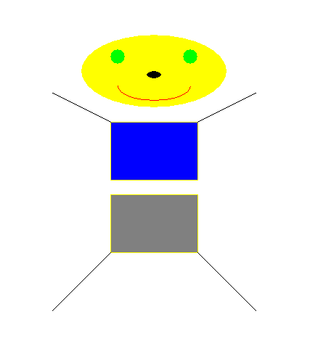
Files Needed ::
GraphicsRunner.java
Robot.java

