A+ Computer Science Move That Shape Lab Value - 10

Lab Goal : This lab was designed to teach you how to design and use classes, instantiate objects, use graphic methods, and use if statements.

Lab Description : Write a program in to create a unique shape using graphics. Make the shape move around the screen and bounce off of the walls.

Part One :: Use the Shape.java file to create your own shape. Complete the Shape constructor and add code to the draw method to draw your own shape. Use GraphicsRunner.java to test your Shape class.

Part Two :: Get your shape to move around the screen. You will need to add set and get methods to the Shape class for instance variables xPos, yPos, xSpeed, and ySpeed.

Part One :
Files Needed ::
Shape.java
GraphicsRunner.java

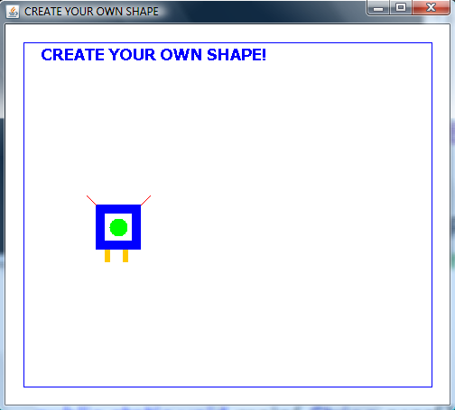

The shape does not move in part one.

Part Two :
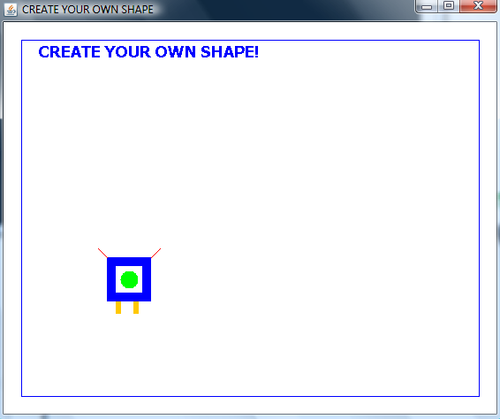
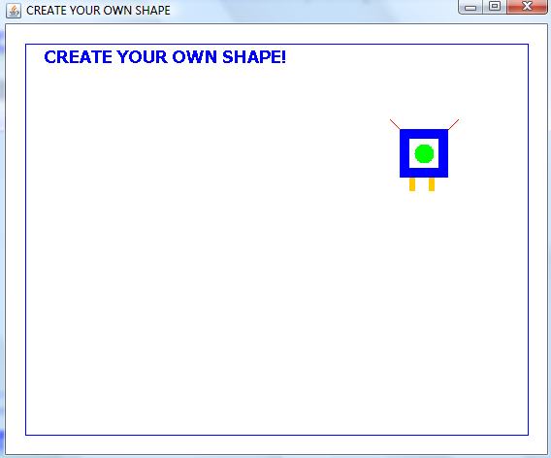
The shape moves around the screen and bounces off the walls in part two.

