A+ Computer Science The Board Lab – THE BOARD Lab Value - 10
Main Topics : classes objects interfaces inheritance

Lab Goal : This lab was designed to teach you more object oriented programming and how to write a very simple game.

Lab Description : Complete the code for the Board class located in Board.java. The Board consists of four Blocks. Each of the four Blocks is a different color. The Board class can be and will be used to write some games.

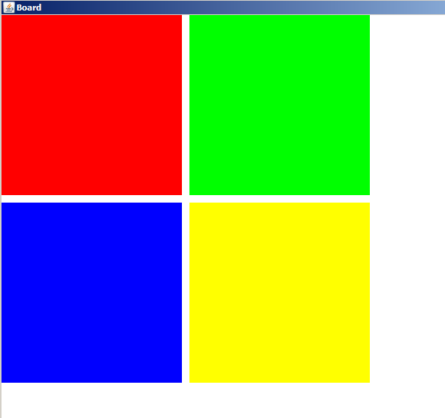
//if mouse clicked on top left block – swap top left with top right
Files Needed ::
Locatable.java
Block.java
Board.java
Tester.java

//if mouse clicked on top right block – swap top right with top left

//more checks for bottom left and bottom right

//else check for right mouse button click

//if mouse clicked on top left block – swap top left with bottom left

//if mouse clicked on top right block – swap top right with bottom right

//more checks for bottom left and bottom right

After left-clicking on top left block.
Before left-clicking on top left block.
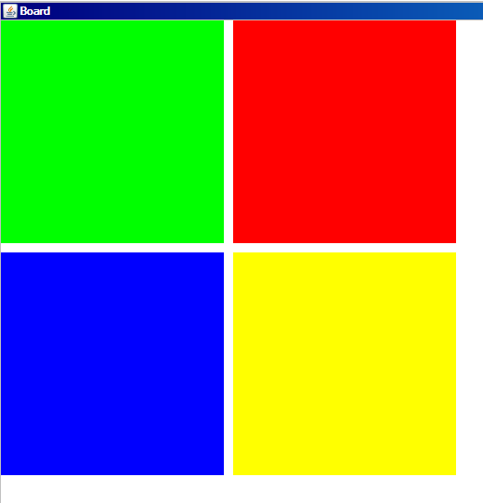
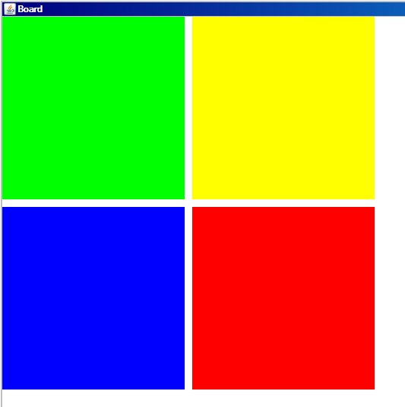
After right-clicking on bottom right block.

