A+ Computer Science If Else If – MOUSE BUTTON TESTER Lab Value - 10

Lab Goal : This lab was designed to teach you more else if statements.
Lab Description : Write a program that will test to see which mouse button was pressed. If the left mouse button is pressed, draw a rectangle at that location. If the right mouse button is pressed, draw a circle at that location. Feel free to change the colors and sizes however you want.

Files Needed ::
MouseButtonTester.java
MouseButtonTesterRunner.java

Sample Data :
lots of mouse clicks

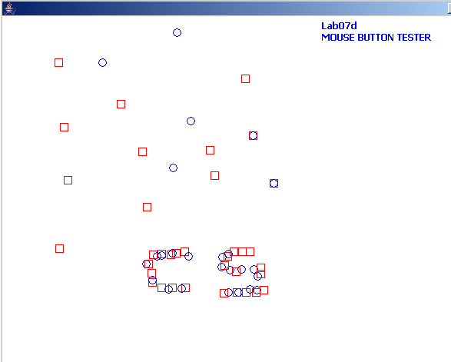
Sample Output :

