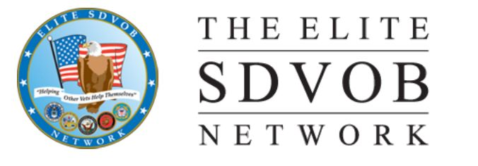

The Elite SDVOB

Northern California Chapter Network

1405 Phelps Ave #36

SAN JOSE, CA 95117

Auto pay link goto website!

www.peek.tips/elitesponsor

**Name**  (she/her)

**Title**

Address

Phone no. 408-533-3764

###### PO Invoice Number 002822023

Date 02/28/2023

**Veteran helping Veterans that need Your help!**

Title

DISABLE VETERANS OUT REACH EVENT

Sponsorship support 2023

* Sponsorship $200.00

**Total**  $200.00

Amount: $200.00

The Elite DVBE Network is a 501(c)19 Veterans organization. You can help us accomplish our mission of "Helping Other Veterans Help Themselves" by making a donation. IRC 501(c)(19) exempts from federal income tax a post or organization of past or present members of the Armed Forces of the United States, or an auxiliary unit or society of, or a trust or foundation for any such post or organization.

501 c 19 tax id 45-0505137