1.Login

<https://teton-kitchen.com/app>

user: [user1@teton-kitchen.com](mailto:user1@teton-kitchen.com)

pass: 123456

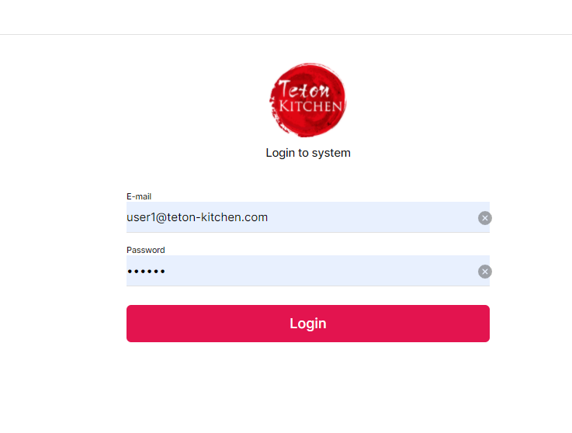

2.Home

User button on the bottom to manage booking & Order

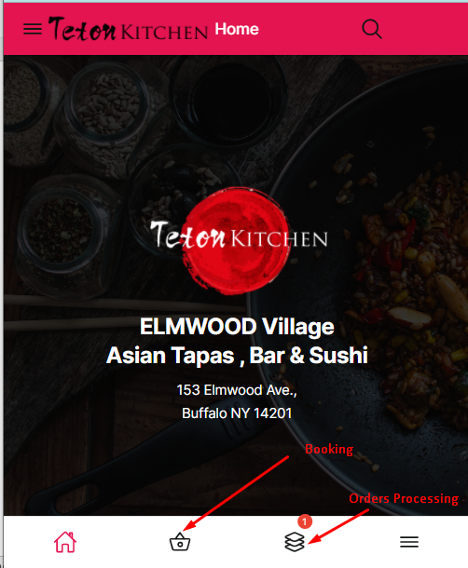

3. Booking

There are 3 Sections for Booking, Each section will contain multiple table or position can order.

For Phone section, it will be Reservation, no need assign position, when customer go to restaurant, staff will assign position for him.

Others position, after make order, no one can make order on these position until order has paid.

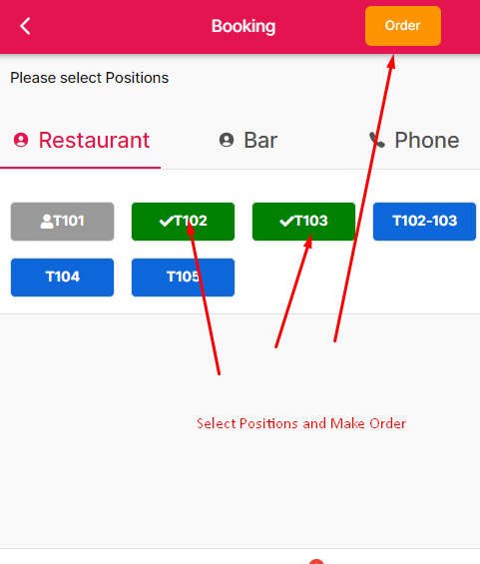

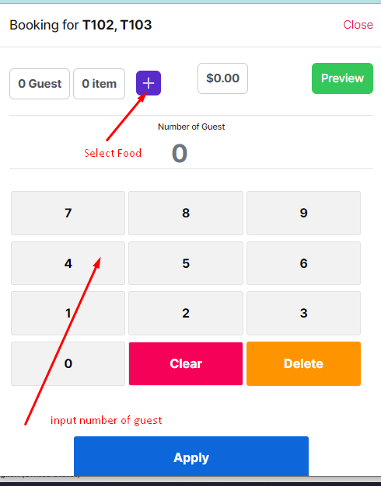

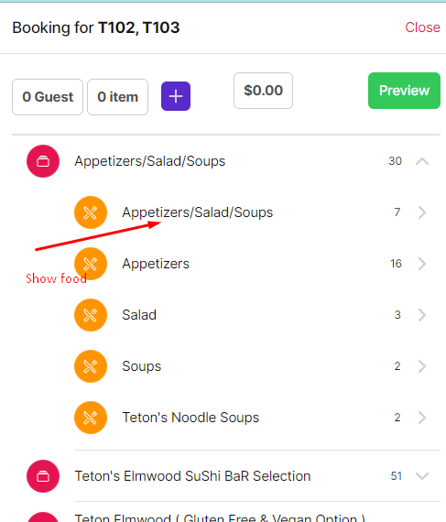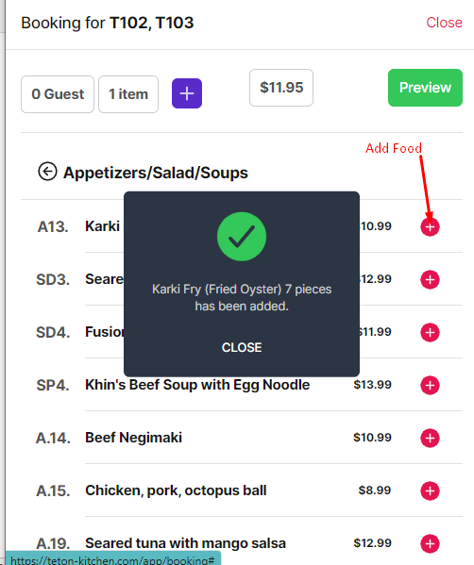

Add options

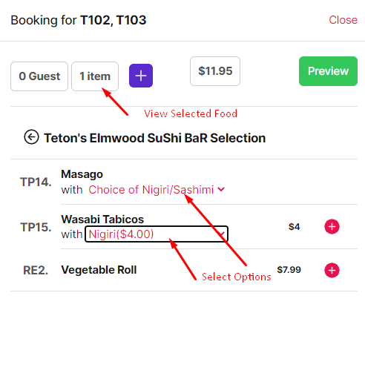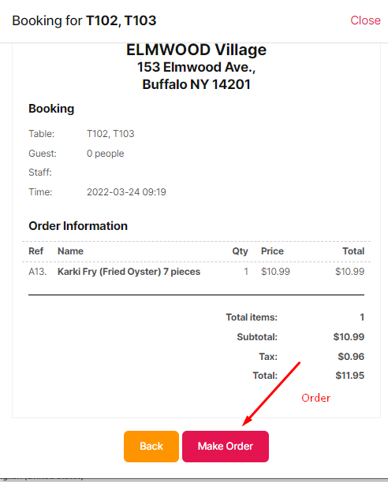

After Order Positions selected will be disabled

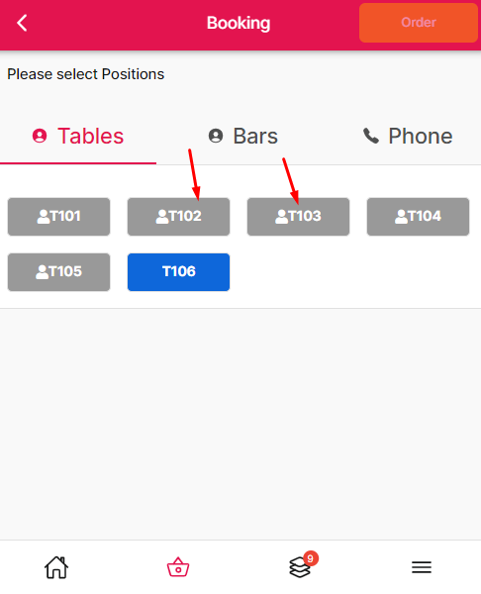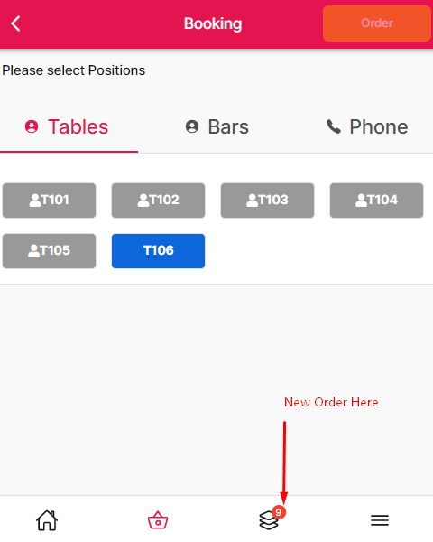

Make a payment & free position

