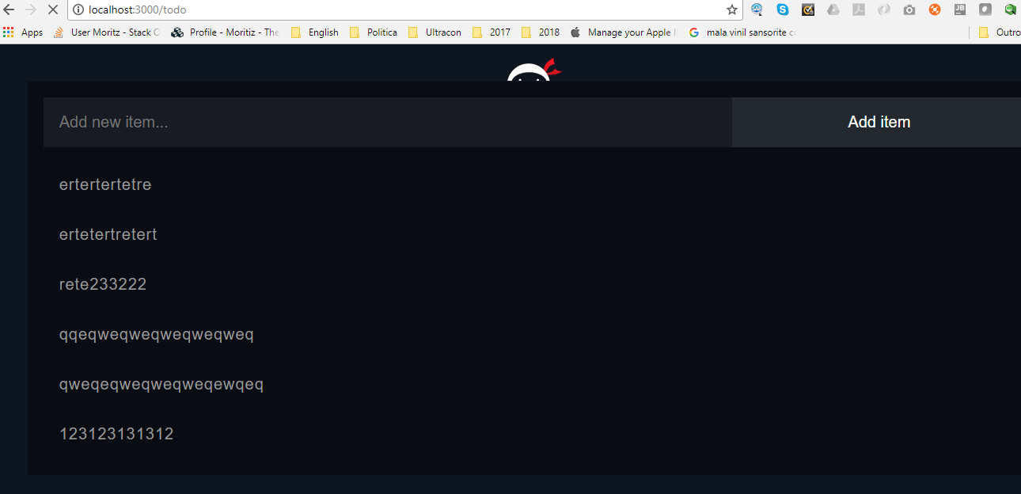

Working perfectly with mongodb mlab