Tom Federan

CRN #82820

IT-1025: Project #1

09-08-2018

Fall, 2018

Table of Contents
Table of Contents 2
"Who Invented the Computer" 3
What is an Information System 3
Careers in IT 4
Ethics and intellectual Property 7
Conclusion…………………………………………………………………………………………………………………………………………….9
Bibliography 10

“Who Invented the Computer?”

The Analytical Engine has been generally distinguished as the first computer was designed and partly built by the British Mathematician Charles Babbage in 1834. The Analytical Engine featured a memory and calculating unit that could be programmed. Even though this device was never completed during Babbage’s lifetime it was completed 150 years later in 1991 and is referred to as The Difference Machine No. 2. Babbage’s work was the forerunner of the modern digital computer.¹

- What is an Information System

- Pumping Gas at your local station.

The five primary components of an information system (hardware, software, data, people, and process) come into play as follows:

- Hardware: The items you can touch or physically use are HMI interface on the pump, and the scanner for your credit card.
- Software: The software drives the pumping system, calculates and processes payment information.
- Data: The information that is provided and in turn collected includes: the date, amount gas, price, and credit card information.
- People: the users of the system are the consumers, the cashiers and managers of the station.
- Process: The business process can be defined by the following steps:
a. Park the vehicle Car, b. Shut off engine, c. Open fuel cap, d. Insert credit card, e. Enter your zip code, f. Pick up nozzle, g. Select grade, h. Insert nozzle into vehicle, i. Squeeze handle, j. Once pump shuts off, remove nozzle, k. Rehang nozzle on pump, l. Close fuel cap, m. Enter Y/N for receipt.

- Online Shopping Community

The five primary components of and information system would contribute to an Online shopping community in the following ways:
- Hardware: PCs allow for the connection to the internet and for the programming and associated product offering descriptors and proceeding of payments from the customers.
- Software: The software will enable detailing product offerings, prices and deliveries as well as processing payments and storing information, e.g. address, credit card info. etc.
- Data: The information that is provided to the customers in terms of the products, their availability, their cost, and delivery timing. Also collected would be customer information, names, addresses, payment information, and demographic info.
- People: Besides the customers and company employees that may interface with them, e.g. chat, or customer service, the other people on the information system would be: system designers and debuggers – design the system, data analysts collect information and use it for evolving the enterprise, and data base administrators, who strive to maintain the systems function.
- Process: a. Provide means for customers while searching to find your website and appropriate product, b. present all necessary consumer information on the product, c. provide means to order and pay for product, d. enable replenishment of inventory.

- Retailer IT Initiatives²
Home Depot is investigating the following 5 technologies to improve the way consumers shop. The 5 technologies are:
VR-Virtual Reality
This technology would allow customers to enter a virtual setting, shop for what they want and get it delivered to their doorstep.
AR – Augmented Reality
Use your computer or phone to visualize what appliances would look like in your home.
Gamification
Like McDonald’s use of monopoly, Home Depot plans to offer promotions and discounts through gamification to increase customer engagement.
Heat-Mapping
By adding led systems to cameras, Home Depot plans to enable the visualization of densely populated areas in their stores such that help can be deployed based on this heat mapping.
Automatic, Mobile Check-Out
Home Depot is investigating technology that will enable consumers to scan items on their mobile phones as they shop such that they can avoid check-out lines at the end of their shopping experience.

- Careers in IT

- Interesting IT Careers
The careers in IT that interest me is that of a Network Engineer not Programming. I like the idea of working with hardware and design such that the interaction of all the equipment enables the communication between devices. I especially like the idea of pursing certification with Cisco and building upon various tracks such as installing, configuring, securing, operation and troubleshooting a company’s network. According to the video on Code.org⁴ and Cisco³ there will be plenty of job opportunities in the future and much of this surrounds training and certification. As technology continues to advance so to must the people to support it whereas keeping up with the latest in network offerings is critical to job performance and salary eligibility.

- IT Toolkit – The Toolkit Approach to Career Development⁵
I’m planning on deciding if IT is a career that I will choose for my future employment. I hope for this class will be to decide on which track would be best for my skills and then gather, collect and keep information that will enable me to be successful. Besides this class, I plan on doing online research to assess my skills, interests and aspirations to see if these collectively along with salary is the way to go or not. Based on the Cisco³ and Code.Org⁴ videos the horizons look bright for IT careers so that is step one, beyond this I will look to see what exact discipline makes sense for me. In terms of a “toolkit” I like the idea of jumpstarting my career by assembling important readings, information, tips and tricks, resources, and overall career networking to assemble or create a repository that will grow with me as my learning and understanding develops.

- Bureau of Labor Statistics⁶
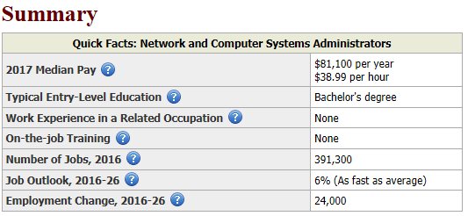
The above table represents information obtained on the BLS website regarding Network and Computer Systems Administrators. The growth in this segment of work is 6% which is encouraging as a career choice. The median pay is less than I expected especially due to the fact that the responsibility for this position is critical to the lifeline of a business or company. This website also provided careers similar to and the requirements and wages for a multitude of computer related positions. Also, another choice was to drill down to state and area data which further provides details geographically.

- Tri-C Career Center

- College Central⁷
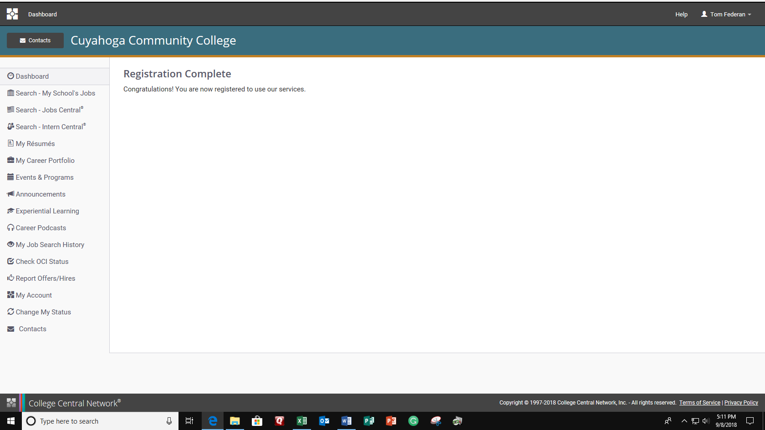
I found the site offered workshops, and announcements to job fairs and internships, co-ops, job training info sessions, and an area to upload my resume. This is my first time visiting this site/resource, so I will plan to spend more time utilizing this area of Tri-C.

- MyPlan⁸
I logged into MyPlan and took the various assessments which did indeed help me to better understand myself and potentially what careers to pursue relative to my personal interests, skillset, and career aspirations. I did find that the assessments helped me to better define my interests since each assessment looked to decipher who I am based on the answer to numerous scenarios and questions in defining who I am.

- Co-op⁷
- Learning to working...working to earning!
- Attention BADM, IT, Engineering, Restaurant / Hospitality, and
- Visual Communication/Creative Arts students....You may qualify for a paid Co-op and gain valuable hands-on work experience in your field.
- Qualifications:
- Min. 2.75 GPA
- currently enrolled students
- Min. 12 credit hours & 2 classes towards your major
- Please stop into The Career Center for an Application of Interest and brochure further explaining the program.

- Ethics and Intellectual Property⁹

Information systems ethics refers to the conduct governing information systems. Ethics is a document that outlines acceptable behavior for a professional group like that of information systems.
Intellectual property defines property that is derived from someone’s mind. This property can be protected so the originator can benefit in using their ideas and not be concerned with others stealing/duplicating their work. This protection is unfortunately time bound since benefits cannot be constrained from others to benefit from in the future. This knowledge will become part of the “public domain” after so much time has transpired. Laws surrounding Intellectual Property deal with the tangible results of these ideas.

The DMCA or “The Digital Millennium Copyright Act” was established to protect infringements regarding copyrights. The act carries two provisions, the “anti-circumvention” provision which makes it illegal to create technology to circumvent means that has been put in place to protect work that is copyrighted and the “safe harbor” provision which limits an online service providers liability when someone using their services commits copyright infringement. If I were to create a website, the DMCA would mean that I must oblige copyrighted work and not use it without prior authorization/permission from the original source. Copyright laws create the originator and provides for judicial grounds if violated. My website would not only have to gain permission but also cite and give credit to the original authors, this may carry a financial obligation or possibly negate usage of material if permissions are not granted or mutually agreed to.

Conclusion
This lab has provided means to research careers in IT and provides for means and resources to further pursue/understand careers and future job prospects. This report also provided just how important IT is to the world and businesses alike. Our dependency on technology and supporting it for future needs is critical as is the need for professionals to seek training and certification in obtaining jobs and positions in business. Lastly, the resources available at Tri-C will help me focus my efforts and career aspirations.

Bibliography

- Computer History. “Who Invented the Computer?” YouTube, YouTube, 17 Nov. 2014, www.youtube.com/watch?reload=9&v=d1pvc9Zh7Tg&feature=youtu.be.
- “5 TECHNOLOGIES THAT WILL CHANGE THE WAY YOU SHOP.” The Home Depot, 30 Jan. 2017, corporate.homedepot.com/newsroom/nrf-2017-technologies-change-how-you-shop.
- Cisco. “Careers in IT Networking: Hear from Cisco Experts.” YouTube, YouTube, 31 May 2012, www.youtube.com/watch?v=0ZUZxZUbg-A.
- CodeOrg. “What Most Schools Don't Teach.” YouTube, YouTube, 26 Feb. 2013, www.youtube.com/watch?v=nKIu9yen5nc&feature=youtu.be.
- http://proquest.safaribooksonline.com.libauth.tri-c.edu:2048/book/career-development/9780132978248/firstchapter#X2ludGVybmFsX0h0bWxWaWV3P3htbGlkPTk3ODAxMzI5NzgyNDglMkZwYXJ0MDFfaHRtbCZxdWVyeT0=
- “What They Do.” U.S. Bureau of Labor Statistics, U.S. Bureau of Labor Statistics, 13 Apr. 2018, www.bls.gov/ooh/occupation-finder.htm.
- “Cuyahoga Community College.” College Central Network®, www.collegecentral.com/tri-c/Student.cfm#announcements.
- “Cuyahoga Community College.” College Central Network®, www.collegecentral.com/tri-c/.
- Bourgeois, David T., and Bourgeois. Information Systems for Business and Beyond, Published through the Open Textbook Challenge by the Saylor Academy, 28 Feb. 2014, bus206.pressbooks.com/chapter/chapter-12-the-ethical-and-legal-implications-of-information-systems/.

