Tom Federan

CRN #82820

IT-1025: Project #2

09-23-2018

Fall, 2018

Table of Contents

Table of Contents 2
Executive Summary 3
Data Representaion 4
How a CPU Works 6
Hardware 7
GroundbreakingTechnology…………………………………………………………………………………………………………….. 10
Four Rings……………………….………………………………………………………………………………………………………………….11
Conclusion…………………………………………………………………………………………………………………………………………. 12
Bibliography 13

Executive Summary
The accompanying documentation provides means to convert decimal numbers to and from other commonly known number systems such as binary, hexadecimal, and octal. A brief description of the interaction of RAM and the CPU relative to instruction sets and their governing or most typical commands that drive calculations between computer components. Also included is how the ALU, Arithmetic Logic Unit utilizes flags (wiring) to help the control unit decide what to do based on the data stored in the flag registry. The flag registry basically uses logical commands as the driver for if the wiring is to indicate on/off or binary output in the flag registry. Removable media is discussed ranging from magnetic to optical to flash technology. To gain a better understanding of computer components a detailed list has been constructed with their cost and is compared to a commercially available system of like performance. E-waste or electronic waste is also explored, and recommendations provided on how to dispose of our discarded electronic devices. As part of searching on the IEEE site, new technology known as 3D Body Processing or (3DBP) was elaborated upon and how this technology carries forward into virtual fitting (VF) for consumers and businesses to benefit by lowering returns and elevating the customer experience of their purchases. Lastly, security rings were defined for 4 levels and applied to a retail establishment for example.

Data Representation

Converting Decimal to Binary, 97 to binary¹
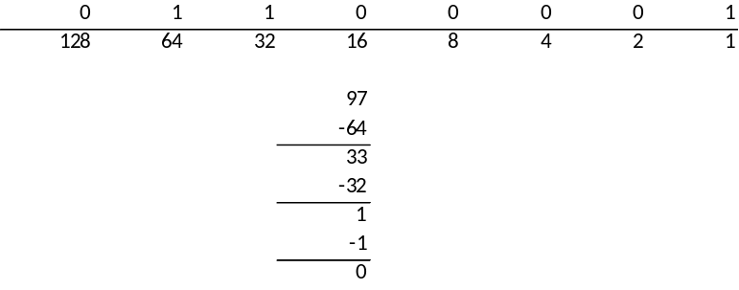

Converting Binary to Decimal, 11000101 to decimal²
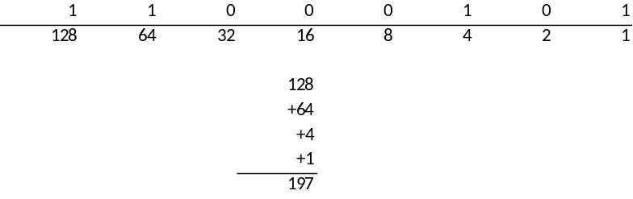

Converting Binary to Hexadecimal, 11011011 to hexadecimal²
First convert 11011011 to decimal.
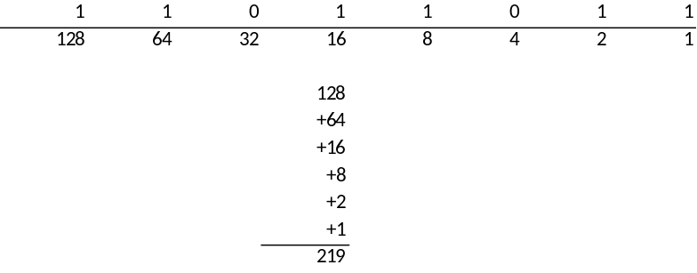
Then convert decimal 219 to hexadecimal.
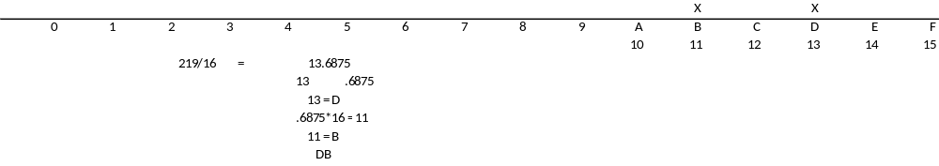

Converting Binary to Octal, 11011011 to octal³
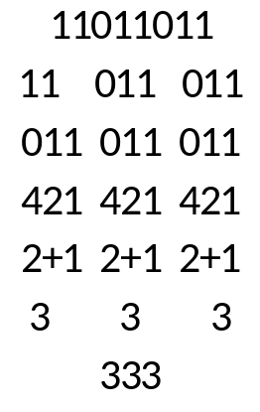

How a CPU Works

The Interaction Basic Commands Performing Instructions of the Instruction Set
Inside the central processing unit is a list of instructions that the CPU can perform based on interacting with data stored in random access memory, or ram. The following list is an example of some of these instructions and their resulting action [4].
- LOAD: a number from Ram into the CPU
- ADD: two numbers together
- STORE: a number from the CPU back out to RAM
- COMPARE: one number with another
- JUMP IF Condition: to another address in RAM
- JUMP: to another address in RAM
- OUTput: to a device such as a monitor
- Input: from a device such as a keyboard

The Purpose of Flags in the ALU⁴
Inside the CPU you will find a Control Unit along with the arithemic lgic unit or the ALU. The ALU performs all math functions inside the CPU. ALU uses flag to help the control unit device decide what to do when it receives the next instruction. Flags also utilize a flag register to store data with having to return to ram. Wires from the ALU to the registry are based on logical statements such as greater than and equal to. Based on the state of the wire be it on or off the ALU flag can use this in determining the outcome of a compare command, e.g. If two numbers 4, and 6 are to be compared the flag registry may just output turining on the wire greater than indicating that 6 is indeed greater than 4.

Hardware

Modern Removable Media
There are three types of removable storage for computers. By definition, a removable storage device allows you to store data while the computer is running and retain it or store int on a device even when the computer is not running. The three technologies are magnetic, optical and solid state.
Magnetic is the oldest technology which includes floppy drives, hard drives, Zip and Jazz drives [5]. Secondly is the optical drive technology which includes CD-ROM, DVD, and Magneto-Optical drives [5]. Most recently, flash memory which is also referred to as solid state since these devices have no moving parts.
Building Your Own Personal Computer
If I were going to build my own computer I would include the following hardware.
- Computer Case, NZXT Source 340 Mid Tower $70
- Motherboard, Giga-byte X99 Gaming 5 $294.95
- CPU, Intel Core i9-7980XE 4.2 Ghz $1699.99
- Water Cooler, DEEPCOOL CAPTAIN 360EX RGB WHITE, AIO Liquid CPU Cooler, Synchronous RGB Waterblock and 2 LED Strips Controlled by Cable Controller or Software, 3×120mm PWM Fans, AM4 Compatible, 3-year Warranty $139.99
- Graphics Card, Gigabyte GeForce GTX 1080 Ti Gaming OC 11GB N108TGAMINGOC-11GD $649.99
- RAM, Ballistix Sport LT 16GB Single DDR4 2400 MT/s (PC4-19200) DIMM 288-Pin - BLS16G4D240FSE (Red) $149.00 ea. x 2 = $298.00
- Hard Drive, Samsung PM863a 3.84TB SATA 6Gb/s 2.5" Enterprise Internal SSD MZ-7LM3T8N $1399.99
- Hard Drive, HGST Ultrastar He10 | HUH721010ALE600 | 0F27452 | 512e | 10TB SATA 6.0Gb/s 7200 RPM 256MB Cache 3.5" | Power Disable Feature | Enterprise Hard Drive (Certified Refurbished) - w/3 Year Warranty $249.99
- Power Supply, PC Power & Cooling Silencer Series 750 Watt (750W) 80+ Gold Semi-Modular Active PFC Industrial Grade ATX PC Power Supply 7 Year Warranty PPCMK3S750 $162.65
- Monitor, ASUS ROG Swift PG348Q 34" 21:9 3440x1440 IPS 100Hz G-SYNC Eye Care Gaming Monitor with DP and HDMI Ports $951.00
- Keyboard, Das Keyboard X50Q Soft Tactile RGB Smart Mechanical Gaming Keyboard (DKGKX50P0GZS0USX) $199.00
- Mouse, ASUS ROG Spatha RGB Wireless/Wired Laser Gaming Mouse (ROG Spatha Gaming Mouse) $151.99
- DVD Drive, LG WH16NS40 16X Super Multi M-Disc Blu-ray BDXL DVD CD Internal Burner Writer Drive + FREE 1pk Mdisc BD + Nero Software + Cables & Mounting Screws $91.00
Total: $6,358.54
Comparable already built system online:
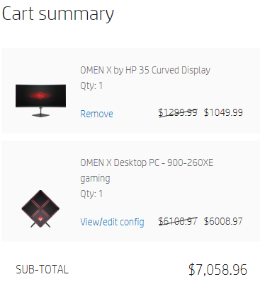

Electronic Waste
Over the next five years approximately 250 million computers will become obsolete according to the EPA [6]. The concern for this waste is the toxic materials used on the construction of the components of the computers such as lead, mercury, cadmium, and hexavalent chromium. Besides the staggering numbers of computers and their toxic components, what is more concerning is that household electronics aren’t classified as hazardous waste and aren’t subject to federal regulation [6]. So, it is up to us to dispose of this equipment properly.
Potential solutions to the issue of Electronic Waste (e-waste) includes [6]:

- Donate: Provide an operable computer to a local family, friend, school, or nonprofit such as Goodwill or Technology Training Foundation.

- Recycle: Take your old equipment to a reputable recycling center for proper disposal.

- Involve Businesses: The IBM PC Recycling Service allows consumers and businesses to recycle any computer for a small fee, including shipping. Hewlett Packard offers a similar service. Or businesses can consult with a company such as Newtech Recycling, which provides equipment resale, donations, or recycling.

Groundbreaking Technology⁷
One of the newer groundbreaking technologies is 3D Body Processing (3DBP). This technology involving the taking and storage of body scans and images. For the past twenty years, 3D scanning and modeling of the human body or body parts have been applied in various applications and industries [7]. 3D body-model processing hardware and software technologies are at an inflection point; i.e., the potential for mass adoption in industries such as apparel design, manufacturing, and retail are conditioned on not just total cost of ownership but on scalability, interoperability, and quality of experience as well [7].
Past hardware was complex and massive, forthcoming application and hardware will notably decrease the size, resolution and potential fragmentation of stored data. The potential for virtual fitting or VF, has the potential to drastically change the landscape of retailers, businesses and customer experiences. With the reduction in cost VF will be able to lower returns, have customers truly evaluate how clothing fits on their bodies, and will enhance the buying experiences of customers and businesses alike.

Four Rings⁸
Physical security defense can be broken into an approach aptly named “Four Rings”.
The rings are defined as:
- Ring 1 – Areas on the perimeter of the business building
- Ring 2 - Immediate area around the business building/environmental (fire, floods,
moisture, power)
- Ring 3 - Internal location of the business building
- Ring 4 - Human factors

In applying these rings to a retail store, ring 1: security measures would include access control, cameras, signage, locks, and night-time lighting. You can also include audible alarms or flashing strobes depending on the indicator you are tracking.

For ring 2, security measures sprinkling systems, hydrants, sump pumps, damming or curbing, moisture sensors/alarms, and finally emergency lighting, strobes or audibles for loss of power, battery backup.

For ring 3, internal locations can be protected by access control of particular areas, cameras, sensors, monitors, signage and physical barriers.

For ring 4, human factors would include having security guards, access control, signage, and scanners.

Conclusion
This lab has provided means to convert between different numbering systems between binary, decimal, hexadecimal, and octal. This exercise helped me to understand the importance of binary and how different numbering schemes can be significantly reduced in length based on different powers, e.g. hexadecimal power of 16. The video regarding the CPU and RAM interaction helped me to understand the basics of the computer’s brain and how instructions, addresses and set and enable are differentiated. The binary system is so much a part of the computer architecture in simply turning I/O on or off to represent the results of calculations. The history of removable storage is something I’m not just learning about but have had first hand experience with over time, from magnetic, to optical, to flash memory. In building a list of computer components I found that you can build your own system for less dollars than purchase comparable systems online. In studying electronic waste, I know have the wherewithal to properly dispose of electronics in the future. I wasn’t exposed to the IEEE website in the past, but due to this assignment I can go there to learn about newer technology and potential opportunities for future career aspirations. The last part of this lab on physical security was not that entirely new since I have been working in building construction, but it did better define varying levels and different approaches to each for the protection of a business.

Bibliography
- “Converting Decimal to Binary.” http://oxygen.tri-c.edu/presentations/Herceg_William/Numerical_Conversions_-_20180207_165820_11.mp4
- “Converting Binary to Decimal.” http://oxygen.tri-c.edu/presentations/Herceg_William/Numerical_Conversions_Part_2_-_20180207_173603_11.mp4
- “Binary to Octal Conversion.” Bing, Microsoft, 23 May 2018, www.bing.com/videos/search?q=how%2Bto%2Bconvert%2Bbinary%2Bto%2Boctal&view=detail&mid=5C64F244635F8A050C845C64F244635F8A050C84&FORM=VIRE.
- InOneLesson. “How a CPU Works.” YouTube, YouTube, 15 Mar. 2013, www.youtube.com/watch?v=cNN_tTXABUA&feature=youtu.be.
- Beal, Vangie. “Removable Storage Reference.” Router vs Switch vs Hub: What's the Difference? Webopedia, 11 Feb. 2005, www.webopedia.com/quick_ref/removable_storage.asp.
- Brown, Chelsea. “3 Solutions to Electronic Waste.” Mother Earth Living, Ogden Publications, Inc, Apr. 2005, www.motherearthliving.com/green-living/3-solutions-to-e-waste.
- Stahl, Michael, et al. “IEEE Industry Connections (IEEE-IC) 3D Body Processing (3DBP) Initiative– An Introduction IEEE.” IEEE Standards Association, The Institute of Electrical and Electronics Engineers, Inc, 2017, standards.ieee.org/industry-connections/3d/bodyprocessing.html.
- Giannoulis, Peter, and Stephen Northcutt. “Security Laboratory.” Physical Security, Sans Technology Institute, 22 Dec. 2015, www.sans.edu/cyber-research/security-laboratory/article/281.

