Taylor Fernandez

5/2/2021

CS478

***Assignment 5: Read Me***

**ML Web Server Description**

I used Jupyter for the server code and I was able to create a Python code in which the request is sent to the client and the server receives the client’s response. For the client side, I also used a brief snippet of code that connects to the server with the server’s ip and port number, and it receives the prompt from the server side. In Colab, I trained the “model.h5” using the given code in multiclass_image_classification.ipynb, and I downloaded it onto my device to be loaded into my server code. Numpy, socket, tensorflow, and other imported elements were used to carry out the basic functions of the server side, and Jupyter’s prompt line on the client side was used to input the data that is needed for the server.

**Testing the Web Server and Clients**

In order to test the Web server and client, I used Jupyter and ran the server code, then I ran the client code once the server code was confirmed to be “listening” for a connection. When I run the client code, the server confirms that a connection has been established, so on the client code side, a line pops up to prompt the user to enter a command (this is seen in the first two images below where the red arrows are). Once the command is entered, the server goes through a series of “if” statements to determine which type of command to carry out/run. Then when the server figures it out, it returns the project/name/date output (and image prediction).

**Screen Captures of Test Run**

*Running client:*

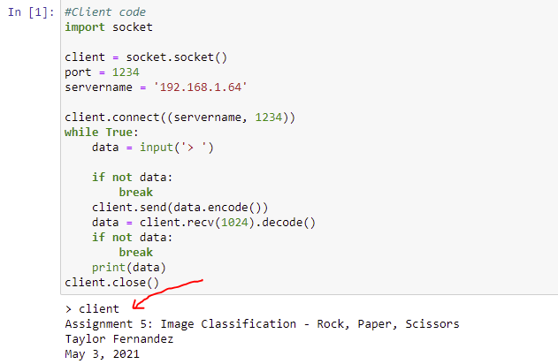

*Running client <imagefile>:*

