

# Texas Politics

**Jack Colpitt -- GEOG 586 Lab 1**

Today we will be analyzing Congressional voting districts of Texas, and understanding the political influence of location and gerrymandering. Wikipedia describes the results of gerrymandering often end in districts with perplexing boundaries rather than compact areas, and the redistricting plan for 2003 in Texas exemplifies that rather well. Figure 1 below is the results of the 2002 federal election which resulted in a close race of 16 Congressional districts won by both parties.

# Data

We will be using geospatial data from the 2002 election results and the redistricted boundaries in 2003 to predict the outcome of the 2004 election. Our prediction model will be created by using Kernel Density Estimation.

|  |  |
| --- | --- |
| **DISTRICT** | **RepMaj** |
| **0** 1 | -18886 |
| **1** 2 | -26922 |
| **2** 3 | 76471 |
| **3** 4 | -21758 |
| **4** 5 | 24378 |

**Table 1-1.** The dataset uses positive values to represent victory for the republican party and a negative values to represent wins for the democratic party in the 2002 federal election.

## **2002 Election**

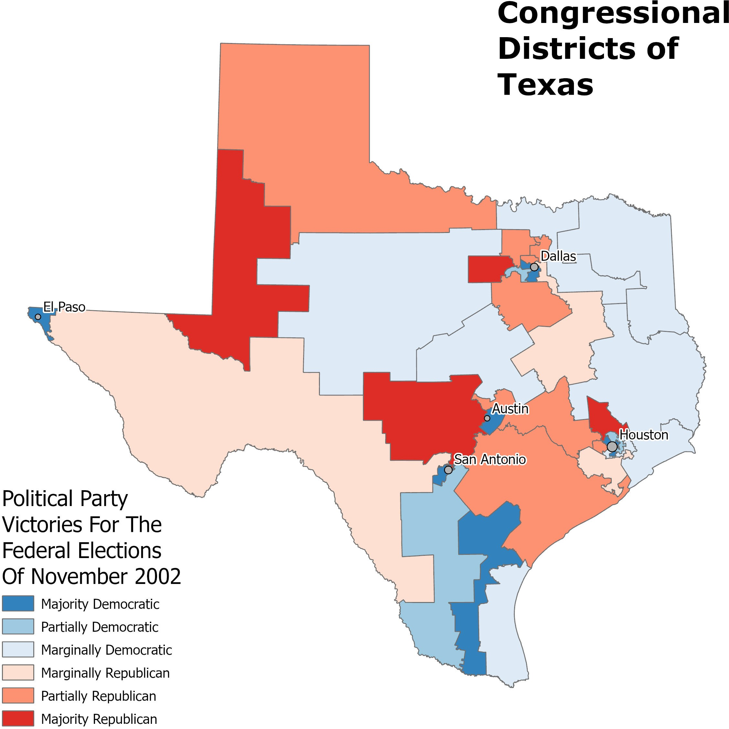

**Figure 1.** The 32 Congressional districts in Texas in which the Federal elections were held in November 2002.

The voting trends for the 2002 federal election in Texas show trends of rural versus urban political demographics. We can visualize that the majority of democratic voting takes place in the major cities, and the majority of republican votes are in the rural areas. There is also an apparent trend of a republican corridor ranging from the Northwest to the Southeast. It's quite interesting that the large congressional districts in East texas marginally represent a favor towards the democratic party.

## **2003 Boundaries and Predictions for 2004**

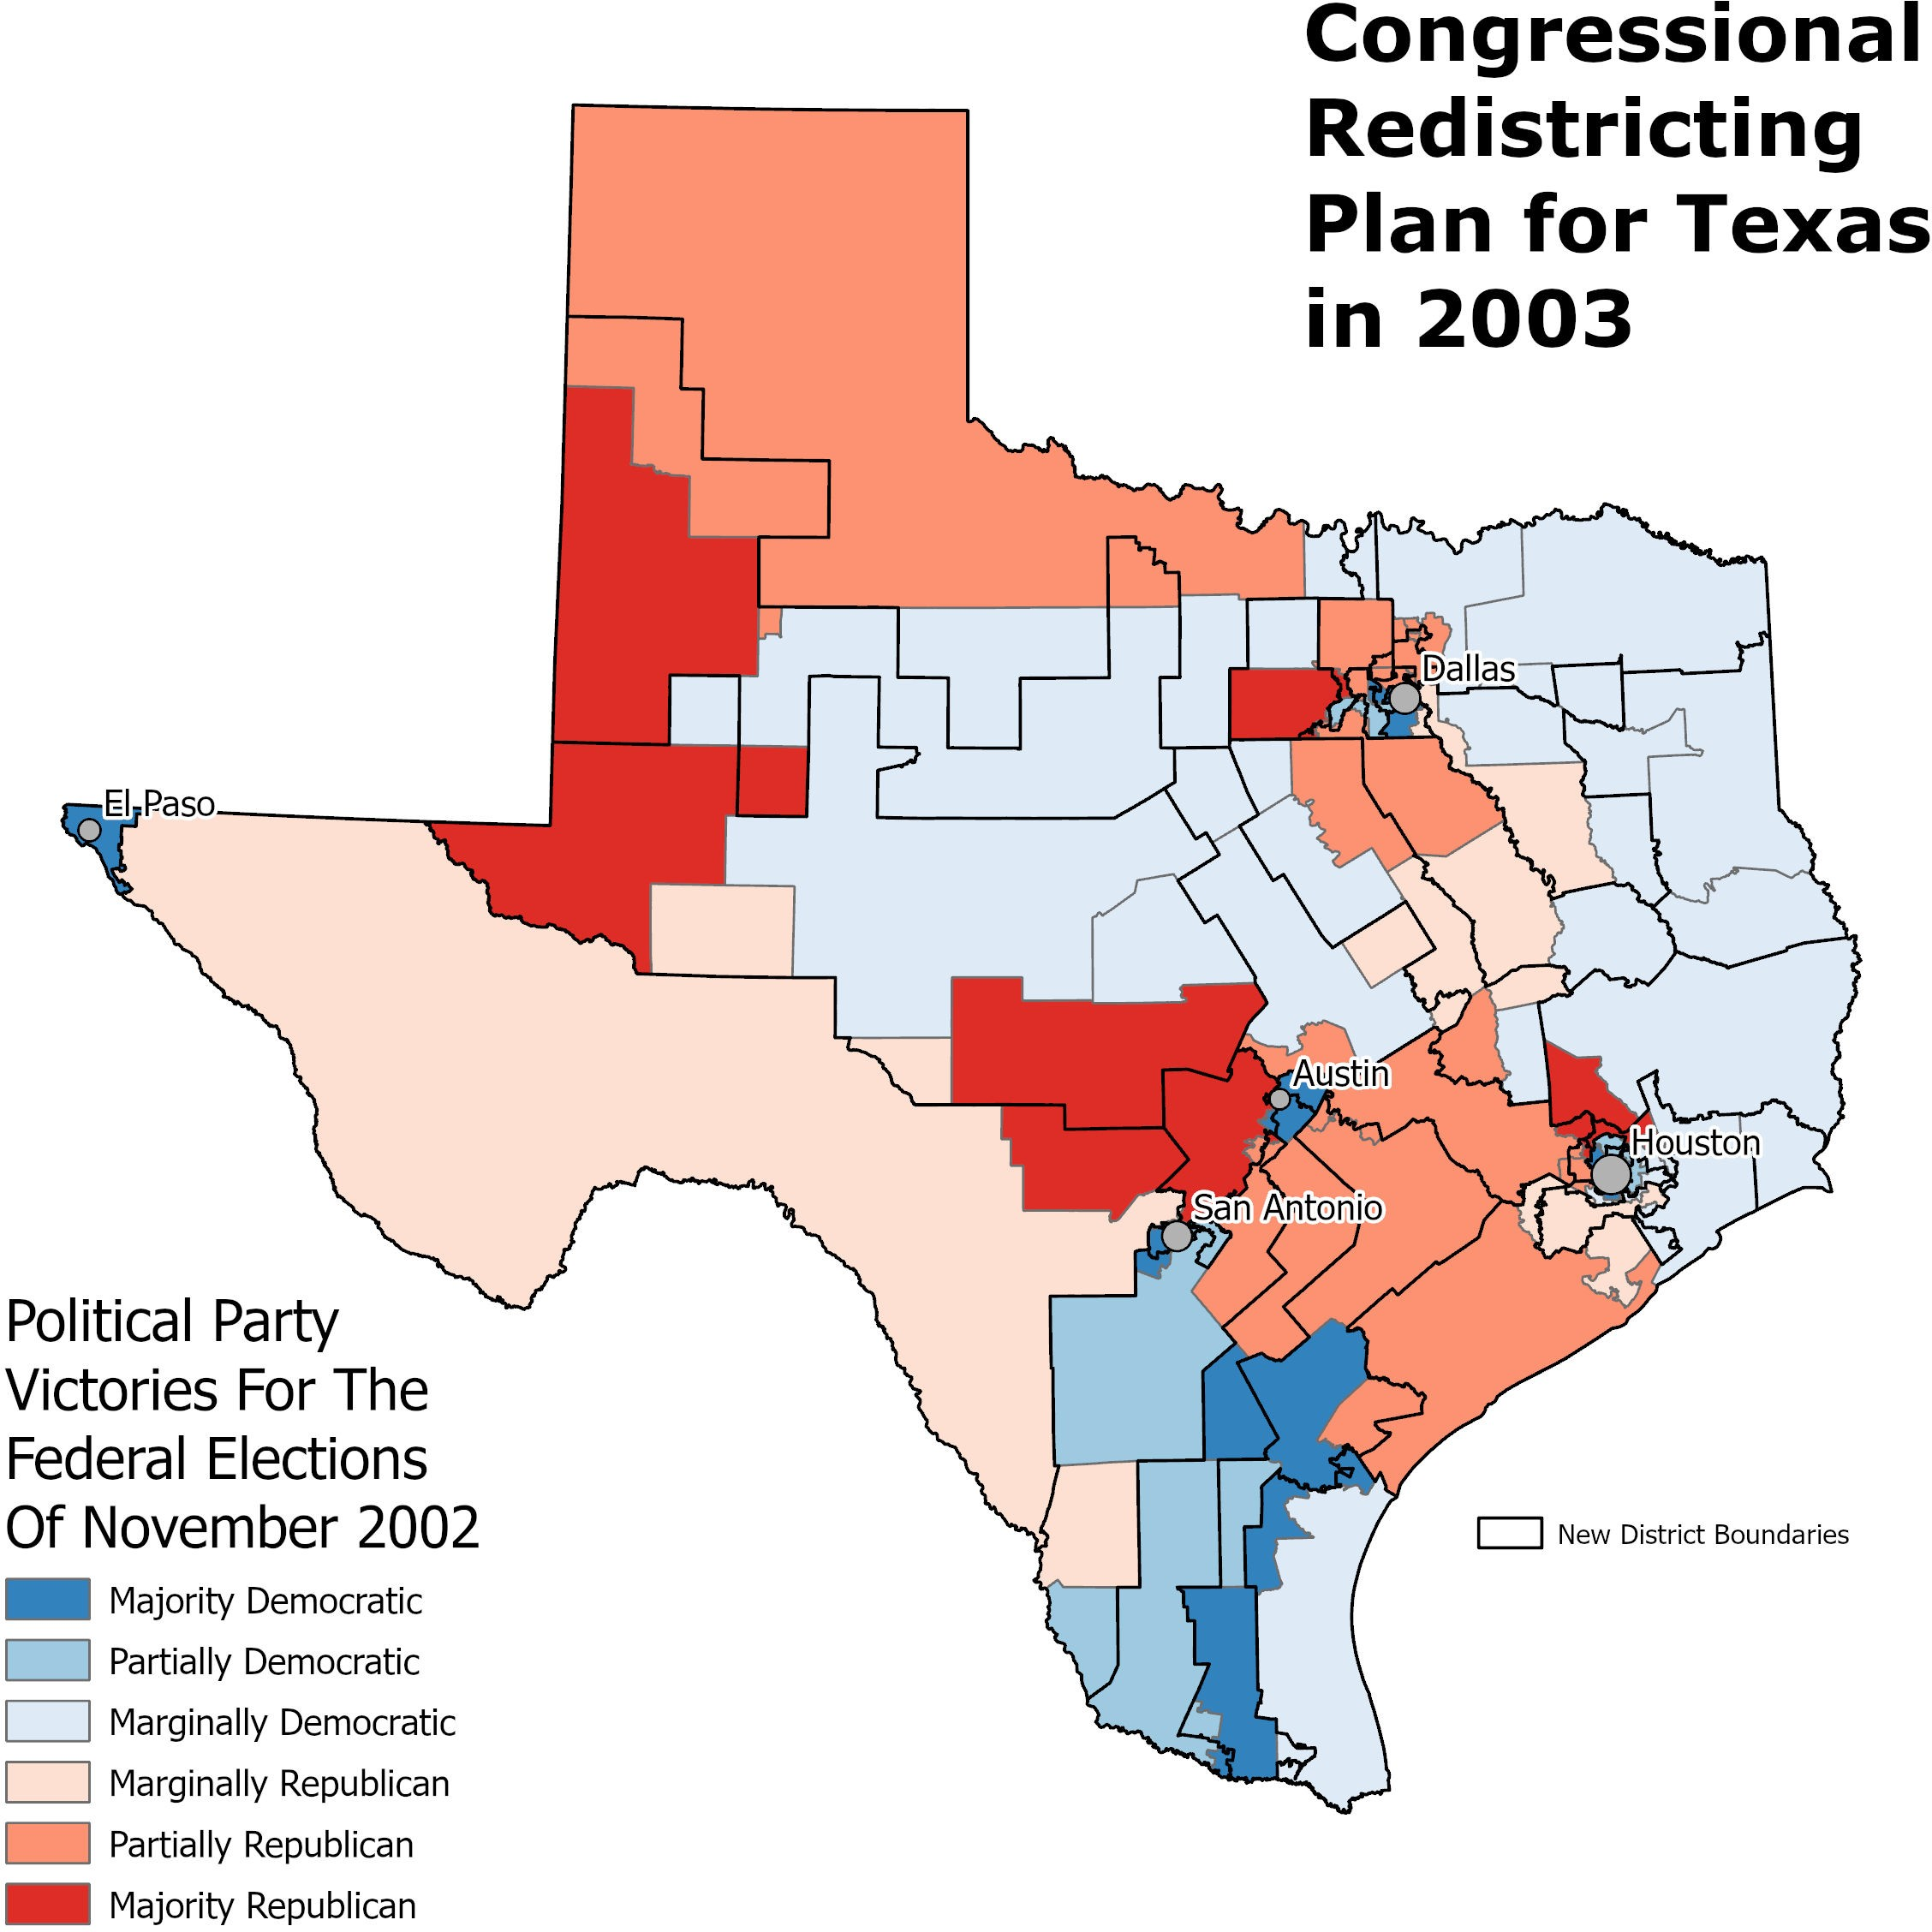

**Figure 2.** The black boundaries represent the new Congressional district boundaries for 2003 with the 2002 election results layered below in their respective boundaries during that year.

By previewing the new district boundaries over the 2002 election results. There are interesting situations for example, where District 21 which is a republican hotspot is moving its boundaries into some of the urban areas where representation of the democratic party could be diminshed. The greater Dallas area is also expanding the district boundaries of republican majority into areas that are voting marginally and partially democratic which could push the vote further in the favor republicans. I cannot predict the outcome based purely based on the previewing the new boundaries, but I would imagine the results will favor the conservative party.

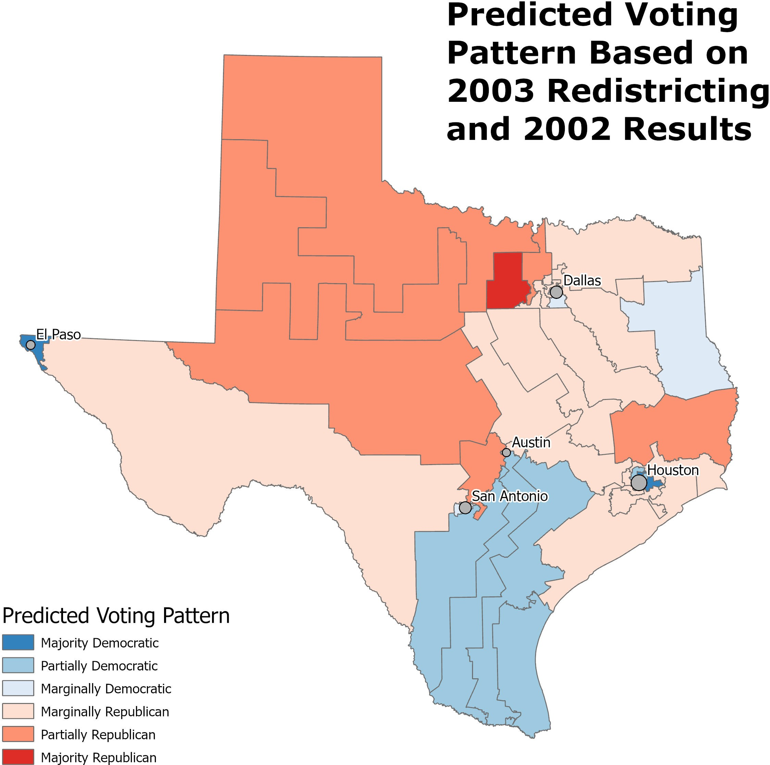

**Figure 3.** Using the Kernel Density Estimation tool in ArcGIS Pro we were able to predict the voting pattern for the next election based on the 2003 Congressional redistricting updates. The new trends reveal an increase in marginally republican voting patterns across the state.

Based on the prediction model analysis the Republican party would increase their win in Congressional districts from 16 to 22, and Democrats would decrease from 16 to 10. The proposed redistricting would have a large affect on the next election in favor of the republican party. The Kernel Density Estimation (KDE) works well for predictions across an operational scale with a variety of distribution and can adequately smooth the local variation.

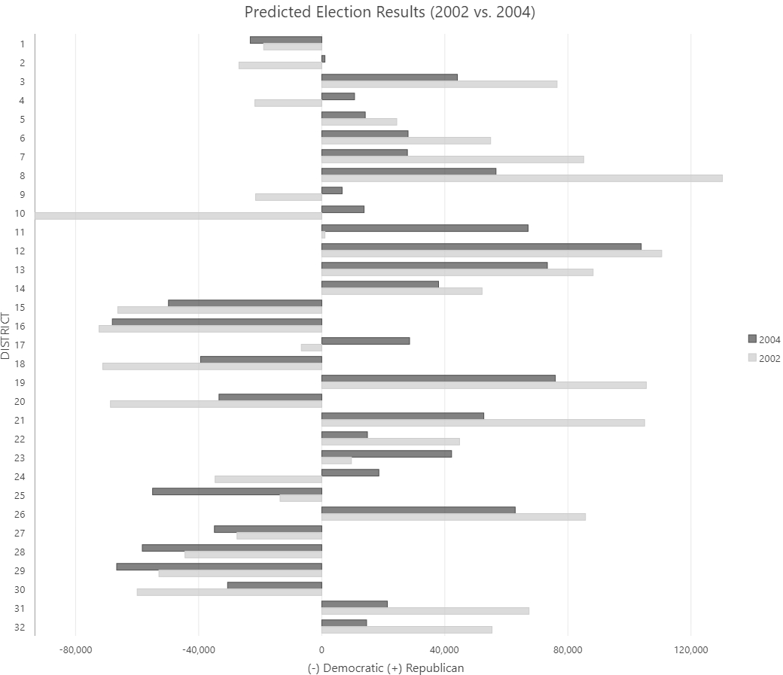

**Figure 4.** The predicted election results reveal further insights into possibilities from redistricting. There are reversals for political parties in districts 2, 4, 9, 10, 17, and 24 based on the Kernel Density Estimation and summation of Zonal Statistics.

## **Conclusion**

Gerrymandering can have clear influence on the results of elections. As you can see in Figure 3 and 4 the republican party would be able have a landslide victory based on the adjusted changes. Kernel Density Estimation was able to make an appropriate model based on the spatial dependence and variation.