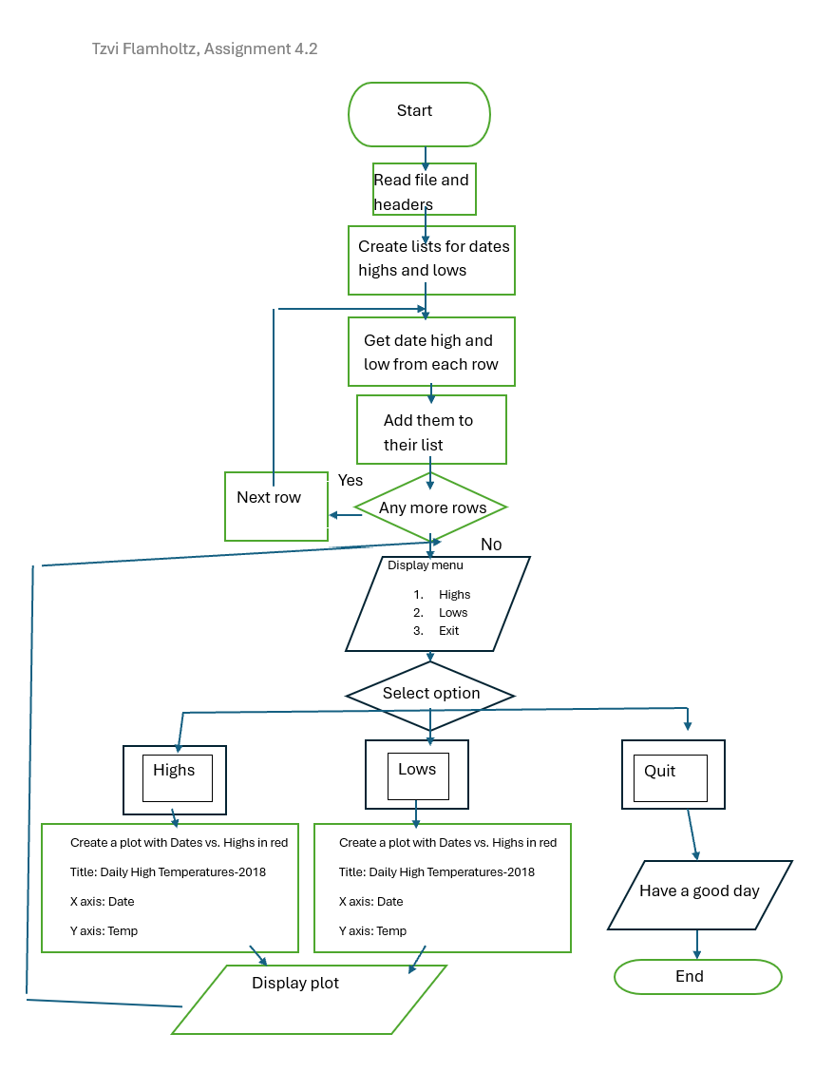

Display plot
Create a plot with Dates vs. Highs in red
Title: Daily High Temperatures-2018
X axis: Date
Y axis: Temp

No
End
Yes
Next row
Any more rows
Add them to their list
Get date and high from each row
Create lists for dates and highs
Read file and headers

a
Start

