Graph Columns ( )
Shows a line graph of the values in a column across all the rows in the table. A graph can be slid up or down by dragging the label with the mouse. This allows separate line graphs to be superimposed. Note that each line graph is normalized to its own value range, so superimposed graphs do not share a common scale.
This might be a useful view of the table if successive rows in the table represent a time series of values.
The user may select rows in the table by pressing the mouse button over a graph and dragging left or right to select a region on the graph.

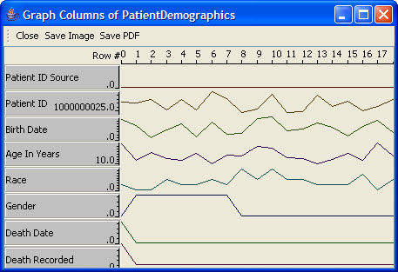
Figure 2.68 | Graph Columns

