Histogram ( )
This view presents a bar chart to represent the histogram. If multiple columns are included in the histogram, this will be a grouped bar chart.

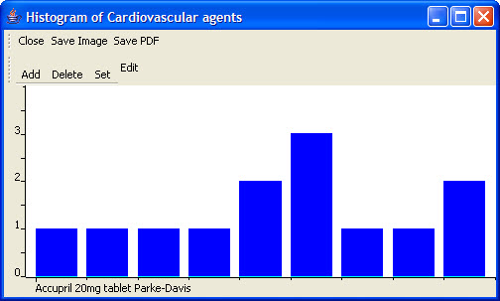
Figure 2.69 | Histogram

Histogram Editor
A histogram divides the range of a set of values into a number of bins, and reports the number of values that fall into each bin.
The Histogram Editor defines the bins for each of the table columns included in the histogram.

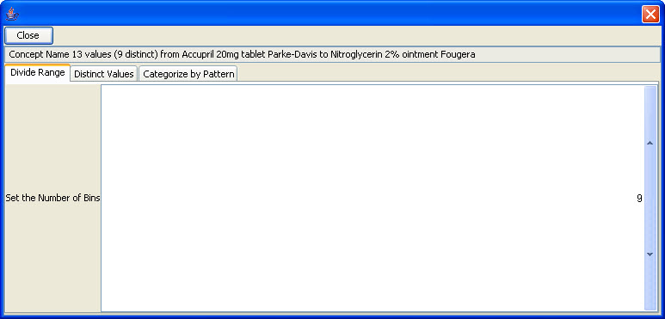
Figure 2.70 | Histogram Editor Dialog Box

