Scatter Plot Icons ( )
This provides a pairwise scatter plot of any two columns in the table. A thumbnail icon is generated for each pair of columns in the table. Clicking an icon open an interactive Scatter Plot view for that pair of columns.

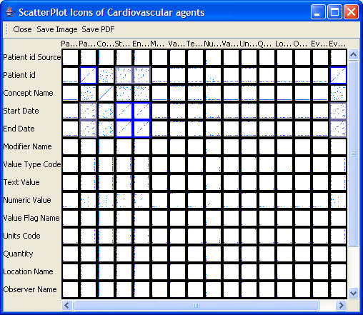
Figure 2.79 | Scatter Plot Icons

