Table View ( )
A table () shows a column for each attribute and one or more rows of data. It provides a view of the data as a table which is similar to a traditional spreadsheet.
The small bar along the left margin shows the location of selected rows within the entire length of the table. A mouse click in this area will scroll the table to that location.
The left margin of the table shows the row number indices of the table in its original sort order.

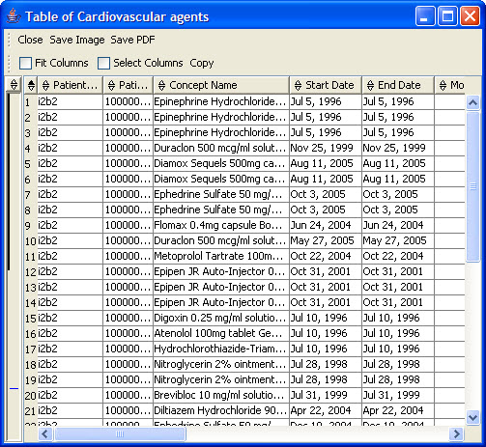
Figure 2.61 | Table

Table View Features
The table view has features for refining the display to suit your needs.

Column Descriptions
Descriptions of the attributes for which data is reported are displayed.

Column Adjustments
You can make the following adjustments to columns:
Adjust column width by dragging a border left or right.
Change a column order by dragging a column heading and dropping to insert it between two columns.
Column sort is done by clicking on the up or down arrow in the column heading. To return to the original sort order, click on the appropriate arrow in the row # column.
Up Arrow – ascending order
Down Arrow – descending order
Additional Sorting criteria – hold the <Shift> key while clicking on other arrows.
Remove Additional Sorting – hold the <Ctrl> key while clicking on an arrow.

Fit Column will force the table to fit the width of the window by either expanding or shrinking the column widths.
Select Columns allows the user to select one or many columns.

Copy
The Copy button copies the text values of the selected cells in the table to the system clipboard. The values can then be pasted in other applications.

Adding a Table

Note: The add table feature can be accessed via the View Menu or by clicking on the table icon () located on the file and edit toolbar.

- On the main Tree View highlight the branch, also referred to as table leaf () in which the new table is to be created (Figure 2.62)

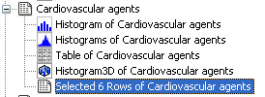
Figure 2.62 | Add Table: Highlight branch/leaf

- Click on the Table icon () on the view toolbar or select Table View from the View menu.
- A new table will be created and appear under the selected branch (Figure 2.63).

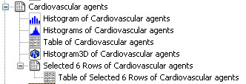
Figure 2.63 | Add Table

Editing a Table
For information on editing a table please see Table Columns section of the help.

Saving a Table
For information on saving a table please see Save Table section of the help.

Removing a Table
For information on removing a table please see Delete Item section of the help.

