Navigation in Views

Zoom In/Out (Axis Displays on Views)
The Axes displays on several of the views allow the user to zoom in, zoom out, pan across, or pan up and down the view of the data by using the mouse or the arrow keys.
Note: Note all axes have the ability to zoom.

Zoom In
Keyboard: Press the UP arrow key.
Mouse: Use Left Mouse Button to zoom in on the view. The point at which the button is pressed will move to the left edge, and the point at which the button is released will move to the right edge.

Figure 2.53 | Zoom In - X Axis

Figure 2.54 | Zoom In - Y Axis

Zoom Out
Keyboard: Press the DOWN arrow key.
Mouse: Use <Ctrl>Left Mouse Button to zoom out on the view. The left edge will move to the point at which the button is pressed, and right edge will move to the point at which the button is released.

Figure 2.55 | Zoom Out - X Axis

Figure 2.56 | Zoom Out - Y Axis

Pan across
Keyboard: Press the LEFT arrow or the RIGHT arrow key.
Mouse: Using <Shift>Left Mouse Button to pan across the view: press the button and drag to pan.

Figure 2.57 | Pan Across - X Axis

Pan Up & Down
Keyboard: Not available.
Mouse: Using <Shift>Left Mouse Button to pan up and down the view: press the button and drag to pan.

Figure 2.58 | Pan Up and Down - Y Axis

Save Images
All views can be saved to an image.
- Open the view to be saved.
- Click on Save Image located at the top of the view.
- The save dialog box will open (see Figure 2.59)

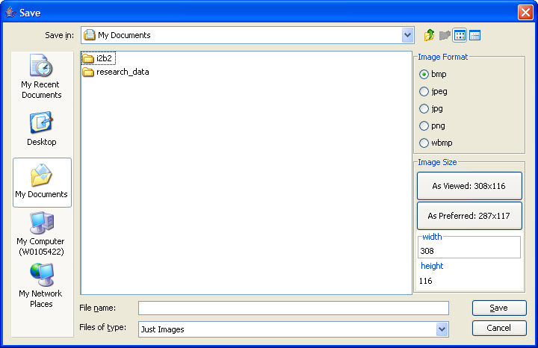
Figure 2.59 | Save Images

- Select the location of where the image will be saved.
- Select the image format that is appropriate for your use.
- If necessary, change the default image size.
- Enter the file name for the image.
- Click on the Save button.

Save PDF
All views can be saved to a PDF.
- Open the view to be saved.
- Click on Save PDF located at the top of the view.
- The save dialog box will open (see Figure 2.60)

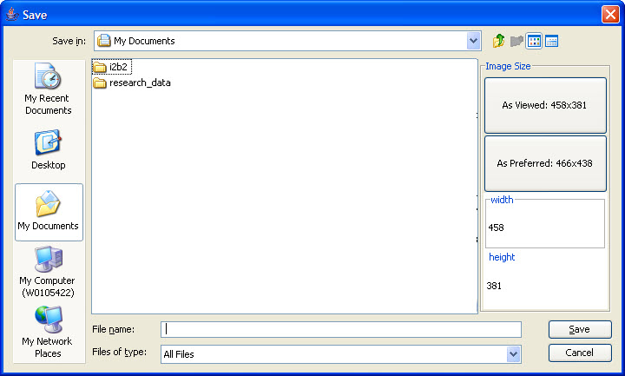
Figure 2.60 | Save PDF

- Select the location of where the image will be saved.
- If necessary, change the default PDF size.
- Enter the file name for the PDF.
- Click on the Save button.

