Histogram 3D ( )
This view presents 3 dimensional bars to represent a histogram calculated over 2 table columns.

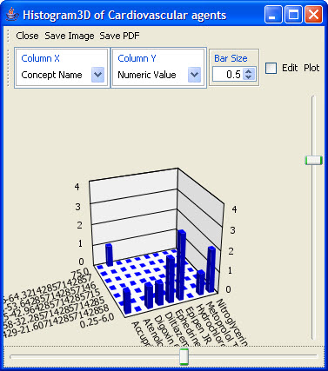
Figure 2.72 | Histogram 3D

