Layout of the Find Terms View
The Find Terms view allows users to search for a concept or group of concepts. There are basically two methods of searching available; (1) by name and (2) by code.

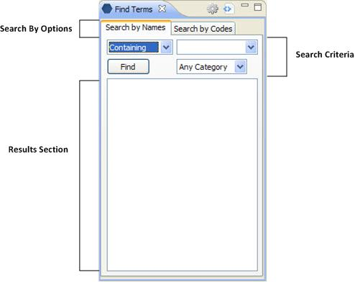
Figure 3. 1 Find Terms View

Note: Regardless of how you search for the concept the layout of both tabs is the same.

Search by Options
This section has two tabs; one is to Search by Name and the other Search by Code. Depending on which tab is active will determine which search method is used to find the concept.

Search Criteria
There are three fields in this section; (1) Qualifier, (2) Text and (3) Category

Qualifier
The qualifier is used to tell the system whether or not you are looking for an exact match or just a partial match. There are four different options to choose from.

- Starting with
- Ending with
- Containing
- Exact

Text
The text box is where you will enter what you are searching for.

Category/Coding System
The category/coding system selection field allows you to narrow down the search to a particular table or set of codes.

Results Section
The results section displays the concepts that were found based on the search criteria.

